***Hopping Back* Game Boards**

**Master 9a**

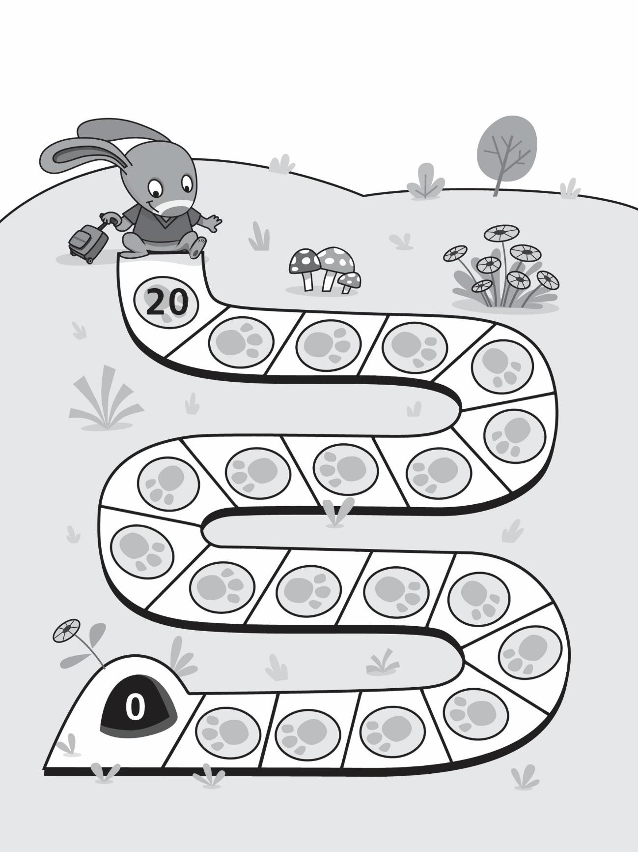

***Hopping Back* Game Boards (for Accommodation)**

**Master 9b**

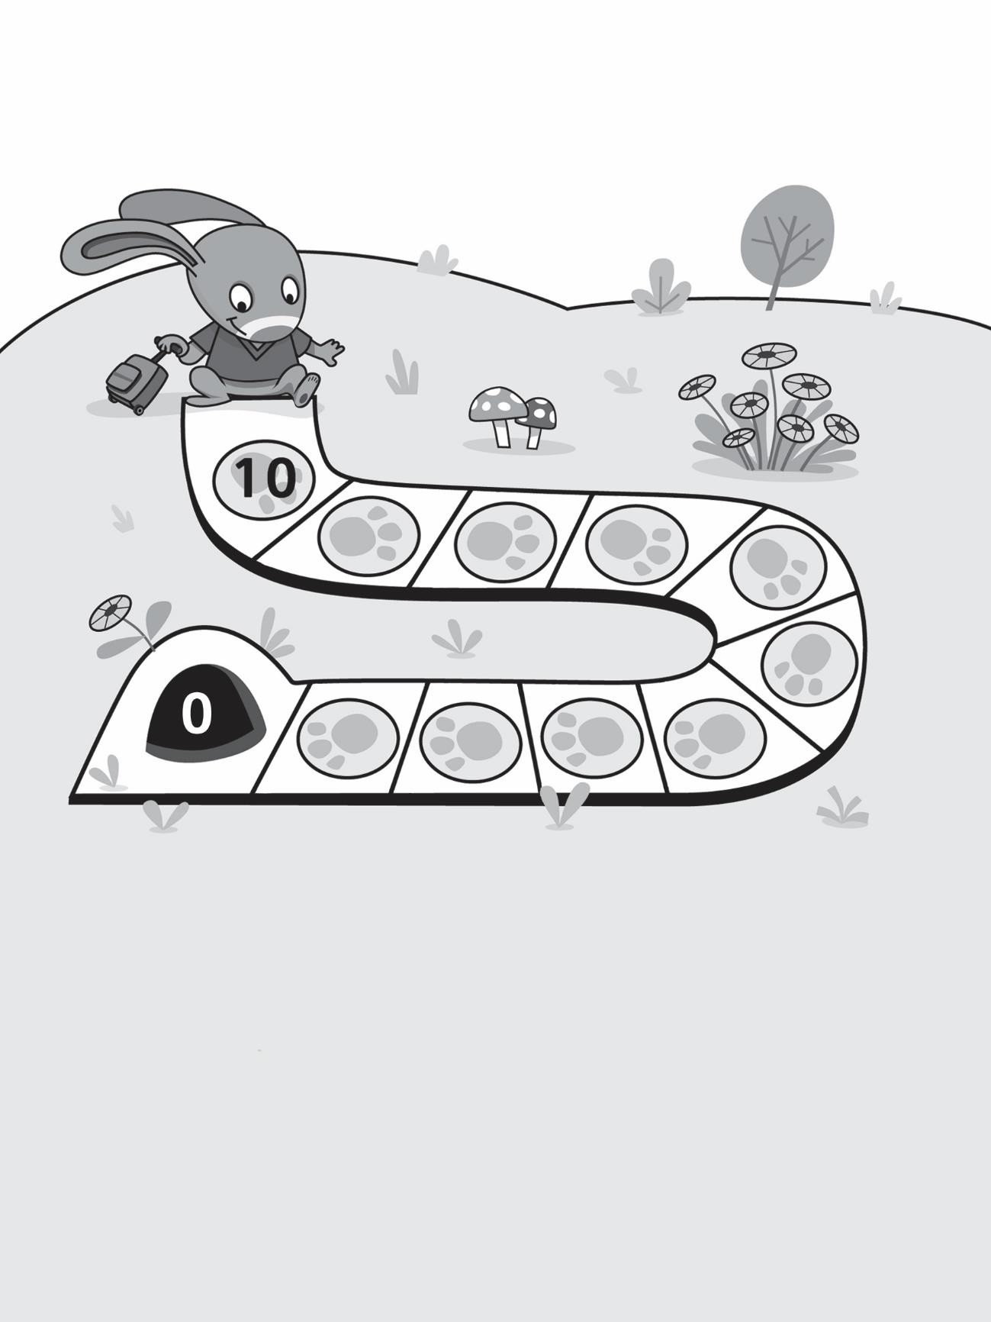

***Hopping Back* Game Boards**

**Master 9c**

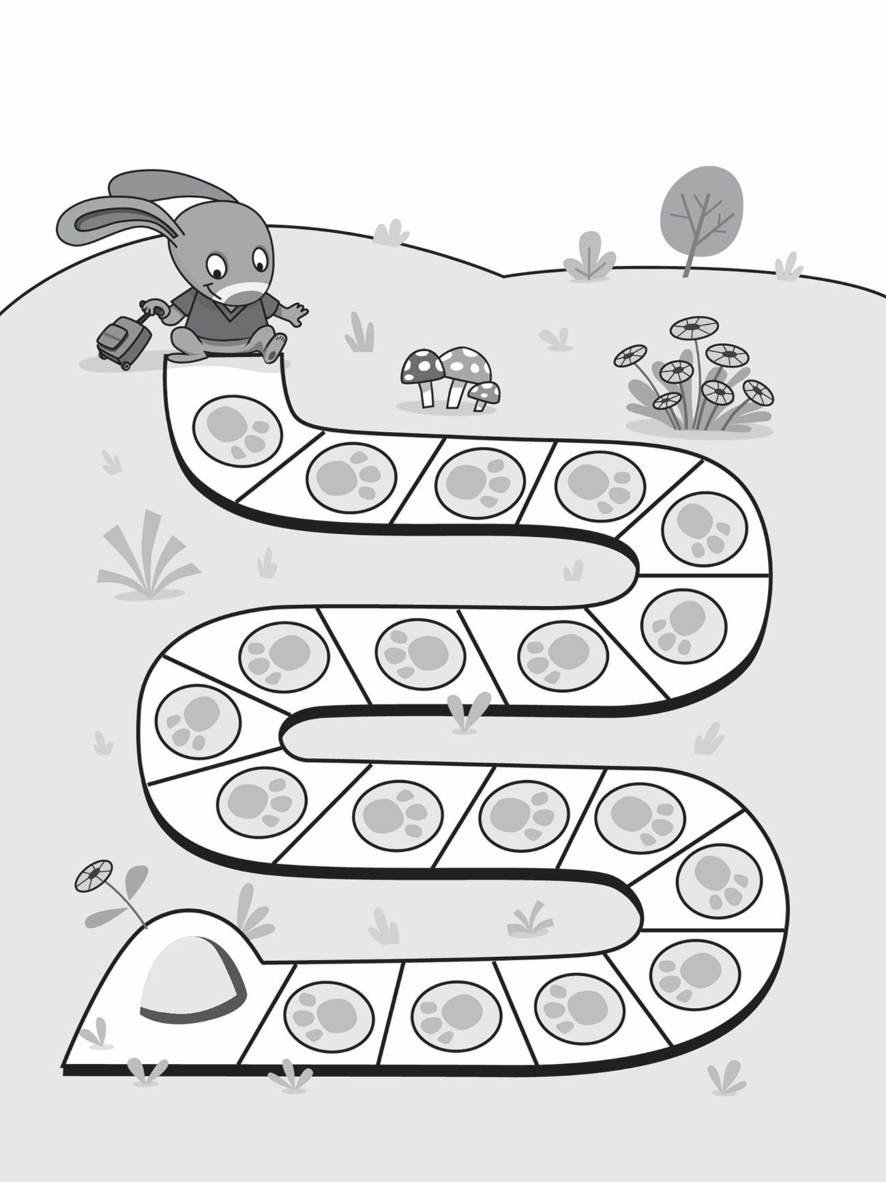

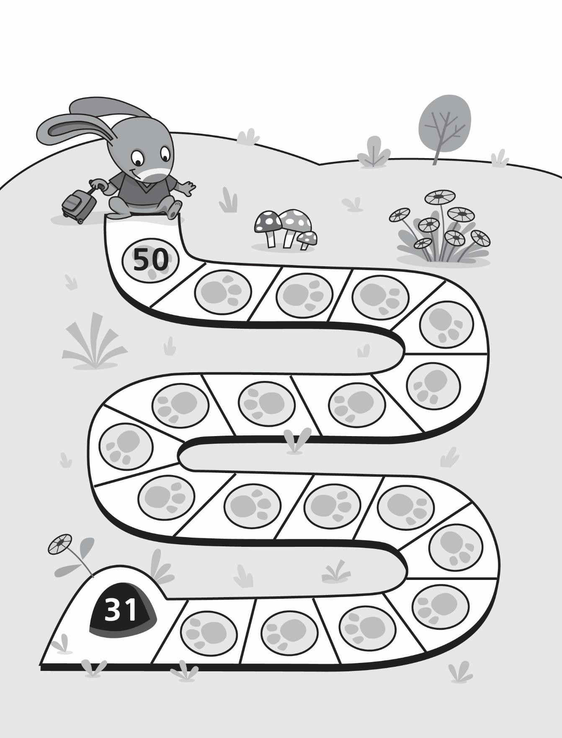

***Hopping Back* Game Boards**

**Master 9d**

***Hopping Back* Game Boards (for Extension)**

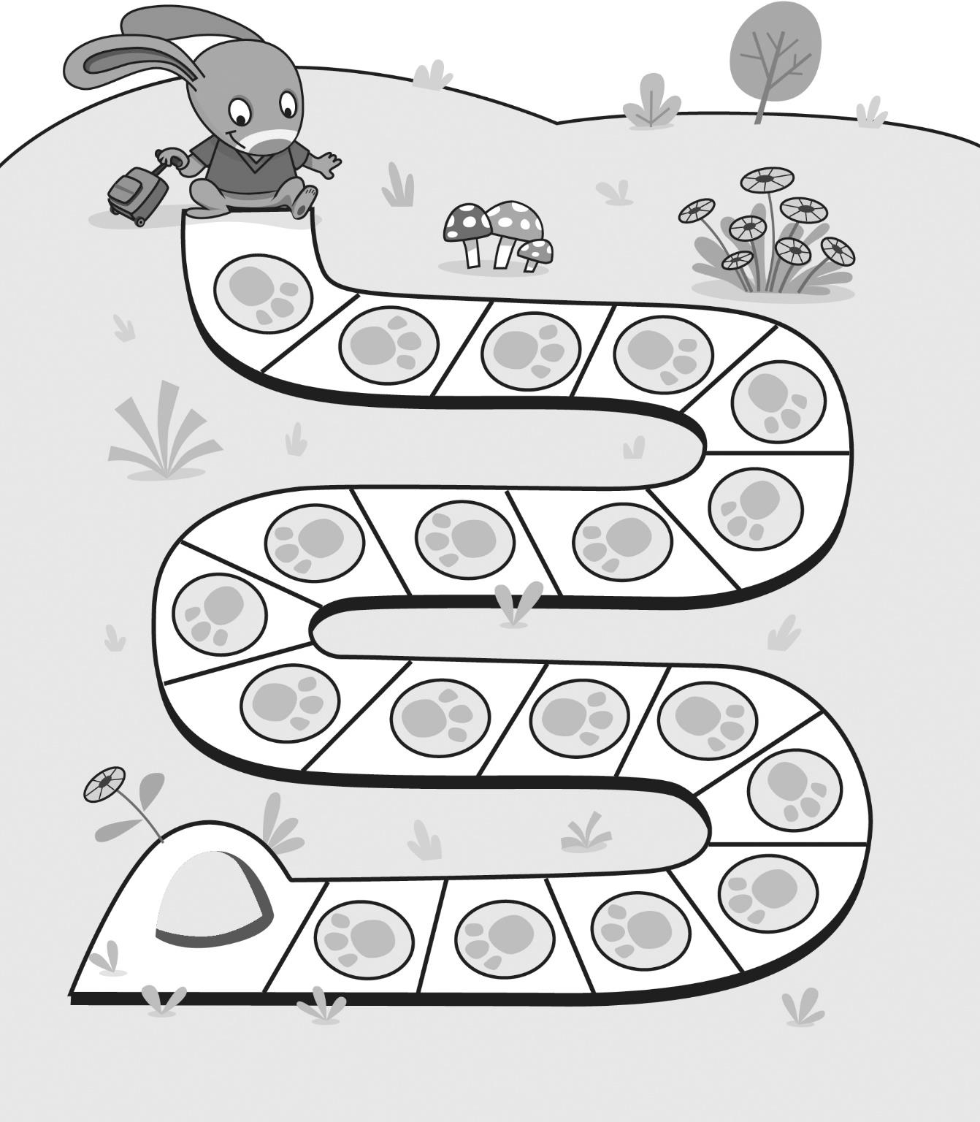

**Master 9e**