***Hopping On* Game Boards**

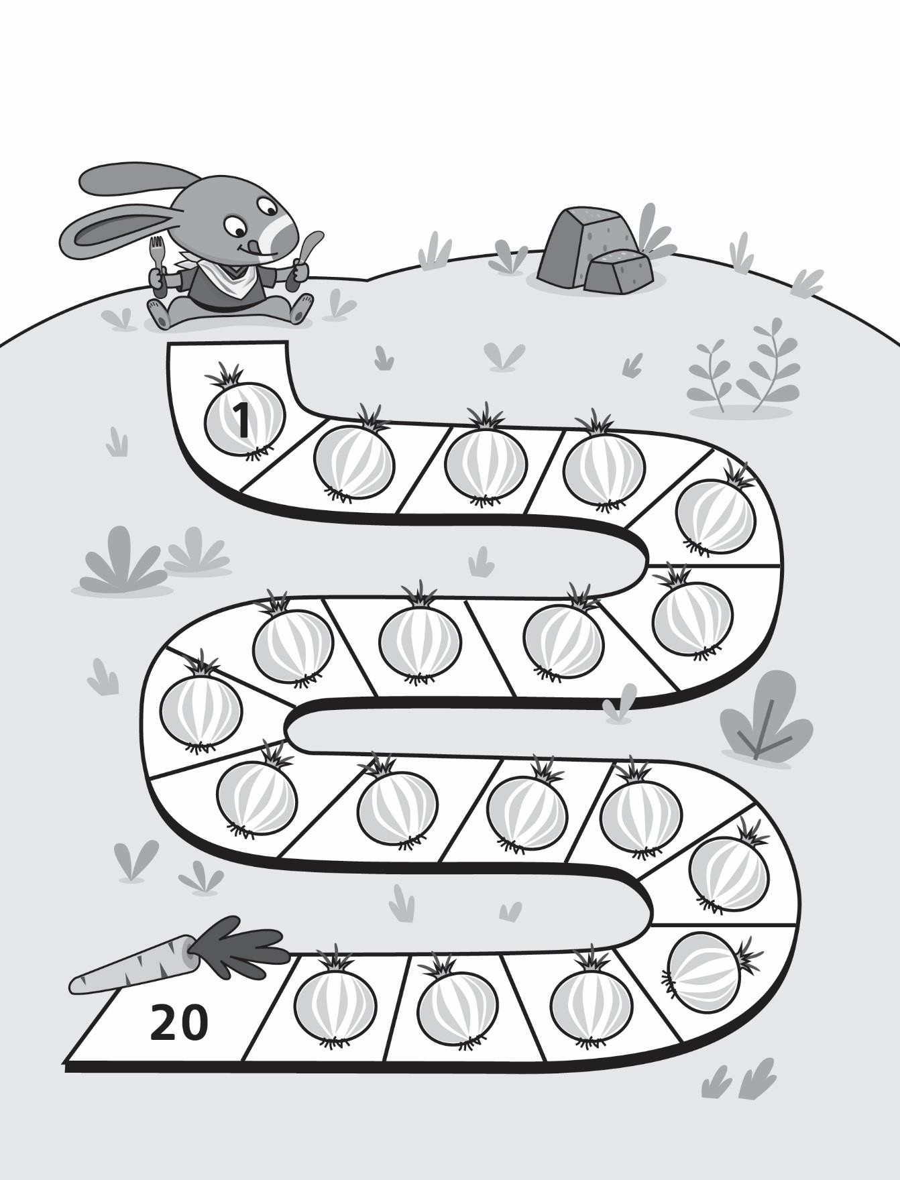

**Master 8a**

***Hopping On* Game Boards (for Accommodation)**

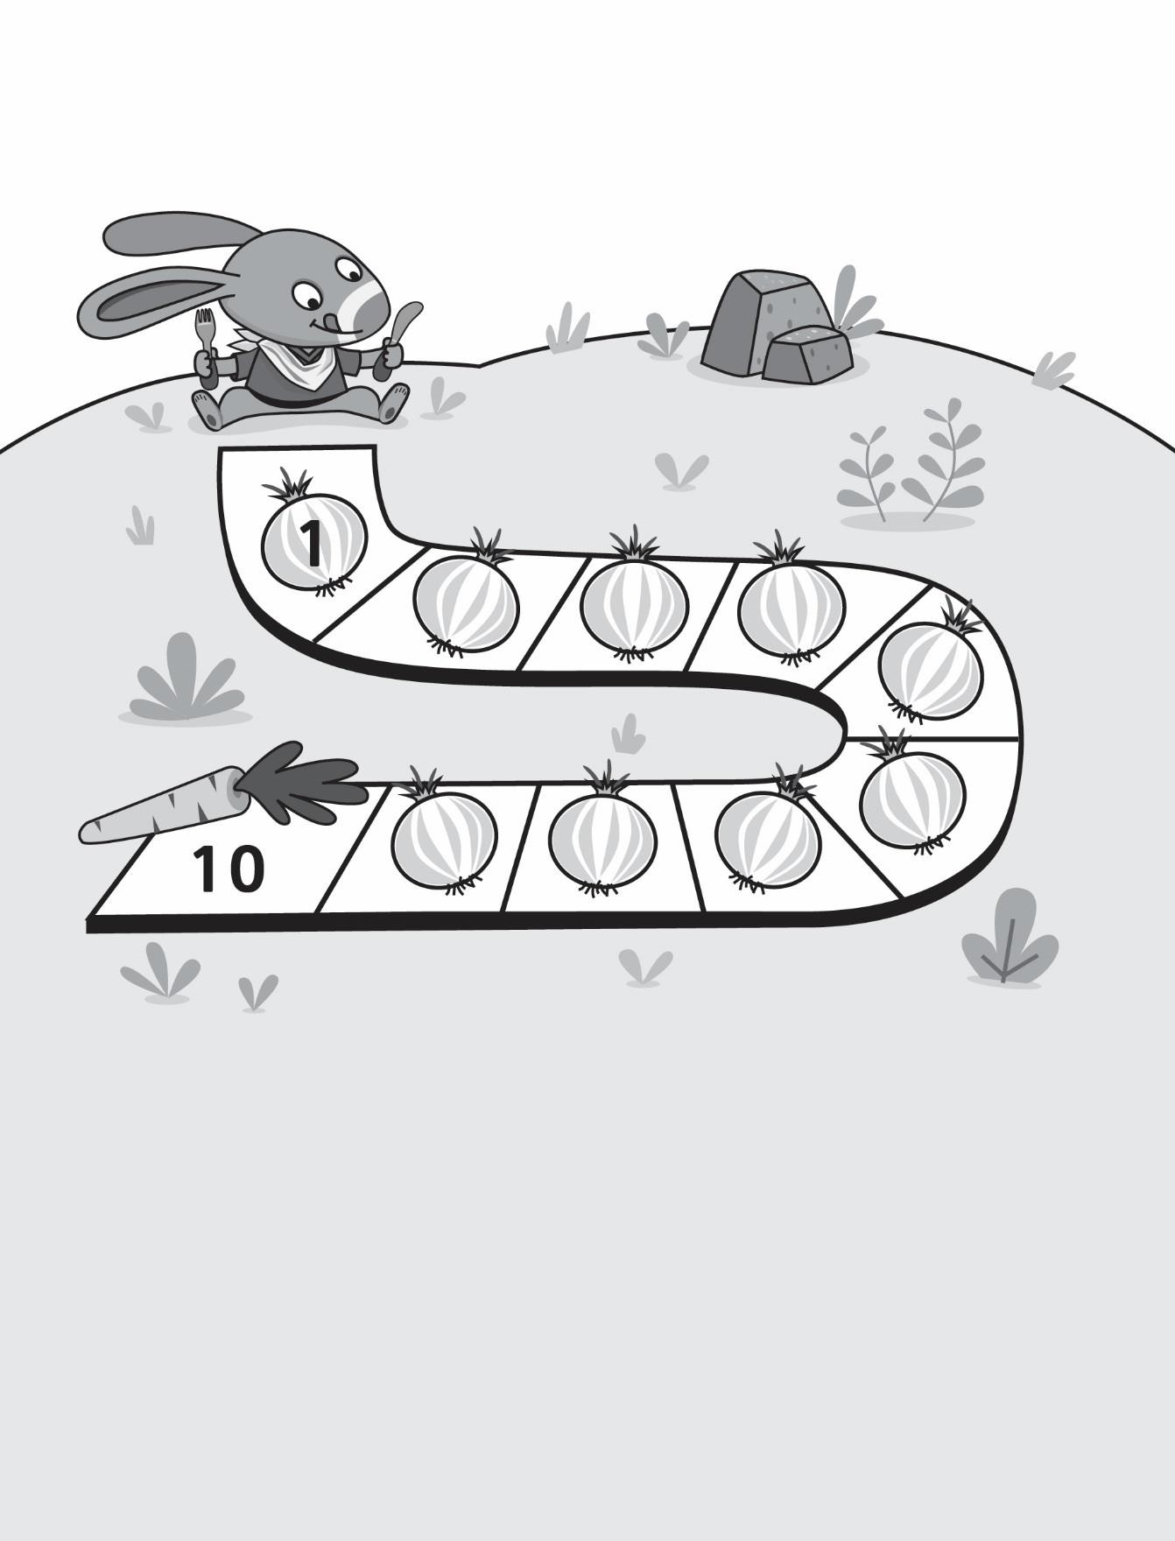

**Master 8b**

***Hopping On* Game Boards**

**Master 8c**

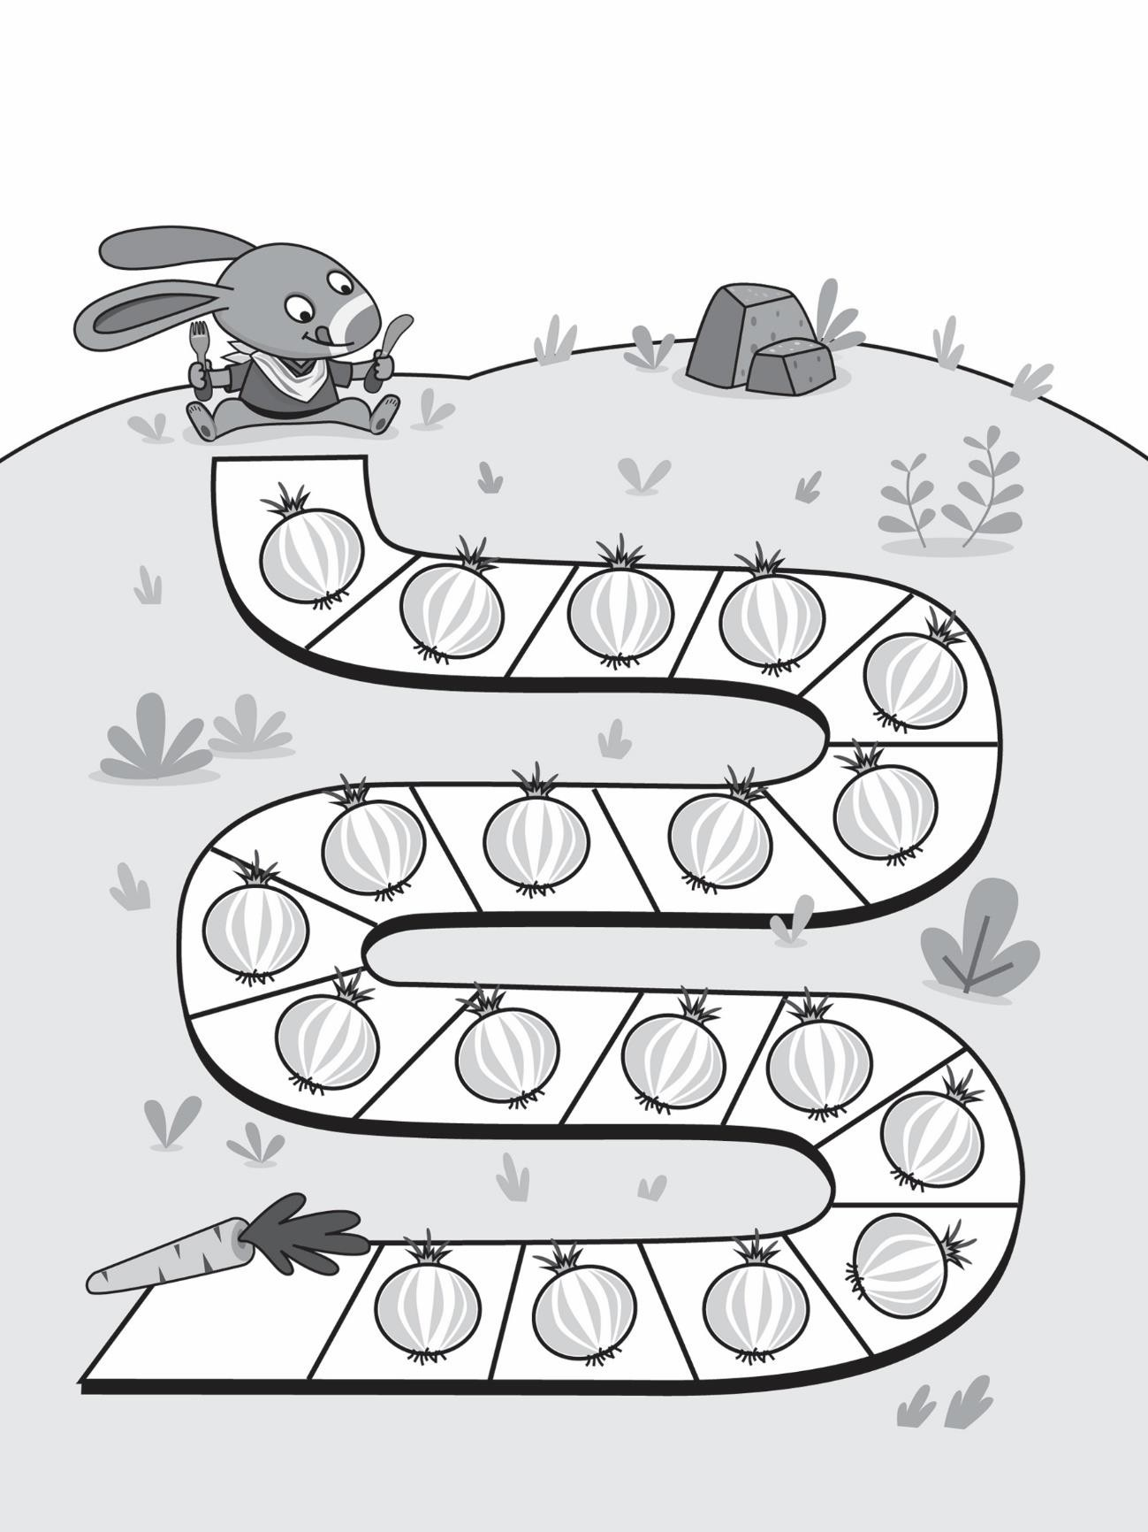

***Hopping On* Game Boards**

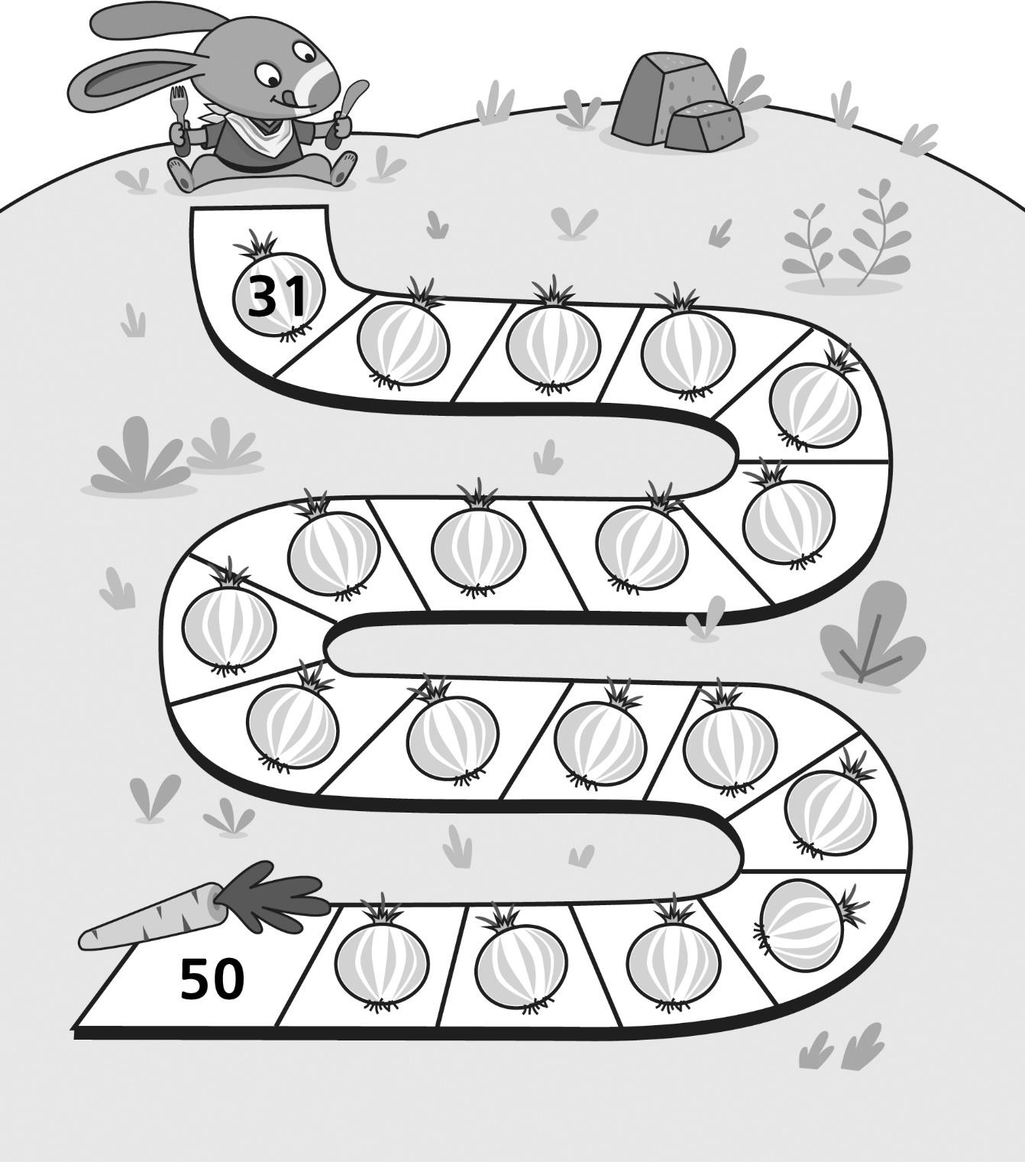

**Master 8d**

***Hopping On* Game Boards (for Extension)**

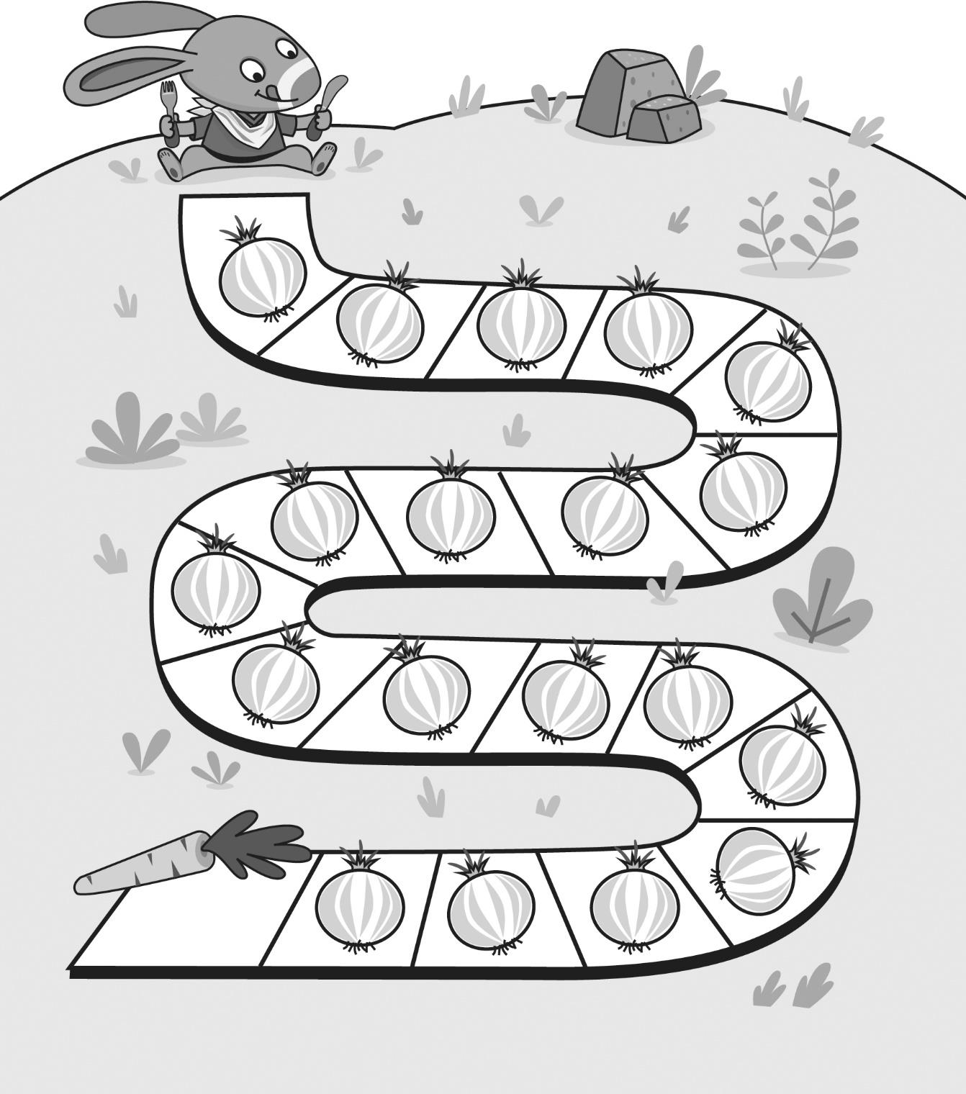

**Master 8e**