The Castle Wall Line Master 1
(Assessment Master)
Name: _____________________________

Explore, Describe, and Compare Shapes and Solids | Not observed | Sometimes | Consistently
Recognizes and describes shapes using geometric attributes (e.g., it has 3 sides and 3 corners/vertices)
Recognizes solids based on geometric attributes (e.g., it has 6 sides/faces and they are all the same shape)
Describes solids based on geometric attributes and/or how they move
Sorts solids based on geometric attributes and/or how they move
Makes connections between shapes and solids (e.g., the bottom/side of the box is a square)
Makes connections between solids and objects in the environment (e.g., the marker looks like a cylinder)
Create and Describe 3-D Structures
Demonstrates an understanding of the attributes of solids when building (e.g., solids with flat faces make sturdy bases)
Applies prior knowledge and experience when building and rebuilding
Can follow directions to create structures
Uses appropriate language and gestures to describe location, position, and/or order
Strengths:

Next Steps:

Connecting Home and School Line Master 2–1

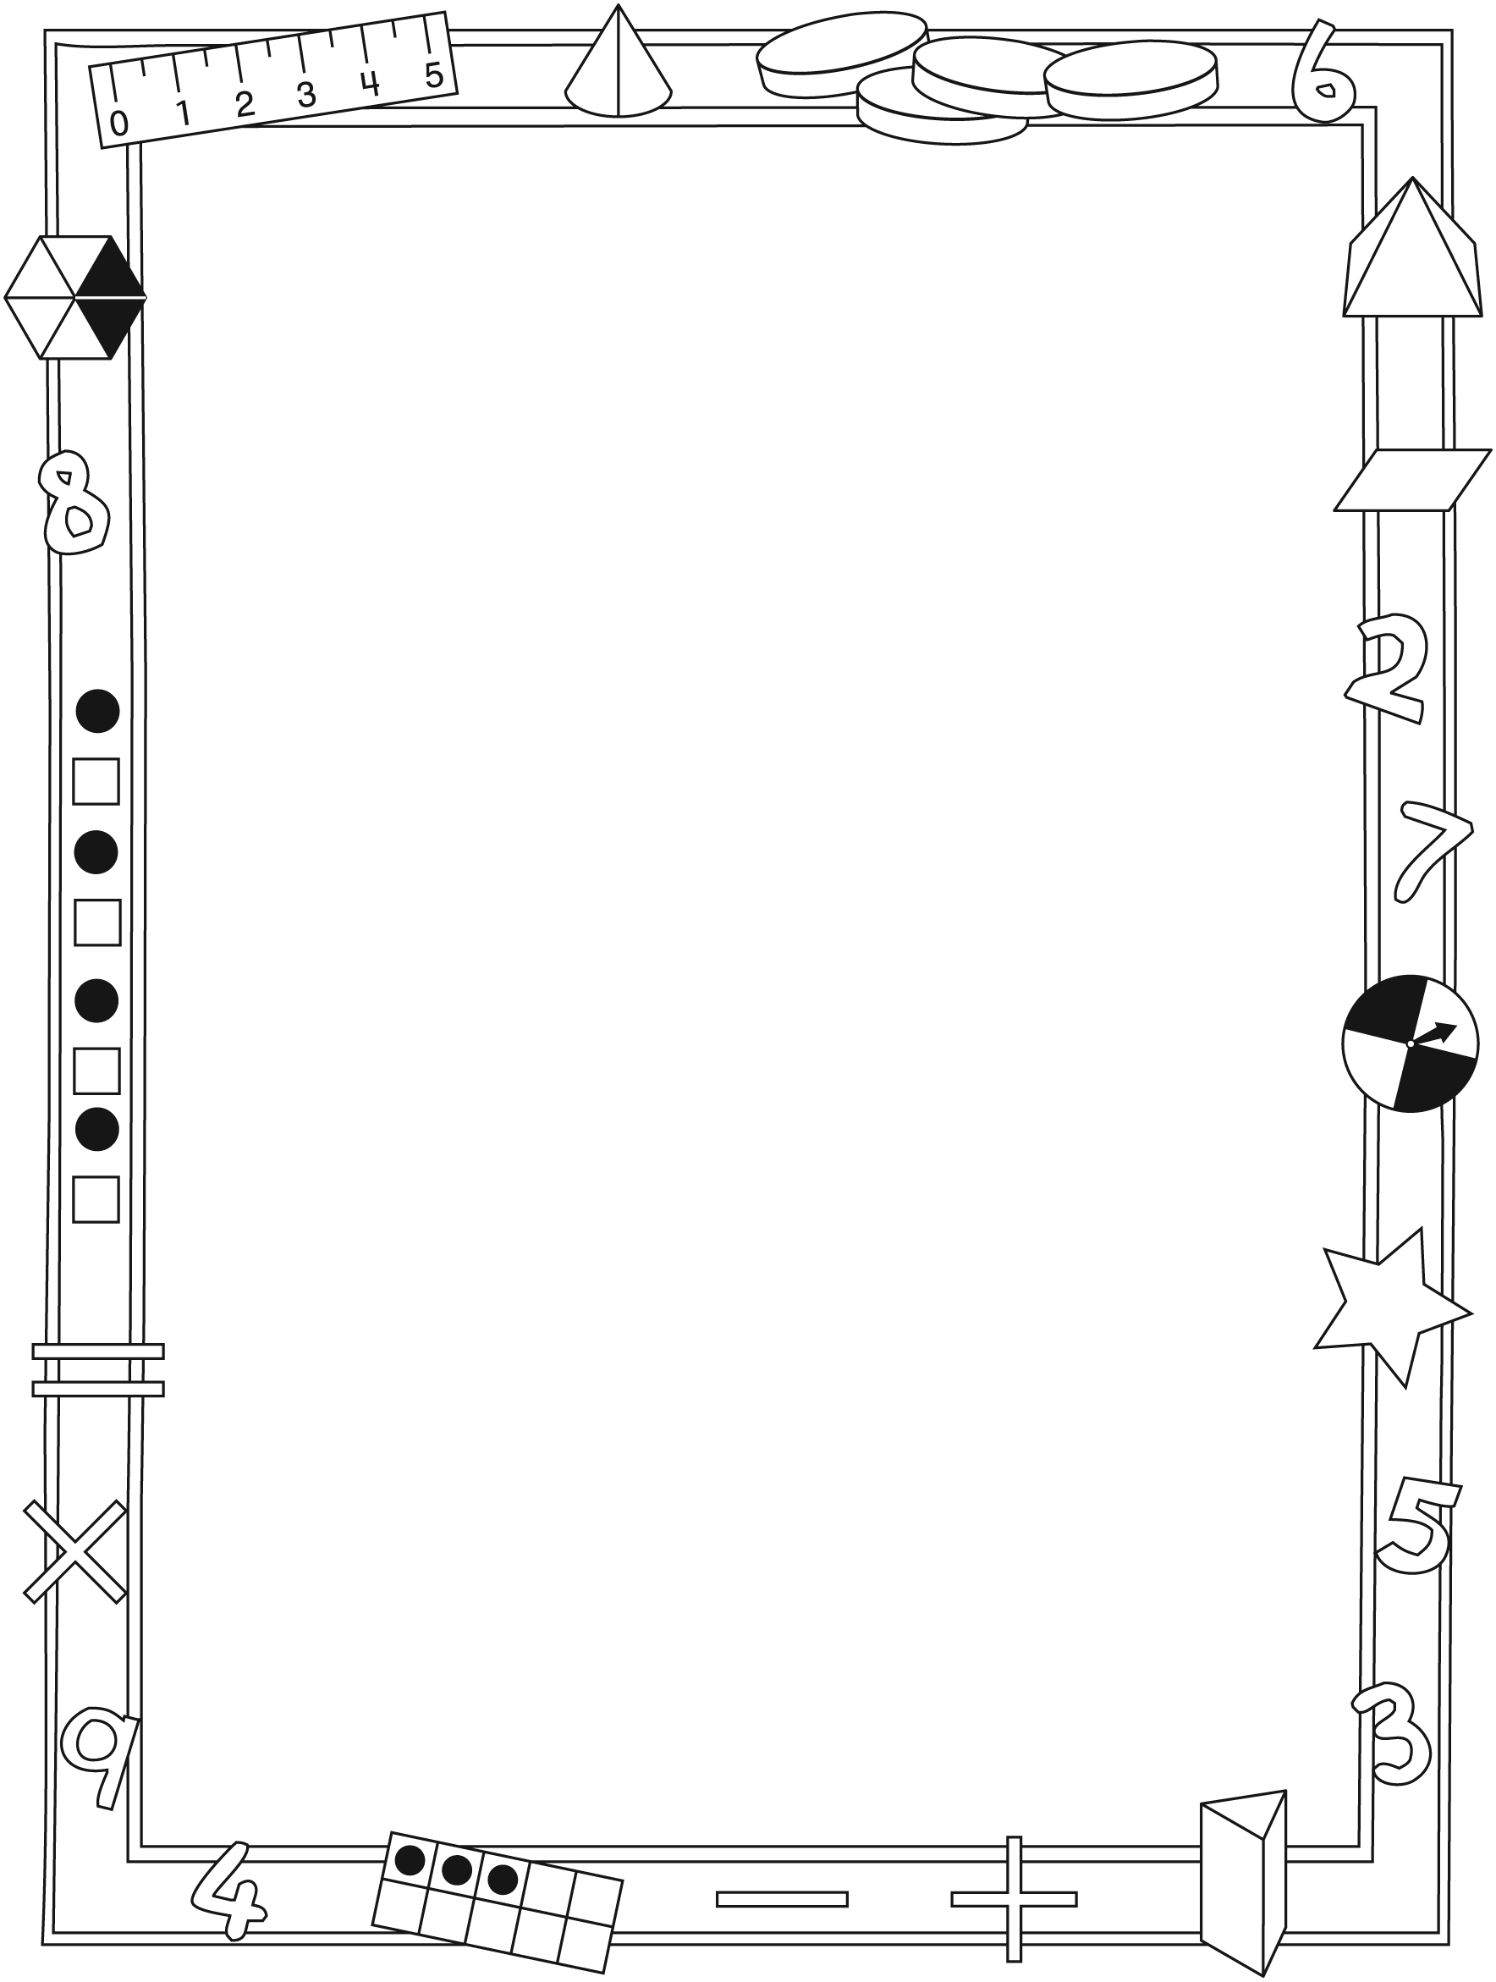

NOTE TO THE TEACHER

You may wish to send families a The Castle Wall letter outlining a familiar activity or two they can do at home with their children.

Create a letter using this template and select one or two activities from the suggestions on the next page. Simply delete these instructions and cut and paste the activities you have selected, adapting them to fit your needs.

Connecting Home and School Line Master 2–2

Dear Family:

We have been working on The Castle Wall, which engages children in conversations, investigations, and activities that help to develop their understanding of the big math idea that “Shapes and solids can be explored
and compared based on attributes.” Particular focus is placed on exploring
2-dimensional shapes and 3-dimensional solids, and creating and describing
3-dimensional structures. Try this activity at home with your child.
– – – – – – – – – – – – – – – – – – – – – – – – – – – – – – – – – – – – – – – – – –
Reading the Story: As you read the story, enjoy talking about and describing the building strategies of the workers and the blocks they are using and combining. Accept your child’s natural, descriptive language, while modelling appropriate terms (e.g., cube, edge).
– – – – – – – – – – – – – – – – – – – – – – – – – – – – – – – – – – – – – – – – – –
Mystery Shapes: Secretly place an object shaped like a cone, cube, cylinder, or other solid into a bag. Your child puts his/her hand in the bag to feel the object and describe it to you. If necessary, ask: Does it feel round? Does it have a flat side(s)? What else do you feel? Reverse roles.
– – – – – – – – – – – – – – – – – – – – – – – – – – – – – – – – – – – – – – – – – –
What Will You Build?: We are learning about the attributes of different solids. You might like to build a structure with your child out of building blocks, clean recycled packaging, and/or found objects. Talk about the 2-dimensional shapes and
3-dimensional solids you see in the structure, and where and how they are positioned. Discuss which blocks/objects are better for building a sturdy base.
– – – – – – – – – – – – – – – – – – – – – – – – – – – – – – – – – – – – – – – – – –
Junk Sculptures: Cardboard boxes, cans and tubes, cone-shaped drinking cups, and other found and recycled objects can be secured together with glue or tape to create works of art. Paint and craft materials can be added to enhance the sculpture.
– – – – – – – – – – – – – – – – – – – – – – – – – – – – – – – – – – – – – – – – – –
Sincerely,

___________________________

The Castle Wall Line Master 3
Math Mat

Blocks for the King Line Master 4

cube  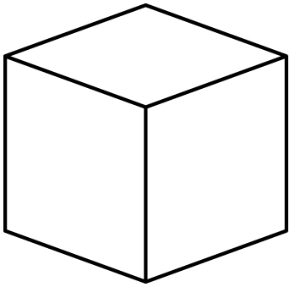 | sphere
cone  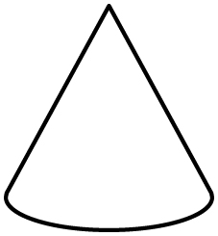 | cylinder  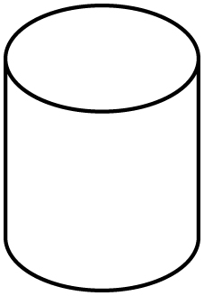
rectangular prism | pyramid  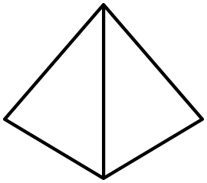

Can You Build It? Line Master 5–1

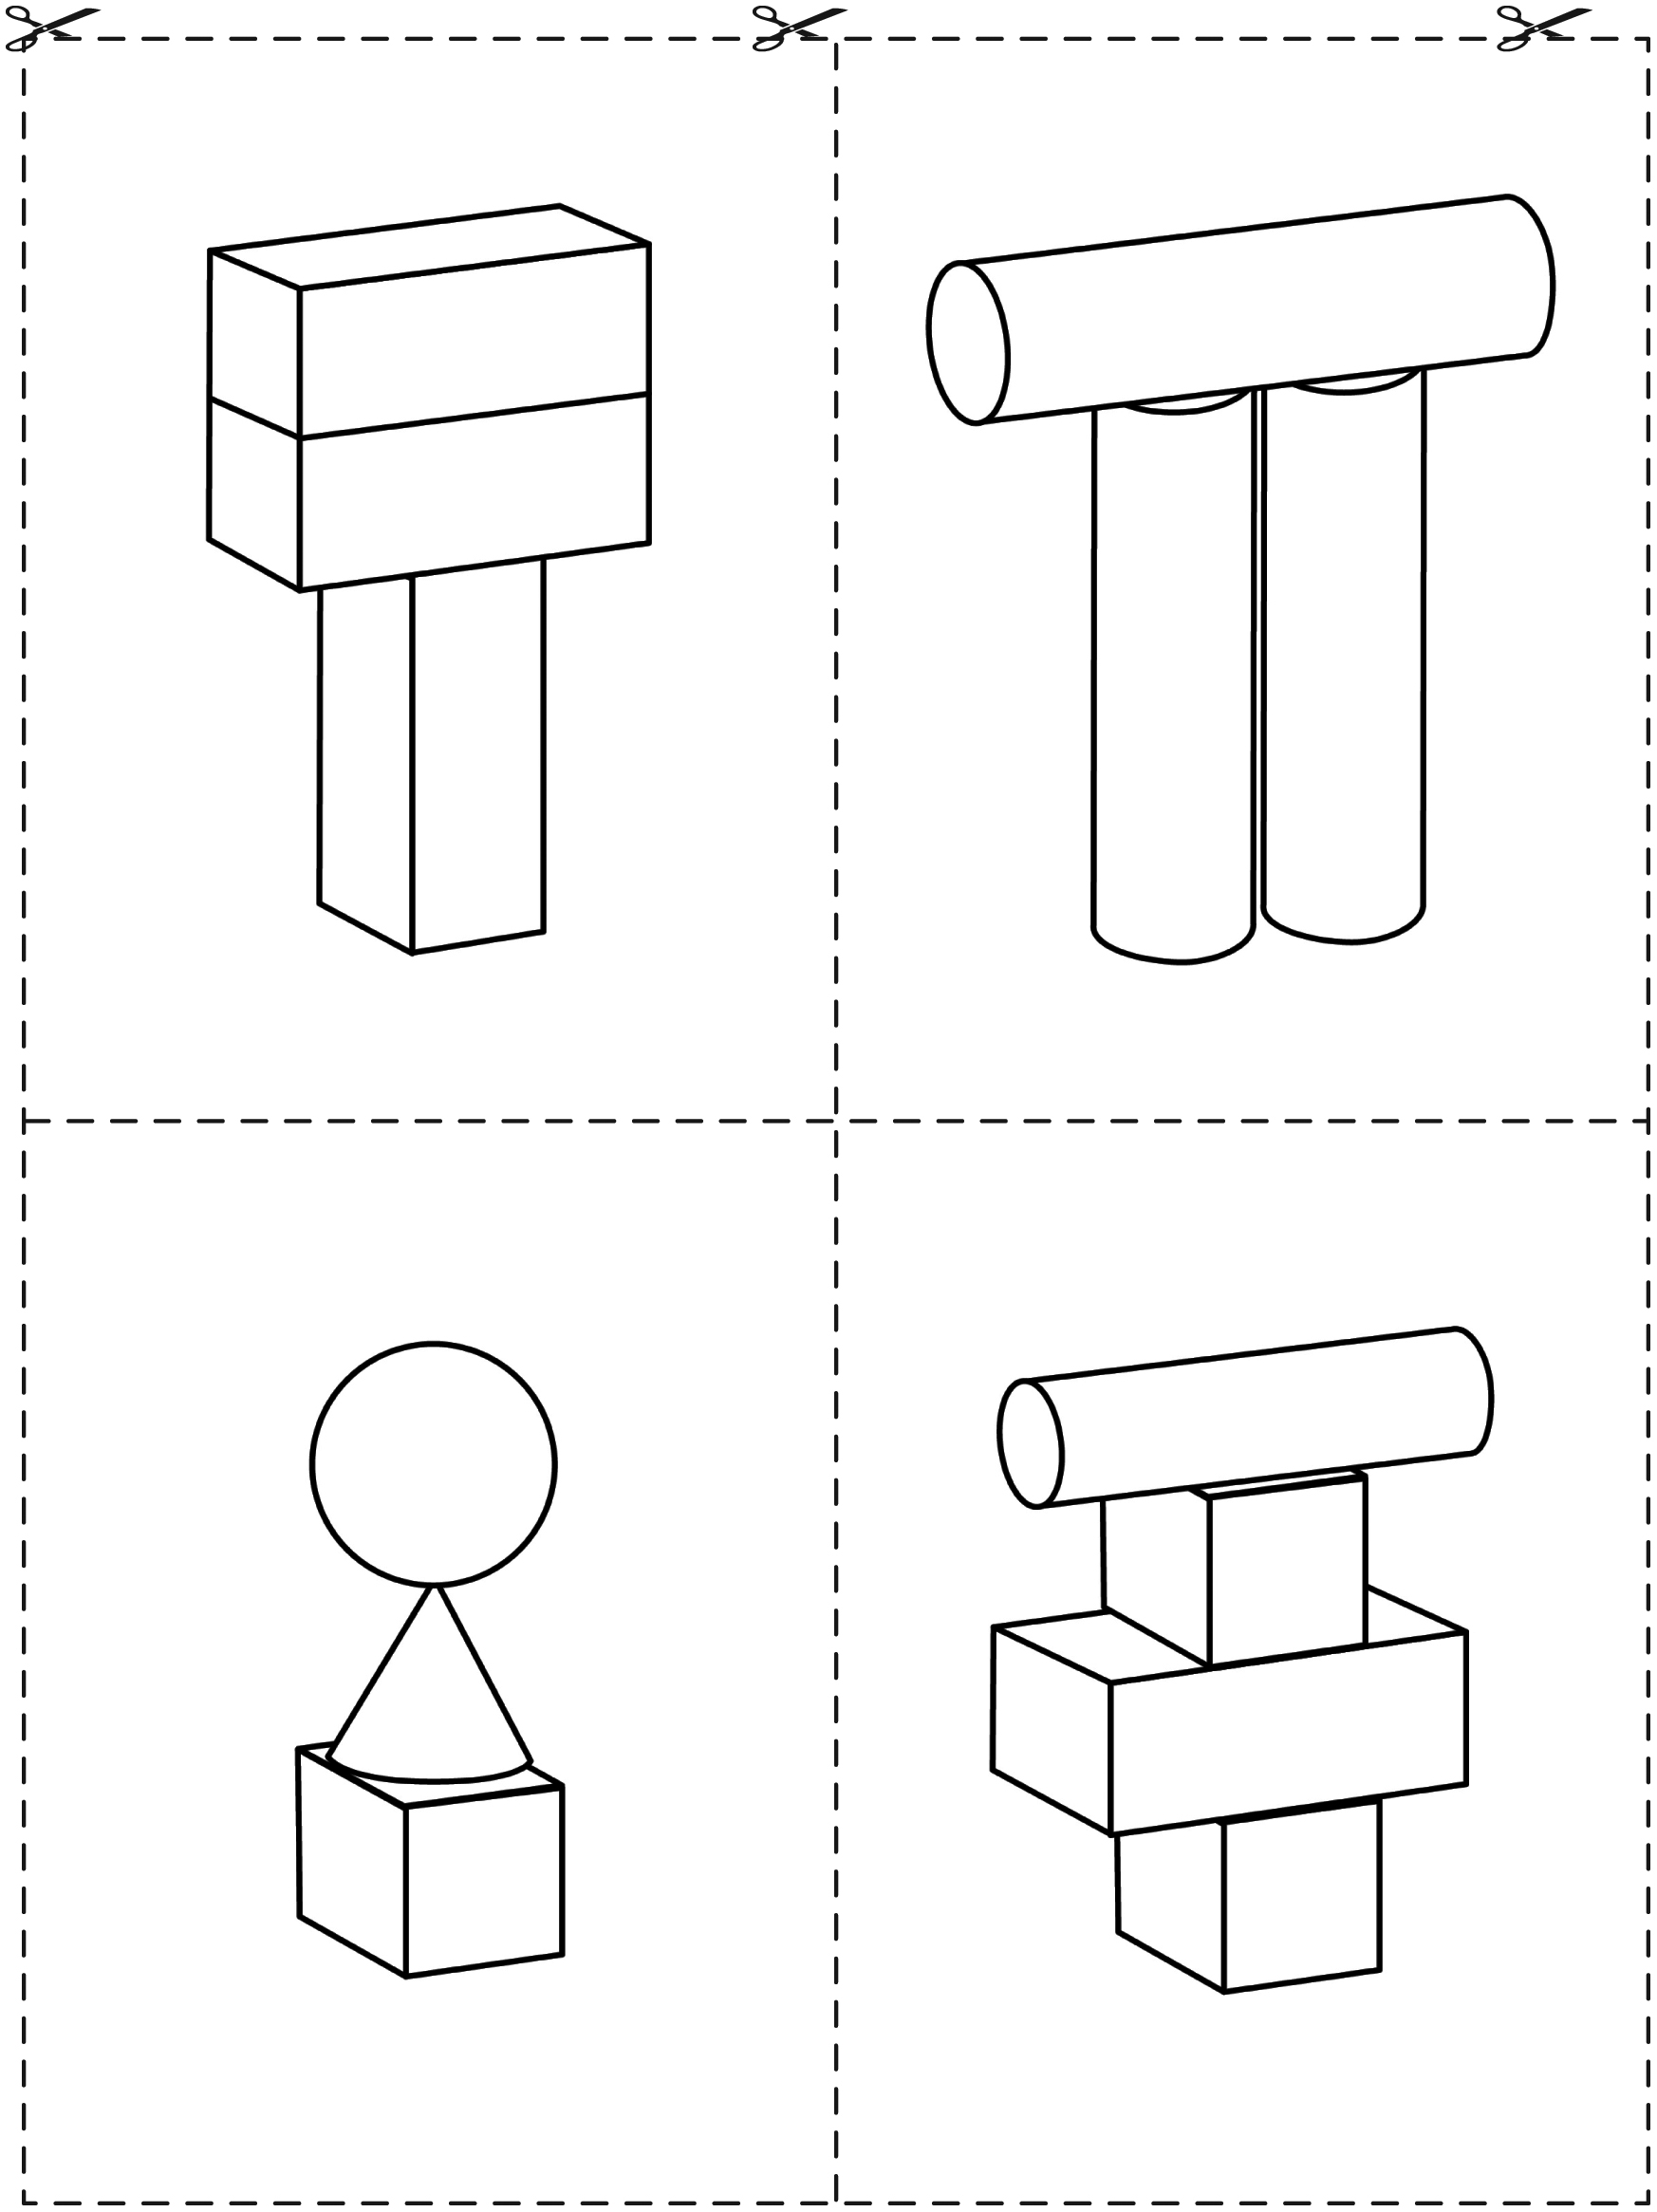

Can You Build It? Line Master 5–2

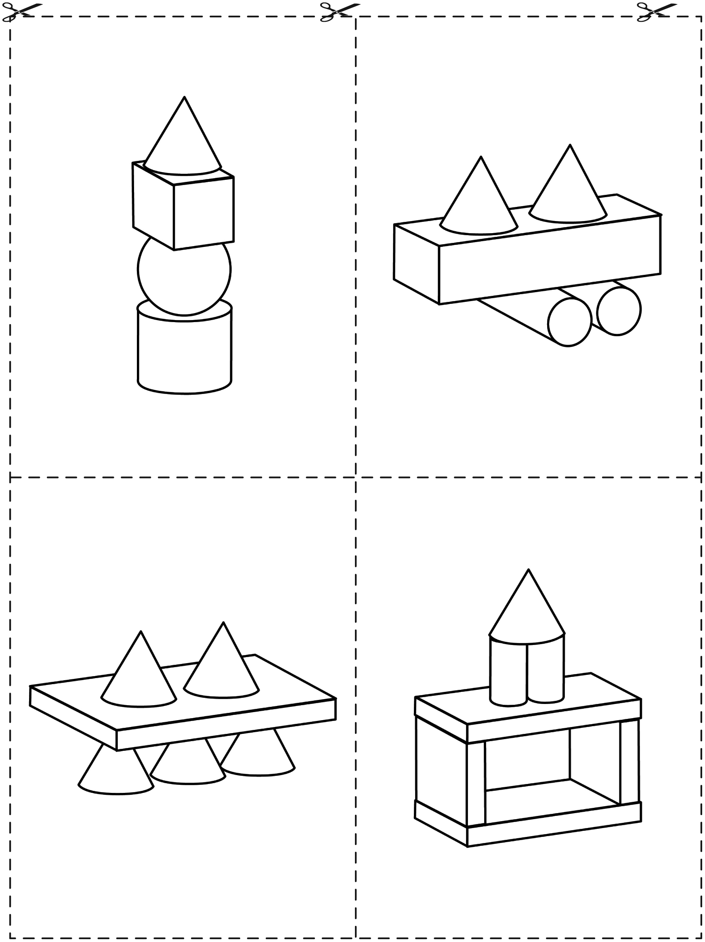

Can You Build It? Line Master 5–3

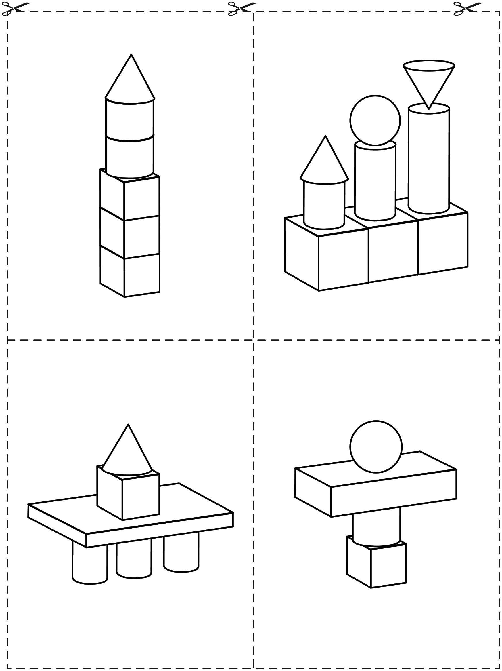

My Builder’s Report Line Master 6
Name: _____________________________
I made a _____________________________ .

Builder’s Challenge: Line Master 7–1
Measurement
– – – – – – – – – – – – – – – – – – – – – – – – – – – – – – – – – – – – – – – – – –

Build something that is wider than your arms can stretch.
– – – – – – – – – – – – – – – – – – – – – – – – – – – – – – – – – – – – – – – – – –

Build something that is longer than this piece of string.
– – – – – – – – – – – – – – – – – – – – – – – – – – – – – – – – – – – – – – – – – –

Build something that is as tall as your leg up to the knee.
– – – – – – – – – – – – – – – – – – – – – – – – – – – – – – – – – – – – – – – – – –

Build 2 towers that are the same height.
– – – – – – – – – – – – – – – – – – – – – – – – – – – – – – – – – – – – – – – – – –

Builder’s Challenge: Line Master 7–2
Position and Location
– – – – – – – – – – – – – – – – – – – – – – – – – – – – – – – – – – – – – – – – – –

Build something that has a round base.
– – – – – – – – – – – – – – – – – – – – – – – – – – – – – – – – – – – – – – – – – –

Build something that this figure can walk over and
the car can go under.
– – – – – – – – – – – – – – – – – – – – – – – – – – – – – – – – – – – – – – – – – –

Build something that this box can fit into.
– – – – – – – – – – – – – – – – – – – – – – – – – – – – – – – – – – – – – – – – – –

Build something around the king’s castle.
– – – – – – – – – – – – – – – – – – – – – – – – – – – – – – – – – – – – – – – – – –

Builder’s Challenge Line Master 7–3

– – – – – – – – – – – – – – – – – – – – – – – – – – – – – – – – – – – – – – – – – –

Build something that tells a story.
– – – – – – – – – – – – – – – – – – – – – – – – – – – – – – – – – – – – – – – – – –

Build something that could be included in The Castle Wall.
– – – – – – – – – – – – – – – – – – – – – – – – – – – – – – – – – – – – – – – – – –

Build something that looks like a letter.
– – – – – – – – – – – – – – – – – – – – – – – – – – – – – – – – – – – – – – – – – –

Build something that tells something about you.
– – – – – – – – – – – – – – – – – – – – – – – – – – – – – – – – – – – – – – – – – –

Builder’s Challenge: Line Master 7–4
Roll, Slide, Stack
– – – – – – – – – – – – – – – – – – – – – – – – – – – – – – – – – – – – – – – – – –

Will it roll? Try!

Yes | No |  | Yes | No |  | Yes | No |  | Yes | No |  | Yes | No

– – – – – – – – – – – – – – – – – – – – – – – – – – – – – – – – – – – – – – – – – –

Will it slide? Try!

Yes | No |  | Yes | No |  | Yes | No |  | Yes | No |  | Yes | No

– – – – – – – – – – – – – – – – – – – – – – – – – – – – – – – – – – – – – – – – – –

Will it stack? Try!

Yes | No |  | Yes | No |  | Yes | No |  | Yes | No |  | Yes | No

– – – – – – – – – – – – – – – – – – – – – – – – – – – – – – – – – – – – – – – – – –

