Zoom In, Zoom Out Line Master 1
(Assessment Master)
Name: _____________________________

Identify Shapes | Not observed | Sometimes | Consistently
Describes and names 2-D shapes
Creates 2-D shapes
Sorts and re-sorts 2-D shapes
Relates 2-D shapes to 3-D objects
Locate Objects
Describes location of objects using positional language
Follows and gives directions
Locates and describes location on a grid
Strengths:

Next Steps:

Connecting Home and School Line Master 2–1

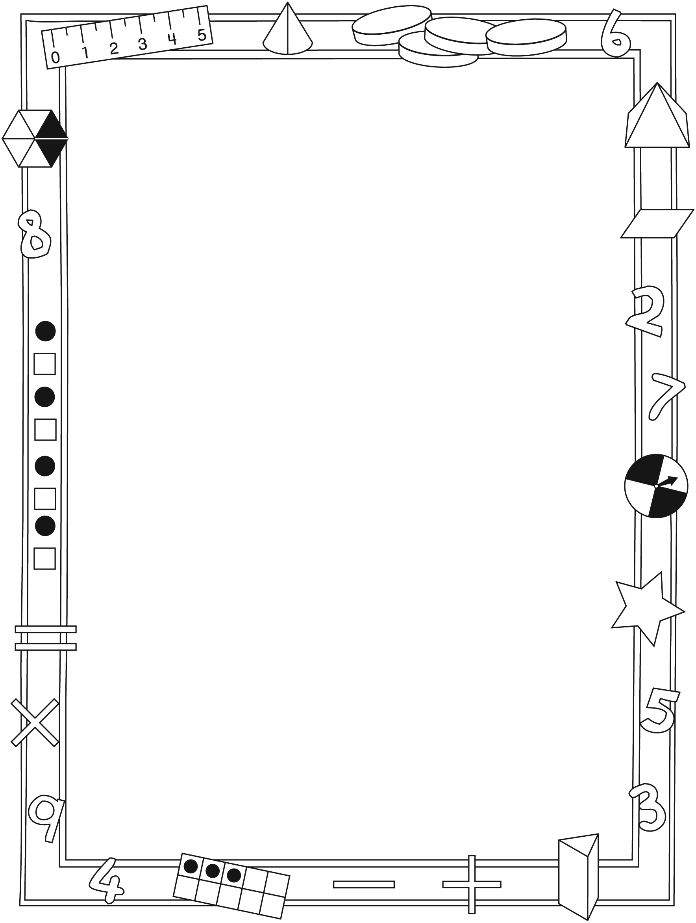

NOTE TO THE TEACHER

You may wish to send families a Zoom In, Zoom Out letter outlining a familiar activity or two they can do at home with their children.

Create a letter using this template and select one or two activities from the suggestions on the next page. Simply delete these instructions and cut and paste the activities you have selected, adapting them to fit your needs.

Connecting Home and School Line Master 2–2

Dear Family:

We have been working on Zoom In, Zoom Out, which engages children in conversations, investigations, and activities that help develop their understanding of the big math ideas that “Shapes and solids can be explored and compared based on attributes” and “Objects can be located in space and looked at from different perspectives.” Particular focus is placed on identifying 2-D shapes and locating 3-D objects. Try this activity at home with your child.
– – – – – – – – – – – – – – – – – – – – – – – – – – – – – – – – – – – – – – – – – –
Reading the Story: As you read the story, enjoy predicting what the children are looking at. Talk about the different shapes they see and others that are evident. When you are out with your child, draw attention to shapes in the environment by playing a version of I Spy: I spy something round like a circle above the fence. What do I spy? Encourage your child to take on the role of describing what he/she sees, describing the shapes and position.
– – – – – – – – – – – – – – – – – – – – – – – – – – – – – – – – – – – – – – – – – –
Trace It, Name It: We are learning about the properties of different shapes. Your child has brought home some cutout shapes. Place them on a surface and say: I’m going to trace one of these shapes on your back. Trace it and invite your child to identify the shape you chose to trace. Reverse roles.
– – – – – – – – – – – – – – – – – – – – – – – – – – – – – – – – – – – – – – – – – –
Where Is It? We are focusing on describing the location of things using words such as above, below, beside, between, near, to the right, to the left, behind, in front of, on top of, under, over. Secretly choose an item and describe where it is using these words. For example, say: My secret object is between the door and the window. It is on the table near my coffee cup. You might also choose an item and invite your child to ask questions about the location, ones that you answer with “Yes” or “No.” For example, ask: Is your secret object beside the TV? Reverse roles and listen to your child describe the location of a secret object.
– – – – – – – – – – – – – – – – – – – – – – – – – – – – – – – – – – – – – – – – – –
Sincerely,

___________________________

Zoom In, Zoom Out Line Master 3
Math Mat

Shape Cards Line Master 4

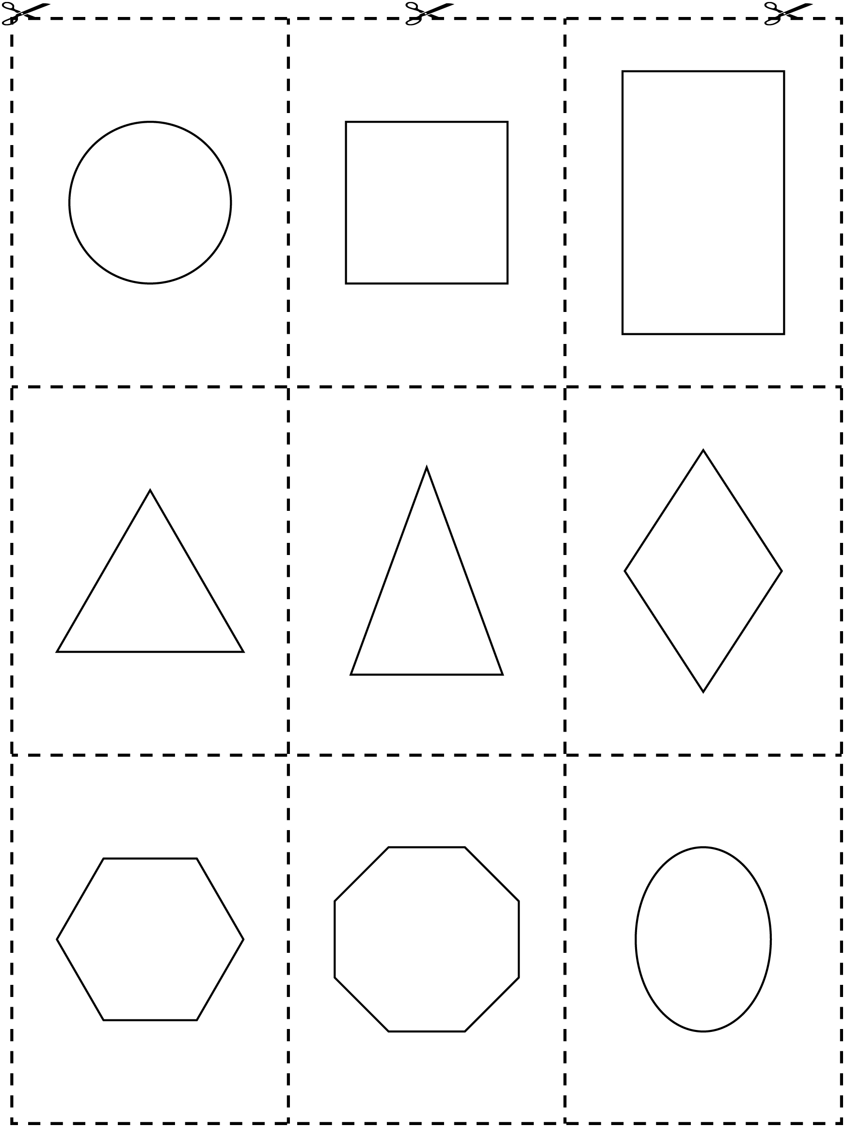

Shape Cutouts Line Master 5–1

Shape Cutouts Line Master 5–2

Shape Cutouts Line Master 5–3

Shape Cutouts Line Master 5–4

Shape Cutouts Line Master 5–5

Shape Cutouts Line Master 5–6

Shape Cutouts Line Master 5–7

Shape Cutouts Line Master 5–8

Shape Cutouts Line Master 5–9

Put It There! Line Master 6

Concentration Cards Line Master 7–1

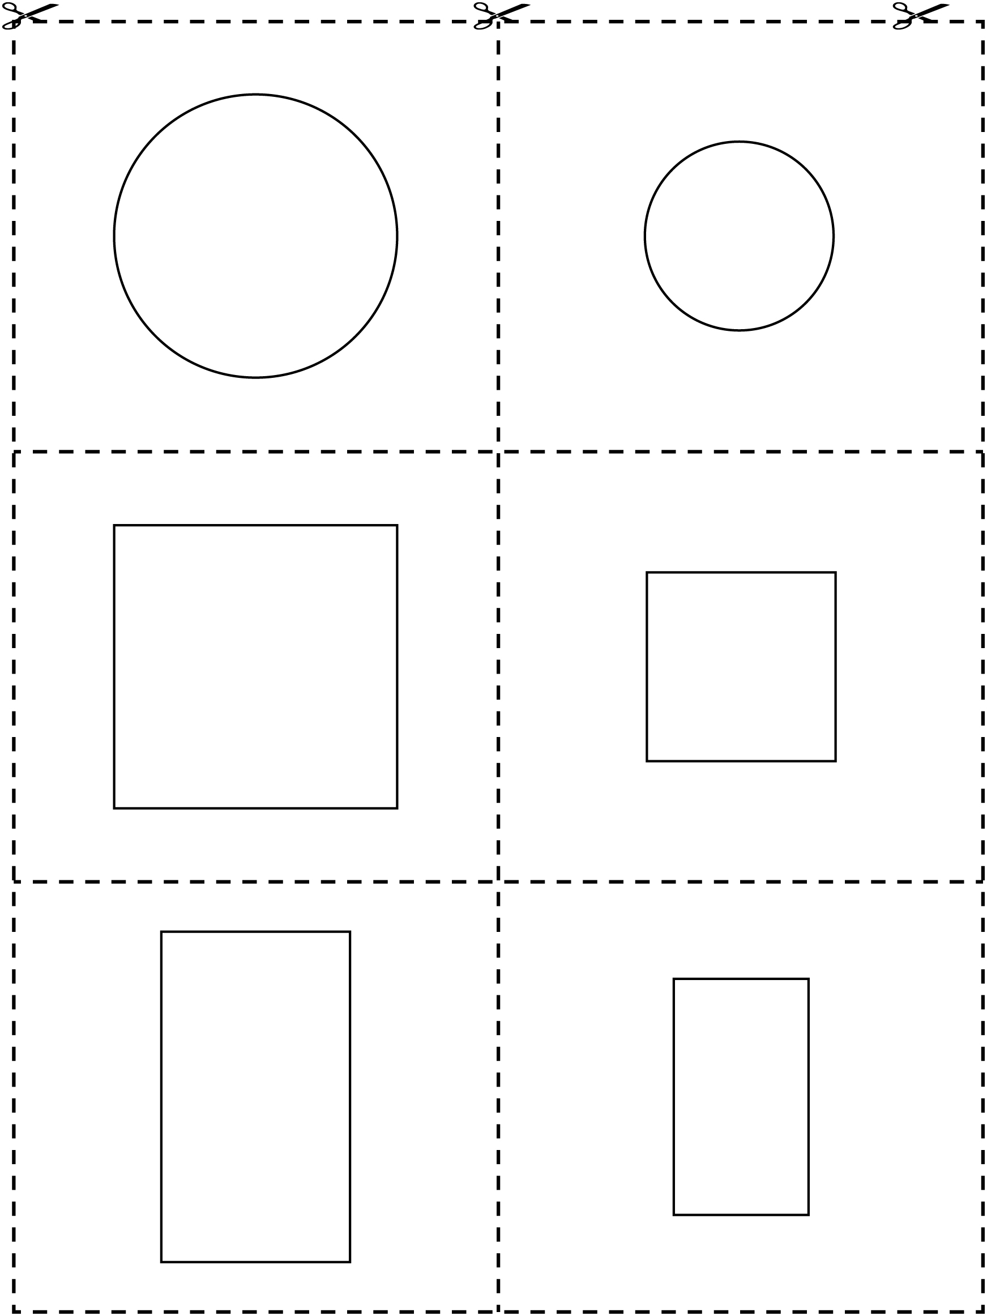

Concentration Cards Line Master 7–2

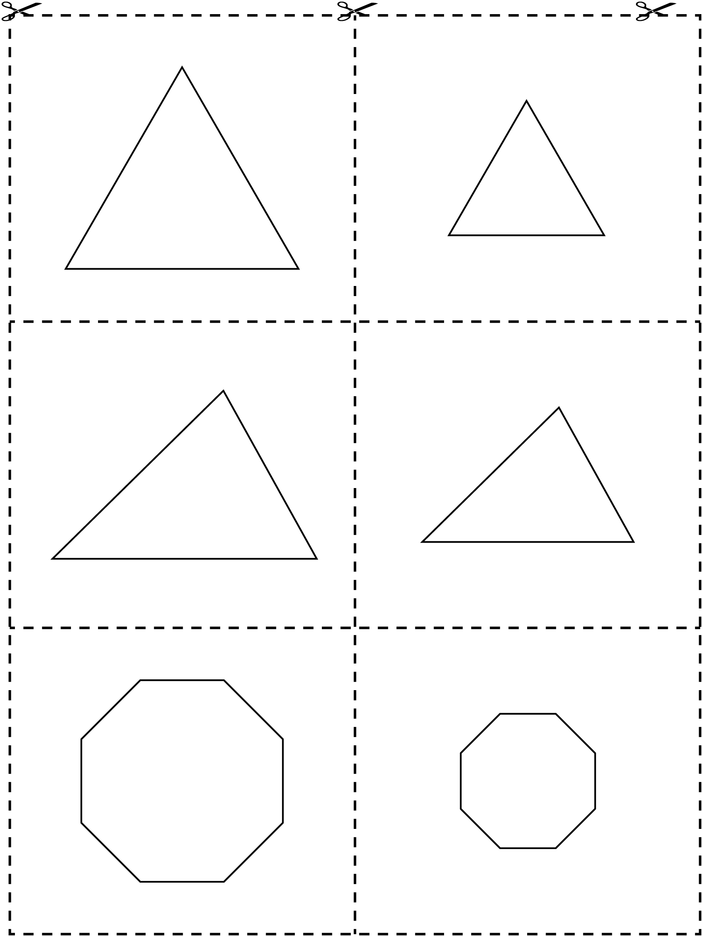

Concentration Cards Line Master 7–3

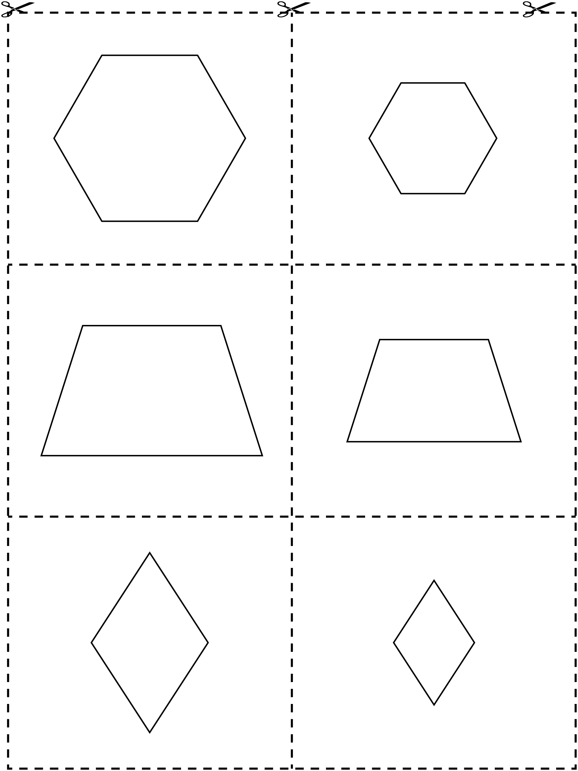

Shape Detective Line Master 8
Name: _____________________________

______________ | _______________
_____________ | 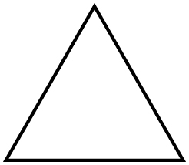 ______________

Story Template Line Master 9–1

Zoom In,  Zoom Out  by ______________ | I zoom in and see...
I see a... | I zoom in and see...

Story Template Line Master 9–2

I see a... | I zoom in and see...
I see a... | I zoom in and see...

Solving Problems Line Master 10–1

– – – – – – – – – – – – – – – – – – – – – – – – – – – – – – – – – – – – – – – – – –

How are these the same?
What will you draw that belongs?

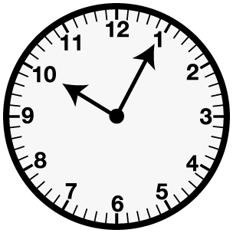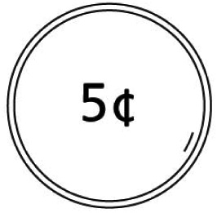
– – – – – – – – – – – – – – – – – – – – – – – – – – – – – – – – – – – – – – – – – –

How are these the same?
What will you draw that belongs?

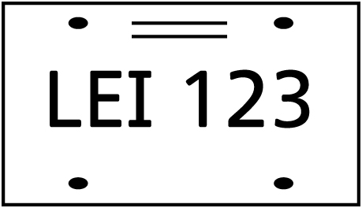
– – – – – – – – – – – – – – – – – – – – – – – – – – – – – – – – – – – – – – – – – –

How are these the same?
What will you draw that belongs?

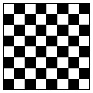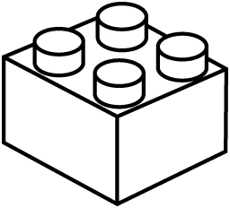
– – – – – – – – – – – – – – – – – – – – – – – – – – – – – – – – – – – – – – – – – –

How are these the same?
What will you draw that belongs?

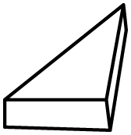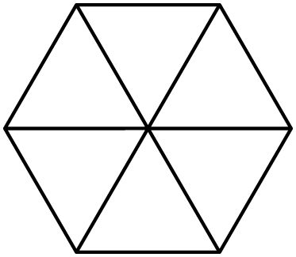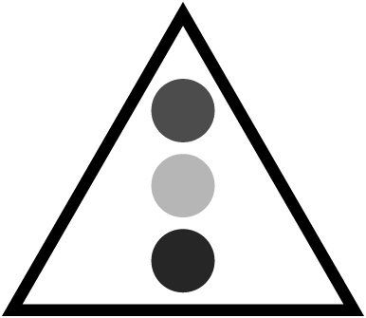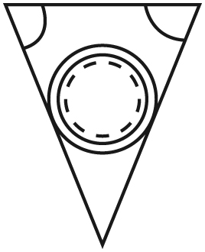
– – – – – – – – – – – – – – – – – – – – – – – – – – – – – – – – – – – – – – – – – –

Solving Problems Line Master 10–2

Draw an X on the shape that does not belong.

