We Can Bead! Line Master 1
(Assessment Master)
Name: _____________________________

Describe, Extend, and Create Repeating Patterns | Not observed | Sometimes | Consistently
Identifies and describes repeating patterns
Copies and extends repeating patterns
Creates and describes repeating patterns
Sort Objects by Attributes
Describes how objects are similar and different
Identifies a sorting rule
Finds items that belong to a set of objects
Strengths:

Next Steps:

Connecting Home and School Line Master 2–1

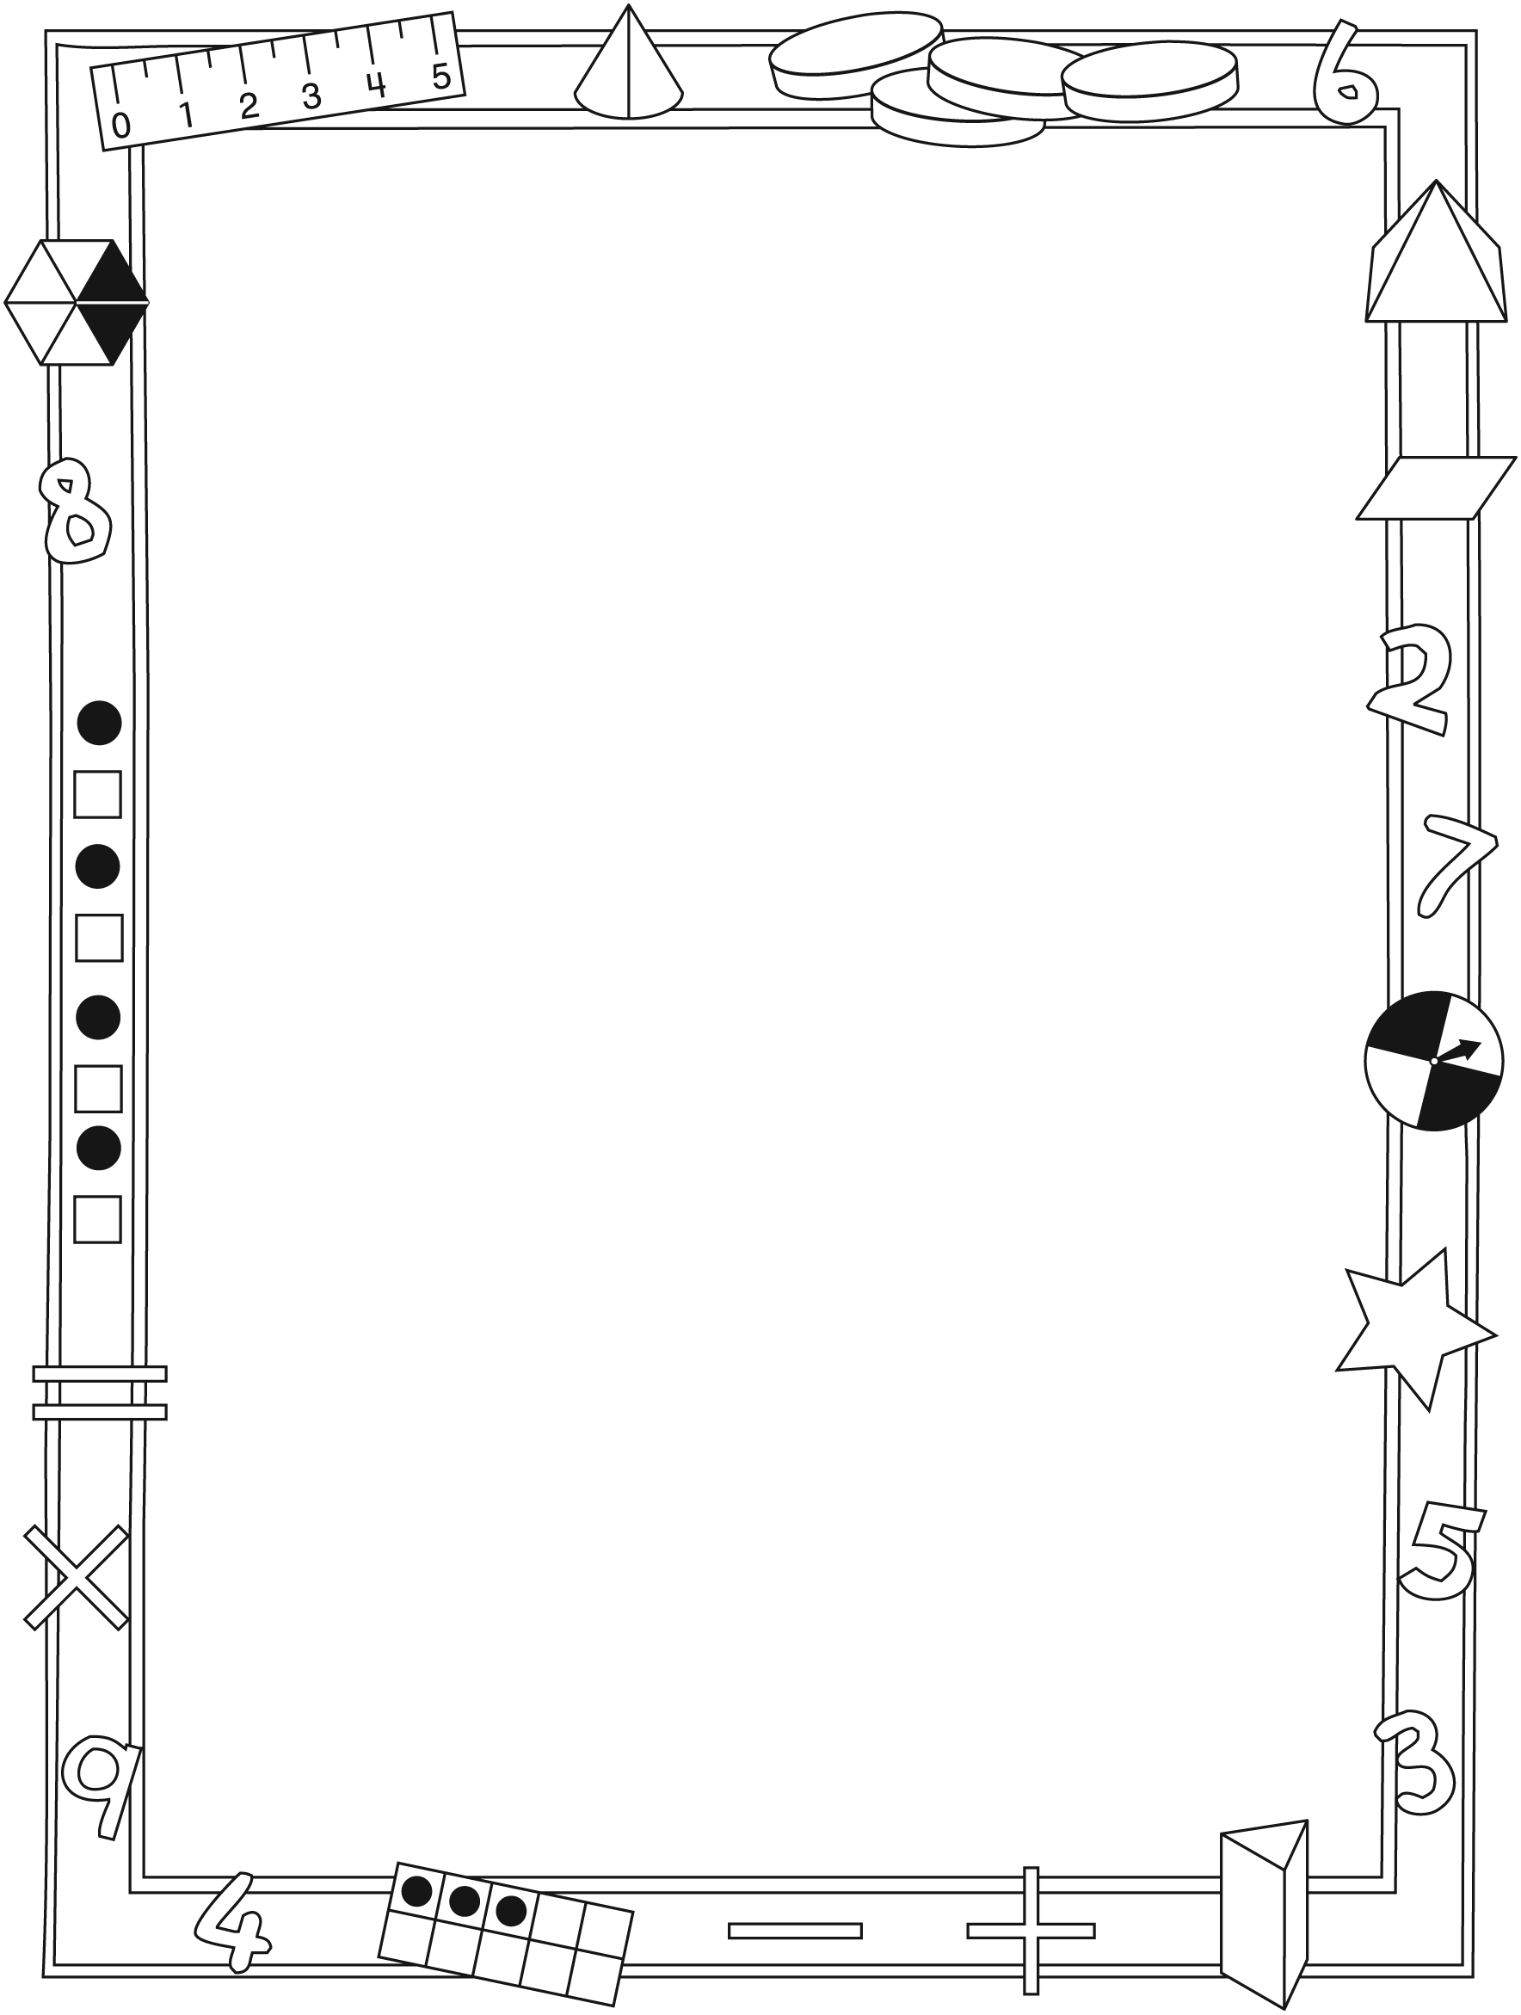

NOTE TO THE TEACHER

You may wish to send families a We Can Bead! letter outlining a familiar activity or two they can do at home with their children.

Create a letter using this template and select one or two activities from the suggestions on the next page. Simply delete these instructions and cut and paste the activities you have selected, adapting them to fit your needs.

Connecting Home and School Line Master 2–2

Dear Family:

We have been working on We Can Bead! which focuses on describing, extending, and creating repeating patterns and sorting objects by attributes. Try this activity at home with your child.
– – – – – – – – – – – – – – – – – – – – – – – – – – – – – – – – – – – – – – – – – –
Reading the Story: As you read the story, encourage your child to describe the beads and the pattern on each necklace. Invite your child to predict what comes next in each pattern. After you read, you might gather beads or other household objects to make your own patterns.
– – – – – – – – – – – – – – – – – – – – – – – – – – – – – – – – – – – – – – – – – –
Make Your Own Necklace: Use the Math Mat on the inside back cover of We Can Bead! to plan your own necklace pattern. Arrange beads into a repeating pattern and invite your child to identify the part of the pattern that repeats. Then work together to string the beads to create a patterned necklace.
– – – – – – – – – – – – – – – – – – – – – – – – – – – – – – – – – – – – – – – – – –
What Does Not Belong? List 3 objects that are around you (e.g., orange, basketball, book) and ask your child which one does not belong with the other 2 (e.g., book). Invite your child to explain her/his thinking (e.g., oranges and basketballs are round; the book is not round). Sorting rules can also include function (e.g., television, light, dish: a dish does not belong because it does not use electricity or turn on). Encourage your child to suggest sets of 3 objects for you to solve.
– – – – – – – – – – – – – – – – – – – – – – – – – – – – – – – – – – – – – – – – – –
What Comes Next? Start a pattern with a repeating part that appears at least 3 times. Invite your child to extend the pattern and explain her/his thinking. Have your child add pattern pieces one at a time or in longer segments. Patterns can be drawn, made with objects, clapped, or said aloud.
– – – – – – – – – – – – – – – – – – – – – – – – – – – – – – – – – – – – – – – – – –
Sincerely,

___________________________

We Can Bead! Math Mat Line Master 3

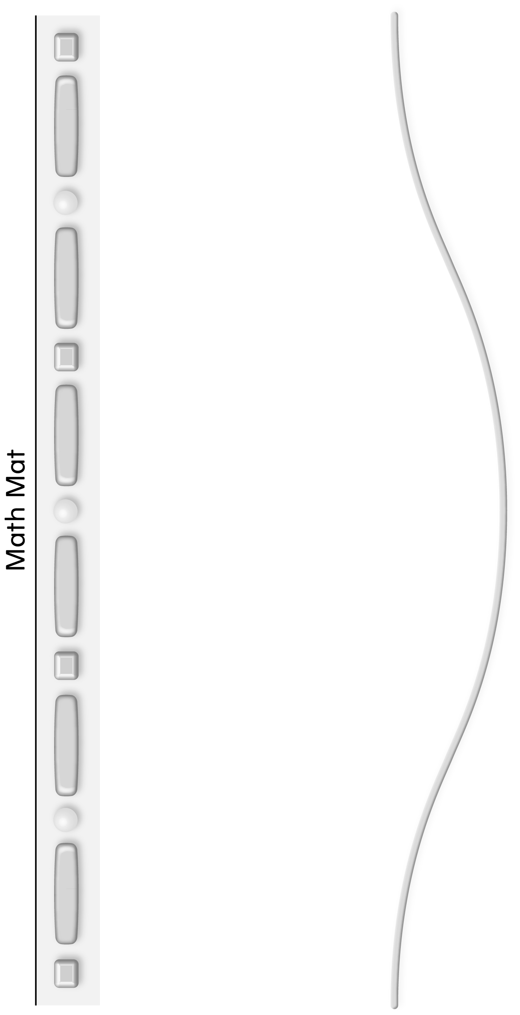

Which Object Does Line Master 4
Not Belong?
Name: _____________________________

Bag | Which objects belong? | Which object does  not belong?

Pattern Starters Line Master 5–1
– – – – – – – – – – – – – – – – – – – – – – – – – – – – – – – – – – – – – – – – – – – – – – – – – – – – – – – – – – –
– – – – – – – – – – – – – – – – – – – – – – – – – – – – – – – – – – – – – – – – – – – – – – – – – – – – – – – – – – –
– – – – – – – – – – – – – – – – – – – – – – – – – – – – – – – – – – – – – – – – – – – – – – – – – – – – – – – – – – –
– – – – – – – – – – – – – – – – – – – – – – – – – – – – – – – – – – – – – – – – – – – – – – – – – – – – – – – – – – –

Pattern Starters Line Master 5–2
– – – – – – – – – – – – – – – – – – – – – – – – – – – – – – – – – – – – – – – – – – – – – – – – – – – – – – – – – – –
– – – – – – – – – – – – – – – – – – – – – – – – – – – – – – – – – – – – – – – – – – – – – – – – – – – – – – – – – – –
– – – – – – – – – – – – – – – – – – – – – – – – – – – – – – – – – – – – – – – – – – – – – – – – – – – – – – – – – – –
– – – – – – – – – – – – – – – – – – – – – – – – – – – – – – – – – – – – – – – – – – – – – – – – – – – – – – – – – – –

Pattern Starters Line Master 5–3
– – – – – – – – – – – – – – – – – – – – – – – – – – – – – – – – – – – – – – – – – – – – – – – – – – – – – – – – – – –
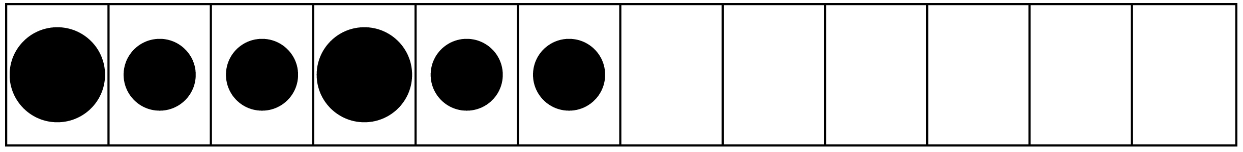
– – – – – – – – – – – – – – – – – – – – – – – – – – – – – – – – – – – – – – – – – – – – – – – – – – – – – – – – – – –
– – – – – – – – – – – – – – – – – – – – – – – – – – – – – – – – – – – – – – – – – – – – – – – – – – – – – – – – – – –
– – – – – – – – – – – – – – – – – – – – – – – – – – – – – – – – – – – – – – – – – – – – – – – – – – – – – – – – – – –

Pattern Starters Line Master 5–4
– – – – – – – – – – – – – – – – – – – – – – – – – – – – – – – – – – – – – – – – – – – – – – – – – – – – – – – – – – –
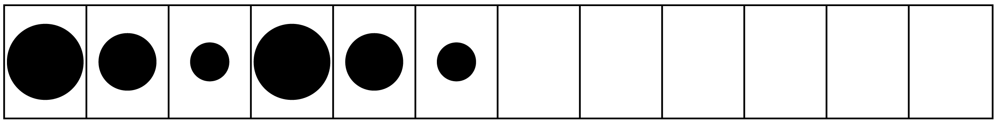
– – – – – – – – – – – – – – – – – – – – – – – – – – – – – – – – – – – – – – – – – – – – – – – – – – – – – – – – – – –
– – – – – – – – – – – – – – – – – – – – – – – – – – – – – – – – – – – – – – – – – – – – – – – – – – – – – – – – – – –
– – – – – – – – – – – – – – – – – – – – – – – – – – – – – – – – – – – – – – – – – – – – – – – – – – – – – – – – – – –
Pattern Starters Line Master 5–5
– – – – – – – – – – – – – – – – – – – – – – – – – – – – – – – – – – – – – – – – – – – – – – – – – – – – – – – – – – –
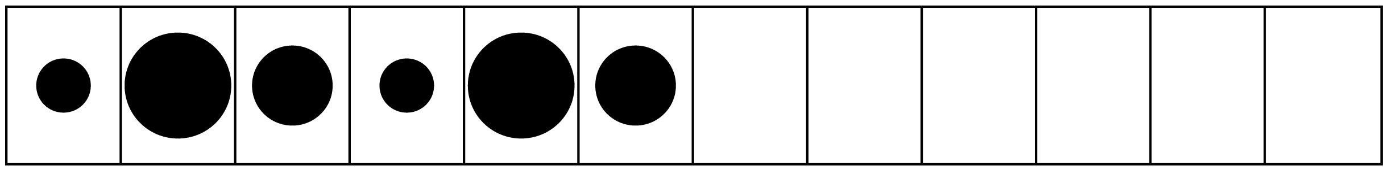
– – – – – – – – – – – – – – – – – – – – – – – – – – – – – – – – – – – – – – – – – – – – – – – – – – – – – – – – – – –
– – – – – – – – – – – – – – – – – – – – – – – – – – – – – – – – – – – – – – – – – – – – – – – – – – – – – – – – – – –
– – – – – – – – – – – – – – – – – – – – – – – – – – – – – – – – – – – – – – – – – – – – – – – – – – – – – – – – – – –

Pattern Starters Line Master 5–6
– – – – – – – – – – – – – – – – – – – – – – – – – – – – – – – – – – – – – – – – – – – – – – – – – – – – – – – – – – –
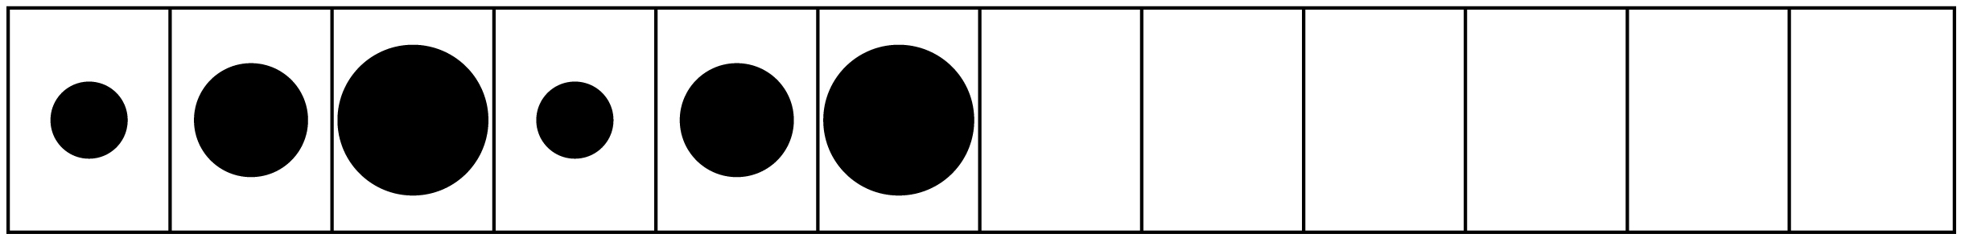
– – – – – – – – – – – – – – – – – – – – – – – – – – – – – – – – – – – – – – – – – – – – – – – – – – – – – – – – – – –
– – – – – – – – – – – – – – – – – – – – – – – – – – – – – – – – – – – – – – – – – – – – – – – – – – – – – – – – – – –
– – – – – – – – – – – – – – – – – – – – – – – – – – – – – – – – – – – – – – – – – – – – – – – – – – – – – – – – – – –

Pattern Starters Line Master 5–7
– – – – – – – – – – – – – – – – – – – – – – – – – – – – – – – – – – – – – – – – – – – – – – – – – – – – – – – – – – –
– – – – – – – – – – – – – – – – – – – – – – – – – – – – – – – – – – – – – – – – – – – – – – – – – – – – – – – – – – –
– – – – – – – – – – – – – – – – – – – – – – – – – – – – – – – – – – – – – – – – – – – – – – – – – – – – – – – – – – –
– – – – – – – – – – – – – – – – – – – – – – – – – – – – – – – – – – – – – – – – – – – – – – – – – – – – – – – – – – –

Pattern Starters Line Master 5–8
– – – – – – – – – – – – – – – – – – – – – – – – – – – – – – – – – – – – – – – – – – – – – – – – – – – – – – – – – – –
– – – – – – – – – – – – – – – – – – – – – – – – – – – – – – – – – – – – – – – – – – – – – – – – – – – – – – – – – – –
– – – – – – – – – – – – – – – – – – – – – – – – – – – – – – – – – – – – – – – – – – – – – – – – – – – – – – – – – – –
– – – – – – – – – – – – – – – – – – – – – – – – – – – – – – – – – – – – – – – – – – – – – – – – – – – – – – – – – – –

Pattern Starters Line Master 5–9
– – – – – – – – – – – – – – – – – – – – – – – – – – – – – – – – – – – – – – – – – – – – – – – – – – – – – – – – – – –
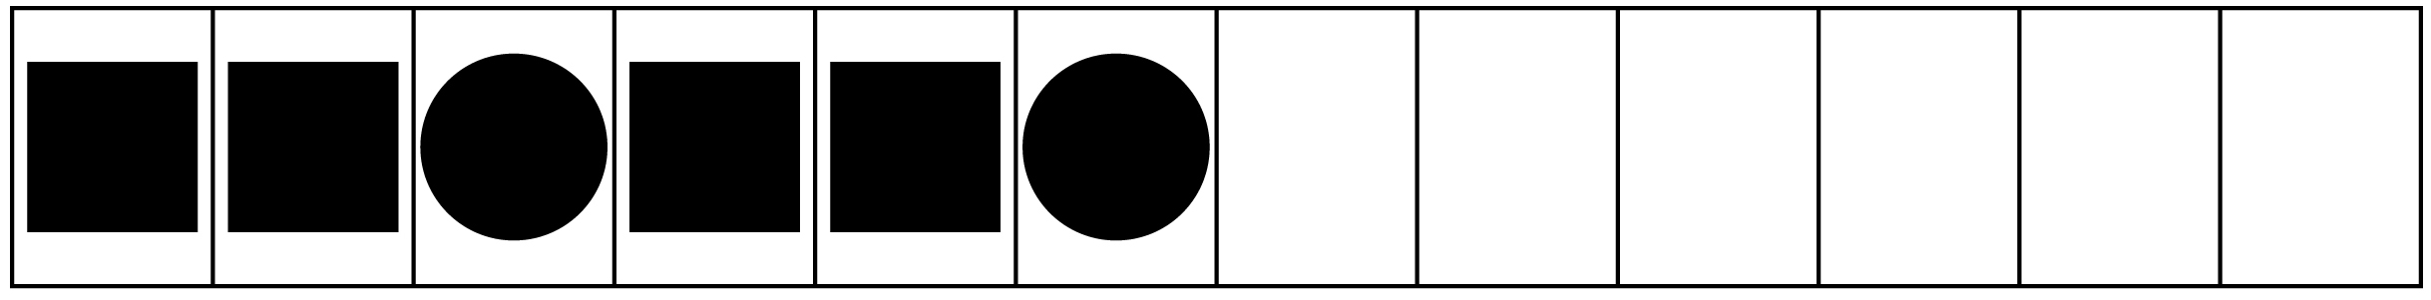
– – – – – – – – – – – – – – – – – – – – – – – – – – – – – – – – – – – – – – – – – – – – – – – – – – – – – – – – – – –
– – – – – – – – – – – – – – – – – – – – – – – – – – – – – – – – – – – – – – – – – – – – – – – – – – – – – – – – – – –
– – – – – – – – – – – – – – – – – – – – – – – – – – – – – – – – – – – – – – – – – – – – – – – – – – – – – – – – – – –

Pattern Starters Line Master 5–10
– – – – – – – – – – – – – – – – – – – – – – – – – – – – – – – – – – – – – – – – – – – – – – – – – – – – – – – – – – –
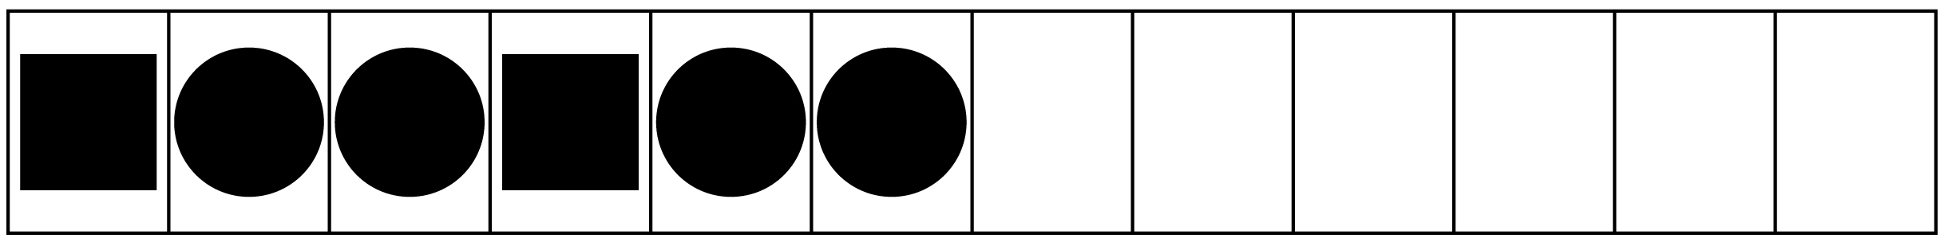
– – – – – – – – – – – – – – – – – – – – – – – – – – – – – – – – – – – – – – – – – – – – – – – – – – – – – – – – – – –
– – – – – – – – – – – – – – – – – – – – – – – – – – – – – – – – – – – – – – – – – – – – – – – – – – – – – – – – – – –
– – – – – – – – – – – – – – – – – – – – – – – – – – – – – – – – – – – – – – – – – – – – – – – – – – – – – – – – – – –

Pattern Starters Line Master 5–11
– – – – – – – – – – – – – – – – – – – – – – – – – – – – – – – – – – – – – – – – – – – – – – – – – – – – – – – – – – –
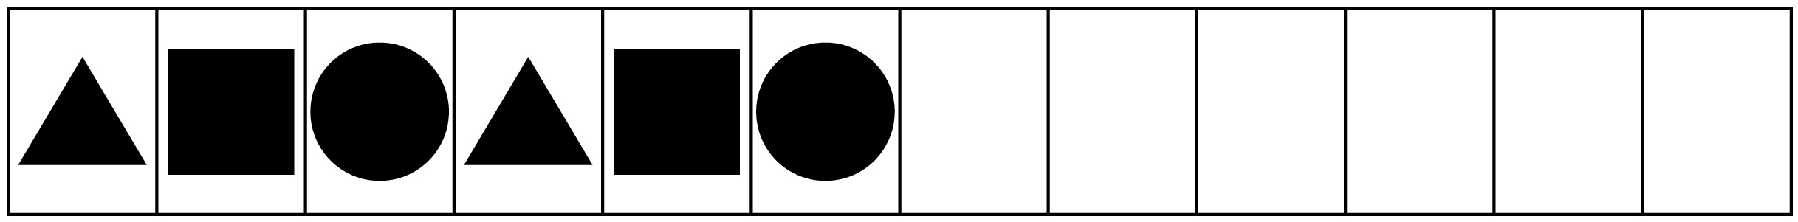
– – – – – – – – – – – – – – – – – – – – – – – – – – – – – – – – – – – – – – – – – – – – – – – – – – – – – – – – – – –
– – – – – – – – – – – – – – – – – – – – – – – – – – – – – – – – – – – – – – – – – – – – – – – – – – – – – – – – – – –
– – – – – – – – – – – – – – – – – – – – – – – – – – – – – – – – – – – – – – – – – – – – – – – – – – – – – – – – – – –

Pattern Starters Line Master 5–12
– – – – – – – – – – – – – – – – – – – – – – – – – – – – – – – – – – – – – – – – – – – – – – – – – – – – – – – – – – –
– – – – – – – – – – – – – – – – – – – – – – – – – – – – – – – – – – – – – – – – – – – – – – – – – – – – – – – – – – –
– – – – – – – – – – – – – – – – – – – – – – – – – – – – – – – – – – – – – – – – – – – – – – – – – – – – – – – – – – –
– – – – – – – – – – – – – – – – – – – – – – – – – – – – – – – – – – – – – – – – – – – – – – – – – – – – – – – – – – –

Sorting Mats Line Master 6–1
Name: _____________________________

Sorting Rule:

Sorting Mats Line Master 6–2
Name: _____________________________

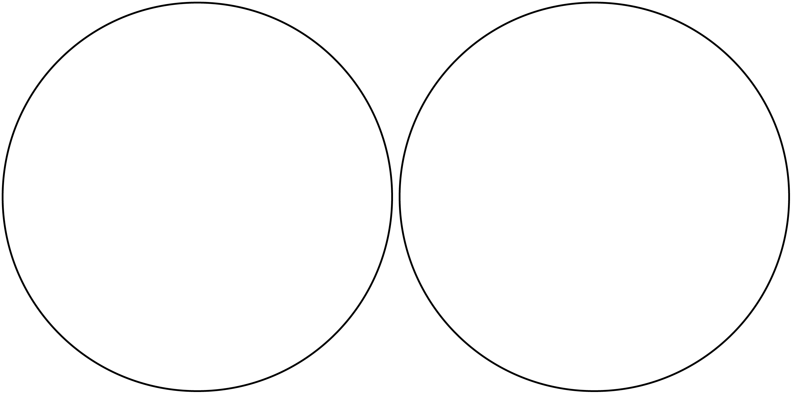

Sorting Mats Line Master 6–3
Name: _____________________________

Sorting Mats Line Master 6–4
Name: _____________________________

Story Template Line Master 7

My Necklace Pattern  by ______________ | Here is the part of my pattern that repeats.
My pattern is a repeating pattern. | Here is my necklace!

Pattern Problems Line Master 8–1
– – – – – – – – – – – – – – – – – – – – – – – – – – – – – – – – – – – – – – – – – – – – – – – – – – – – – – – – – – –

Circle the part of the pattern that repeats. What shapes come next?

– – – – – – – – – – – – – – – – – – – – – – – – – – – – – – – – – – – – – – – – – – – – – – – – – – – – – – – – – – –

Circle the part of the pattern that repeats. What shapes come next?

Pattern Problems Line Master 8–2
– – – – – – – – – – – – – – – – – – – – – – – – – – – – – – – – – – – – – – – – – – – – – – – – – – – – – – – – – – –
What is missing?

– – – – – – – – – – – – – – – – – – – – – – – – – – – – – – – – – – – – – – – – – – – – – – – – – – – – – – – – – – –
What is missing?

