**To Be Long** **Line Master 1** (Assessment Master)

**Name:** _____________________________

|  |  |  |  |
| --- | --- | --- | --- |
| **Compare Objects by Length** | **Not observed** | **Sometimes** | **Consistently** |
| Identify and use a baseline |  |  |  |
| Compare 2 objects by length |  |  |  |
| Describe lengths of 2 objects (longer, shorter) |  |  |  |
| **Order Objects by Length** |  |  |  |
| Order 2 or more objects by length |  |  |  |
| Describe order of lengths (longer, longest, shorter, shortest, taller, tallest) |  |  |  |

**Strengths:**

**Next Steps:**

**Connecting Home and School Line Master 2–1**

**NOTE TO THE TEACHER**

You may wish to send families a ***To Be Long*** letter outlining a familiar activity or two they can do at home with their children.

Create a letter using this template and select one or two activities from the suggestions on the next page. Simply **delete these instructions and cut and paste the activities you have selected**, adapting them to fit your needs.

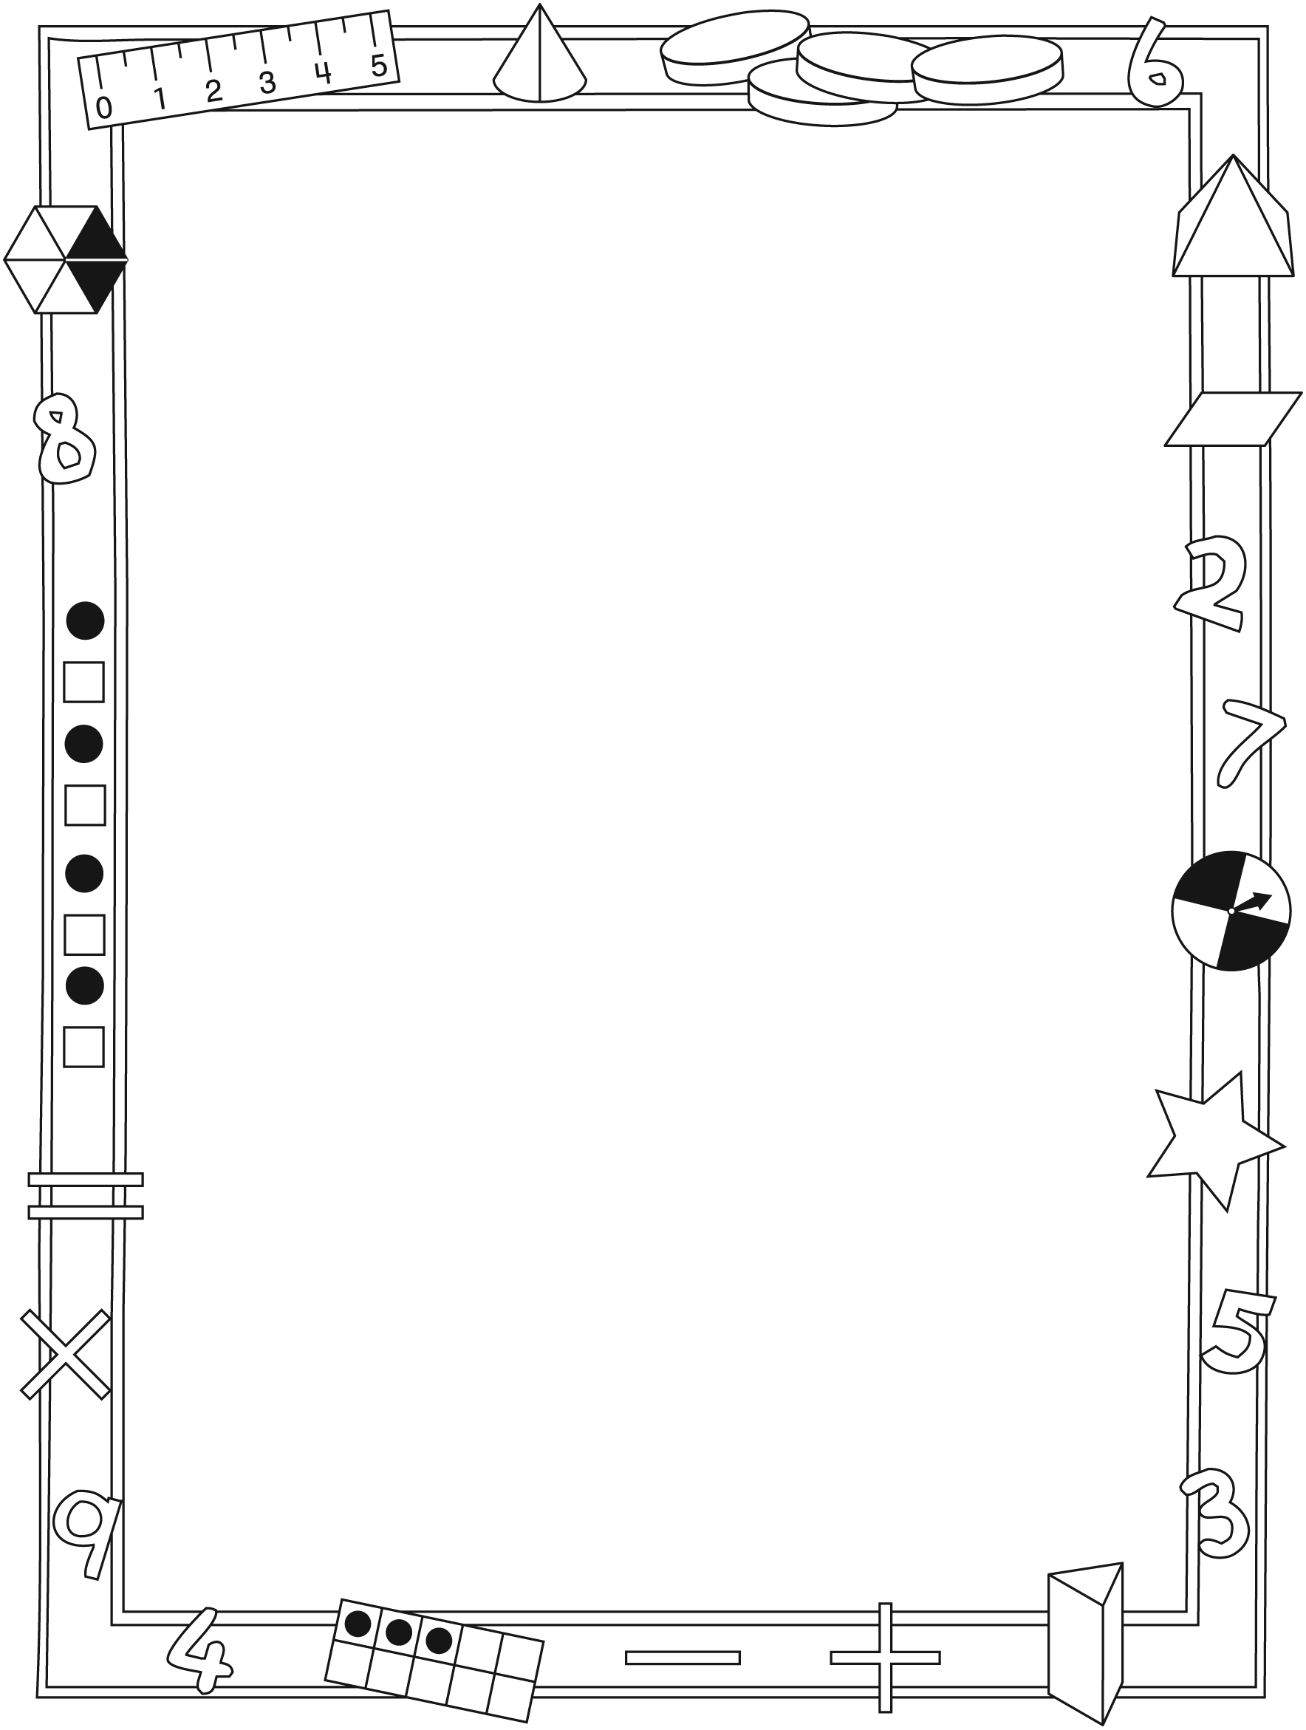

**Connecting Home and School Line Master 2–2**

Dear Family:

We have been working on ***To Be Long***, which engages children in conversations, investigations, and activities that help to develop their understanding of the big math idea that “Many things in our world have attributes that can be measured and compared.” Particular focus is placed on comparing by length and ordering by length. Try this activity at home with your child.

✂ – – – – – – – – – – – – – – – – – – – – – – – – – – – – – – – – – – – – – – – – – –

**Reading the Story:** As you read the story, enjoy predicting whether Sally will find out whether she is longer than, shorter than, or the same length as the friends she meets. After you read, you might collect a few small objects (e.g., spoons, forks, pencils, and crayons) and use the Math Mat on the inside back cover of the book to find out whether they are longer than, shorter than, or the same length as the log. Before aligning the objects, ask your child to estimate whether the object is longer, shorter, or the same length. You might then also put them in order from shortest to longest.

✂ – – – – – – – – – – – – – – – – – – – – – – – – – – – – – – – – – – – – – – – – – –

**Tall, Taller, Tallest:** Ask your child to think of how you can help her/him order your family members by height. Who does he/she think is the tallest (the shortest, the same height)? Think beyond immediate family members and talk about adding members of your extended family or friends into the order you establish.

✂ – – – – – – – – – – – – – – – – – – – – – – – – – – – – – – – – – – – – – – – – – –

**Comparing Measures:** Engage your child in estimating by asking: **Do you think your arm span (outstretched arms) is longer or shorter than the longest step you can take?** You can offer a ball of string, yarn, or ribbon for your child to use to make a comparison. Ask: **How can you use this (string) to figure out which is longer? How can I help you find out?**

✂ – – – – – – – – – – – – – – – – – – – – – – – – – – – – – – – – – – – – – – – – – –

**Wavy Lines:** Draw 2 wavy lines on a sheet of paper. Ask your child to estimate which line is longer and which is shorter. Talk about how he/she can check to find out. In class, we have used string to measure and compare. If your child suggests other ways to figure out which line is longer and which is shorter, enjoy the problem-solving process.

✂ – – – – – – – – – – – – – – – – – – – – – – – – – – – – – – – – – – – – – – – – – –

Sincerely,

___________________________

***To Be Long* Math Mat Line Master 3**

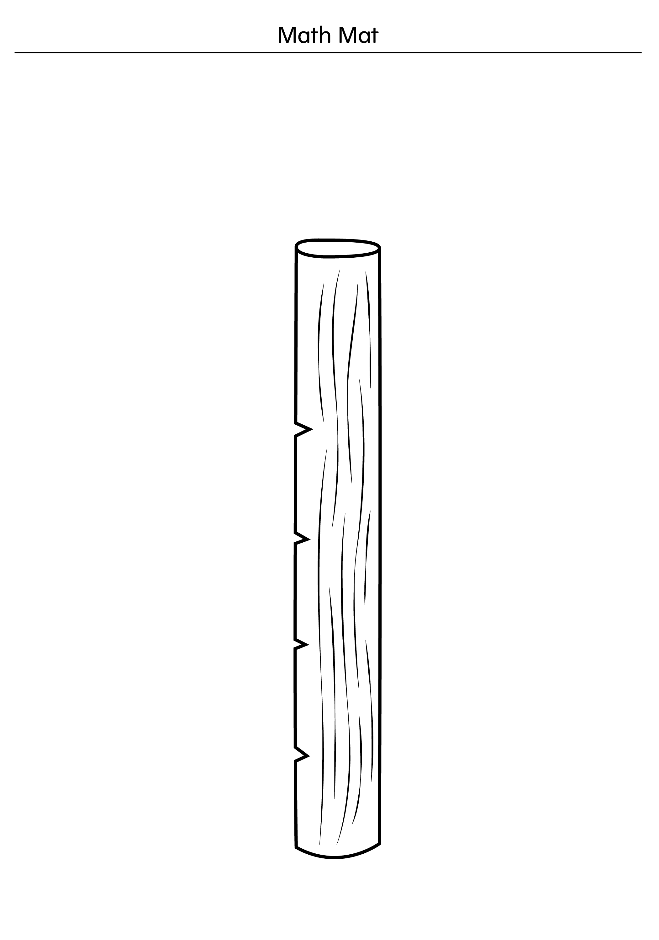

**Recording Mat—Height Line Master 4**

**Name:** _____________________________

|  |  |  |
| --- | --- | --- |
| Shorter | The Same | Taller |

**Sorting Mat—Length Line Master 5**

**Name:** _____________________________

|  |  |  |
| --- | --- | --- |
| Shorter | The Same | Longer |

**Spinner Line Master 6**

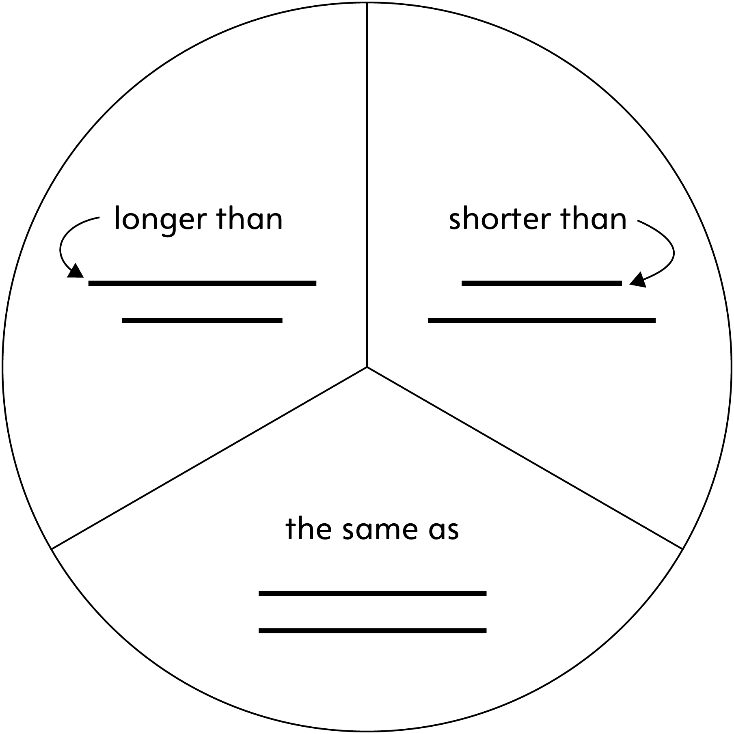

**Mini-Book Template Line Master 7**



|  |  |
| --- | --- |
| **To Be Long**  by ______________ | This snake is short. |
| This snake is long. | This snake is ___________. |

**Challenges Line Master 8–1**

✂ – – – – – – – – – – – – – – – – – – – – – – – – – – – – – – – – – – – – – – – – – –

What can you find that is longer than a

?



✂ – – – – – – – – – – – – – – – – – – – – – – – – – – – – – – – – – – – – – – – – – –

What can you find that is shorter than a

?



✂ – – – – – – – – – – – – – – – – – – – – – – – – – – – – – – – – – – – – – – – – – –

What can you find that is shorter than a



and longer than a

?



✂ – – – – – – – – – – – – – – – – – – – – – – – – – – – – – – – – – – – – – – – – – –

**Challenges Line Master 8–2**

✂ – – – – – – – – – – – – – – – – – – – – – – – – – – – – – – – – – – – – – – – – – –

What can you find that is shorter than your

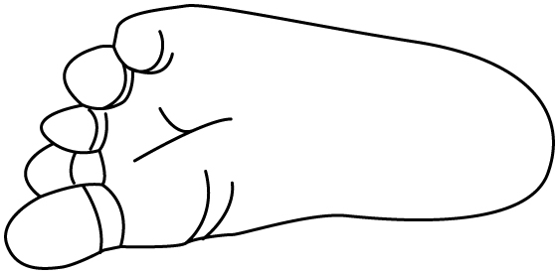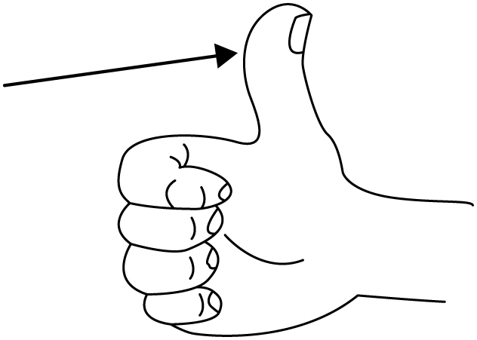

and longer than your ?

✂ – – – – – – – – – – – – – – – – – – – – – – – – – – – – – – – – – – – – – – – – – –