**The New Nest** **Line Master 1** (Assessment Master)

**Name:** _____________________________

|  |  |  |  |
| --- | --- | --- | --- |
| **Locate Objects in Space** | **Not observed** | **Sometimes** | **Consistently** |
| Uses positional language to describe location and movement (e.g., *in the tree, over the fence*) |  |  |  |
| Follows simple directions |  |  |  |
| Gives simple directions |  |  |  |
| Uses positional language to describe relative position and/or order (e.g., *between the birds, second from the left*) |  |  |  |
| **Recognize Shapes** |  |  |  |
| Describes and names 2-D shapes |  |  |  |
| Identifies 2-D shapes in 3-D objects |  |  |  |

**Strengths:**

**Next Steps:**

**Connecting Home and School Line Master 2–1**

**NOTE TO THE TEACHER**

You may wish to send families a ***The New Nest*** letter outlining a familiar activity or two they can do at home with their children.

Create a letter using this template and select one or two activities from the suggestions on the next page. Simply **delete these instructions and cut and paste the activities you have selected**, adapting them to fit your needs.

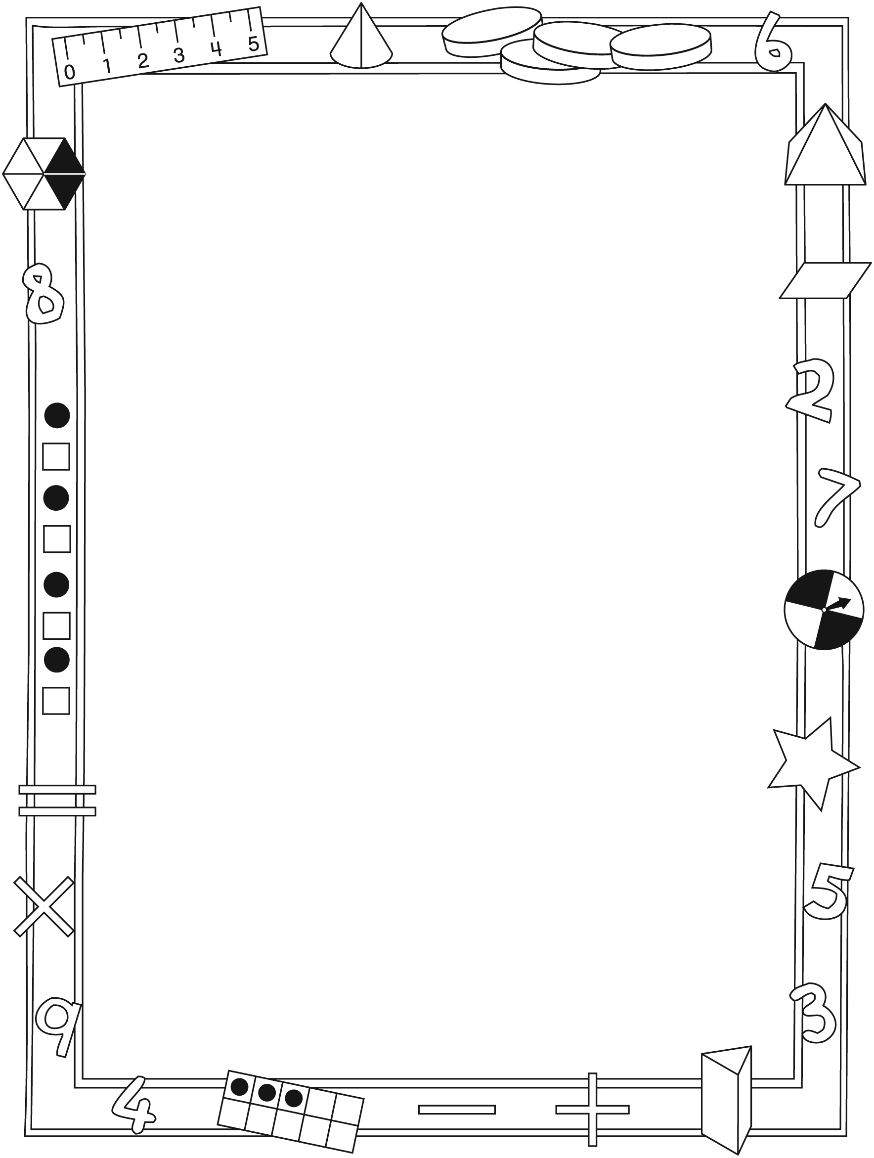

**Connecting Home and School Line Master 2–2**

Dear Family:

We have been working on ***The New Nest***, a book about 5 birds looking for a new home after a cat moves into their nest. This book focuses on the language used to describe location and position, as well as recognizing 2-dimensional shapes and seeing objects from different perspectives. Try this activity at home with your child.

✂ – – – – – – – – – – – – – – – – – – – – – – – – – – – – – – – – – – – – – – – – – –

**Reading the Story:** As you read the story, enjoy the antics of the birds and engage your child in focusing on the boldfaced words—those that describe position and direction and are the focus of the story. Afterward, find 5 small objects (e.g., buttons, coloured paper clips) and use the mat on the inside back cover of the book to show birds on a wire. Invite your child to place the objects according to your directions. For example: **Put the blue bird (button) in the middle of the wire and the red bird (button) on the left side of the blue bird (button). Put another bird above the wire.** Invite your child to direct you to place objects on the wire.

✂ – – – – – – – – – – – – – – – – – – – – – – – – – – – – – – – – – – – – – – – – – –

**Make It Like Mine:** Sit beside your child at a table and set up a barrier between you so that you are not able to see each other’s work. Create a simple arrangement of about 5 small items on the table. Give directions so that your child can create the same arrangement. For example: **Put a nickel on the table in front of you. Now place another nickel on the table above that nickel. Place a dime on the right side of the top nickel. Place another dime on the table below the dime. And now put a nickel to the right of the last dime.** Lift the barrier so your child can check and make any needed adjustments. Give your child a chance to make and describe an arrangement for you to re-create.

✂ – – – – – – – – – – – – – – – – – – – – – – – – – – – – – – – – – – – – – – – – – –

**Let’s Walk!** Take a walk around your home or outdoors. Give and follow directions such as the following: **Let’s take 4 steps forward. Stop! Now let’s turn to the right and take 3 steps in that direction. Stop! Now let’s walk 5 steps backward and turn to our left. Where should we walk next?**

✂ – – – – – – – – – – – – – – – – – – – – – – – – – – – – – – – – – – – – – – – – – –

Sincerely,

___________________________

***The New Nest* Math Mat Line Master 3**

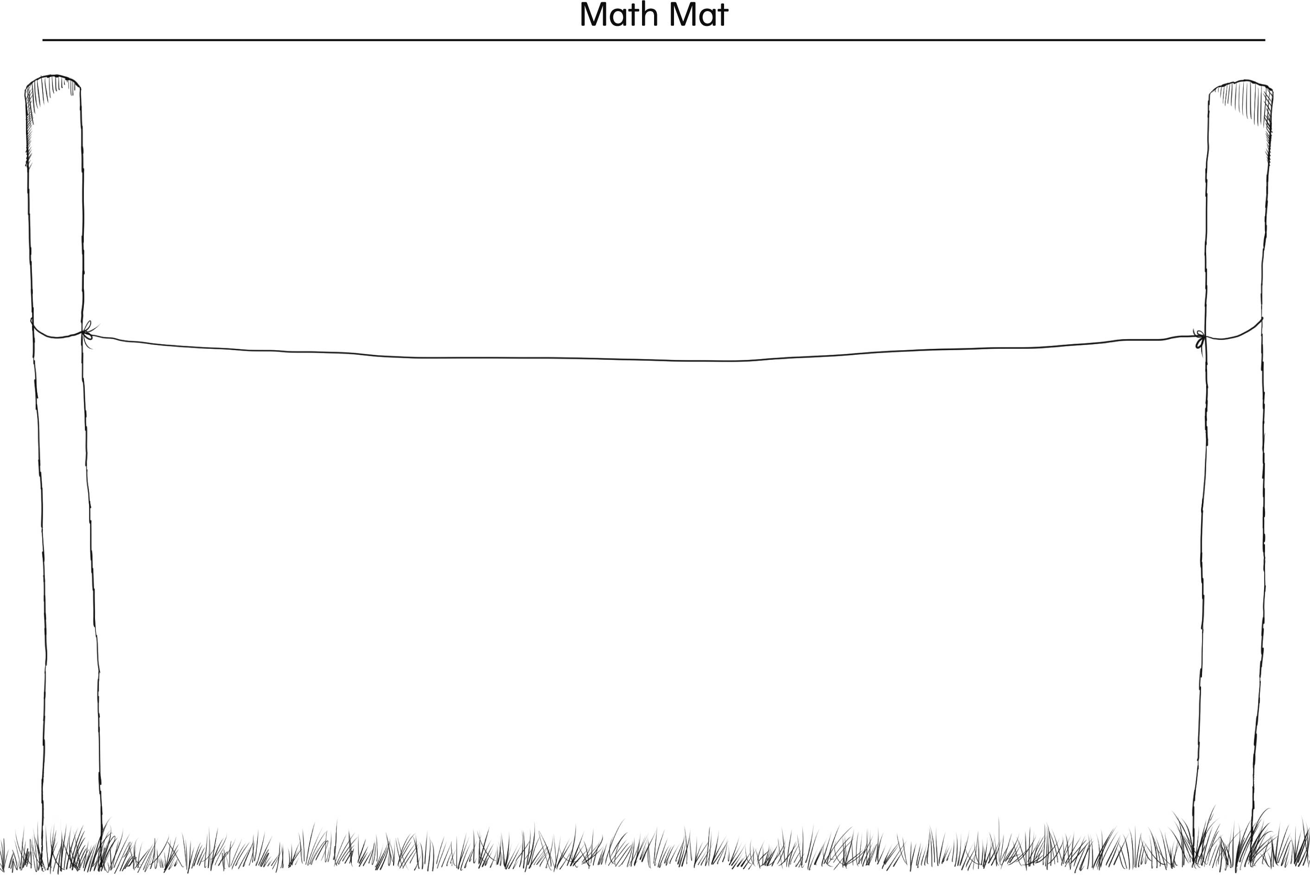

**Bird Finger Puppets Line Master 4**

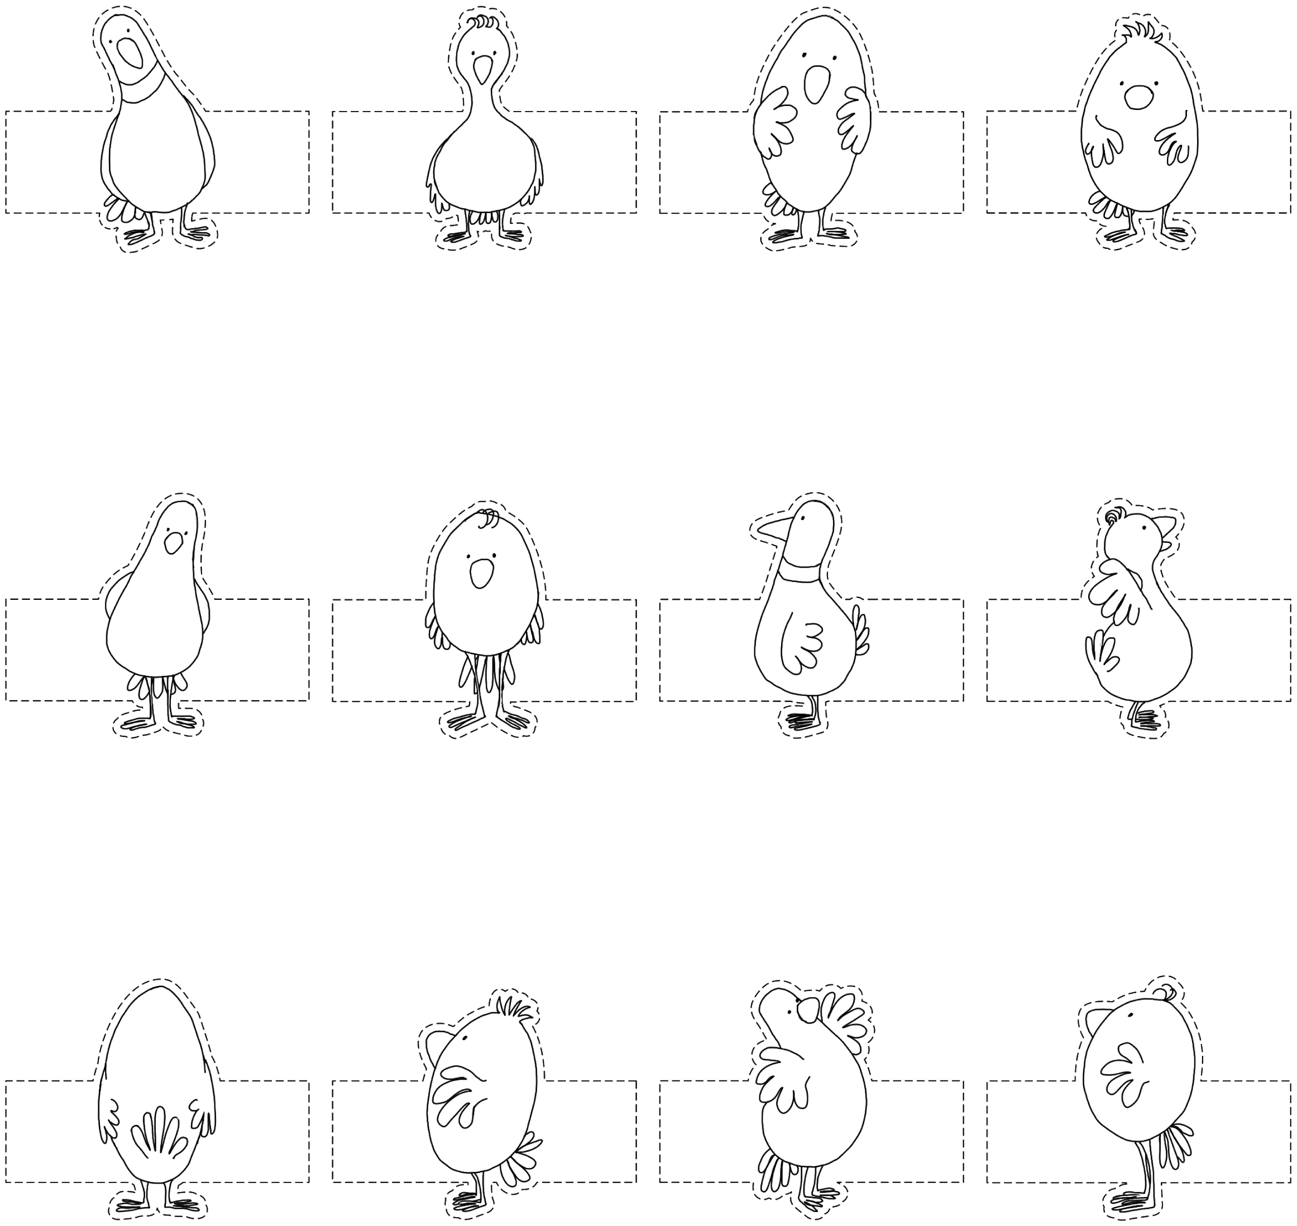

**Story Mat Line Master 5**

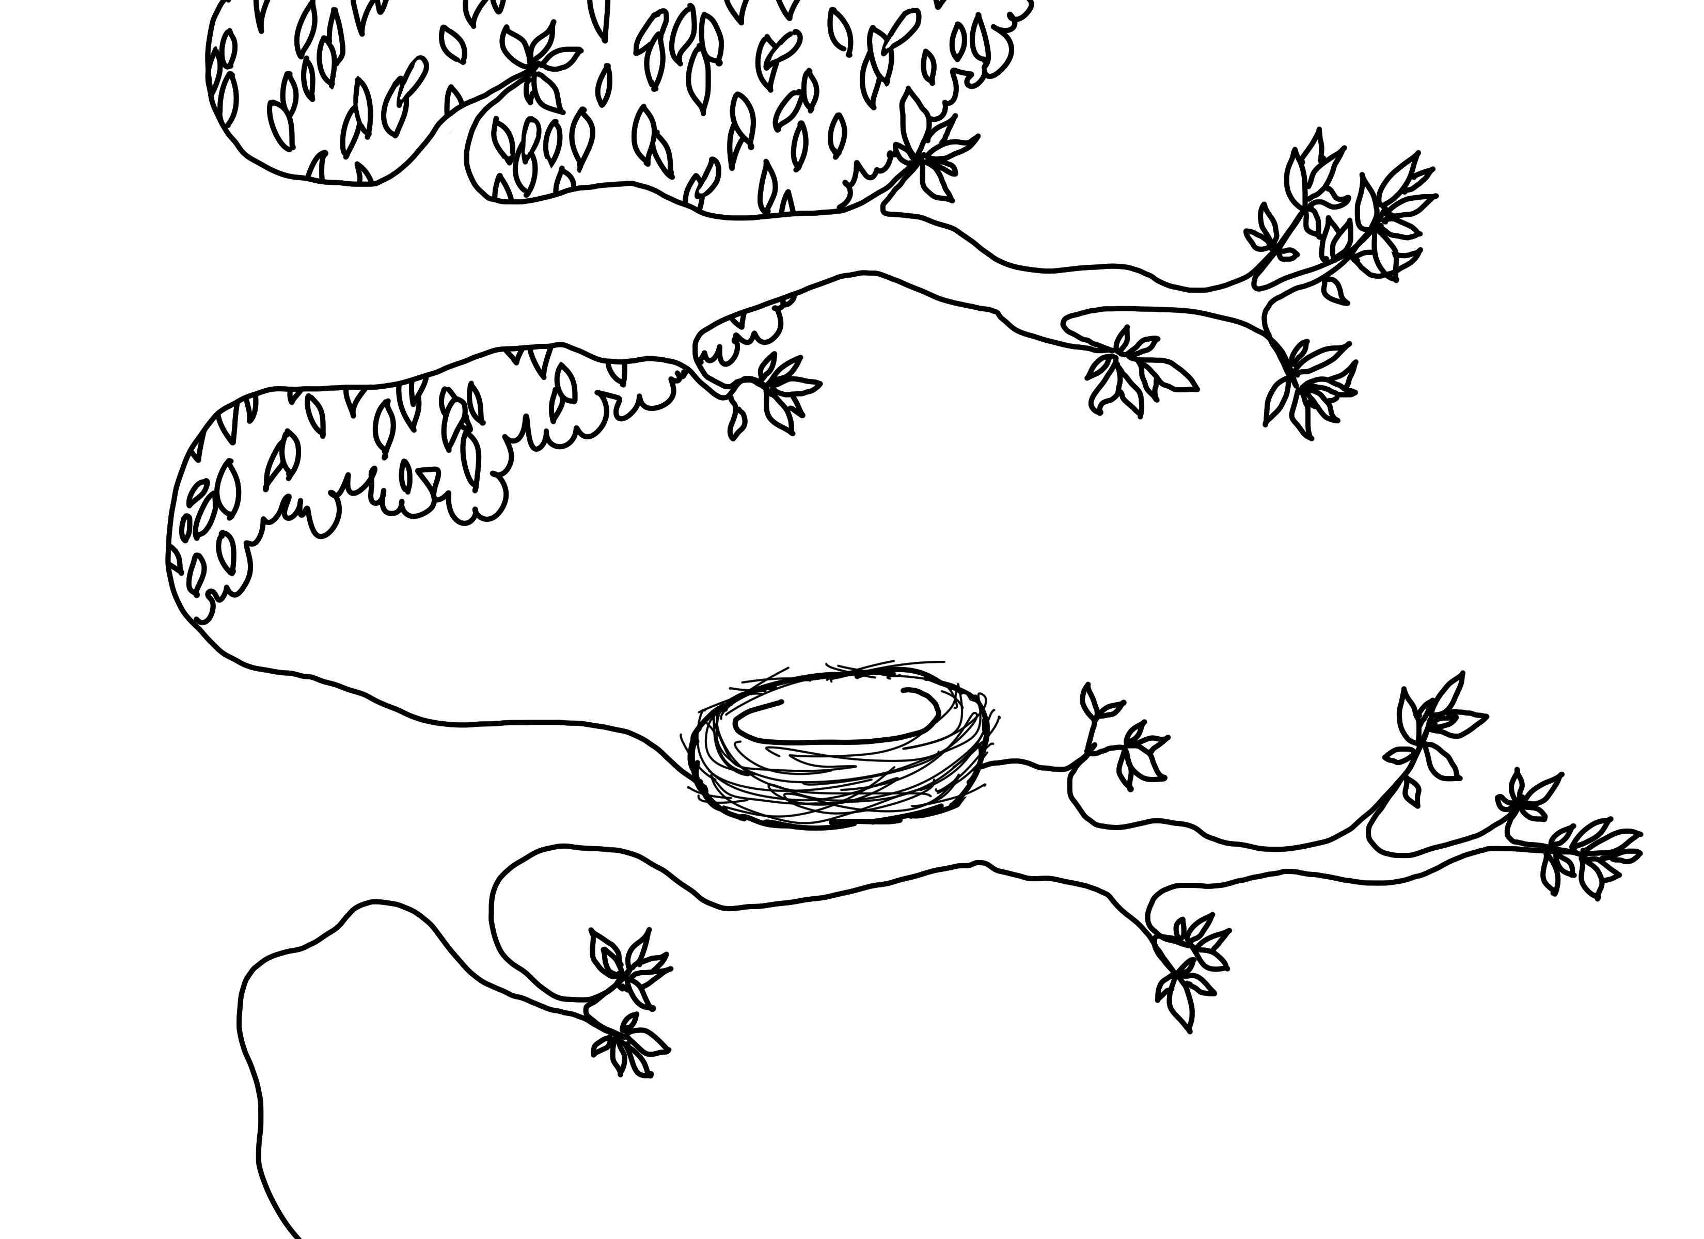

**Labels Line Master 6–1**

The bird is…

|  |  |
| --- | --- |
| inside | outside |
| above | below |
| left | right |

**Labels Line Master 6–2**

The bird is…



|  |  |
| --- | --- |
| between | beside |
| over | under |
| behind | in front of |

**Small Grids Line Master 7**

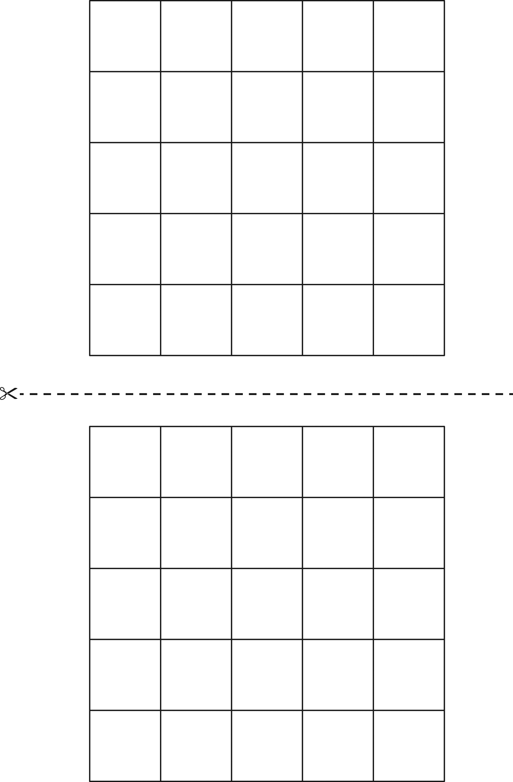

**Shape Cutouts Line Master 8–1**

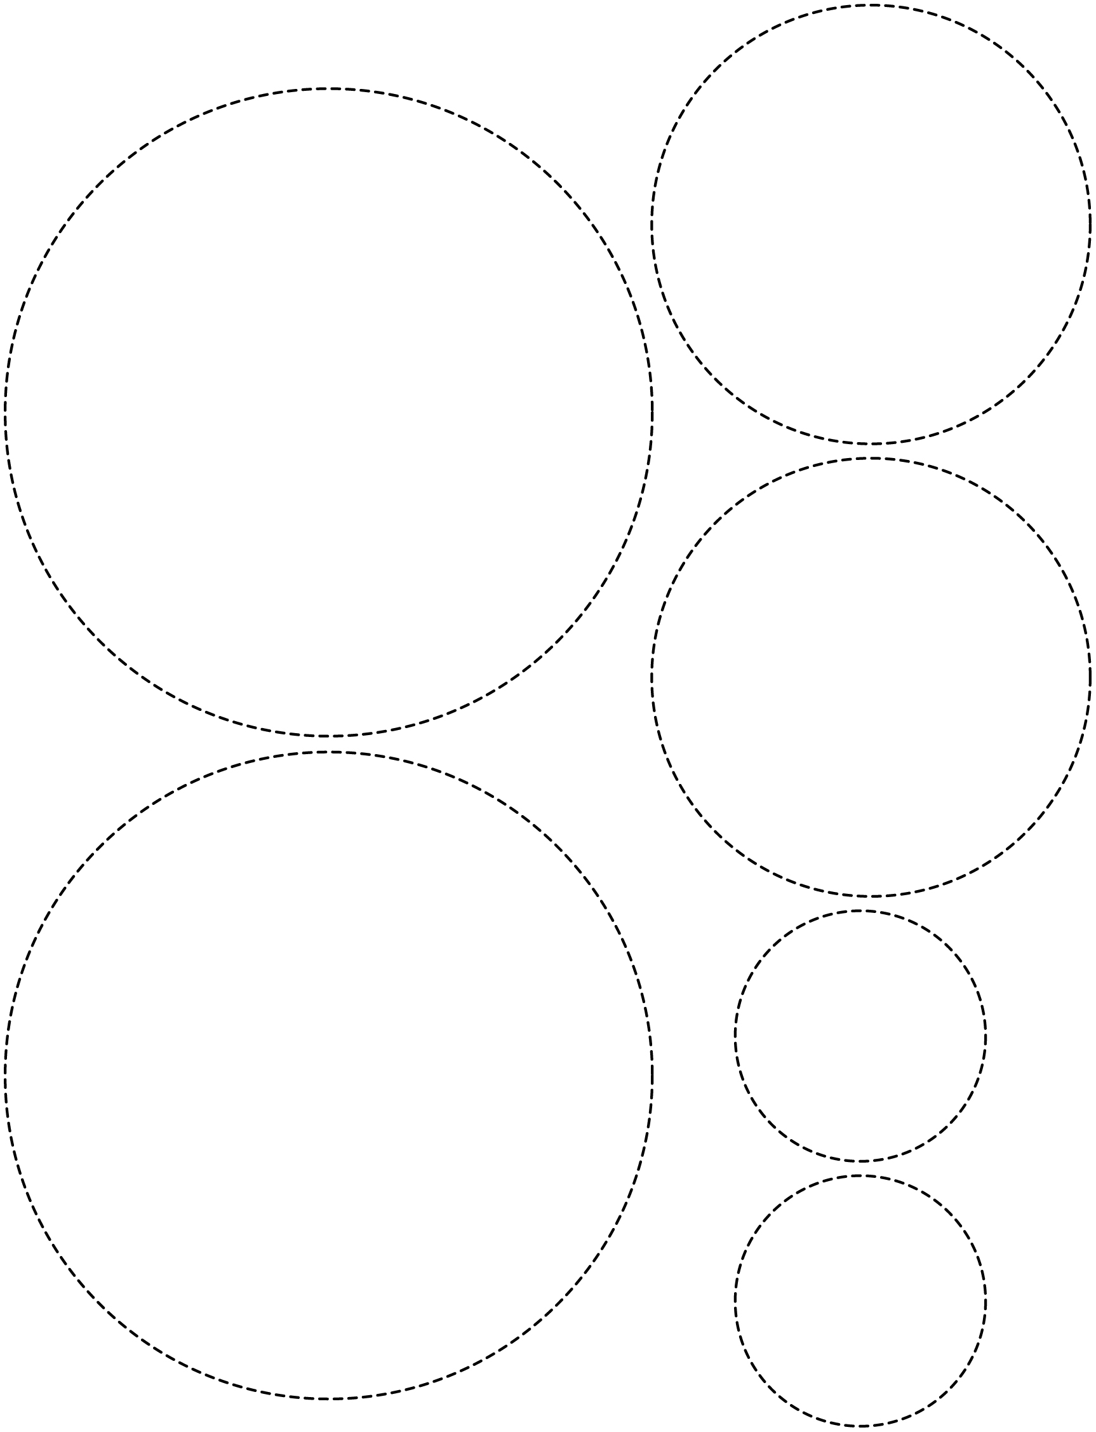

**Shape Cutouts Line Master 8–2**

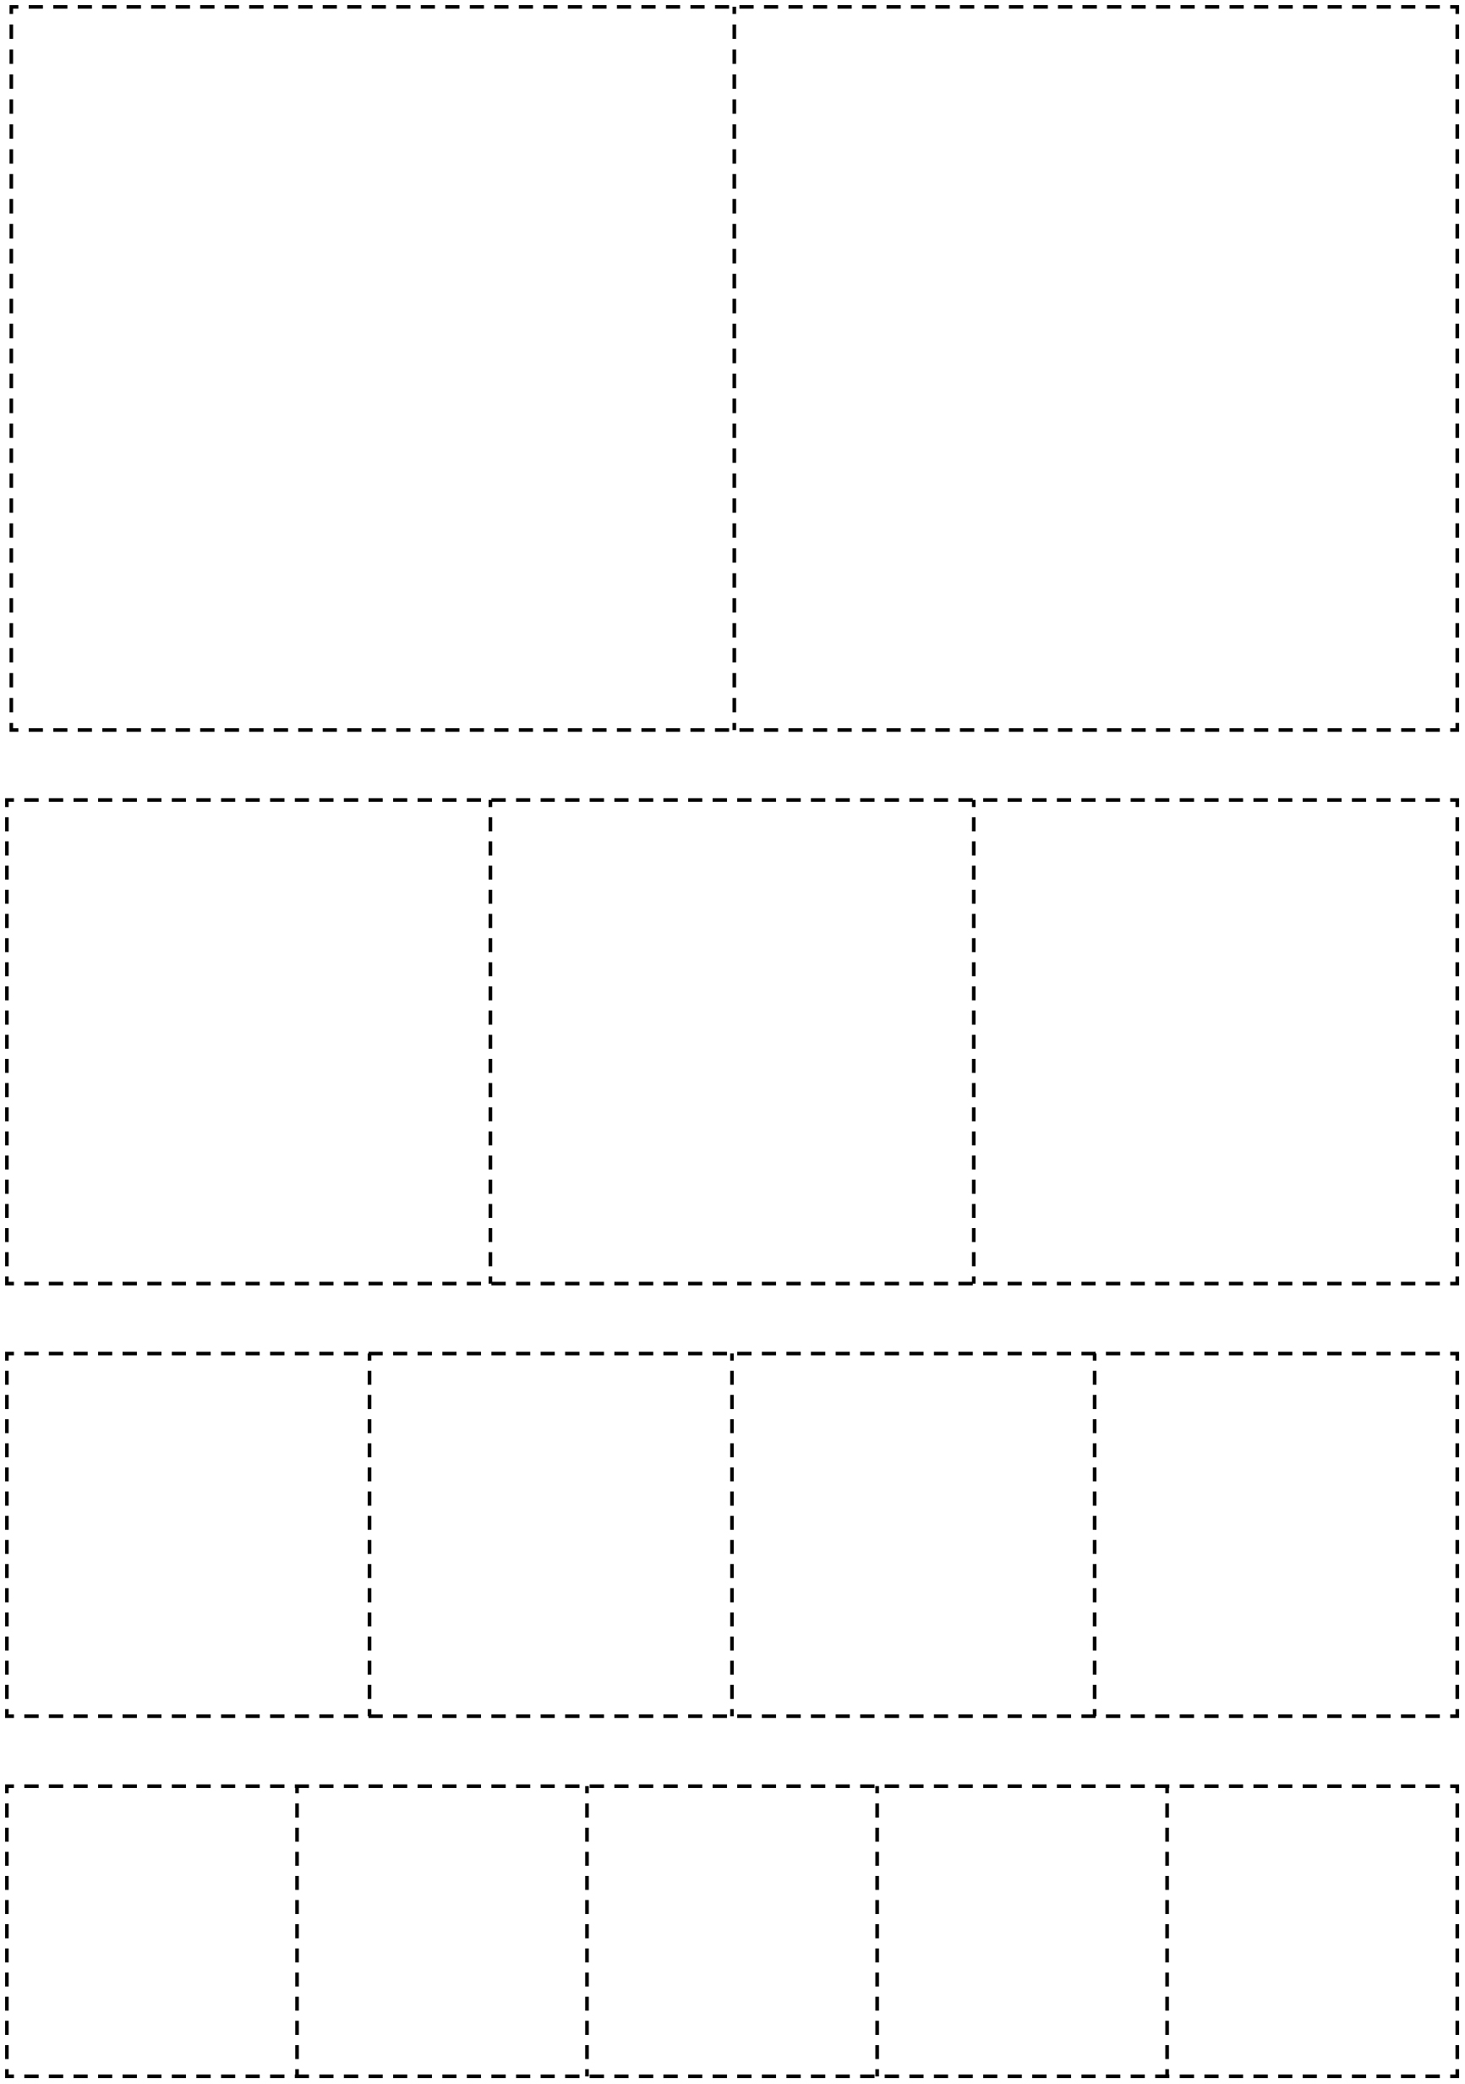

**Shape Cutouts Line Master 8–3**

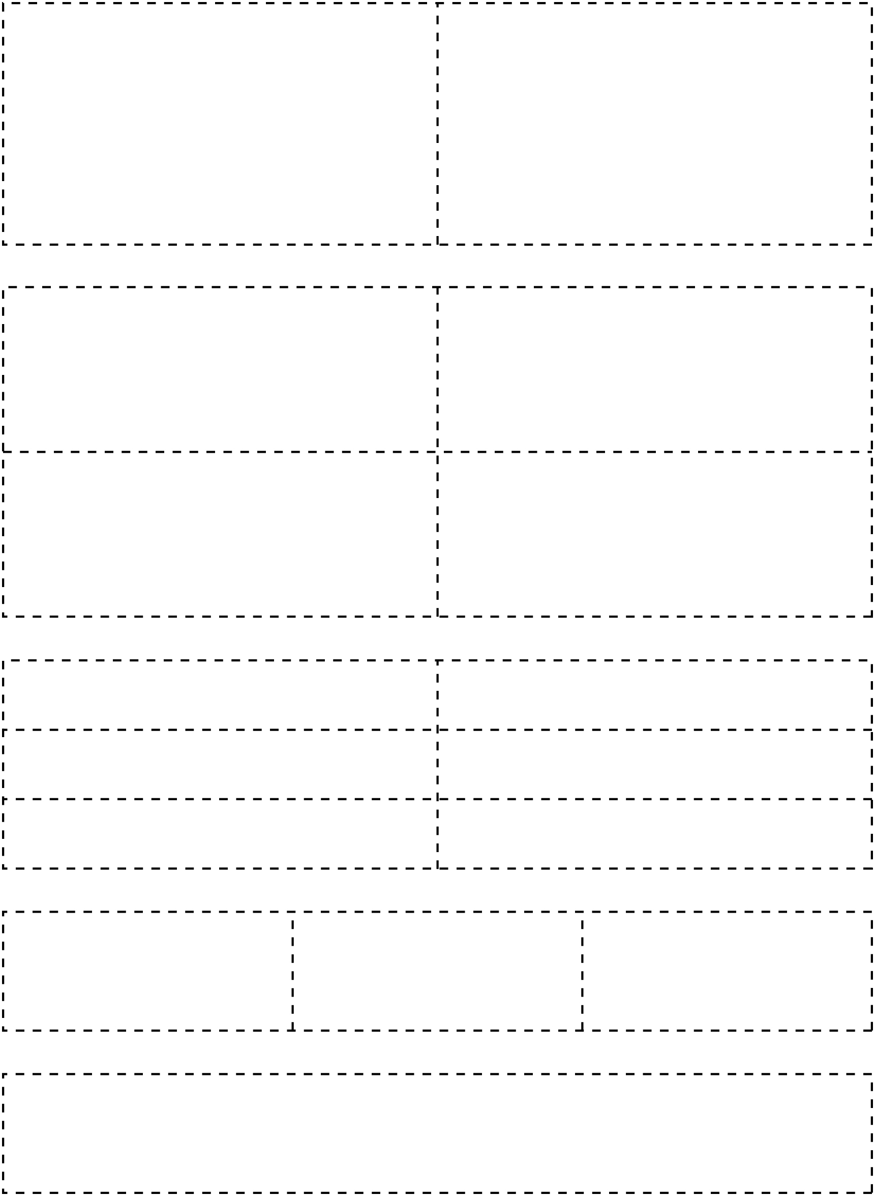

**Shape Cutouts Line Master 8–4**

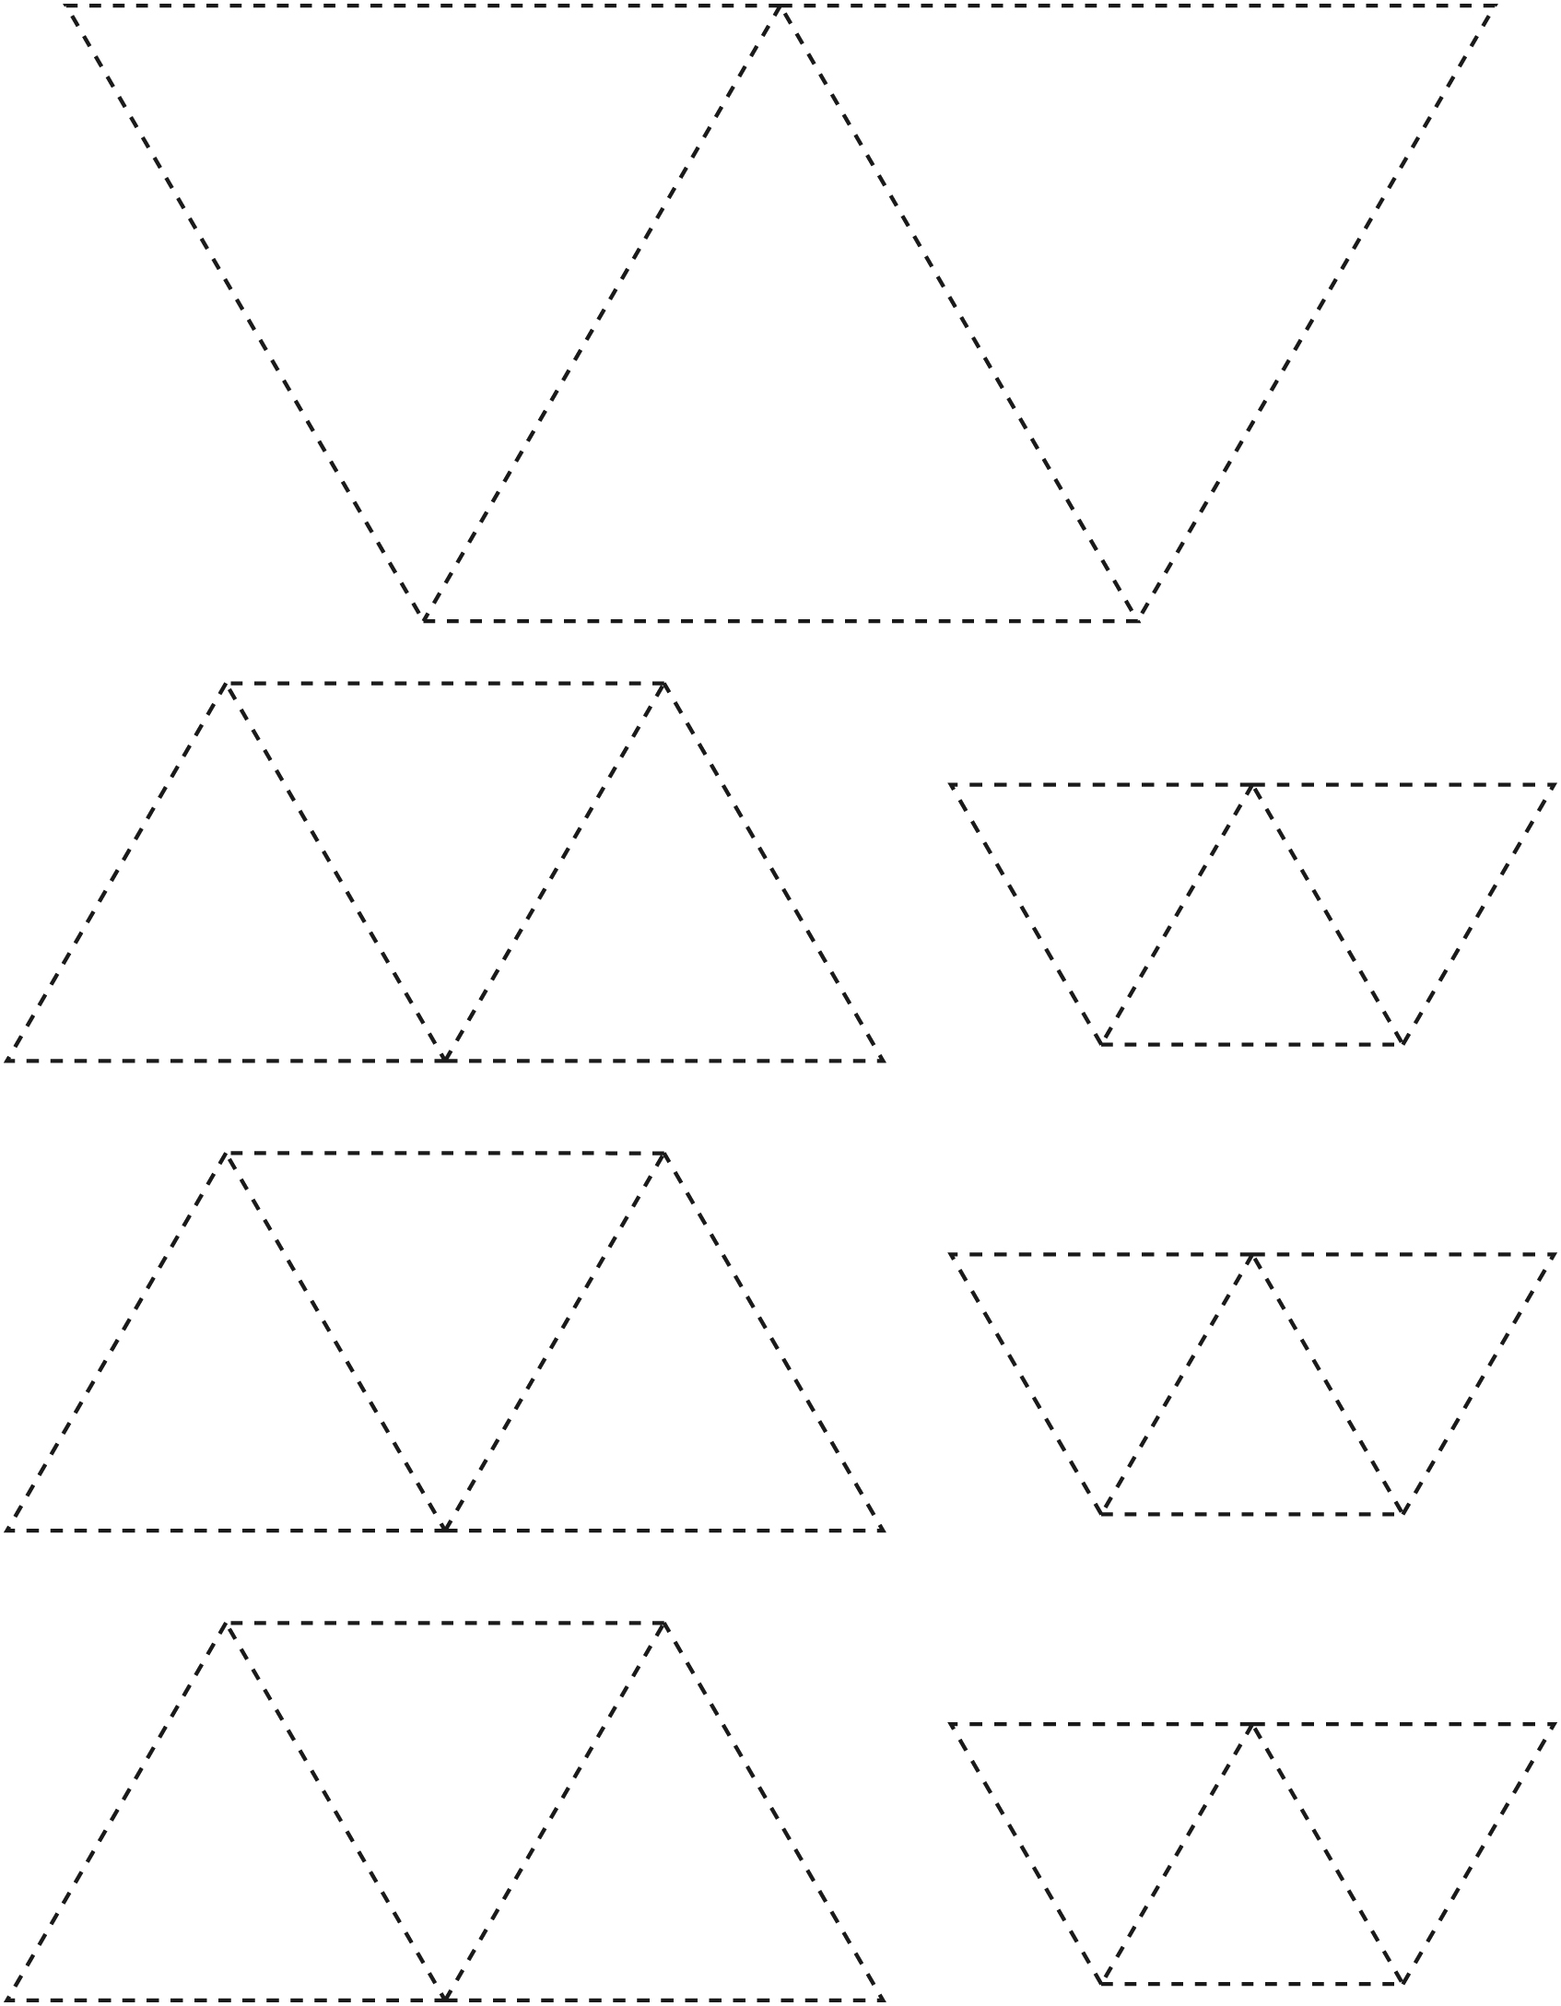

**Shape Cutouts Line Master 8–5**

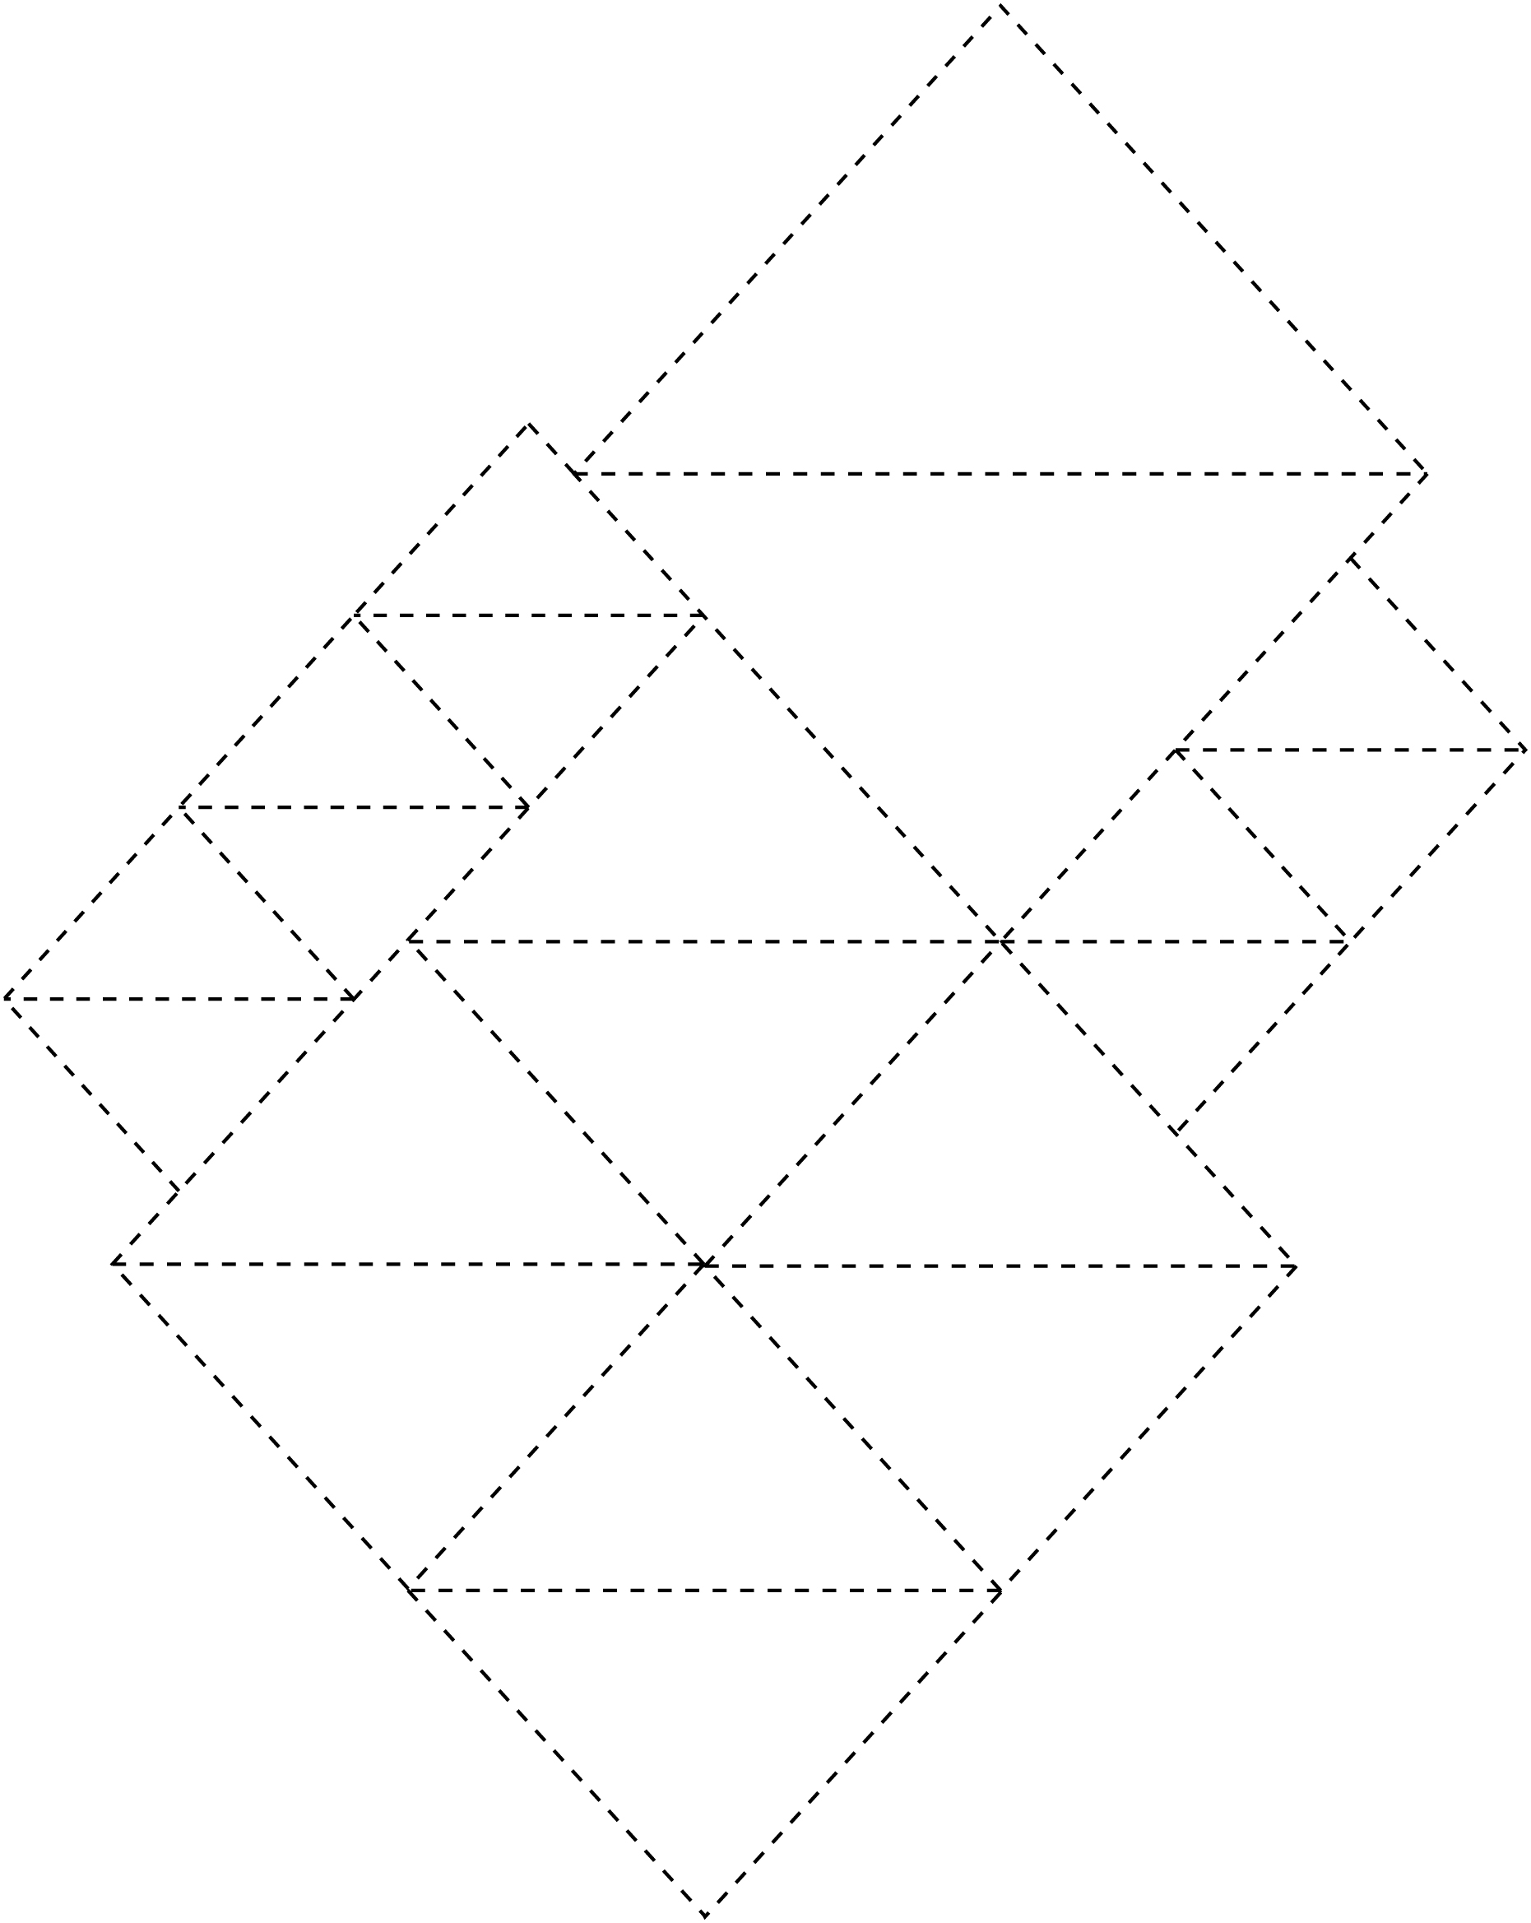

**Shape Cutouts Line Master 8–6**

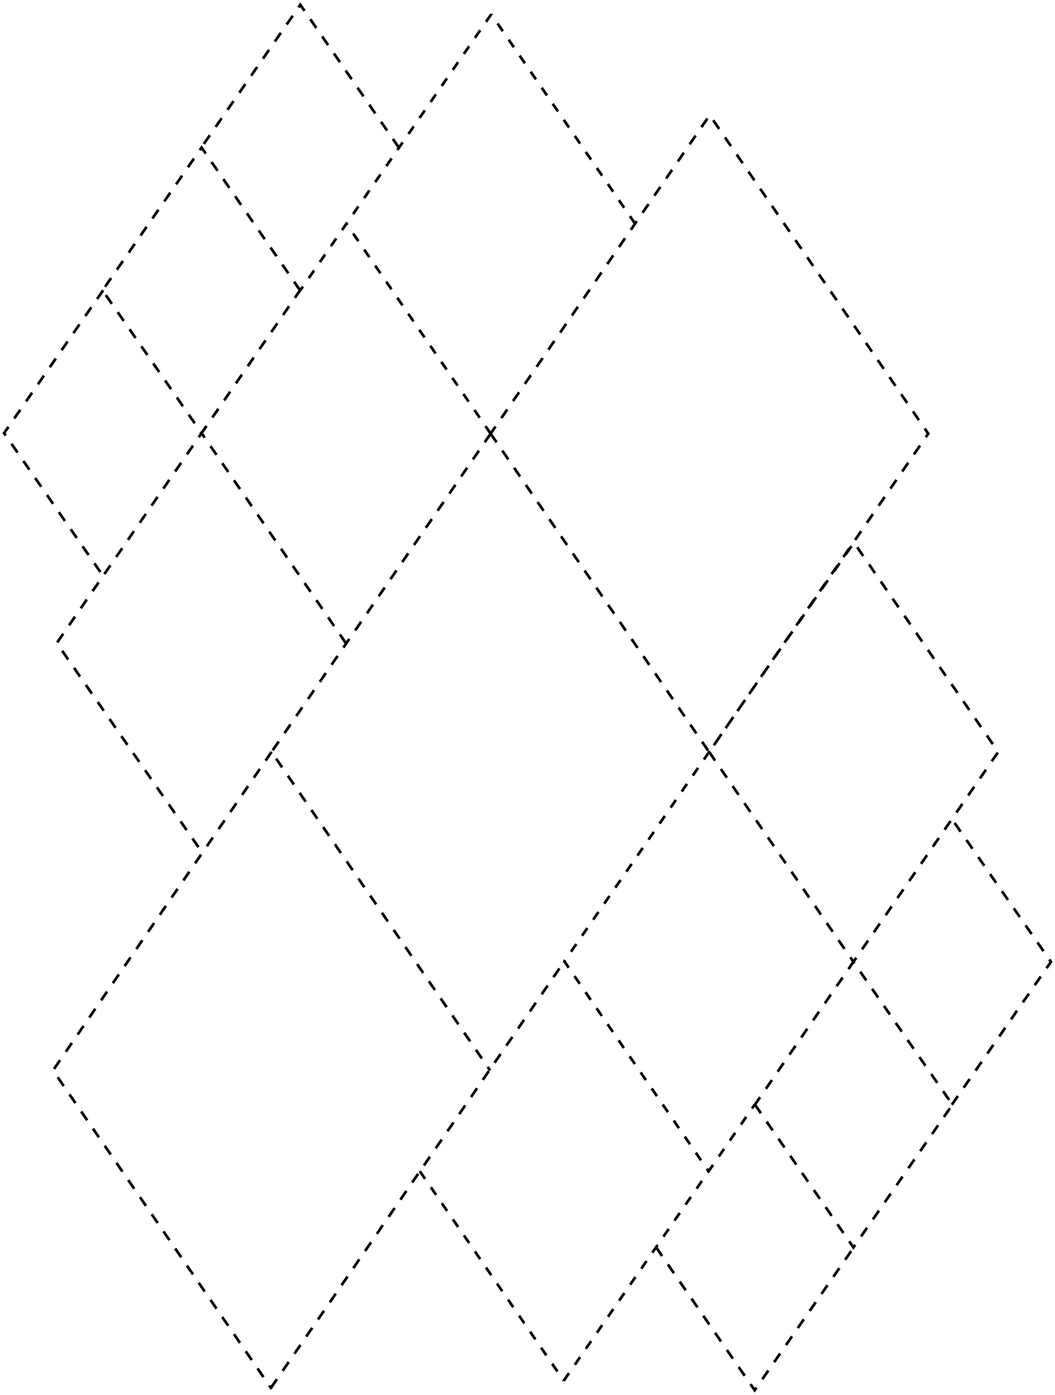

**Pattern Block Birds Line Master 9**

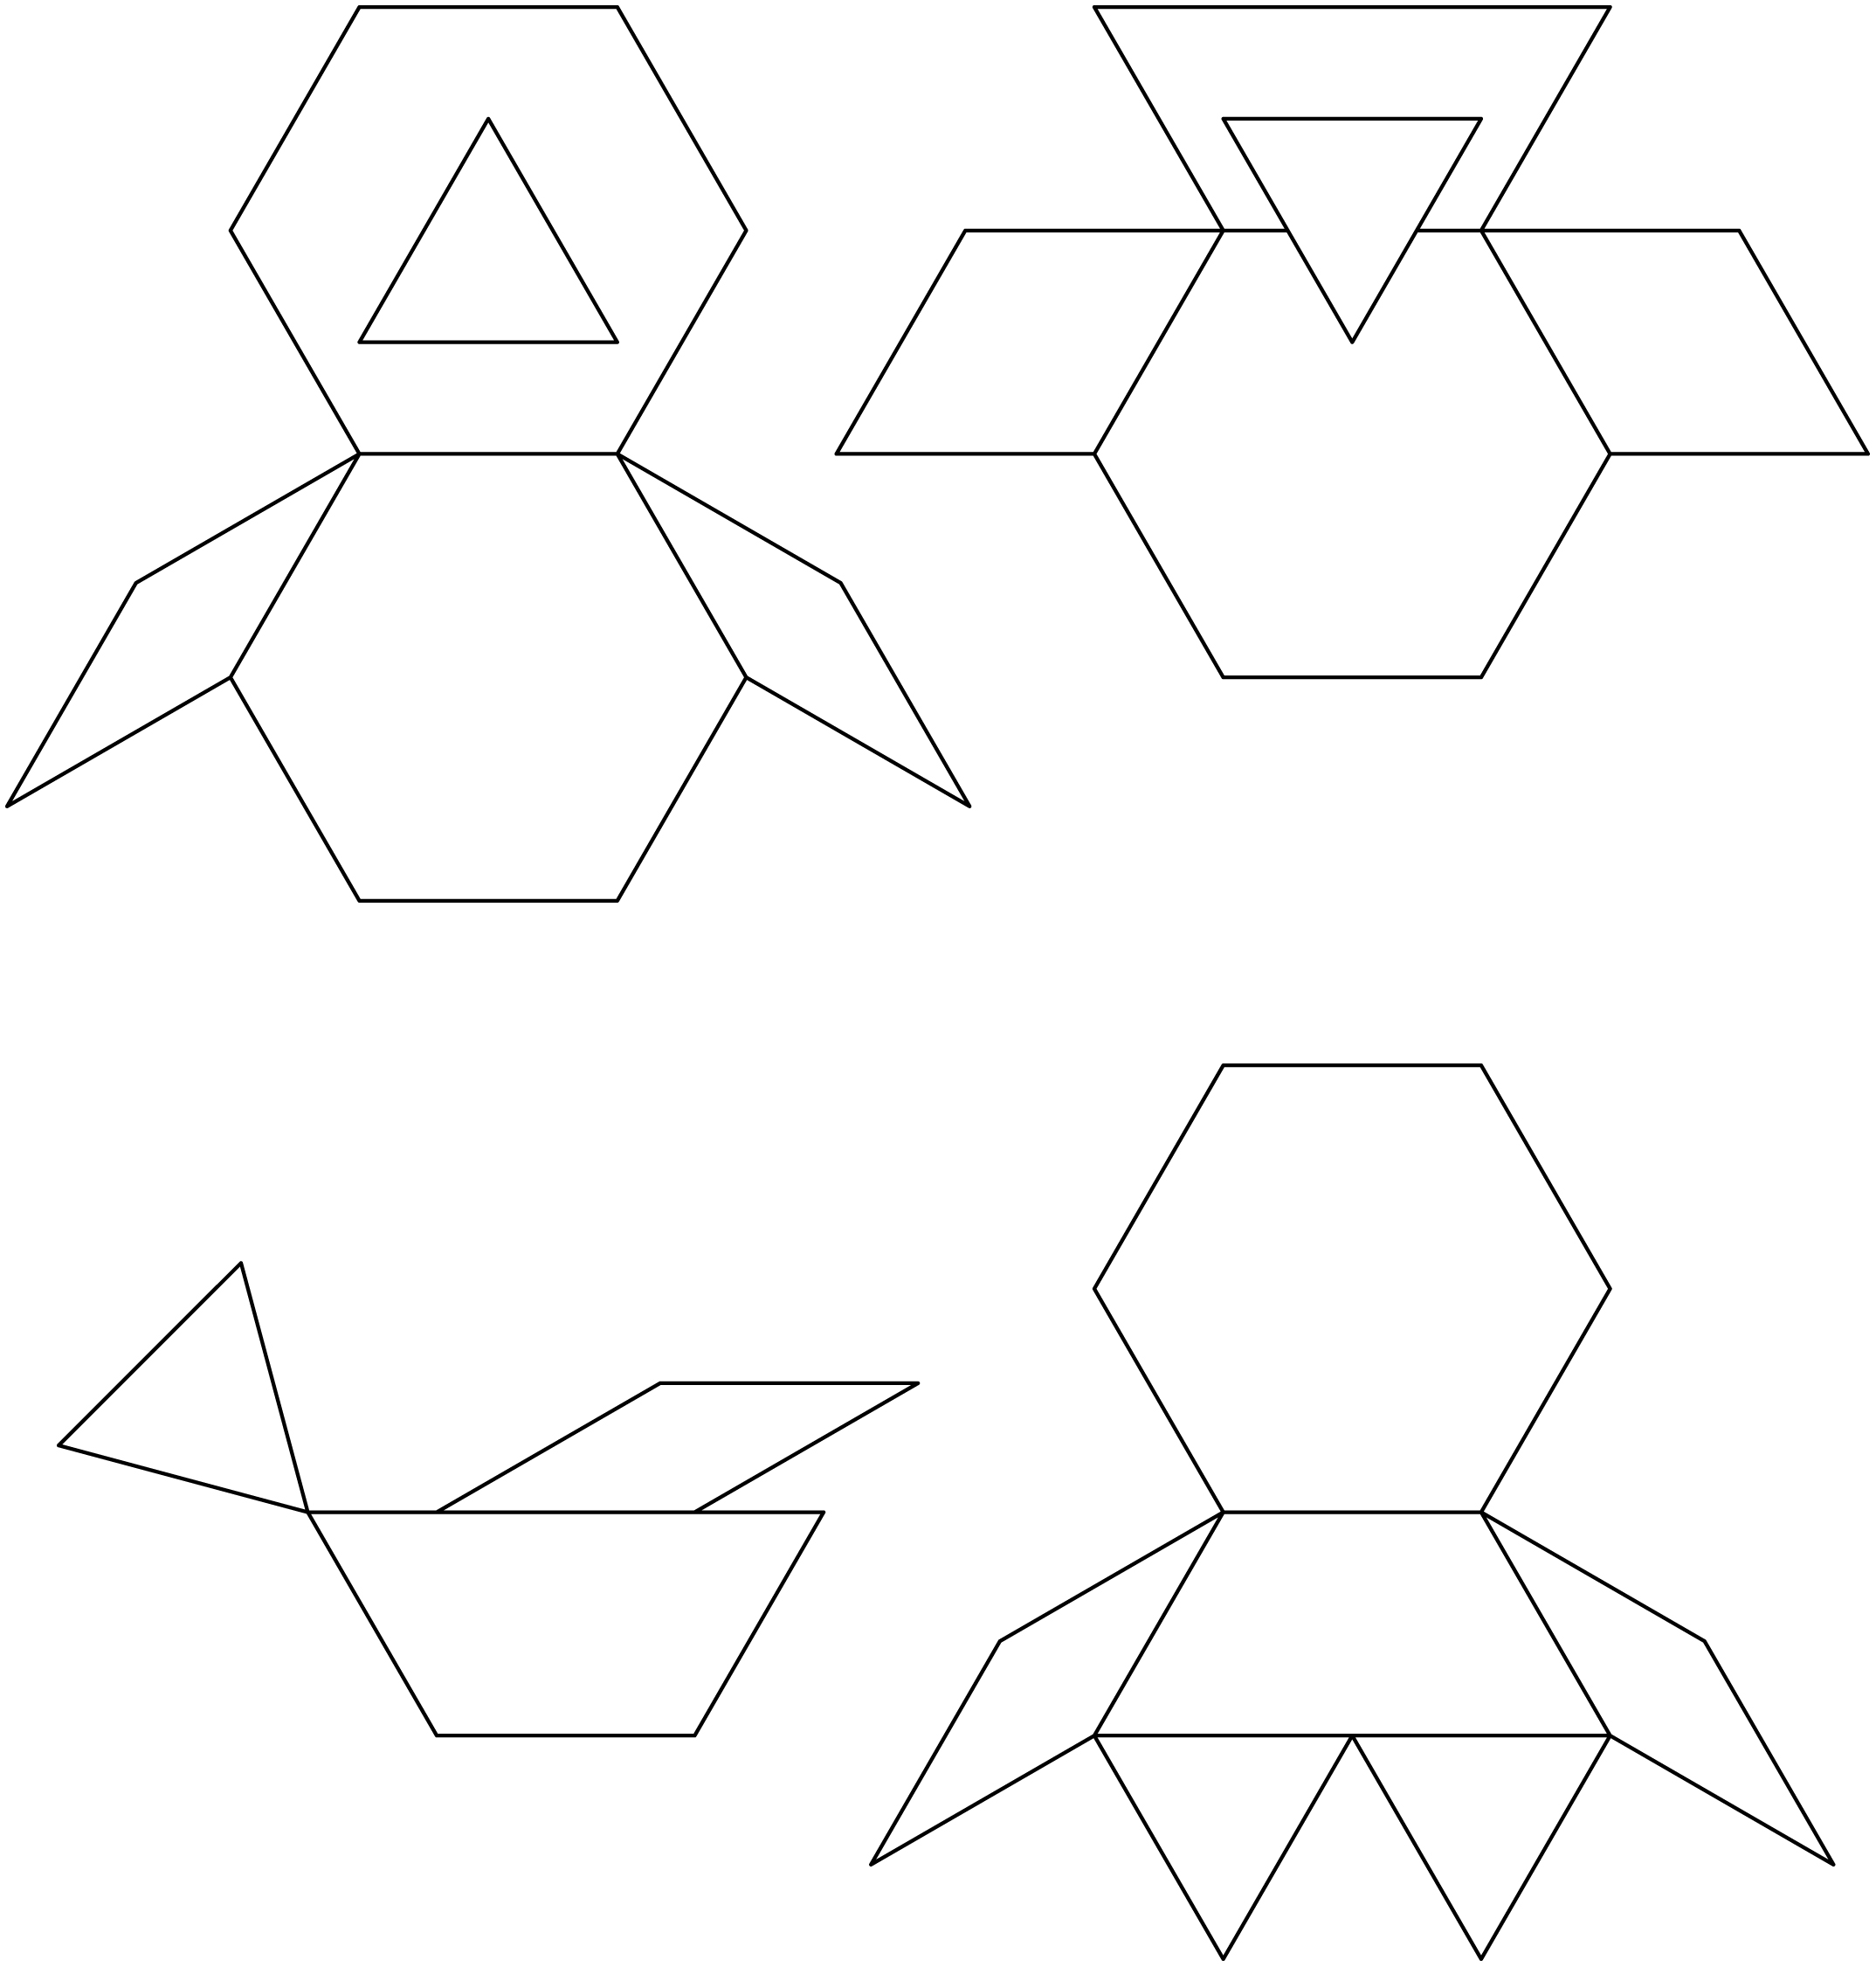

**Mini-Book Template Line Master 10**



|  |  |
| --- | --- |
| **A New Nest**  **by ____________________________** | **The birds fly**  **_______________________________.** |
| **The birds fly**  **_______________________________.** | **The birds fly**  **_______________________________.** |

**Where Will You Draw It? Line Master 11–1**

Use these questions with *The New Nest* Math Mat (LM 3).

✂ – – – – – – – – – – – – – – – – – – – – – – – – – – – – – – – – – – – – – – – – – –

Draw 3 birds **on** the wire.

✂ – – – – – – – – – – – – – – – – – – – – – – – – – – – – – – – – – – – – – – – – – –

Draw 2 birds **above** the wire.

✂ – – – – – – – – – – – – – – – – – – – – – – – – – – – – – – – – – – – – – – – – – –

Draw 2 birds **below** the wire.

✂ – – – – – – – – – – – – – – – – – – – – – – – – – – – – – – – – – – – – – – – – – –

Draw 1 bird **above** and 2 birds **below** the wire.

✂ – – – – – – – – – – – – – – – – – – – – – – – – – – – – – – – – – – – – – – – – – –

Draw 2 birds **on** and 2 birds **below** the wire.

✂ – – – – – – – – – – – – – – – – – – – – – – – – – – – – – – – – – – – – – – – – – –

Where will you draw 2 birds?

✂ – – – – – – – – – – – – – – – – – – – – – – – – – – – – – – – – – – – – – – – – – –

**Where Will You Draw It? Line Master 11–2**

Use these questions with Story Mat (LM 5).

✂ – – – – – – – – – – – – – – – – – – – – – – – – – – – – – – – – – – – – – – – – – –

Draw a bird **below** the nest.

✂ – – – – – – – – – – – – – – – – – – – – – – – – – – – – – – – – – – – – – – – – – –

Draw a bird **above** the tree.

✂ – – – – – – – – – – – – – – – – – – – – – – – – – – – – – – – – – – – – – – – – – –

Draw a bird **inside** the nest.

✂ – – – – – – – – – – – – – – – – – – – – – – – – – – – – – – – – – – – – – – – – – –

Draw a bird **outside** the nest.

✂ – – – – – – – – – – – – – – – – – – – – – – – – – – – – – – – – – – – – – – – – – –

Draw a bird **beside** the tree.

✂ – – – – – – – – – – – – – – – – – – – – – – – – – – – – – – – – – – – – – – – – – –

Draw a bird **between** the nest and a branch.

✂ – – – – – – – – – – – – – – – – – – – – – – – – – – – – – – – – – – – – – – – – – –

Where will you draw your bird?

✂ – – – – – – – – – – – – – – – – – – – – – – – – – – – – – – – – – – – – – – – – – –

**Where Are the Birds? Line Master 12**

Here is the nest. Where are the birds?



                                          

