Time for Games Line Master 1 (Assessment Master)
Name: _____________________________

Compare Quantities to 10 | Not observed | Sometimes | Consistently
Knows what number is 1 or 2 more and 1 or 2 less than another number
Perceptually compares quantities to determine more/less or the same
Compares quantities by matching or counting to determine more/less/equal quantities
Determines how many more/less one quantity is compared to another
Count Sets to 10
Says one word for each object counted (one-to-one correspondence)
Says counting numbers in correct sequence (stable order)
Knows that the last counting word tells how many are in the set (cardinality)
Counts and describes sets to 10
Identifies number without counting each object (subitizes)
Count on by 1, by 2
Strengths:

Next Steps:

Connecting Home and School Line Master 2–1



NOTE TO THE TEACHER

You may wish to send families a Time for Games letter outlining a familiar activity or two they can do at home with their children.

Create a letter using this template and select one or two activities from the suggestions on the next page. Simply delete these instructions and cut and paste the activities you have selected, adapting them to fit your needs.
Connecting Home and School Line Master 2–2

Dear Family:

We have been working on Time for Games, which focuses on Comparing Quantities to 10 and Counting Sets to 10. Try this activity at home with your child.

 – – – – – – – – – – – – – – – – – – – – – – – – – – – – – – – – – – – – – – – – – –

Reading the Story: This book presents 3 games. Each game poses questions for the reader to answer and involves work with counting and comparing numbers. Talk about and compare your responses. For example, you may have very different ideas as to where Pam should move next (which domino tile to play; how to find the scores in tiddlywinks).

 – – – – – – – – – – – – – – – – – – – – – – – – – – – – – – – – – – – – – – – – – –

Playing Games: Choose to play one (or all) of the games with your child. Review the materials needed and the rules. Ask questions such as these to promote reflection and strategic thinking: What do you think a good next move is? Why is it a good idea if I put my counter here (choose this domino; land on this part of the target)?

 – – – – – – – – – – – – – – – – – – – – – – – – – – – – – – – – – – – – – – – – – –

Playing Another Way: Change the rules and/or materials to create variations of the games. For example, you might design a tiddlywinks target with different numbers or sections.

 – – – – – – – – – – – – – – – – – – – – – – – – – – – – – – – – – – – – – – – – – –

Sincerely,

___________________________

Tic-tac-toe Board Line Master 3

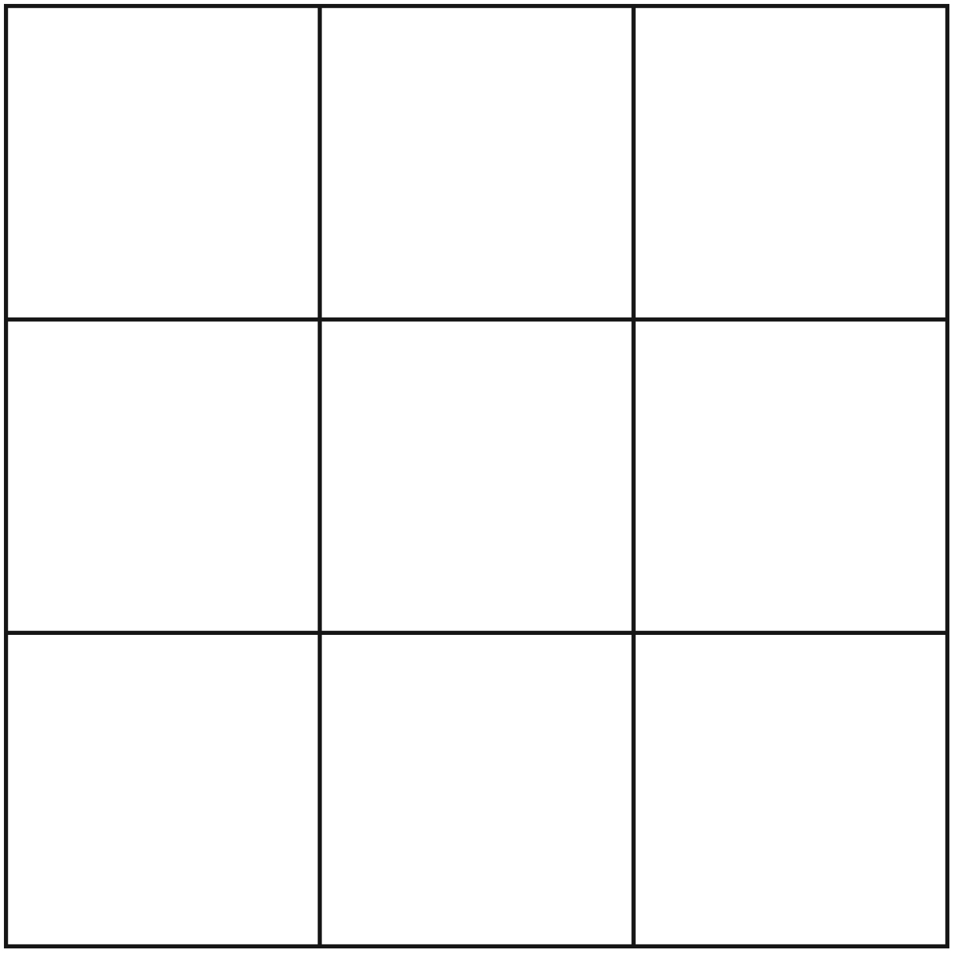

Domino Tiles Line Master 4–1

Photocopy these tiles on card stock paper and cut them out before distributing to children.
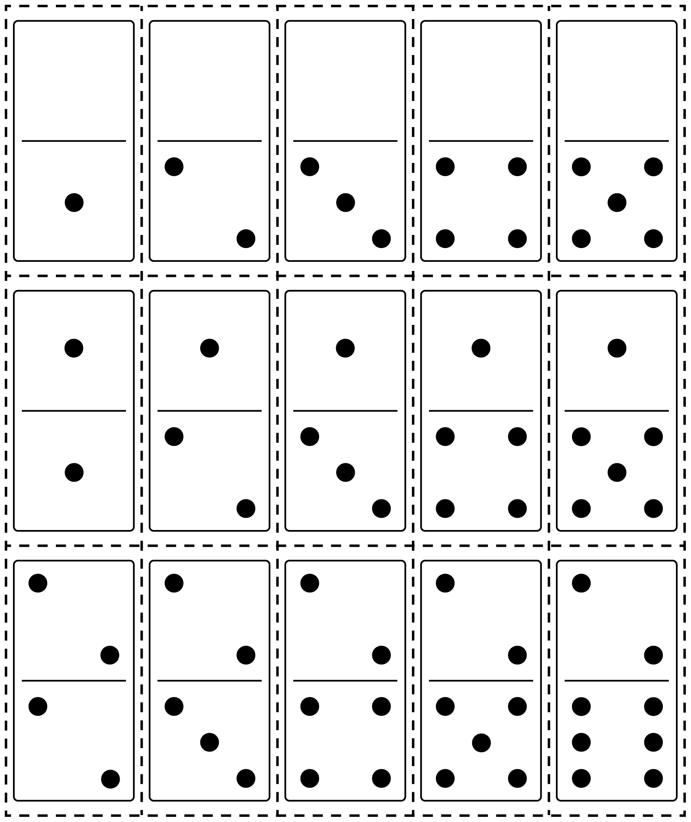

Domino Tiles Line Master 4–2

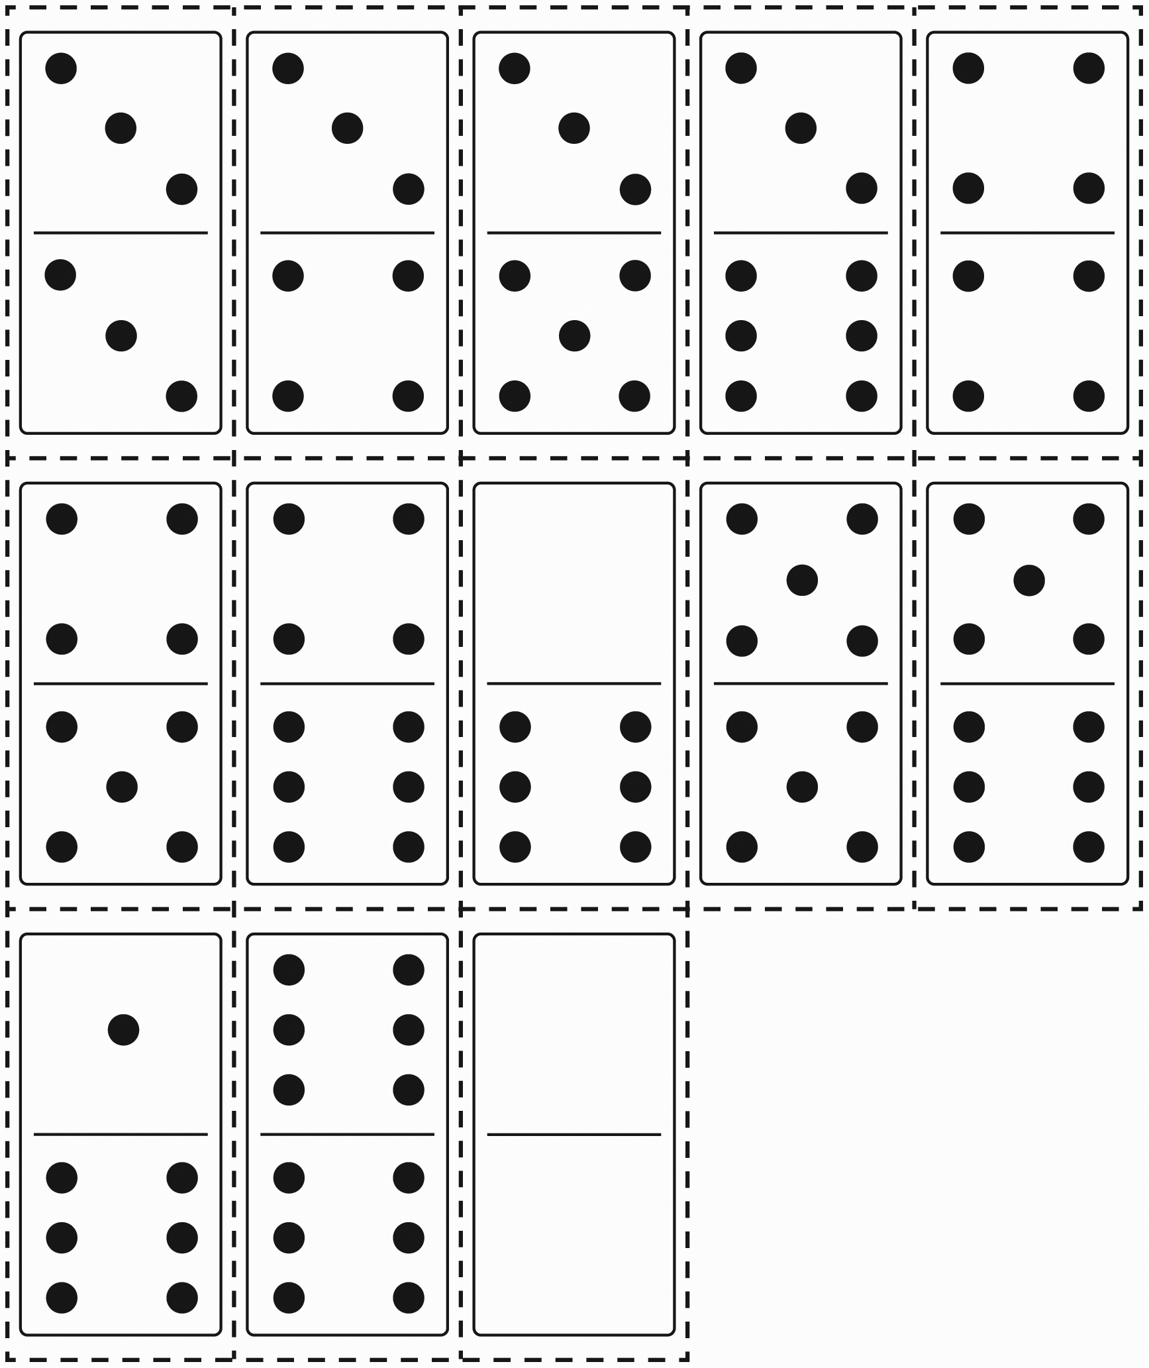

Time for Games Math Mat Line Master 5

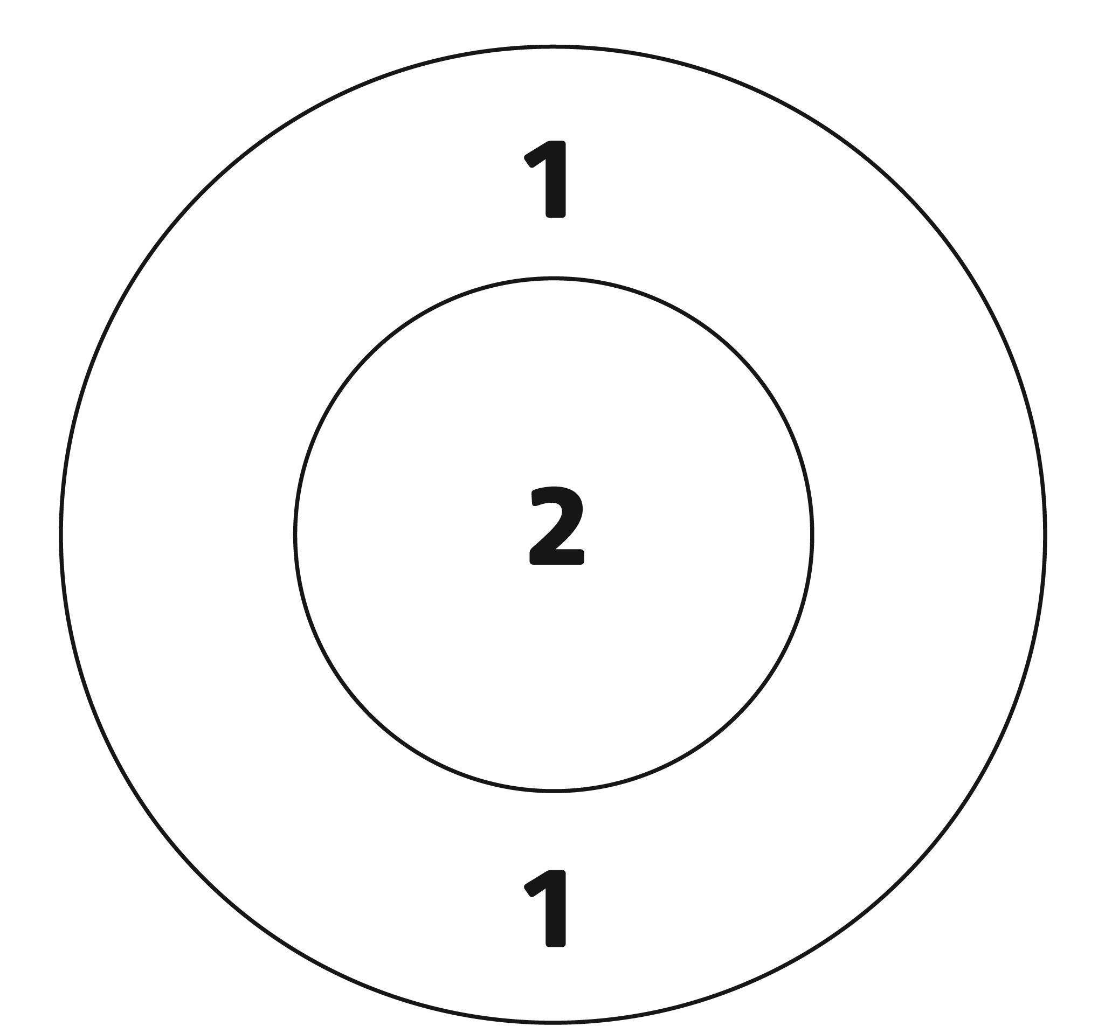

Domino Tiles Template Line Master 6

Photocopy these tiles on card stock paper and cut them out before distributing to children.
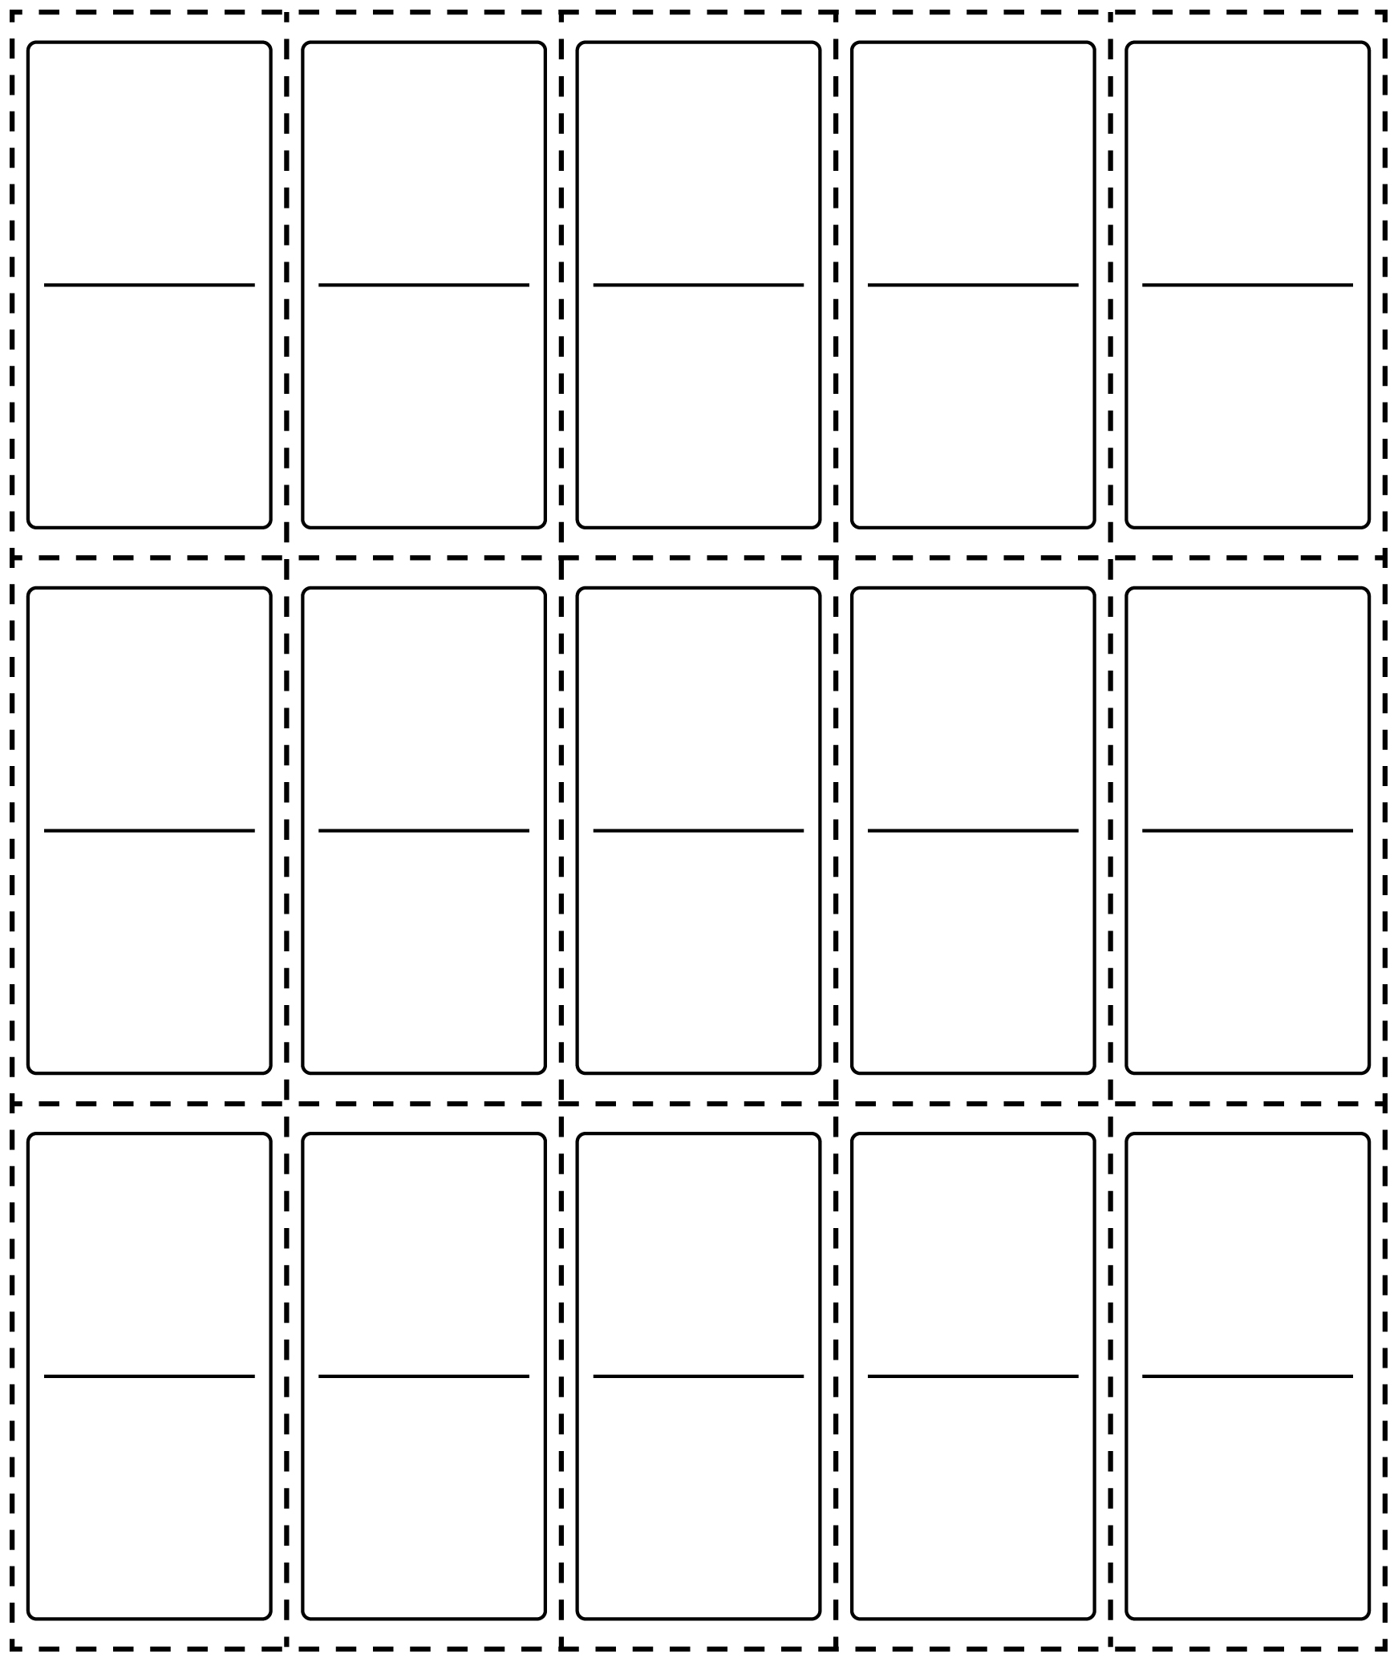

Achi Game Board Line Master 7

What you need
• 4 counters for each player. Each player should have a different colour of counter.

How to Play
• On your turn, put 1 counter on a circle on the board.
• When all of the counters are on the board, take turns moving your counter to an empty circle.
• The player who lines up 3 of their counters in a row wins the game.

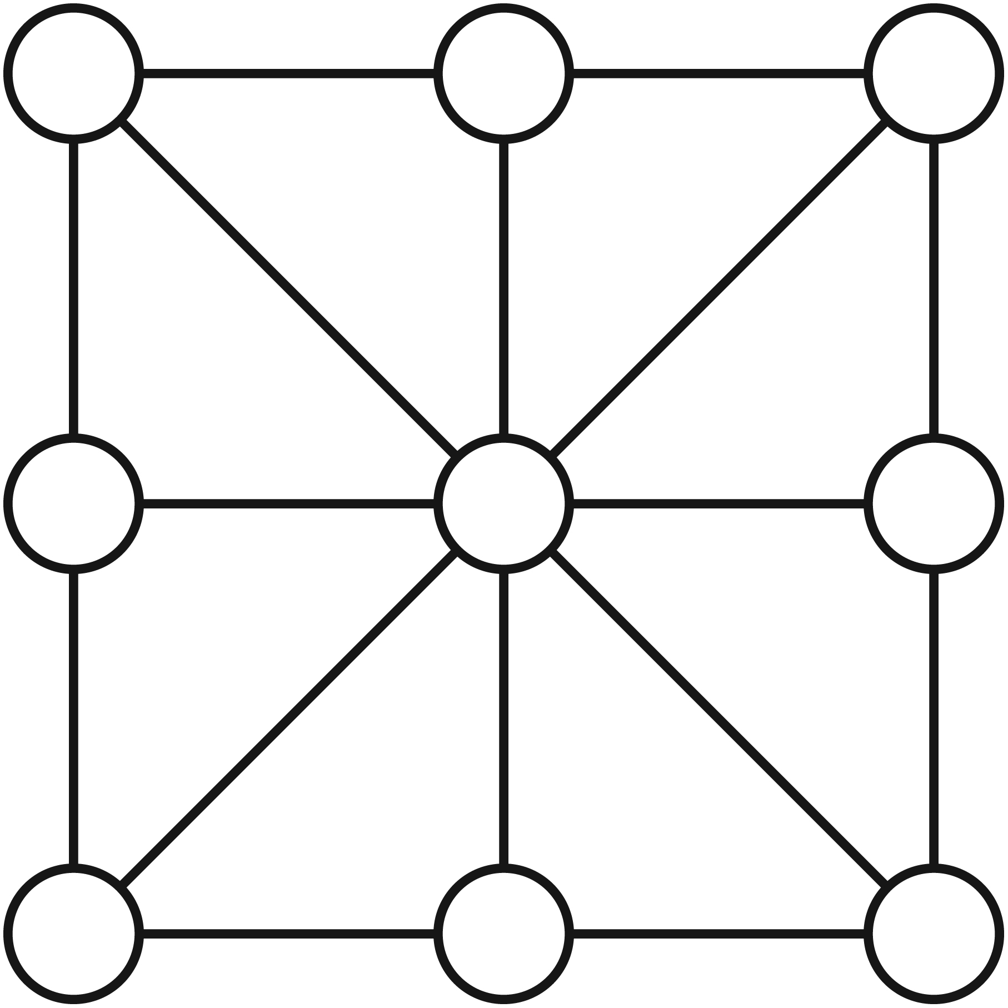
Games We Like Line Master 8

Name: _________________________________________

Ask your friends these questions.
Draw a smiley face if they answer yes.

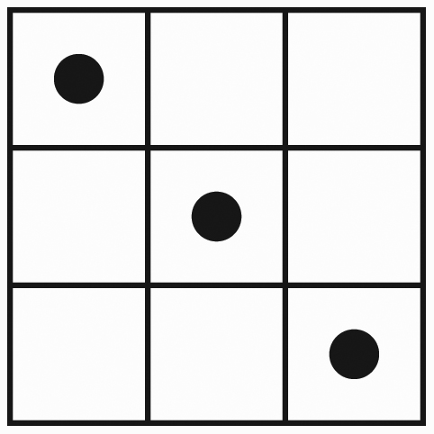
1. Do you like tic-tac-toe?

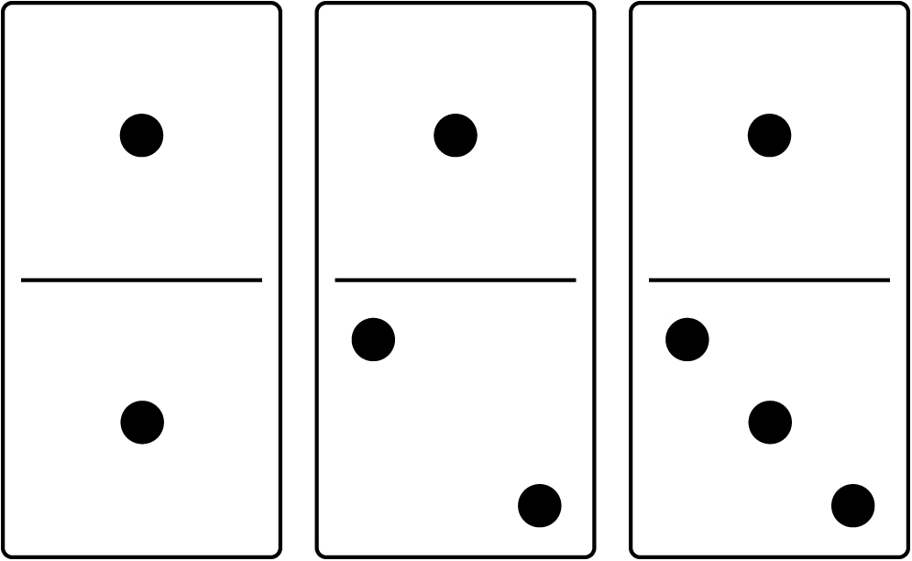
2. Do you like dominoes?

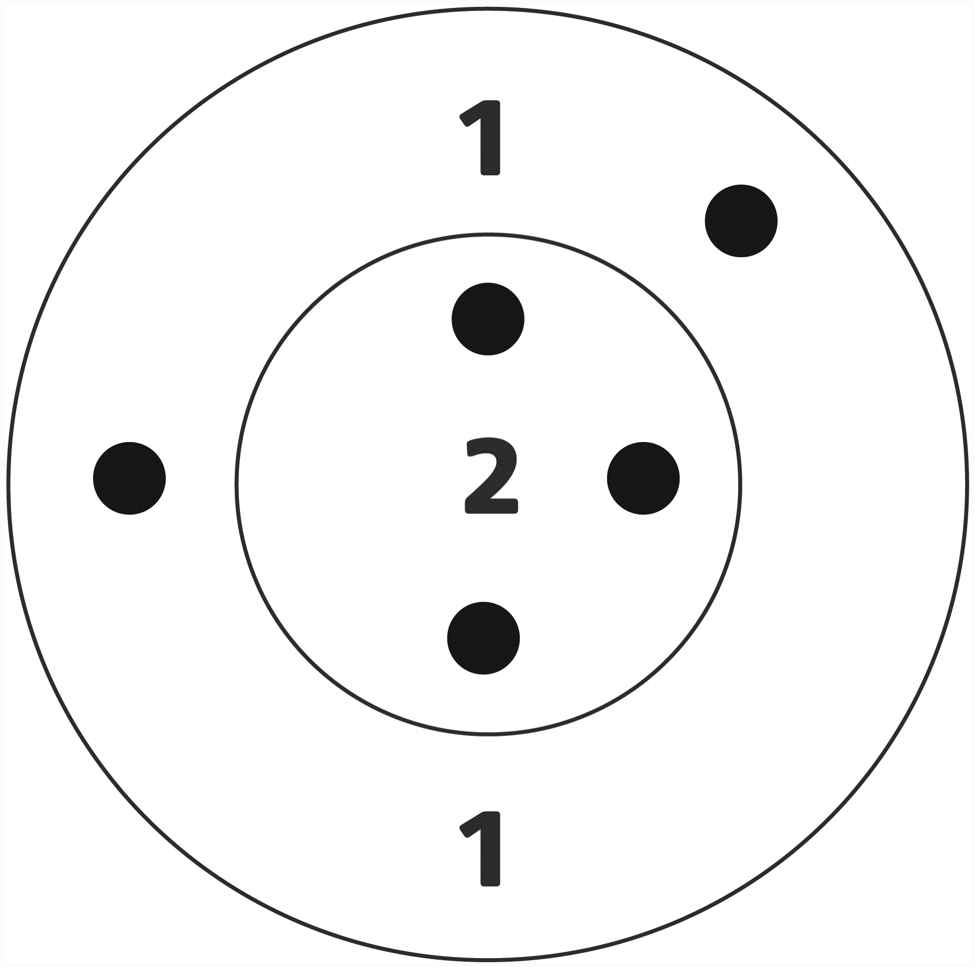
3. Do you like tiddlywinks?

How many like tic-tac-toe? __________________
How many like dominoes? __________________
How many like tiddlywinks? __________________
Which game do the most people like? __________________

Tiddlywinks Target Score Sheet Line Master 9

Name: _________________________________________

Draw where your counters land on the target.
What is your score?
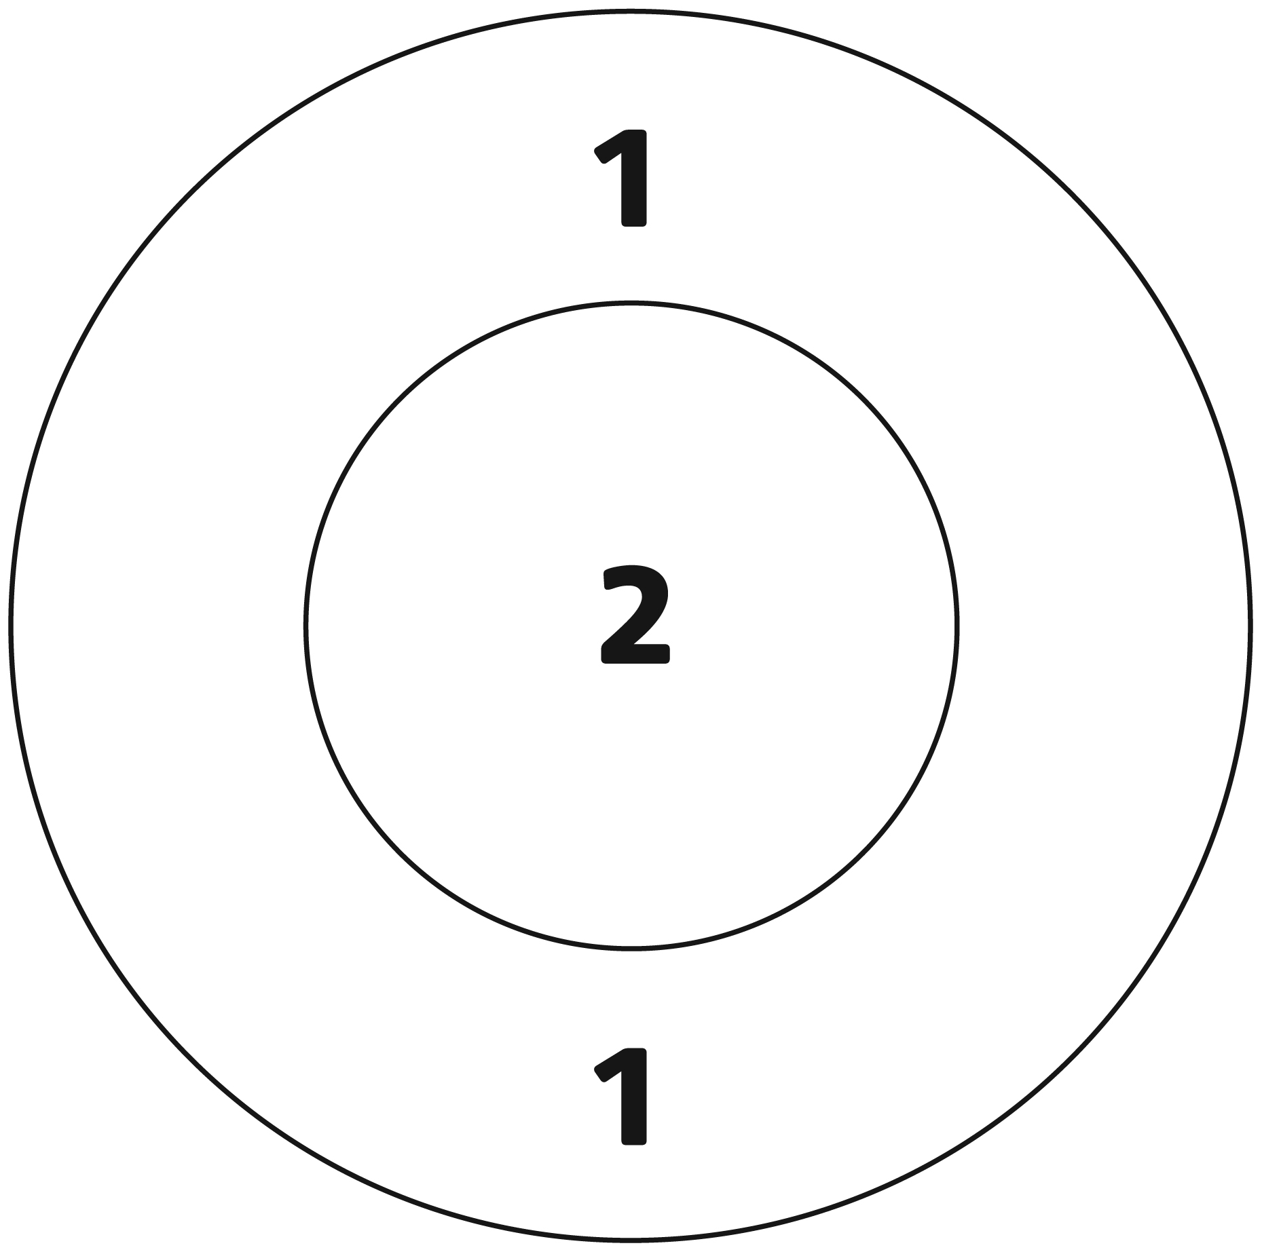  Total Score: _________________ | Total Score: _________________
Total Score: _________________ | Total Score: _________________

