Let’s Play Waltes! Line Master 1 (Assessment Master)
Name: _____________________________

Count and Compare to 10 | Not observed | Sometimes | Consistently
Says number name sequence in correct order when counting forward from 1 (stable order)
Says one word for each object counted (one-to-one correspondence)
Knows that the last number spoken tells how many objects are in the set (cardinality)
Compares quantities by matching or counting to determine more/less or equal quantities
Determines how many more/less one set is compared to another
Compose and Decompose to 10
Decomposes quantities to 10 into parts
Strengths:

Next Steps:

Connecting Home and School Line Master 2–1



NOTE TO THE TEACHER

You may wish to send families a Lets Play Waltes! letter outlining a familiar activity or two they can do at home with their children.

Create a letter using this template and select one or two activities from the suggestions on the next page. Simply delete these instructions and cut and paste the activities you have selected, adapting them to fit your needs.
Connecting Home and School Line Master 2–2

Dear Family:

We have been working on Lets Play Waltes! which engages children in conversations, investigations, and activities that help to develop their understanding of the big math idea that “Numbers are related in many ways.” Particular focus is placed on counting and comparing to 10. Try this activity at home with your child.

 – – – – – – – – – – – – – – – – – – – – – – – – – – – – – – – – – – – – – – – – – –
Reading the Story: As you read the story, enjoy counting the dice and the points won, pay attention to all the different ways to get 6, and notice the different ways in which 10 is depicted (e.g., Grandpa had 10 but gave 1 point to Callie and now he has 9). After you read, you might gather 10 small objects and use the Math Mat on the inside back cover to re-create some of the different situations that Grandpa or Callie encounter each time they have a turn.
 – – – – – – – – – – – – – – – – – – – – – – – – – – – – – – – – – – – – – – – – – –
Play Waltes: Get a plate or bowl, 6 Waltes dice (e.g., counters with different sides or coins), and at least 20 counting sticks. Use the instructions from page 16 to play head-to-head as in the story. Or, for a three-player version, give all the counting sticks to a scorekeeper. Players take turns, and the scorekeeper determines whether points will be given based on how the dice land. Play until all the sticks are gone. The player with more sticks at the end wins.
 – – – – – – – – – – – – – – – – – – – – – – – – – – – – – – – – – – – – – – – – – –
Team Up and Team Down: Play a different version of Waltes in which each player is assigned a different side of the Waltes dice (e.g., facing up or down on the Waltes dice in the book, or red and yellow when playing with 2-colour counters). Players take turns tossing the dice. After each turn, separate the dice into the two categories. Whoever gets all 5 or 6 dice scores the same points as in the story.
 – – – – – – – – – – – – – – – – – – – – – – – – – – – – – – – – – – – – – – – – – –

Sincerely,

___________________________
Waltes Scoring Guide Line Master 3

5 points

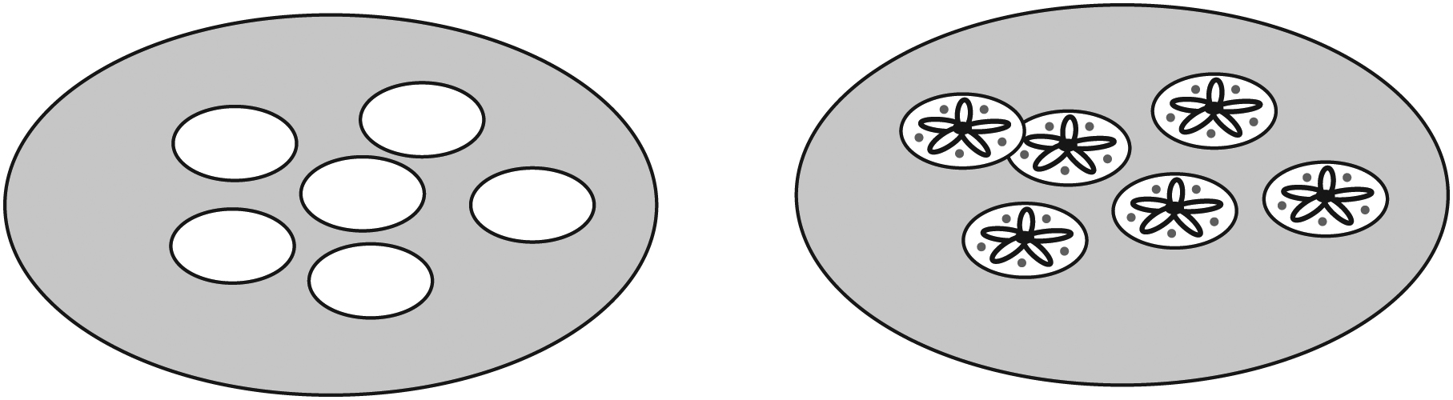
1 point

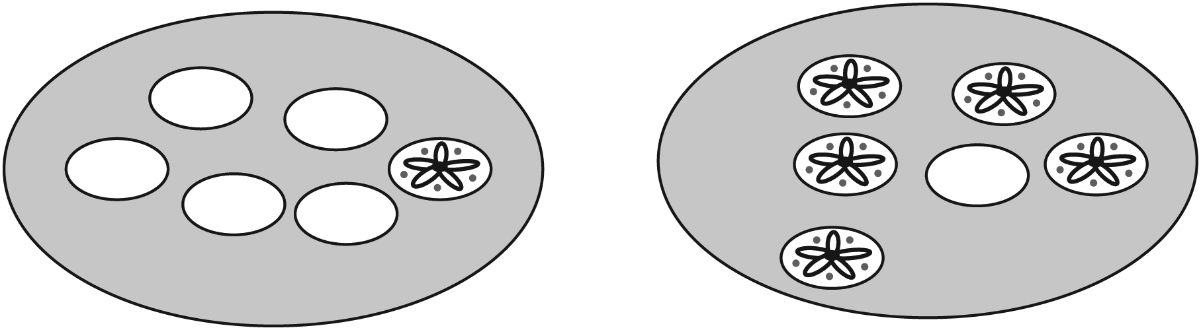
0 points

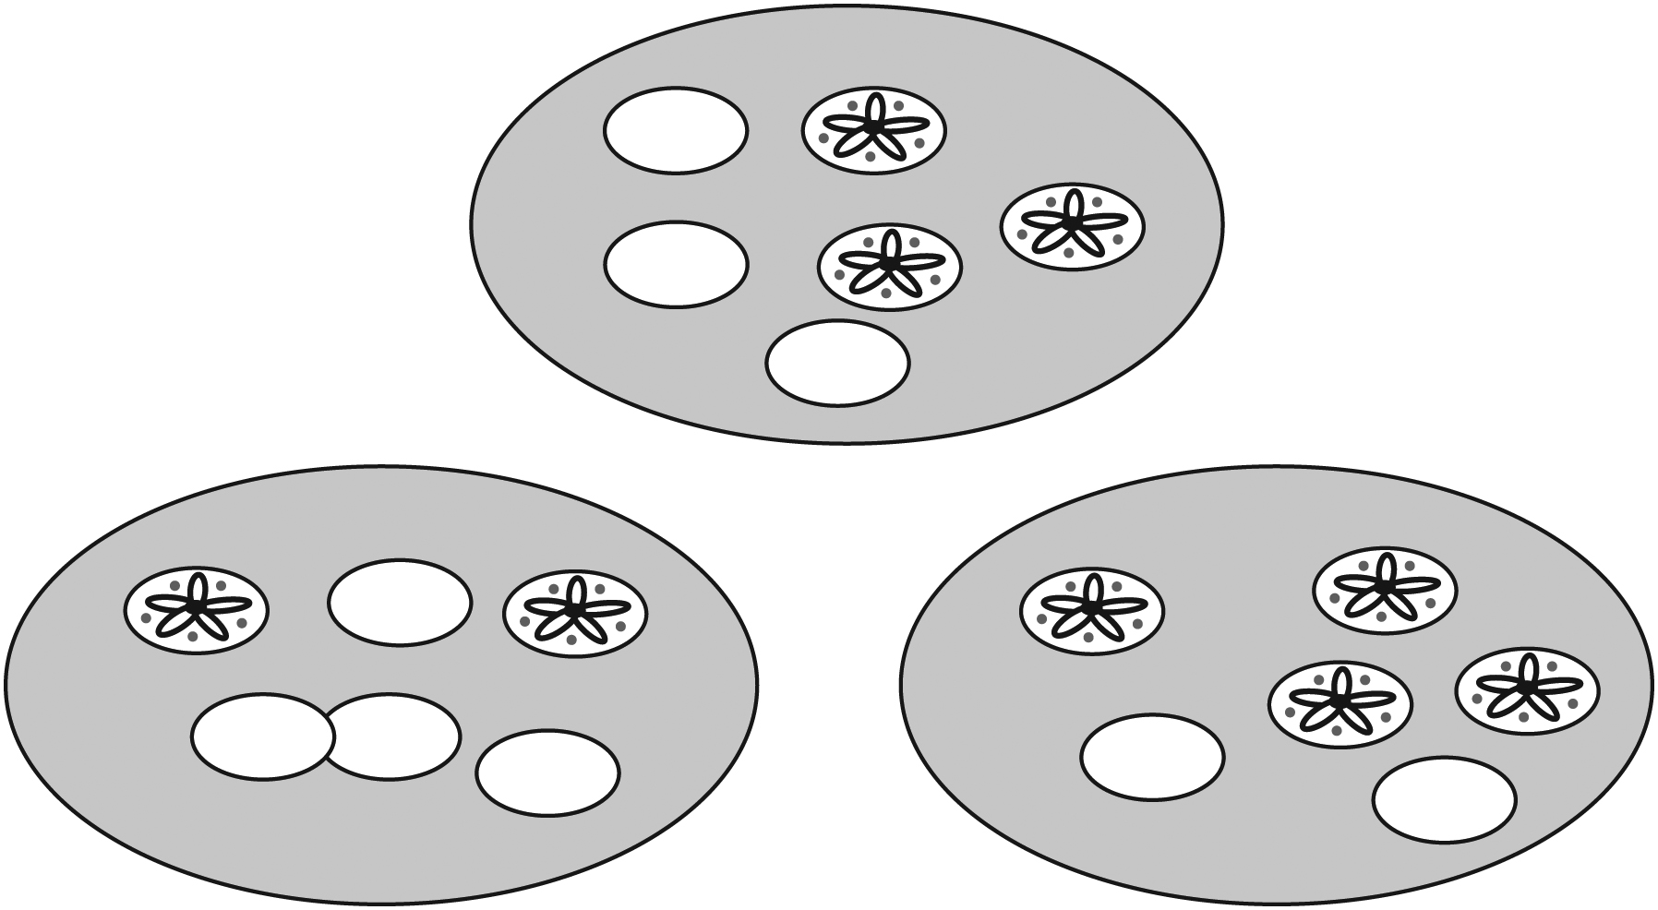

Waltes Results Line Master 4

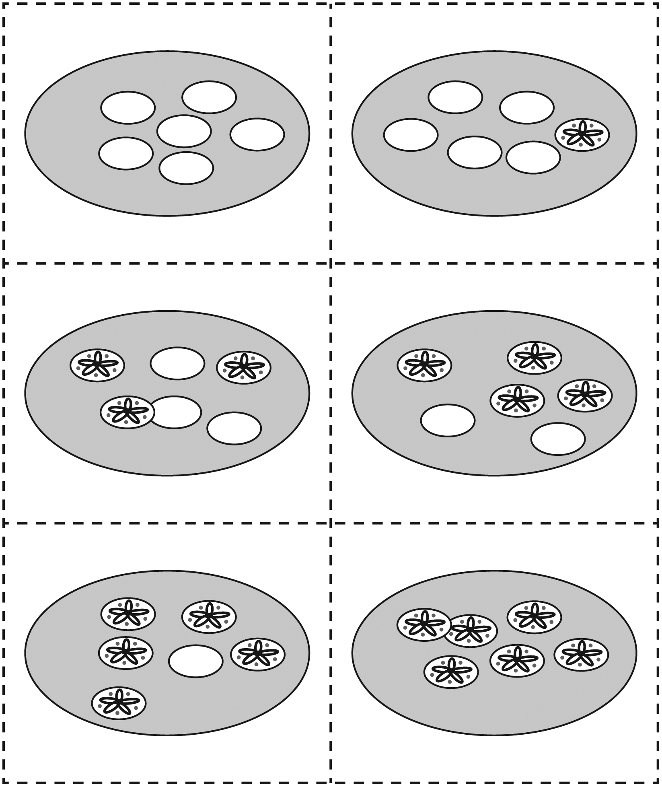

How Can 4 Land? Line Master 5-1
Name: _____________________________
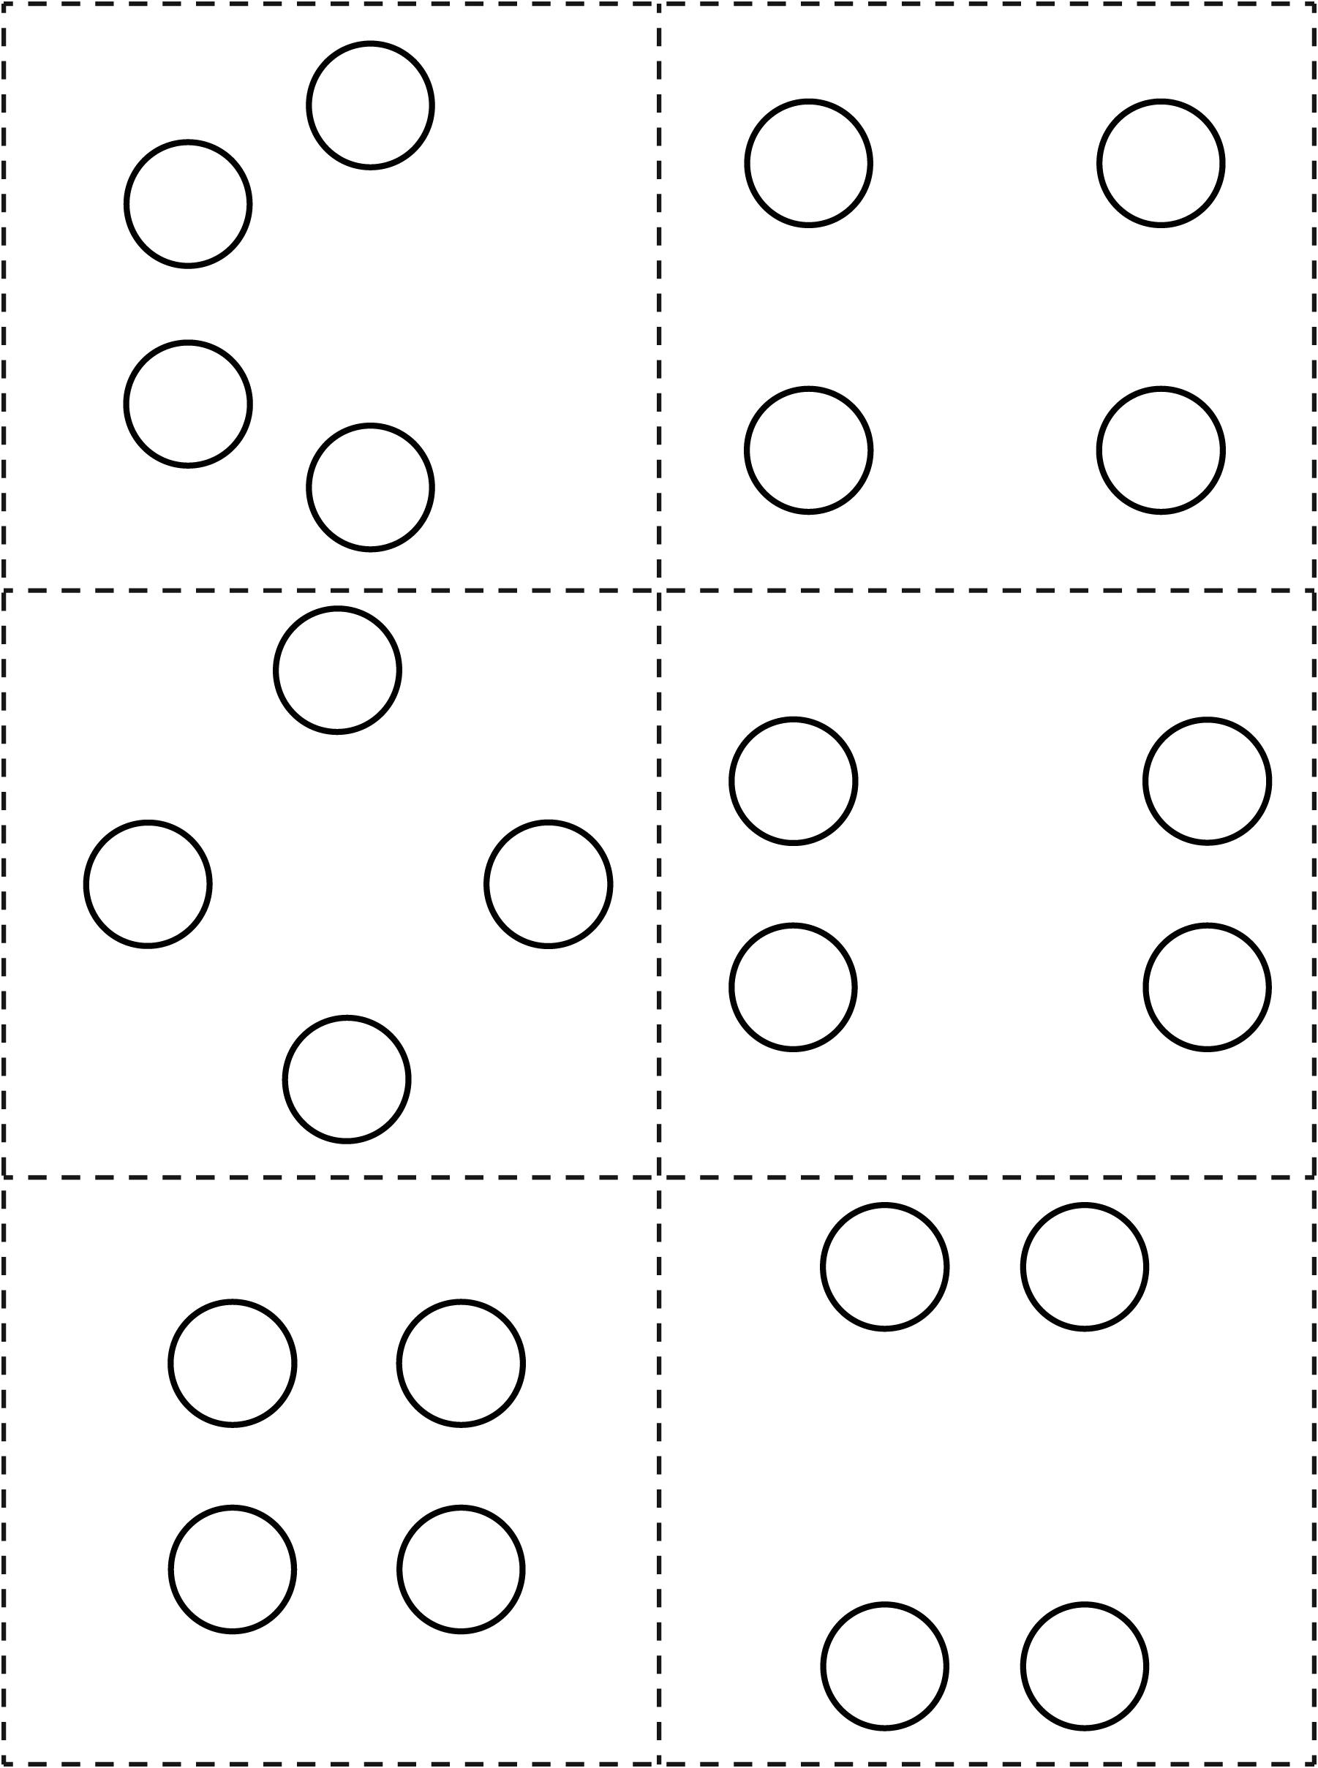

How Can 5 Land? Line Master 5-2
Name: _____________________________
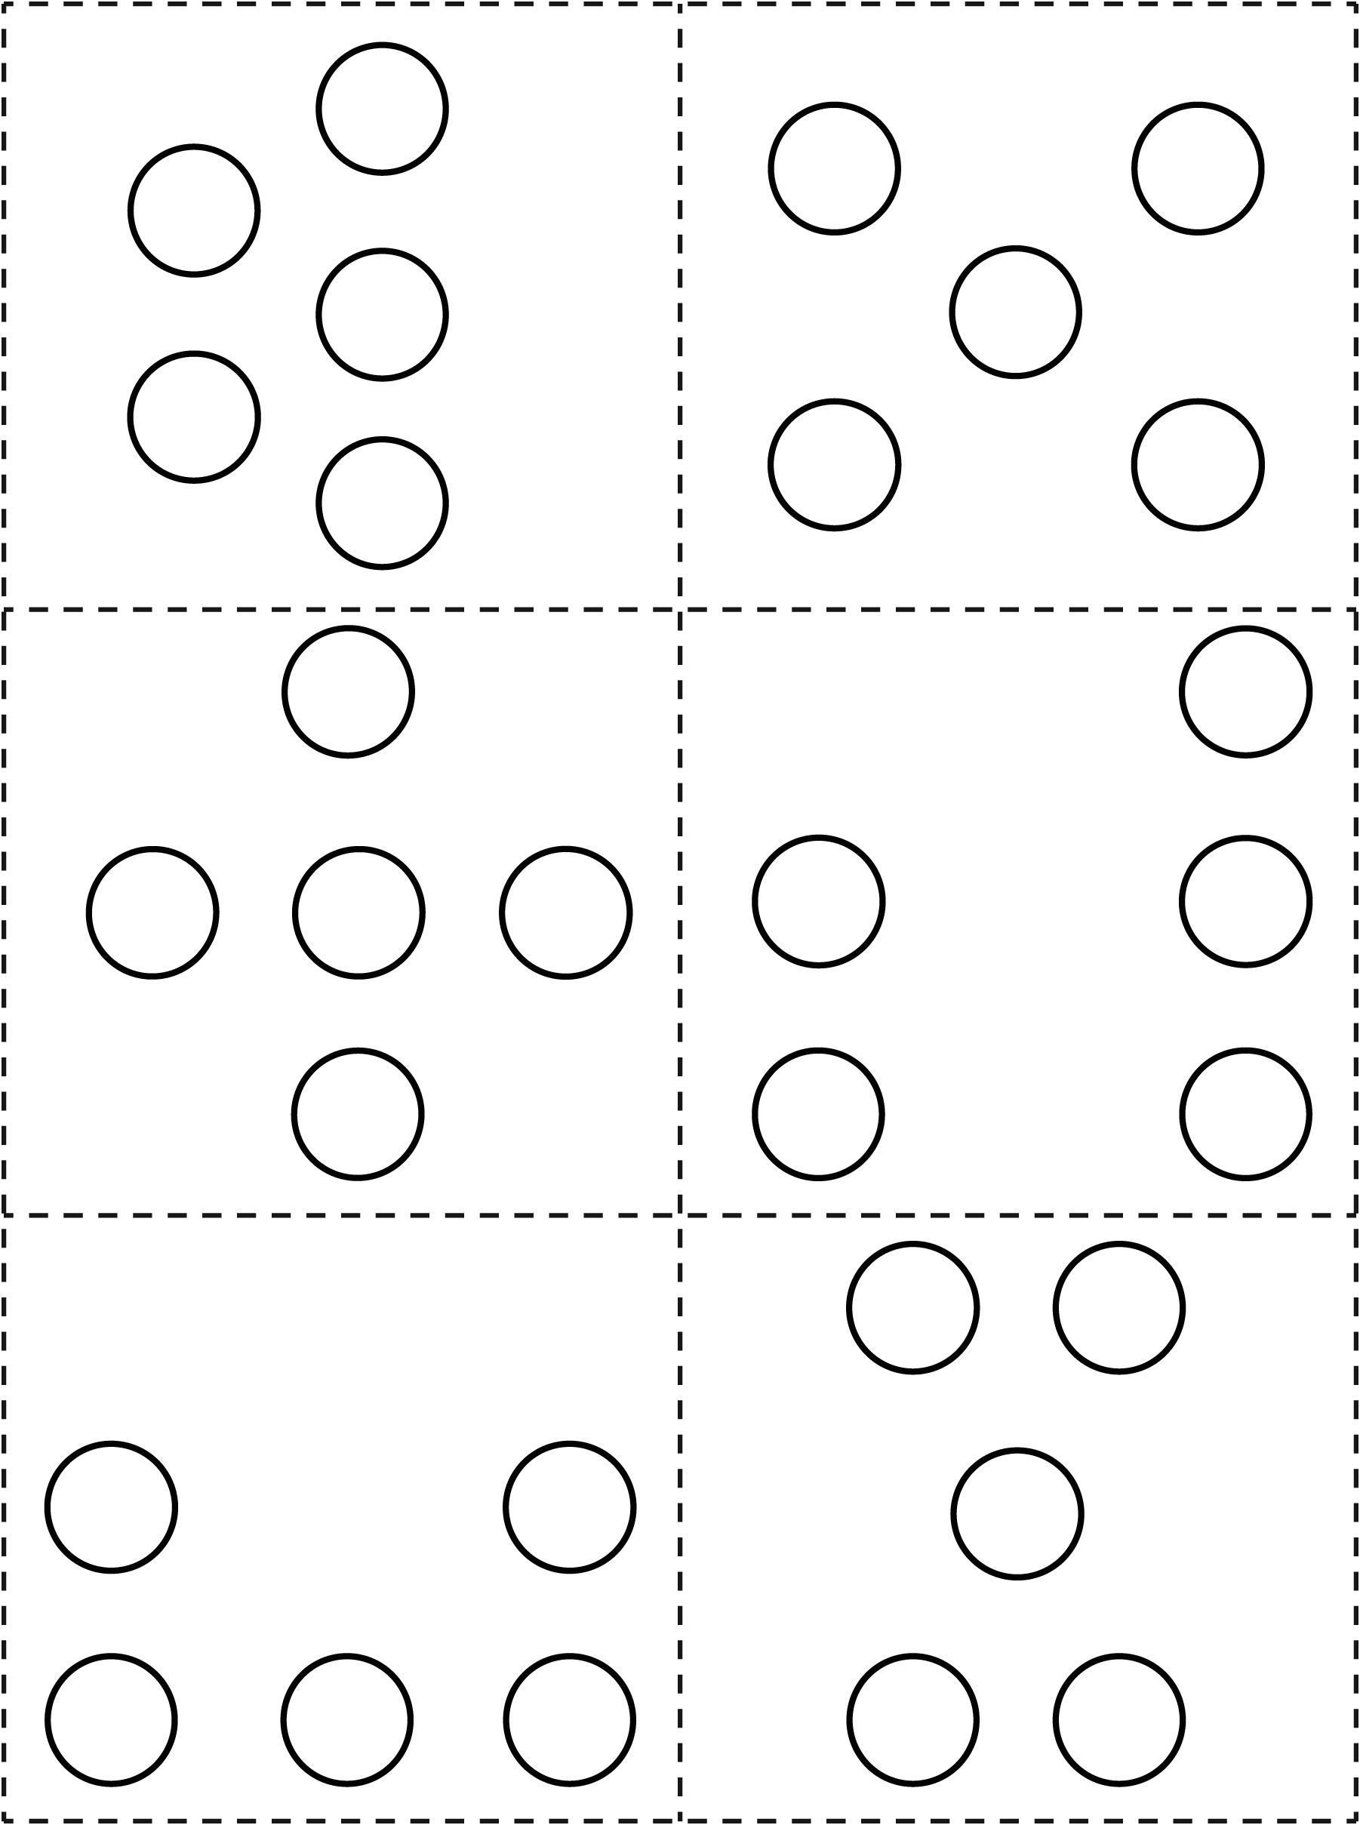

How Can 6 Land? Line Master 5-3
Name: _____________________________
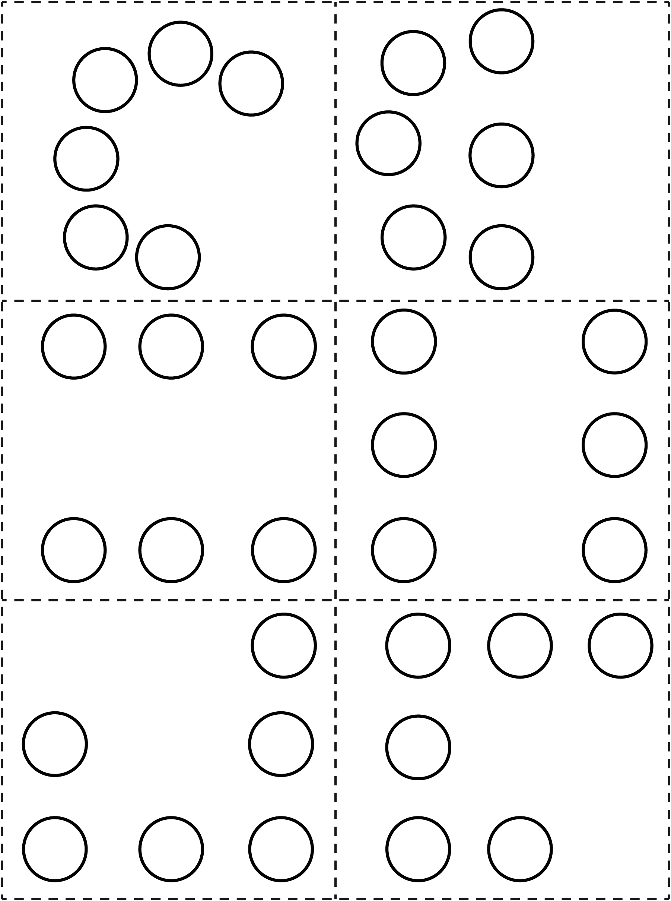

How Can 7 Land? Line Master 5-4
Name: _____________________________
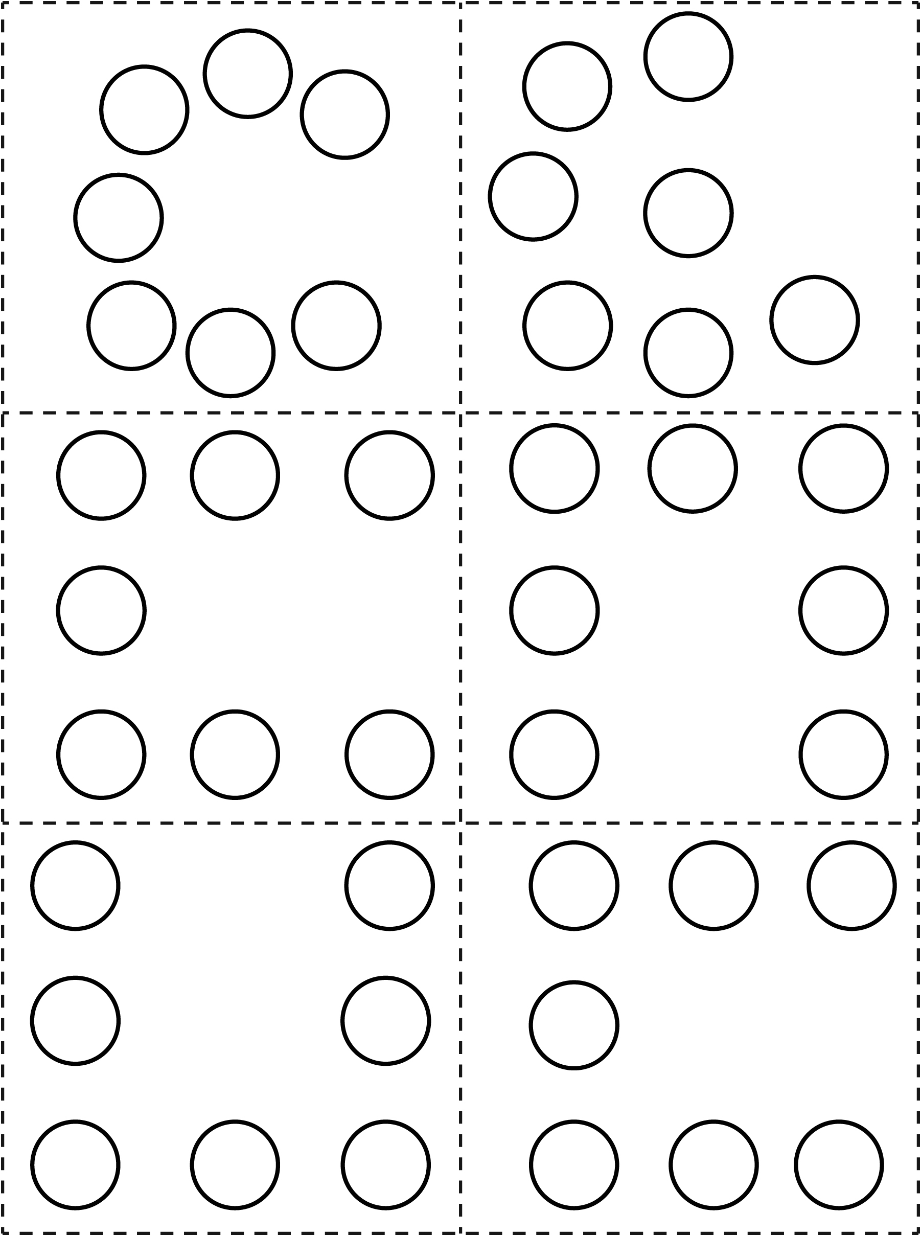

How Can 8 Land? Line Master 5-5
Name: _____________________________
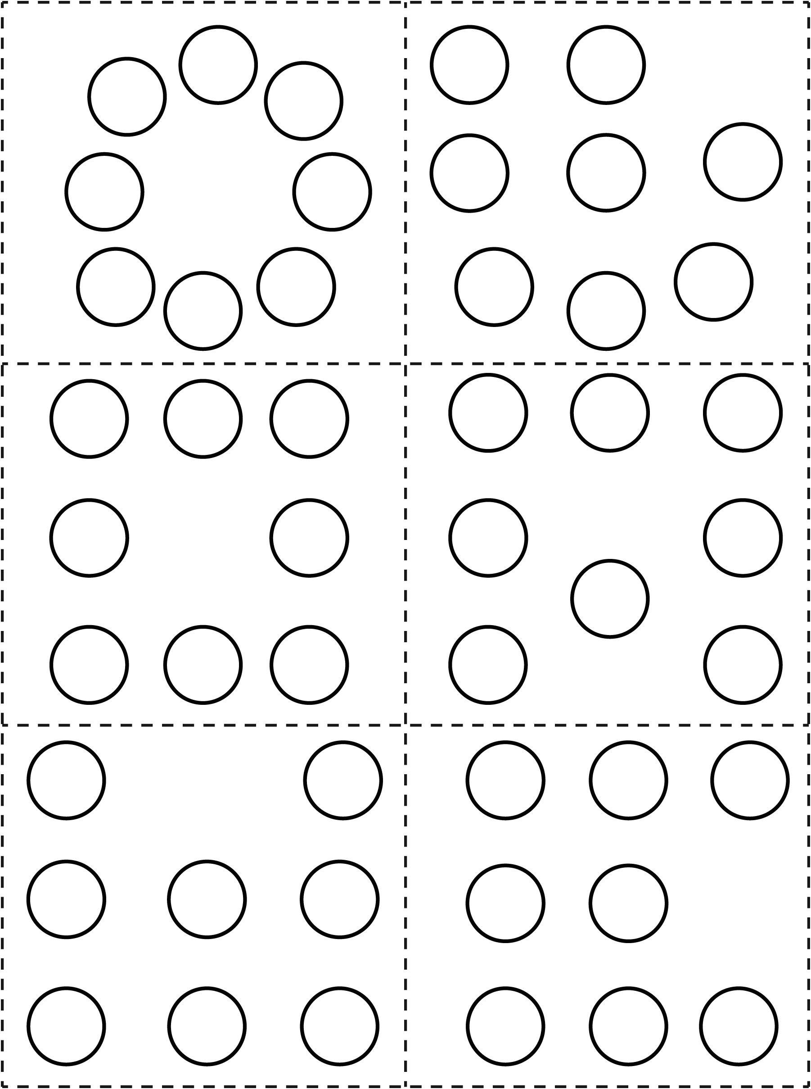

How Can 9 Land? Line Master 5-6
Name: _____________________________
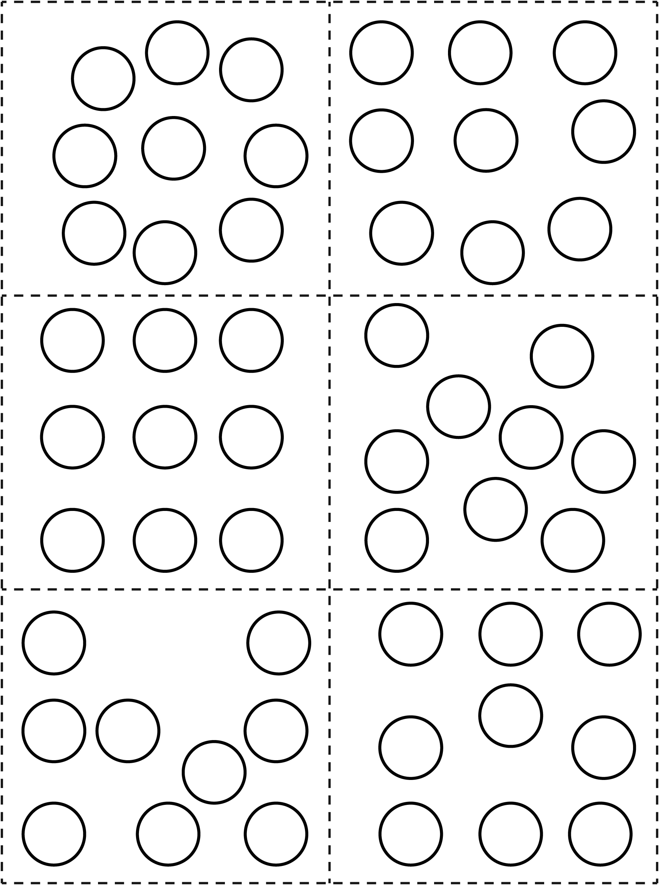

How Can 10 Land? Line Master 5-7
Name: _____________________________
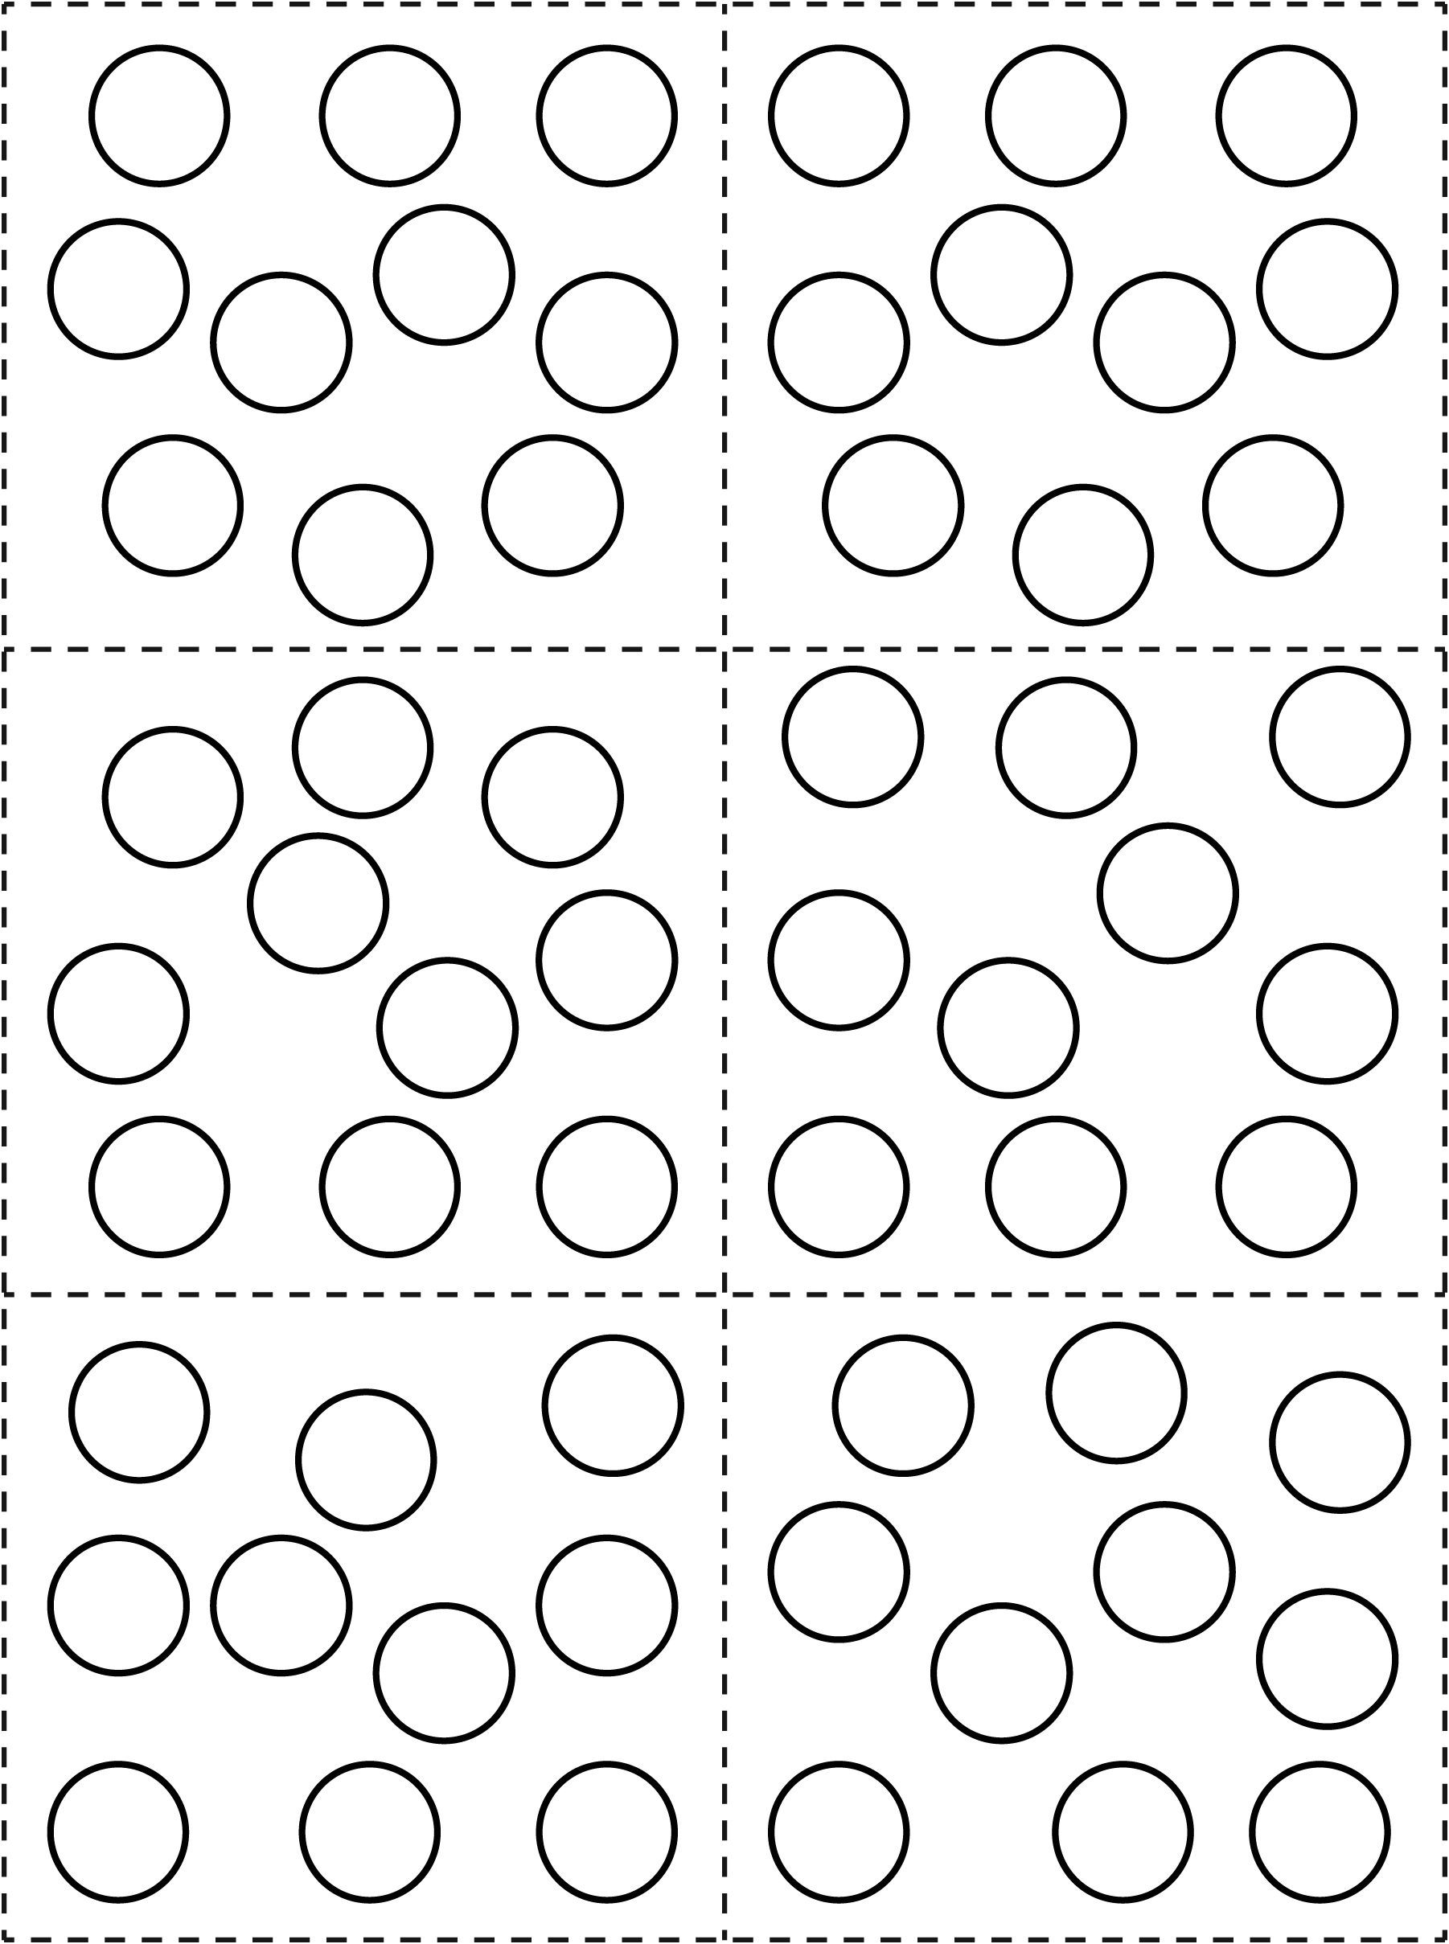

Quilt Star Line Master 6

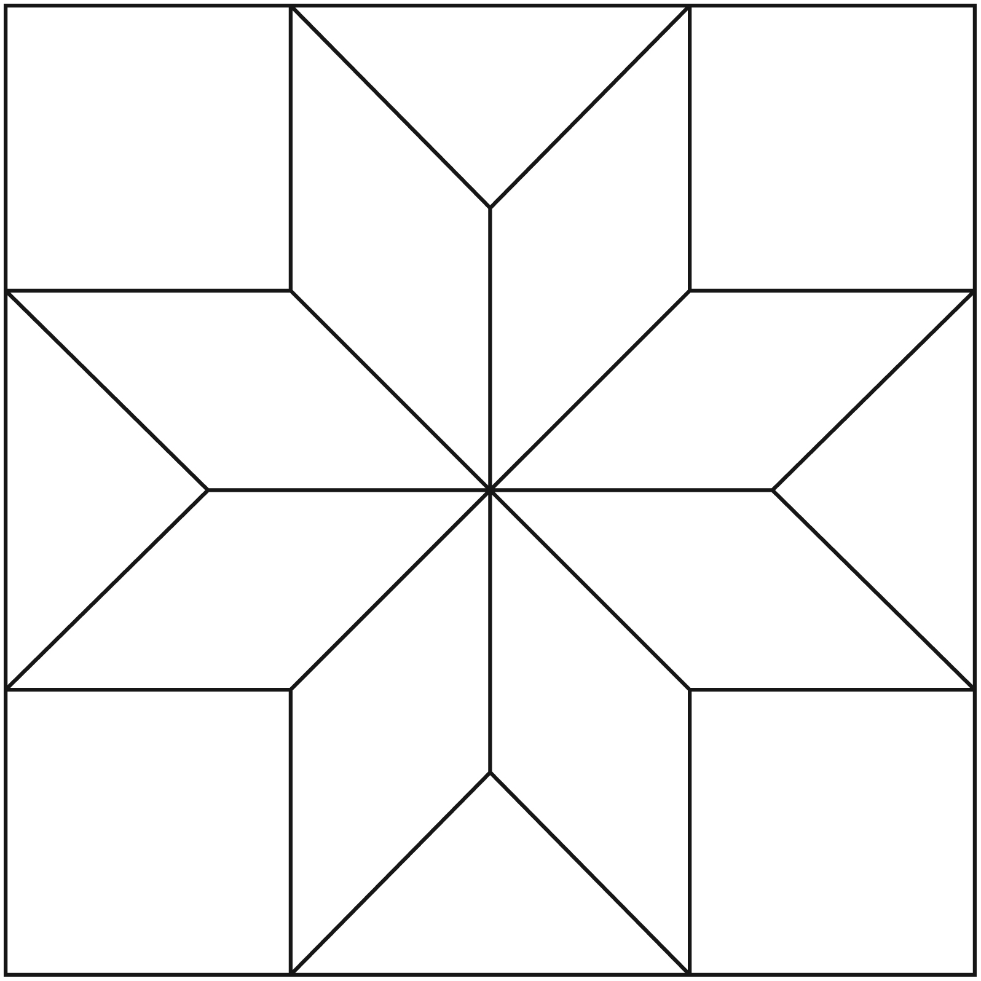

Dot Pattern Cards Line Master 7–1
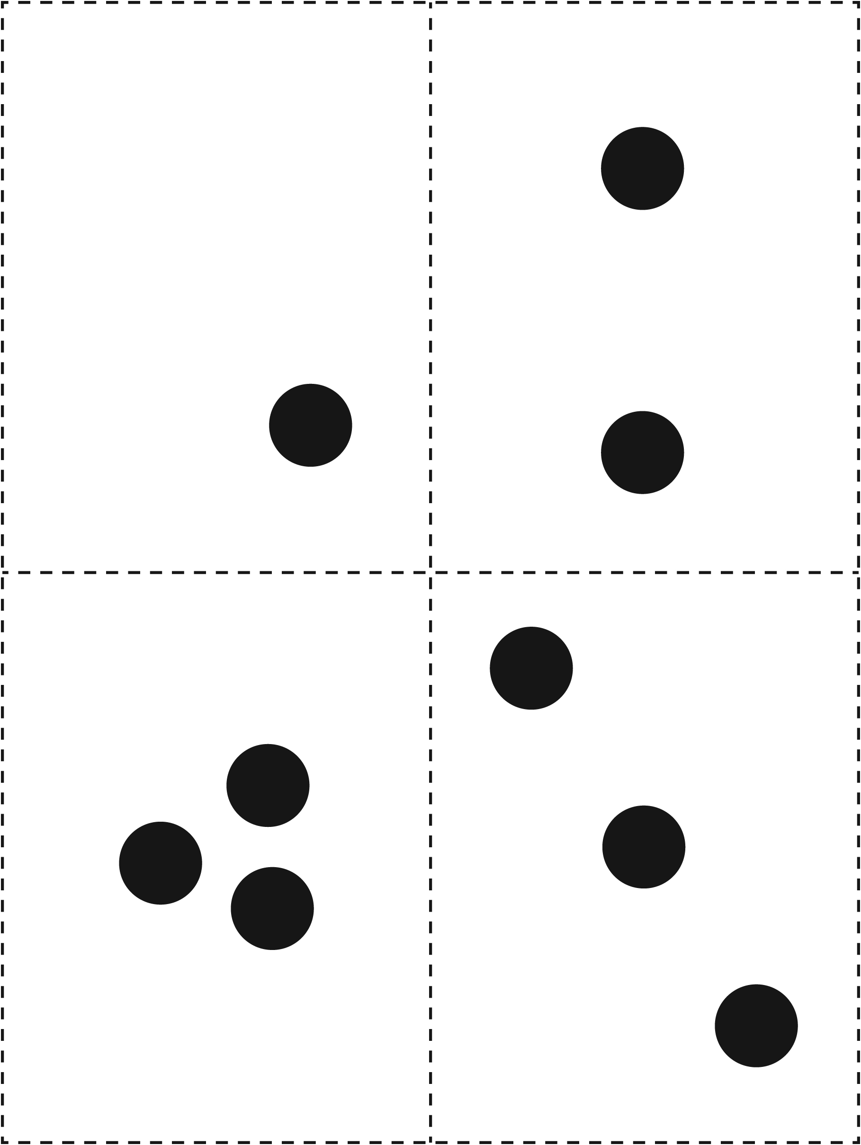

Dot Pattern Cards Line Master 7–2
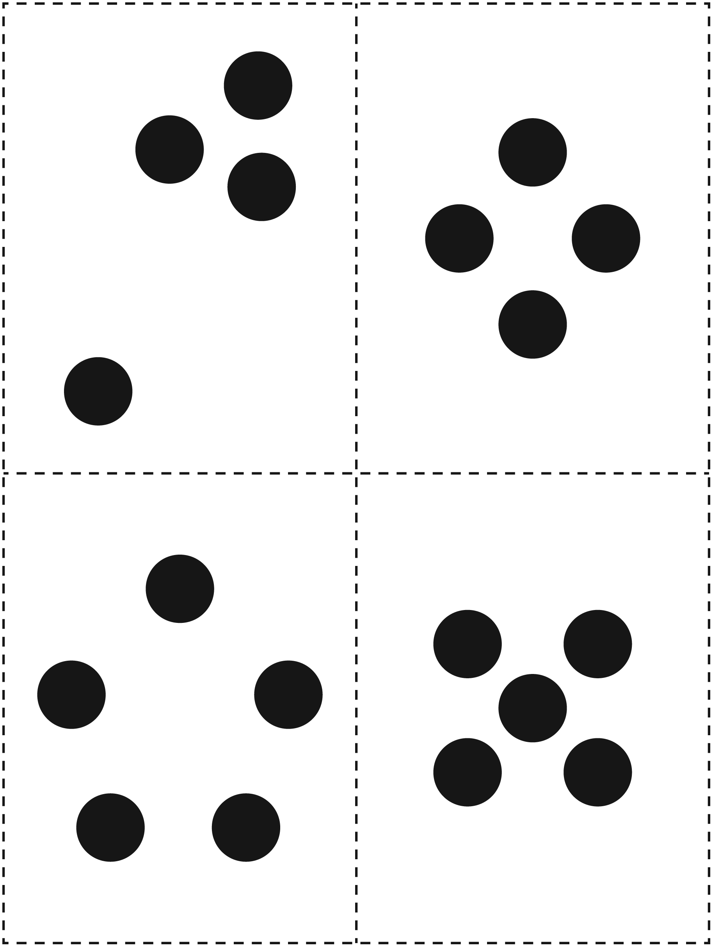

Dot Pattern Cards Line Master 7–3
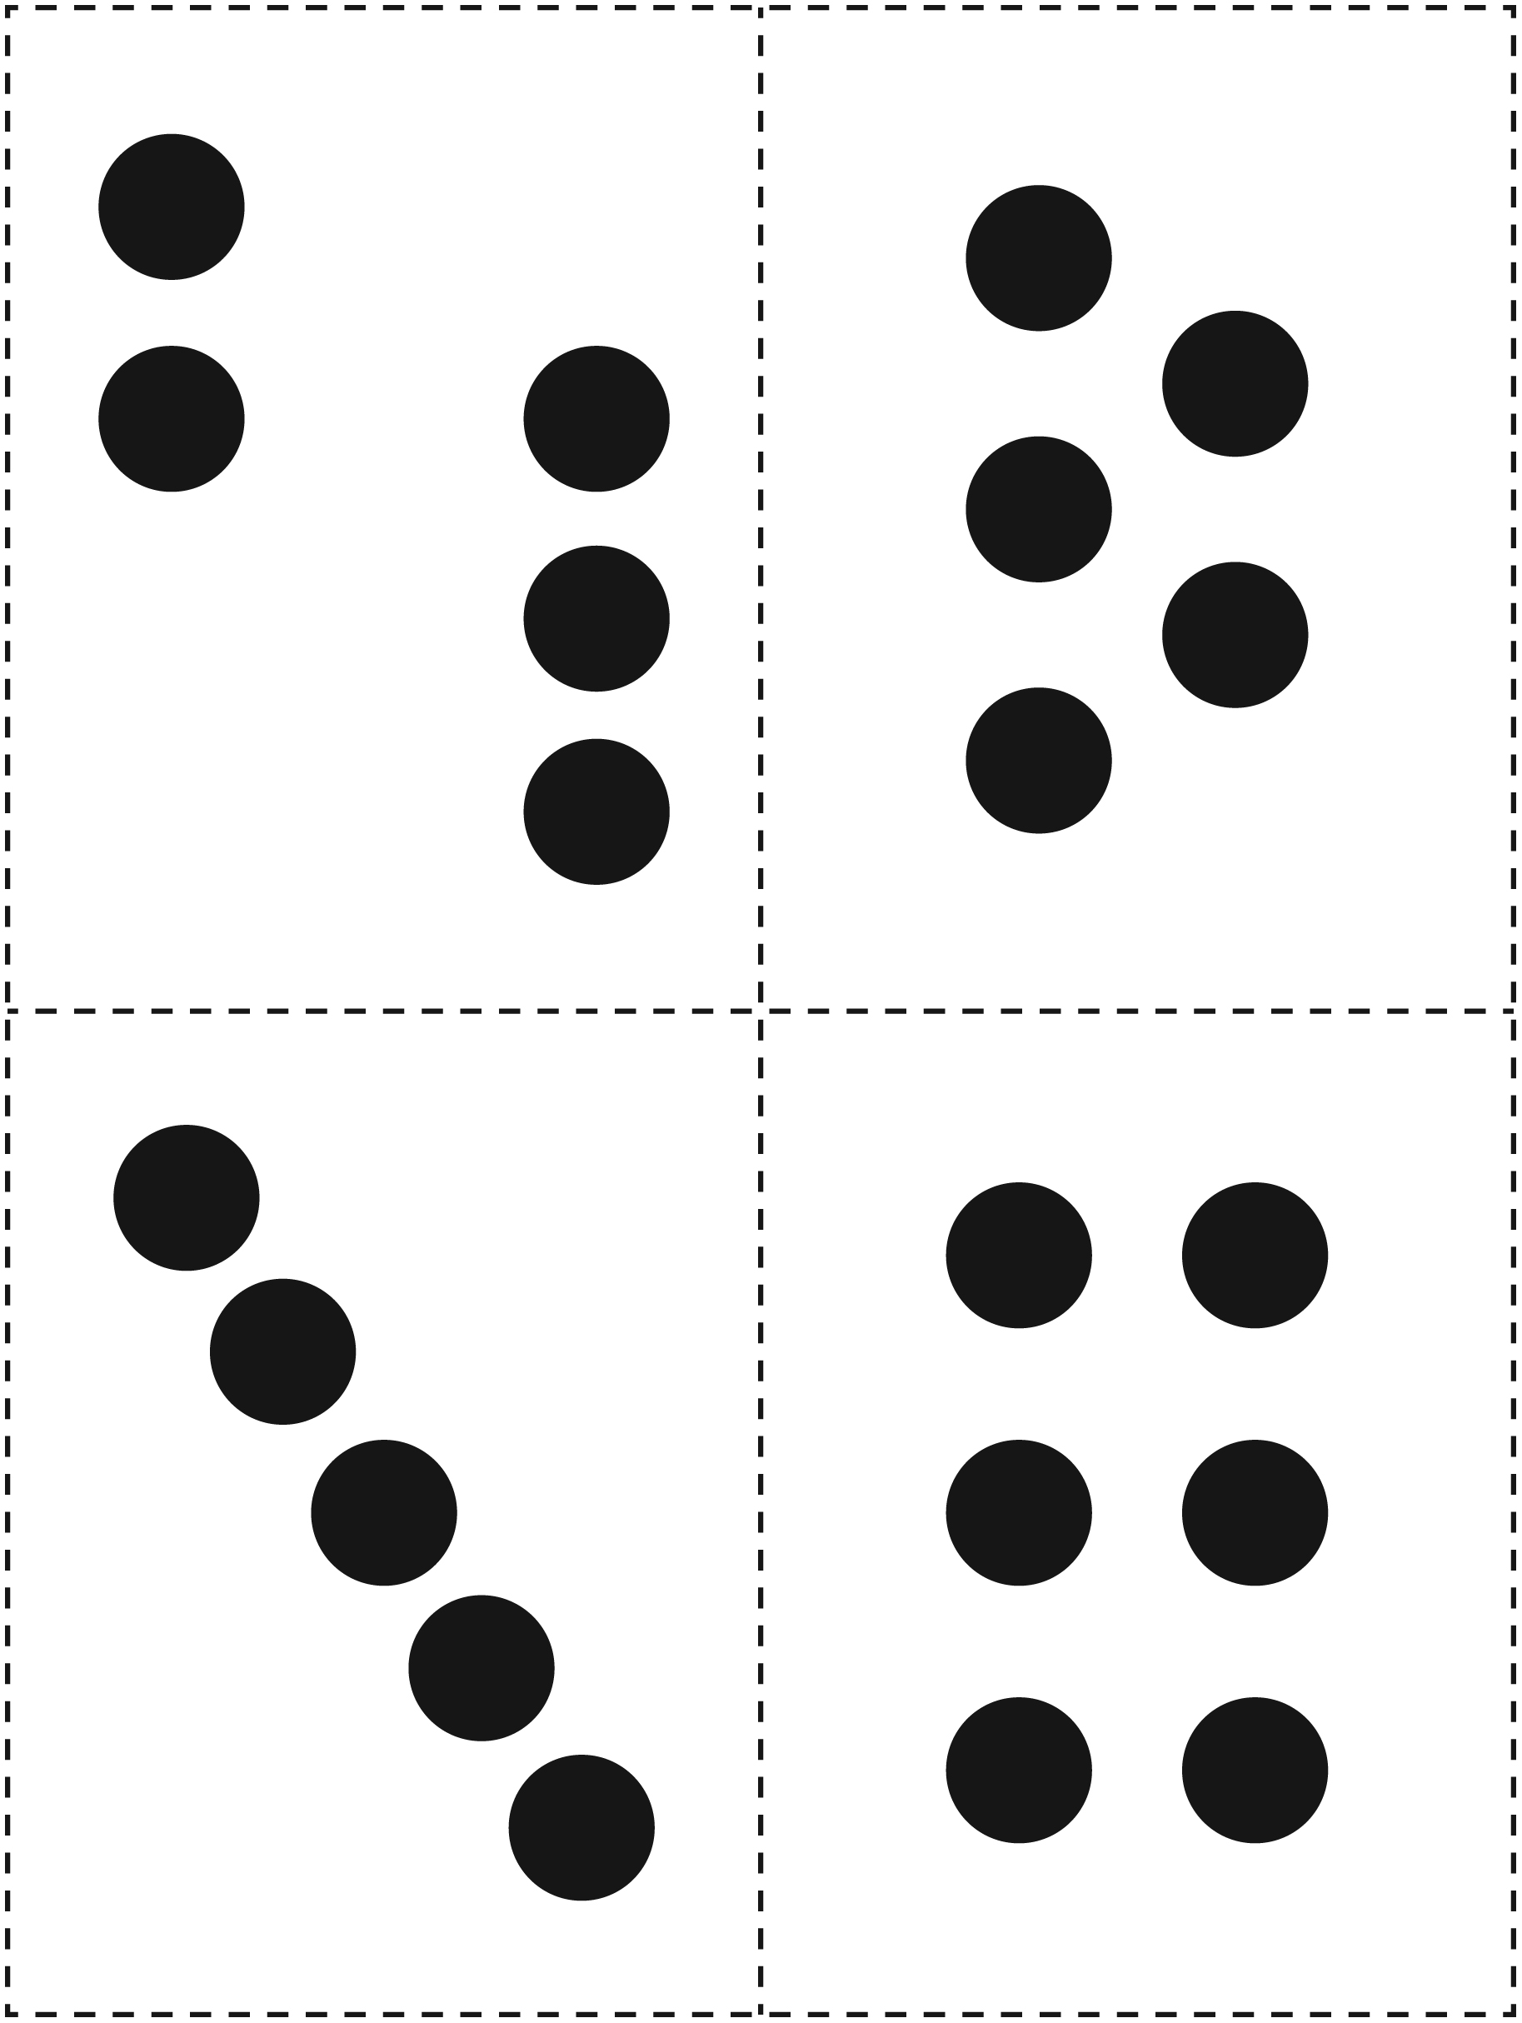

Dot Pattern Cards Line Master 7–4
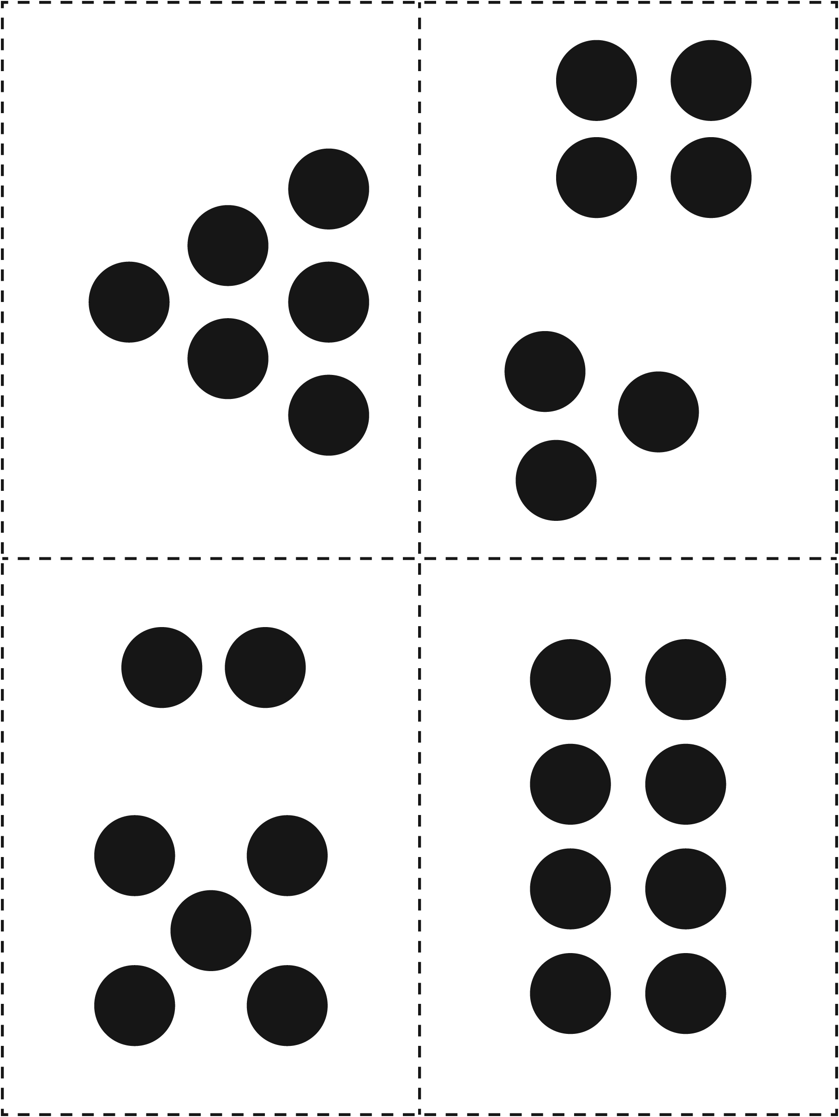

Best Score Recording Sheet Line Master 8

 – – – – – – – – – – – – – – – – – – – – – – – – – – – – – – – – – – – – – – – – – –

6 the same = 5 points
5 the same = 1 point

Player | Points

 – – – – – – – – – – – – – – – – – – – – – – – – – – – – – – – – – – – – – – – – – –

6 the same = 5 points
5 the same = 1 point

Player | Points

Making Dice Line Master 9
Name: _____________________________

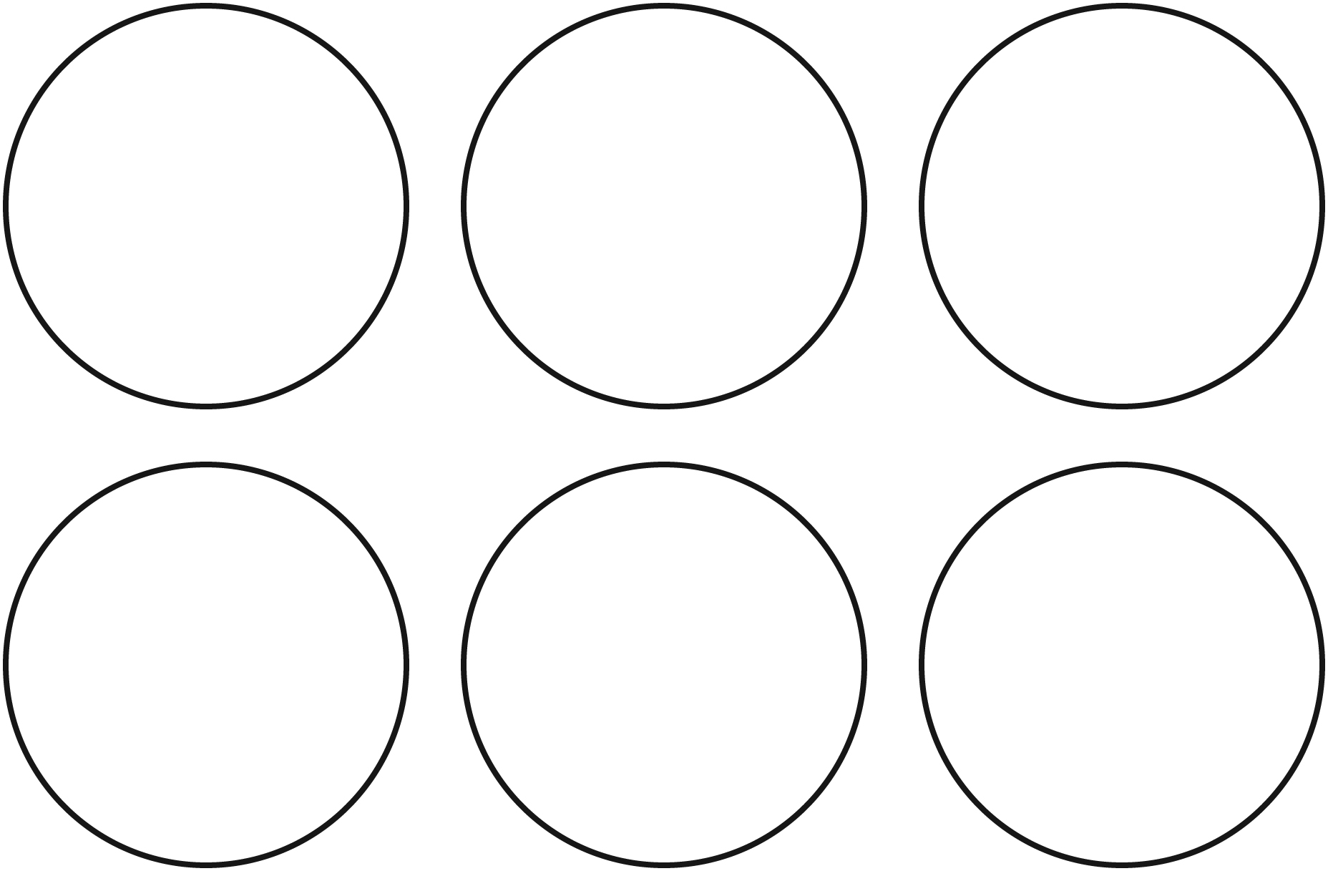

I chose these pictures because

_____________________________________________

_____________________________________________

_____________________________________________

Story Template Line Master 10
Playing Waltes  by  _____________________ | 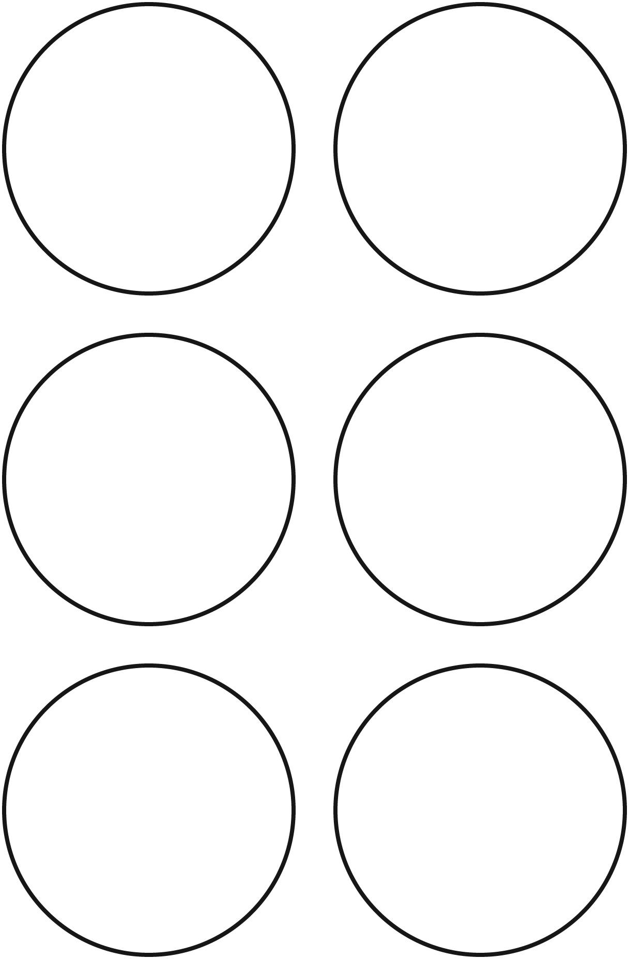  I get _____ points.
I get _____ points. | I get _____ points.

Secret Dice Line Master 11
Name: _____________________________

?    5 points | ?  1 point | ?    0 points
?    1 point | ?    1 point | ?  1 point
?  0 points | ?  0 points | ?  5 points

