Spot Check! Line Master 1 (Assessment Master)
Name: _____________________________

Compare Quantities to 10 | Not observed | Sometimes | Consistently
Compares quantities to identify more/less/the same
Creates a set that has more, less, or as many as a given number
Counts Sets to 10
Says counting numbers in correct sequence (stable order)
Says one number for each object counted (one-to-one correspondence)
Knows that the last counting word tells how many are in the set (cardinality)
Creates sets (to 10)
Knows that rearranging the objects in a set does not change the quantity (conservation of number)
Identifies number without counting each object (subitize)
Strengths:

Next Steps:

Connecting Home and School Line Master 2–1



NOTE TO THE TEACHER

You may wish to send families a Spot Check! letter outlining a familiar activity or two they can do at home with their children.

Create a letter using this template and select one or two activities from the suggestions on the next page. Simply delete these instructions and cut and paste the activities you have selected, adapting them to fit your needs.

Connecting Home and School Line Master 2–2

Dear Family:

We have been working on Spot Check!, which focuses on Comparing Quantities to 10 and Counting Sets to 10. Try this activity at home with your child.

 – – – – – – – – – – – – – – – – – – – – – – – – – – – – – – – – – – – – – – – – – –

Reading the Story: As you read the story, enjoy predicting the number of spots, counting to check, and guessing what you will see on the next page. Count the animals together. After you read, you might gather 10 small round objects and use the mat on the inside back cover of the book to re-create different sets of spots. You might prompt using questions such as: Do you think there are 5 spots? How many are there?

 – – – – – – – – – – – – – – – – – – – – – – – – – – – – – – – – – – – – – – – – – –

Flash and Count: Use the mat on the inside back cover as a game board along with 10 small objects in 2 colours. Ask your child to secretly arrange a set of counters on the mat and place a paper towel or tissue over it so it is concealed from your sight. When ready, your child uncovers the set for 2 to 3 seconds and conceals it again. Your job is to guess how many and describe how you saw it! Uncover and count to check. Take turns and have fun!

 – – – – – – – – – – – – – – – – – – – – – – – – – – – – – – – – – – – – – – – – – –

Tile Shapes: Select a number between 2 and 10. Each of you makes a design or shape using that number of tiles or paper squares. Take turns using numbers to describe your creation.

--------------------------------------------------------------------------------------------------------

Sincerely,

___________________________

Numeral Cards Line Master 3

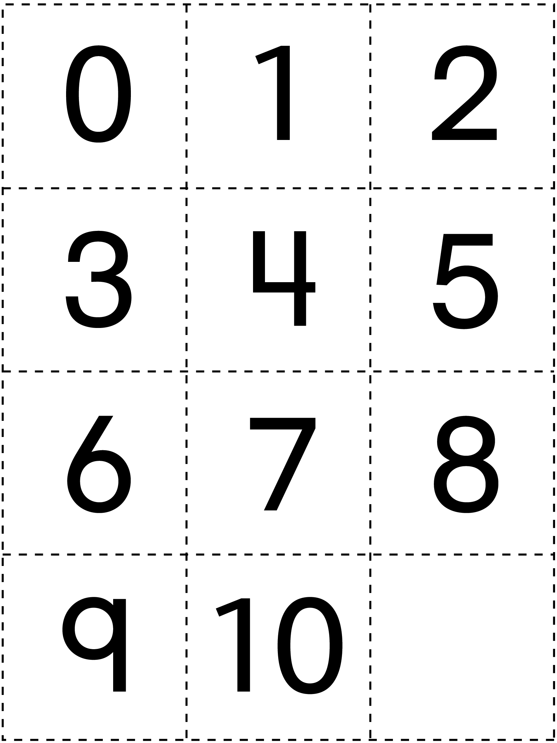

Grid Paper Line Master 4

Spot Cards Line Master 5–1

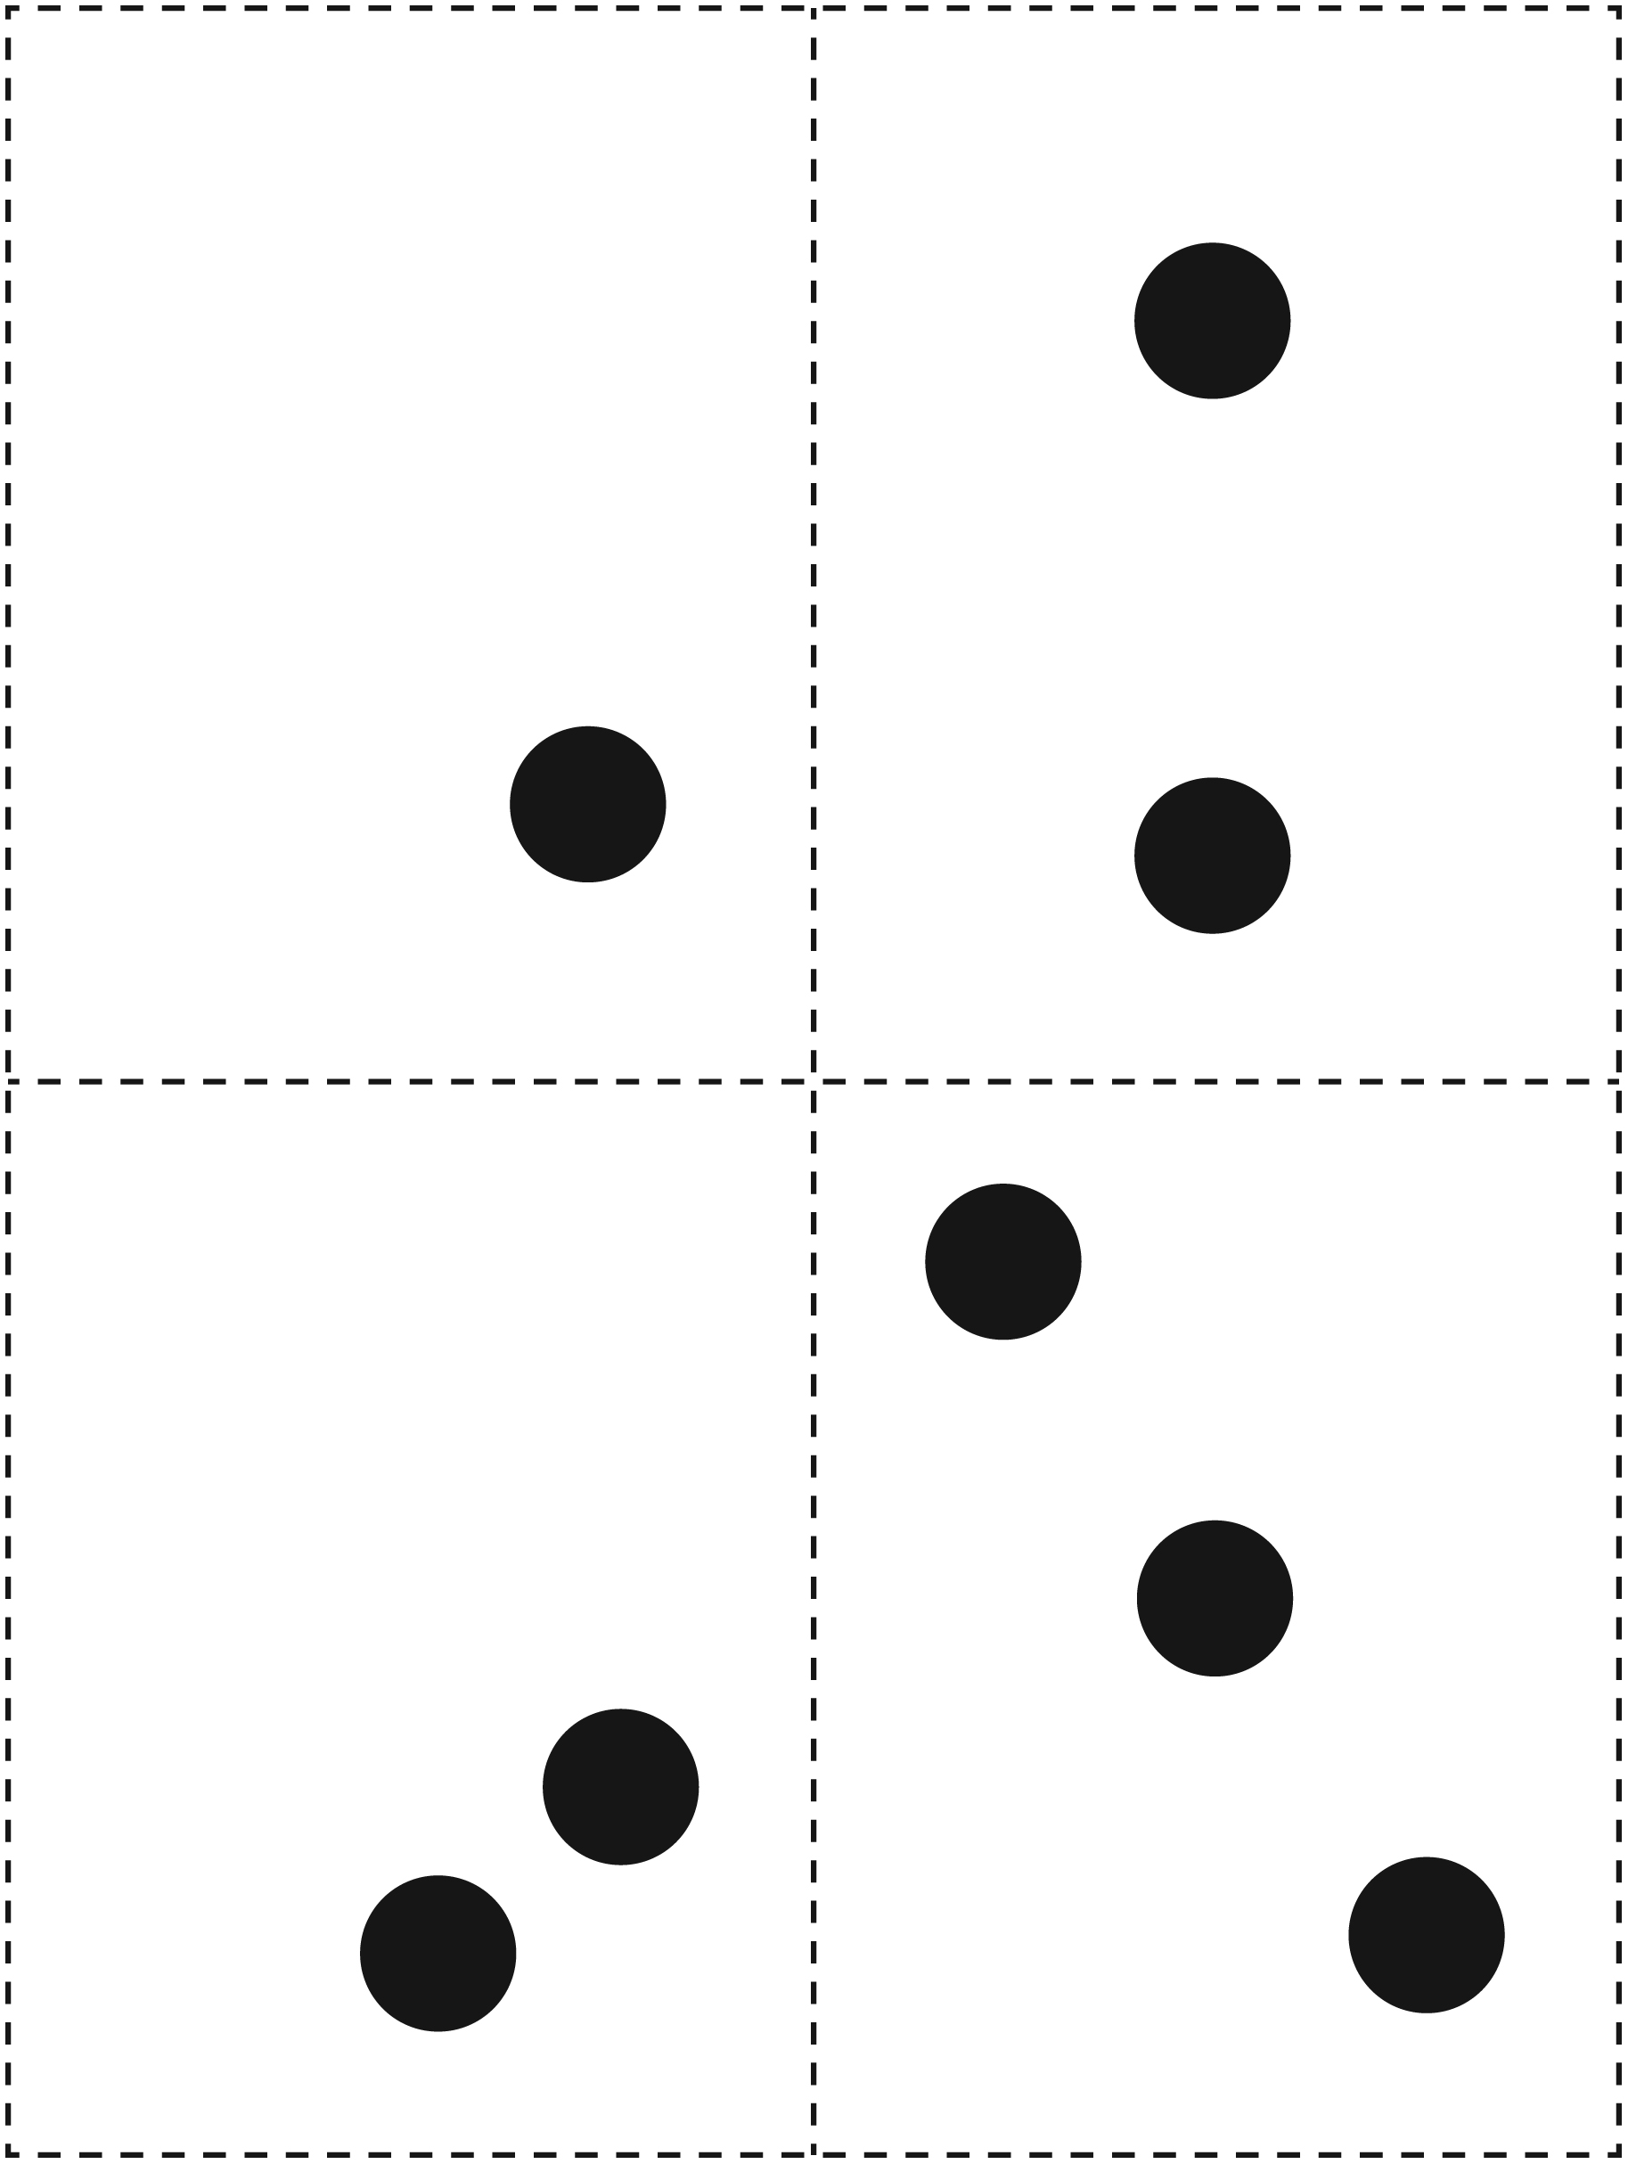

Spot Cards Line Master 5–2

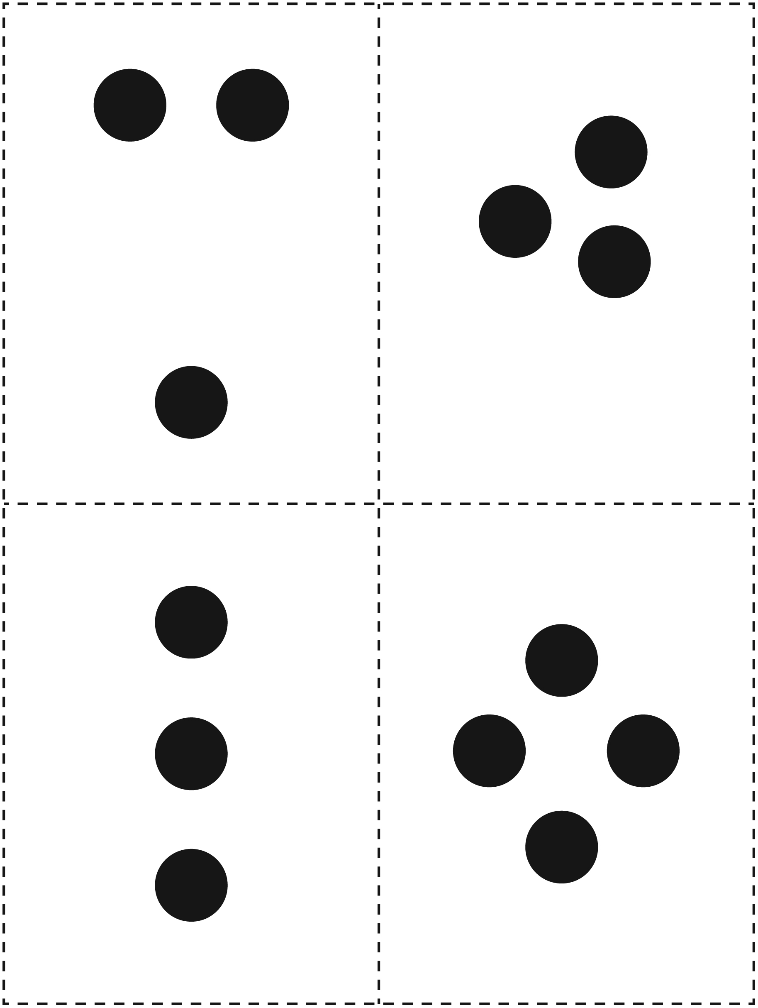
Spot Cards Line Master 5–3

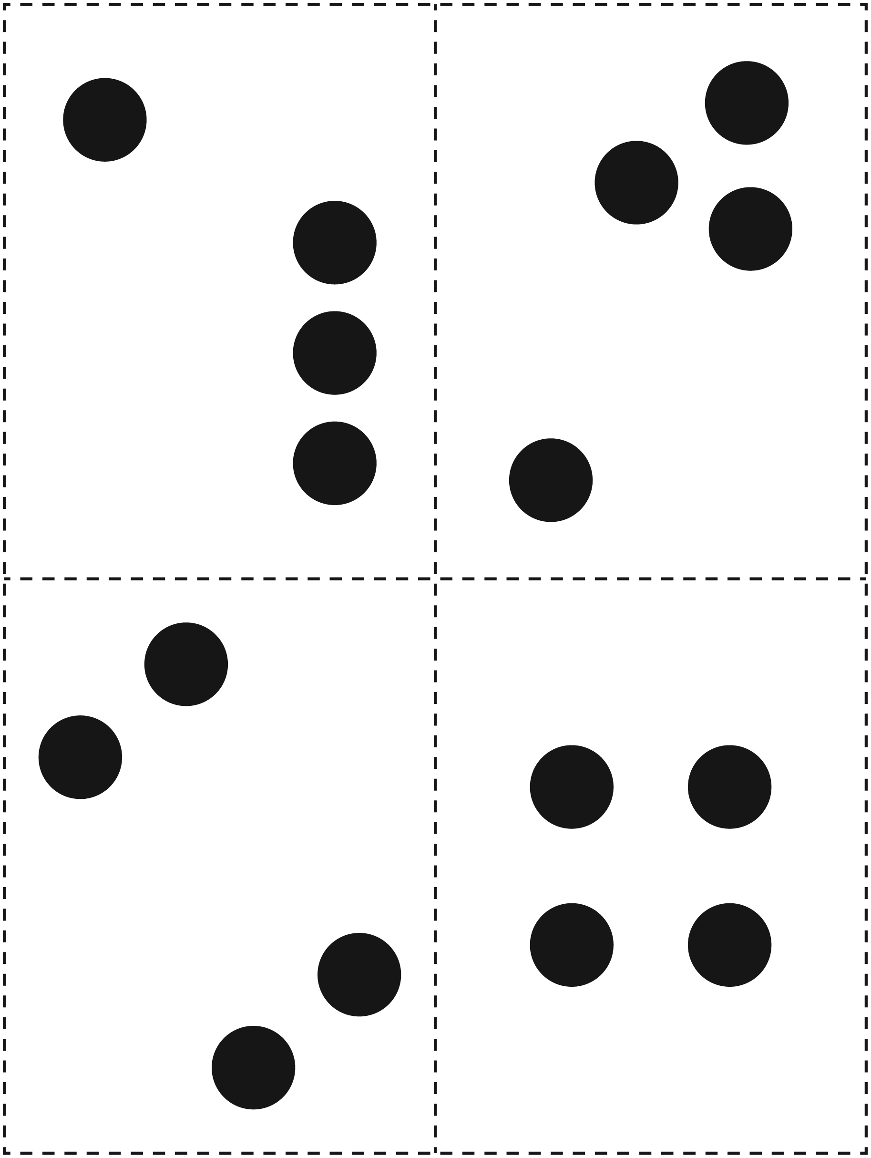
Spot Cards Line Master 5–4

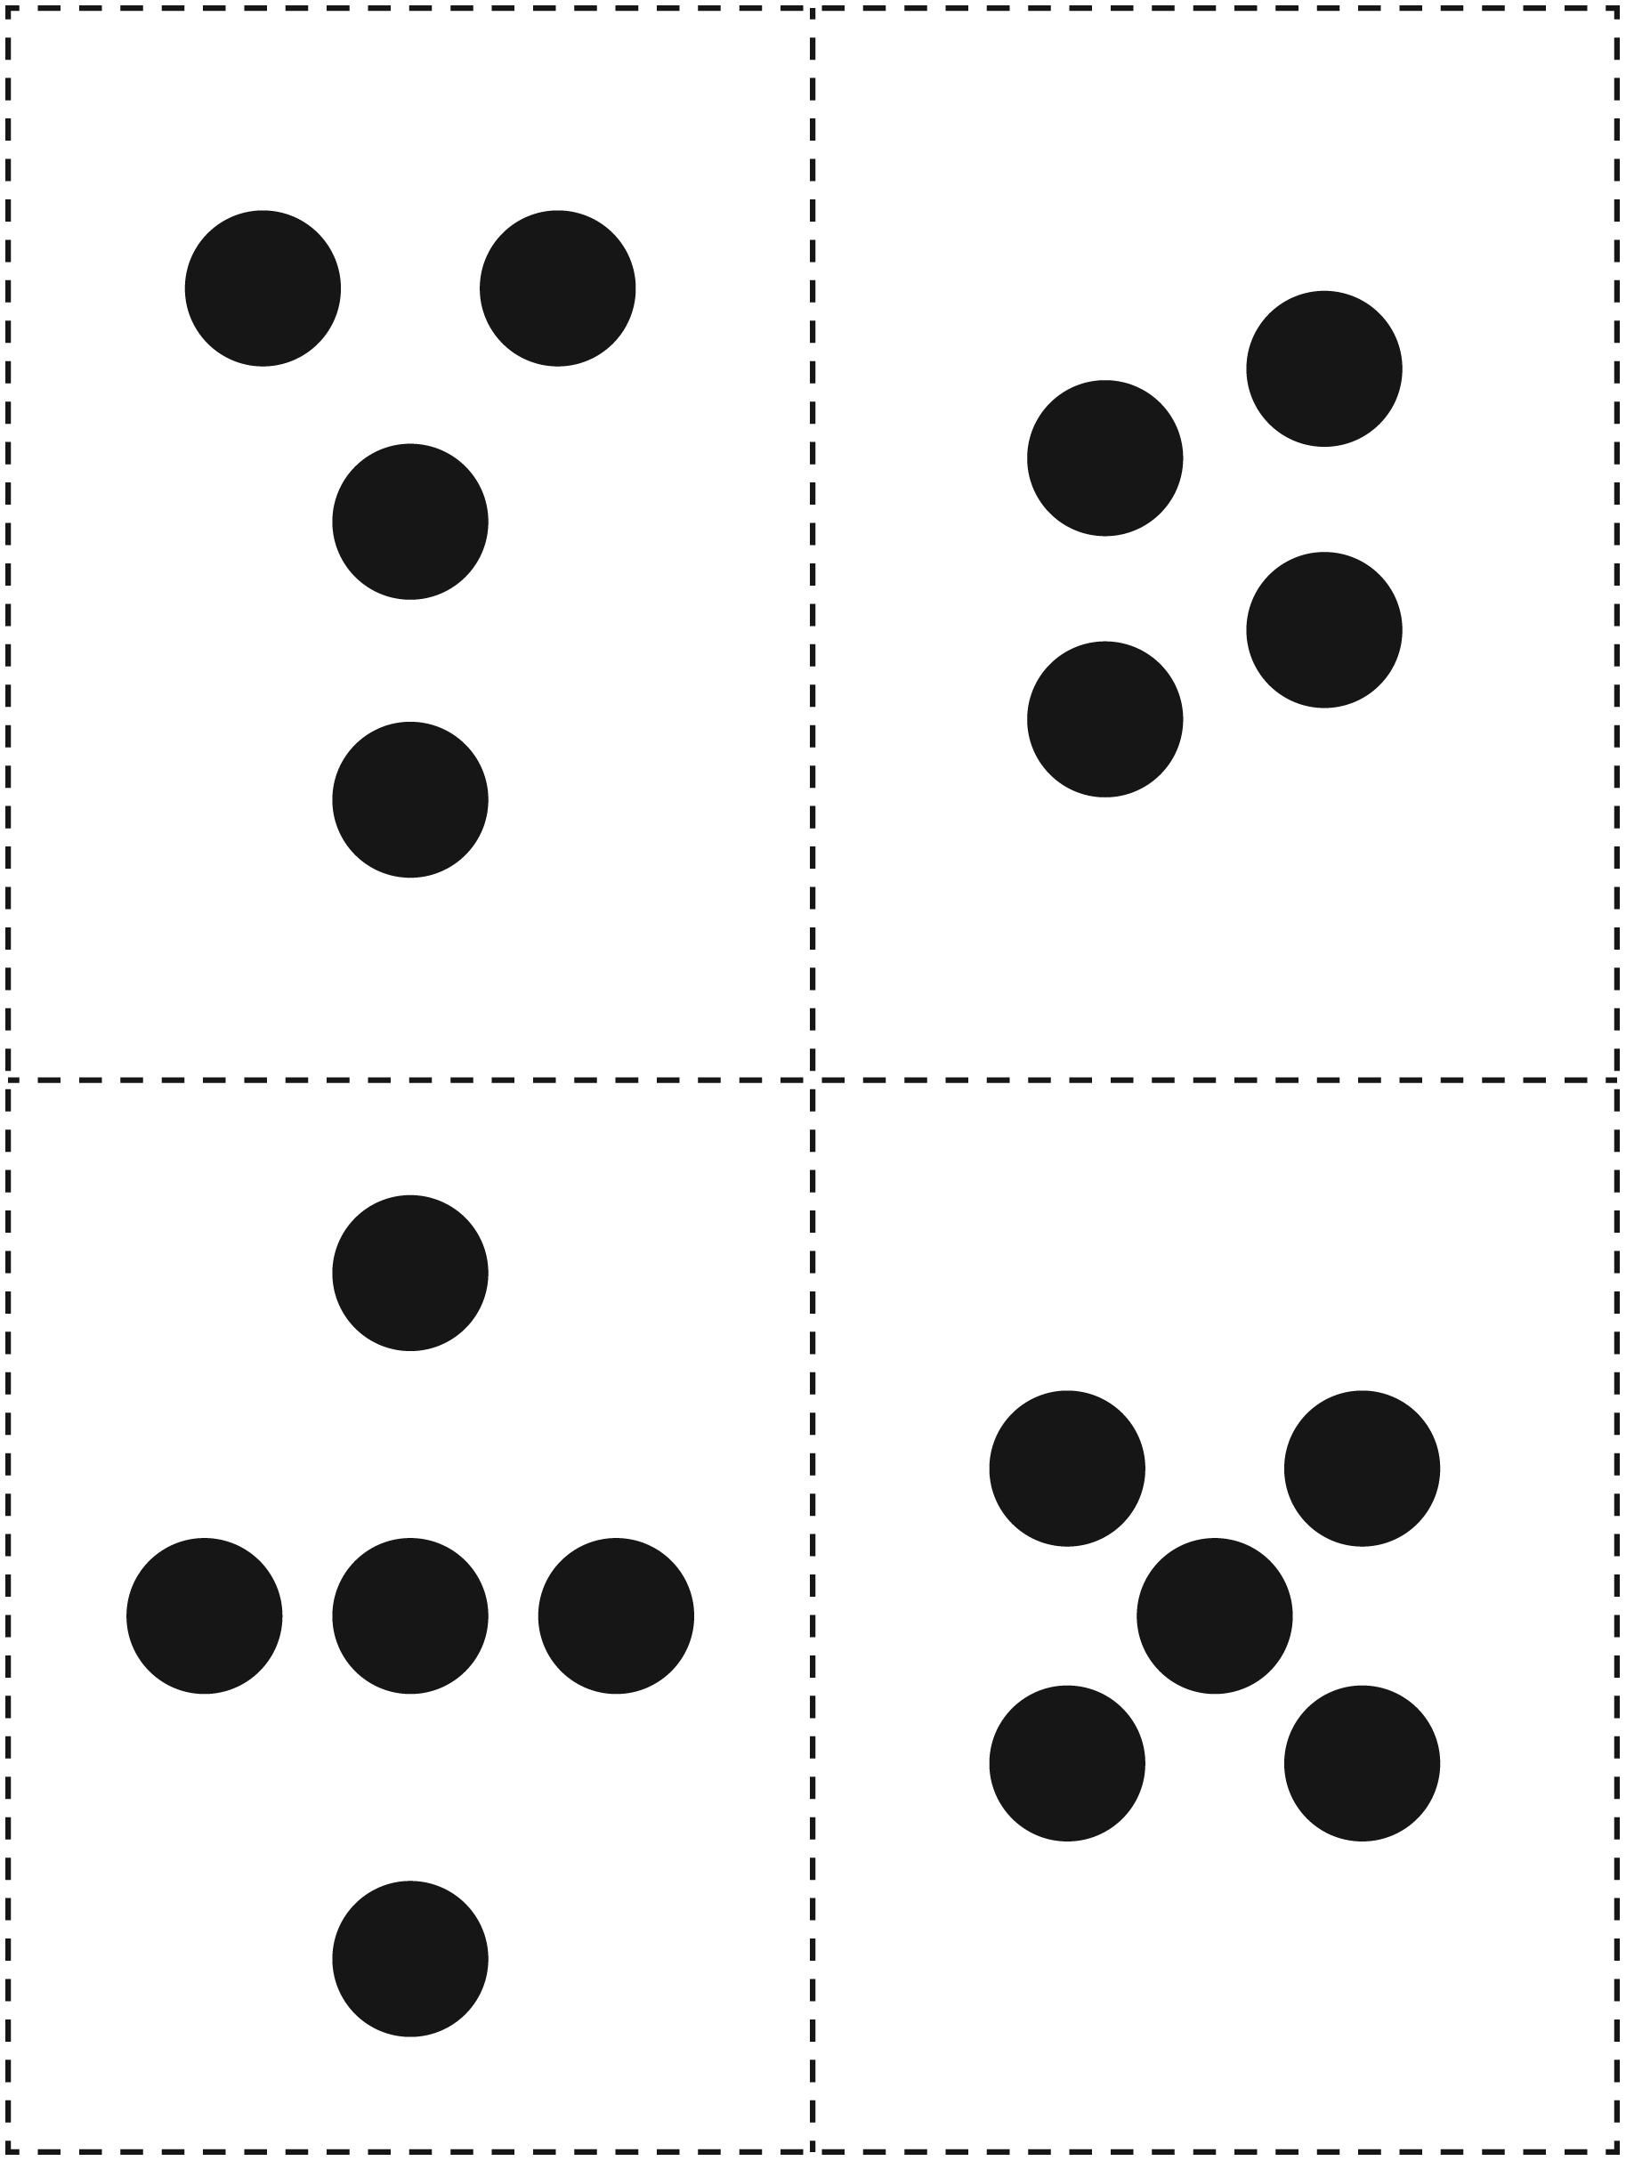
Spot Cards Line Master 5–5

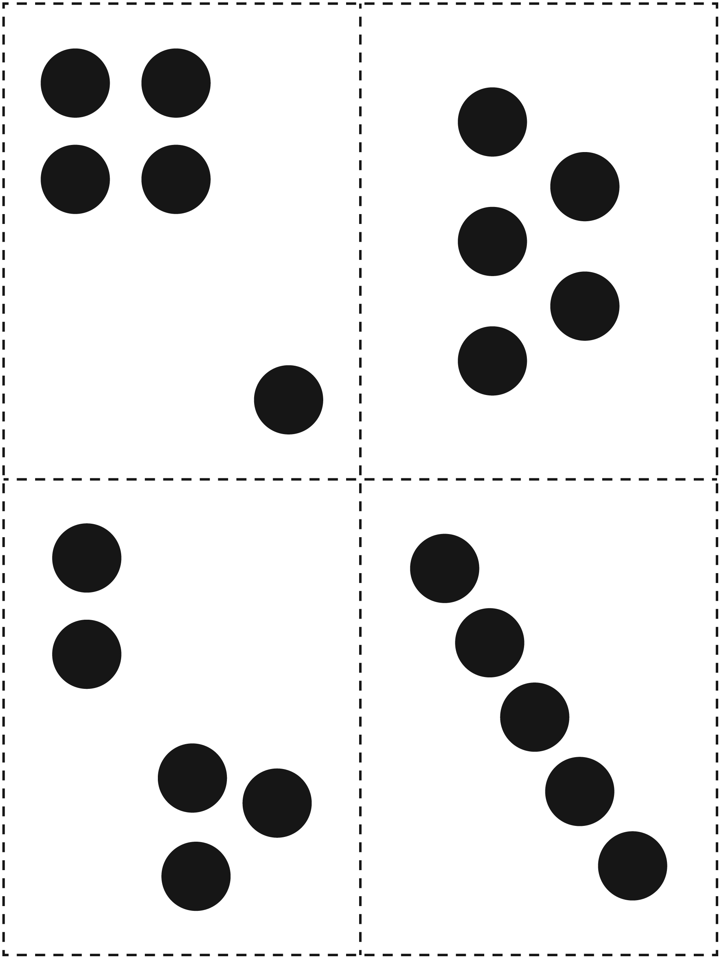
Spot Cards Line Master 5–6

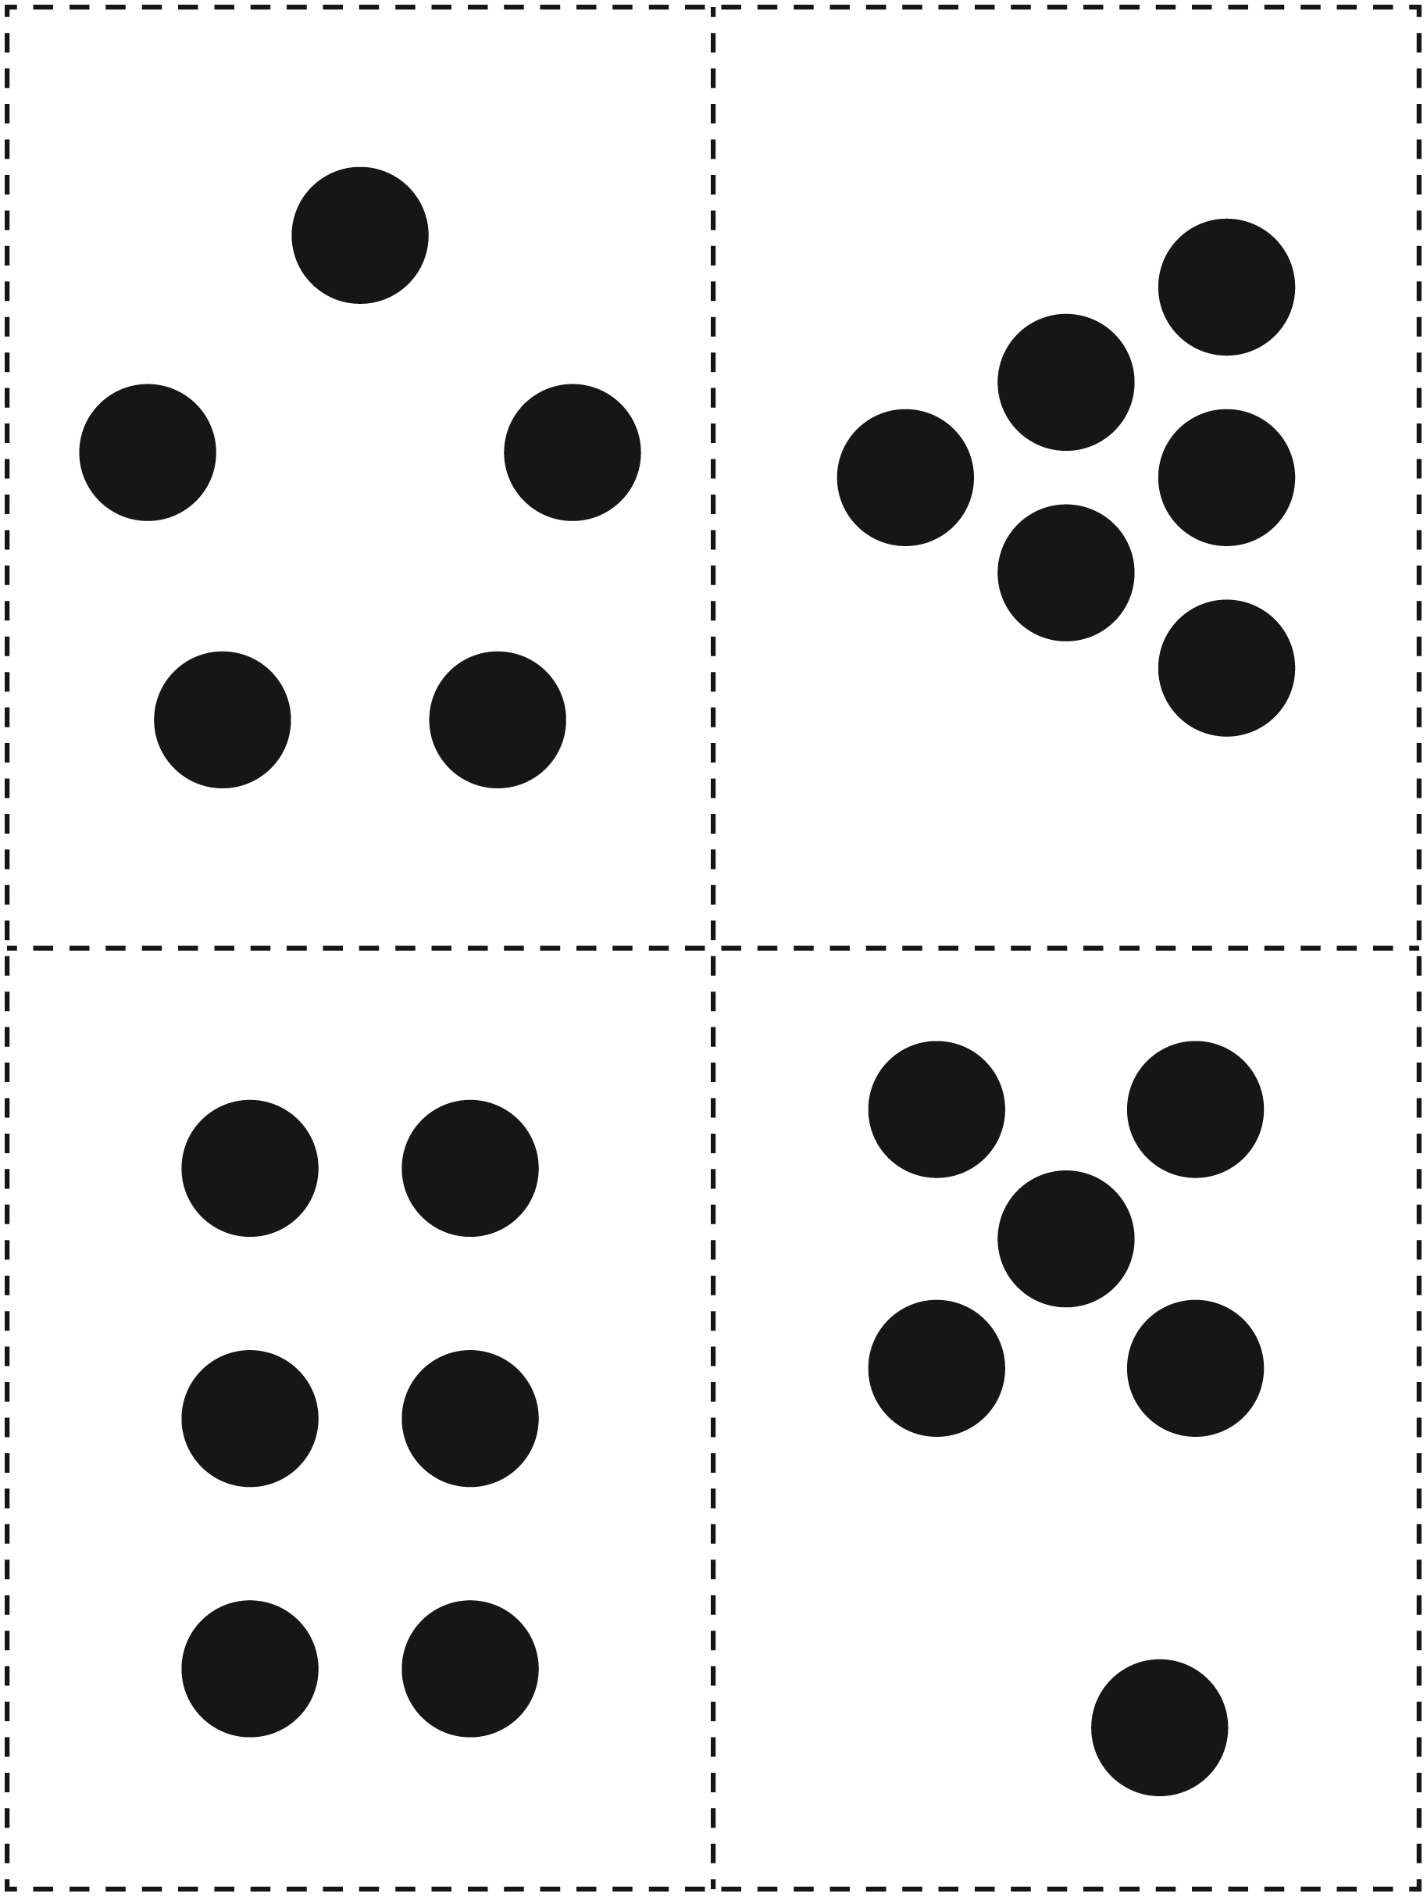
Spot Cards Line Master 5–7

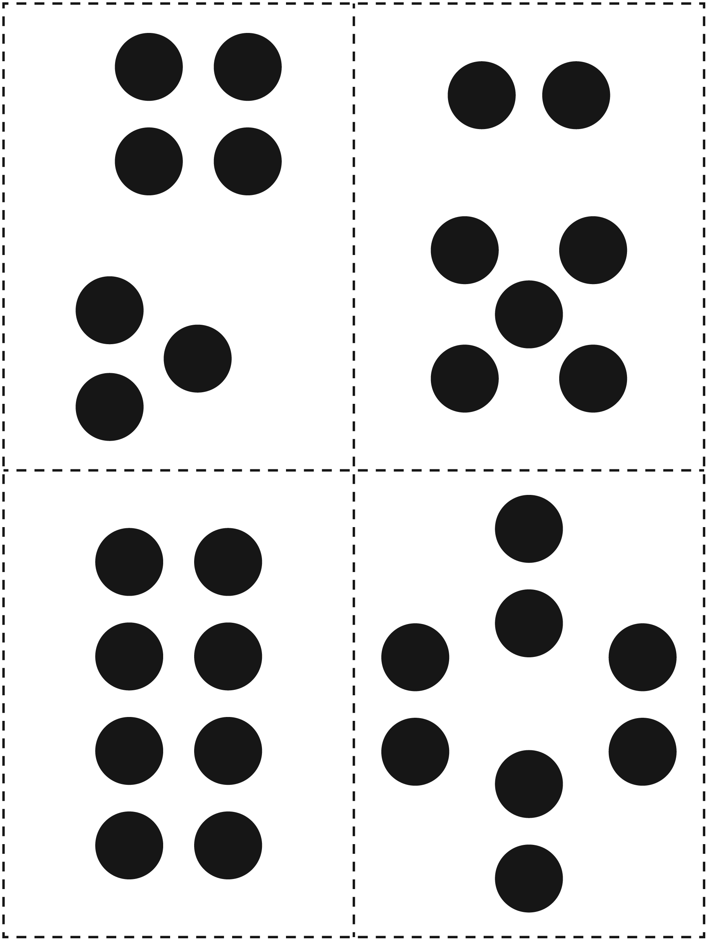
Spot Cards Line Master 5–8

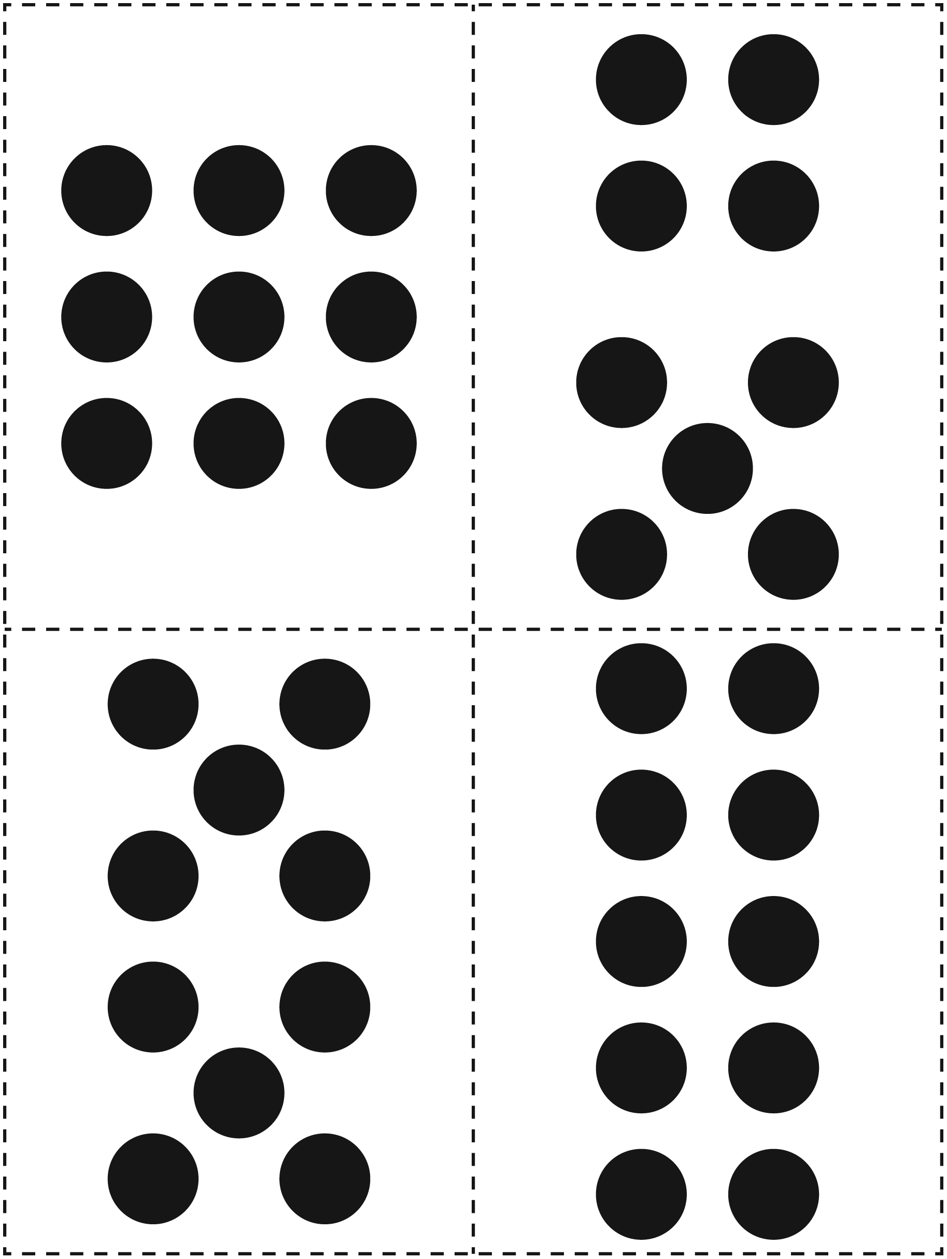
Graphing Mat Line Master 6

RED |  | YELLOW

More/Fewer/The Same Cards Line Master 7

 – – – – – – – – – – – – – – – – – – – – – – – – – – – – – – – – – – – – – – – – – –
MORE

 – – – – – – – – – – – – – – – – – – – – – – – – – – – – – – – – – – – – – – – – – –
FEWER
 – – – – – – – – – – – – – – – – – – – – – – – – – – – – – – – – – – – – – – – – – –
THE SAME

Five-Frames Line Master 8

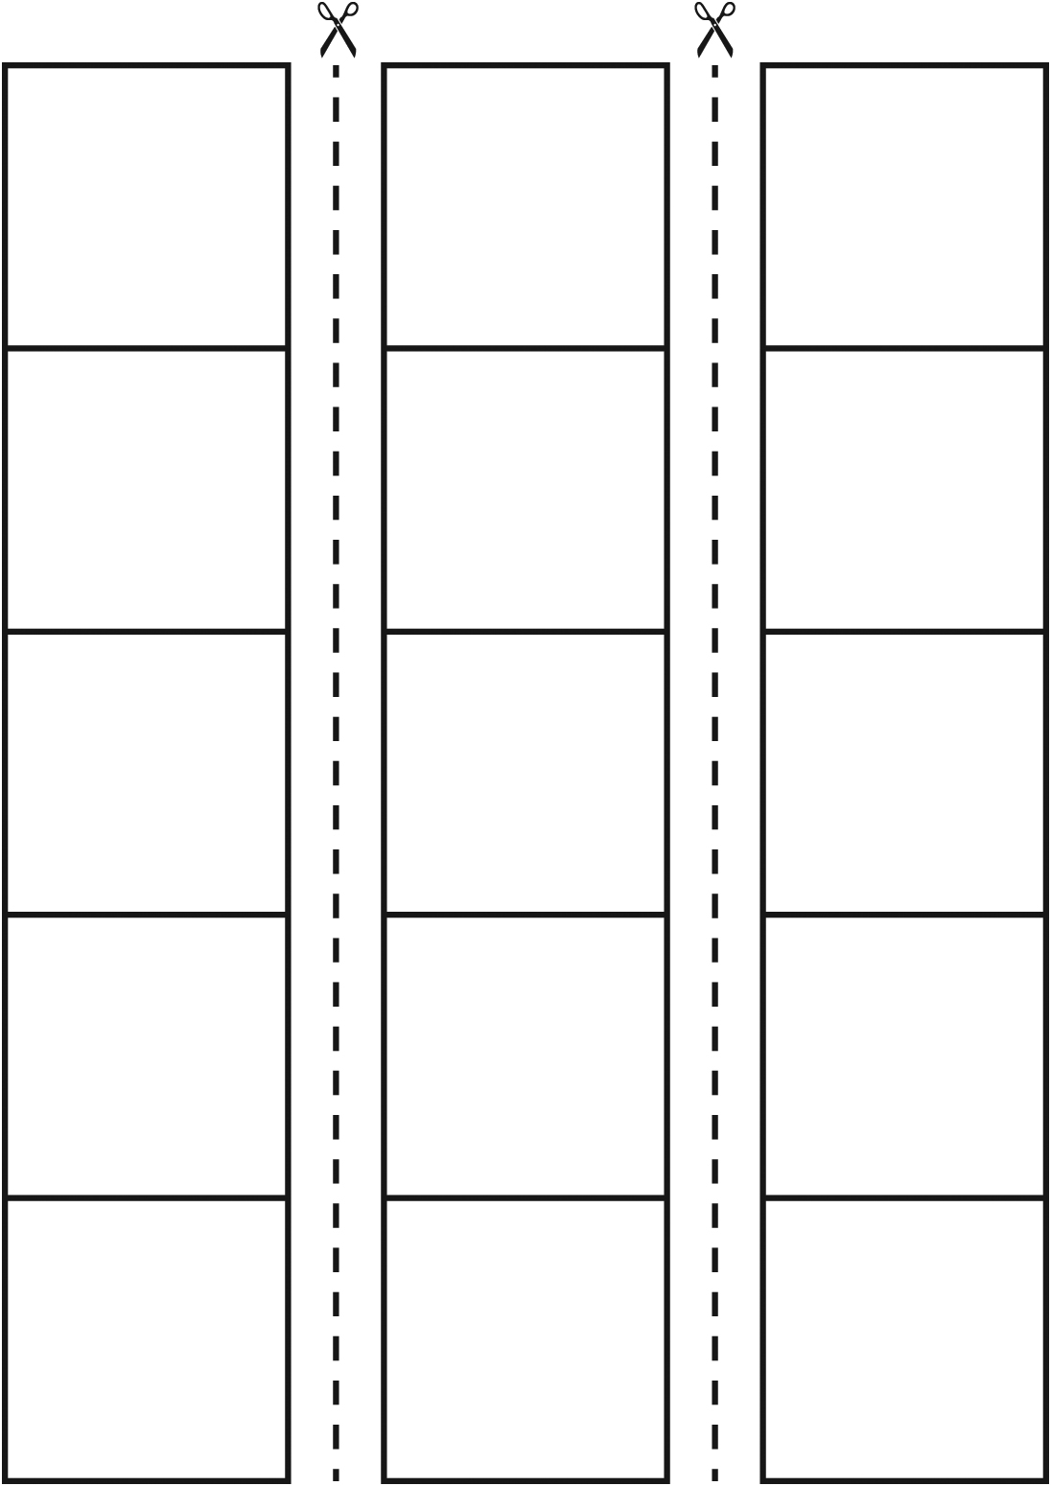

Spot Check Match-up Line Master 9

How to Play
Take turns.
Turn over a number card.
If you have that number of spots, cover it with a counter.
Cover all the spots on your game board to win!

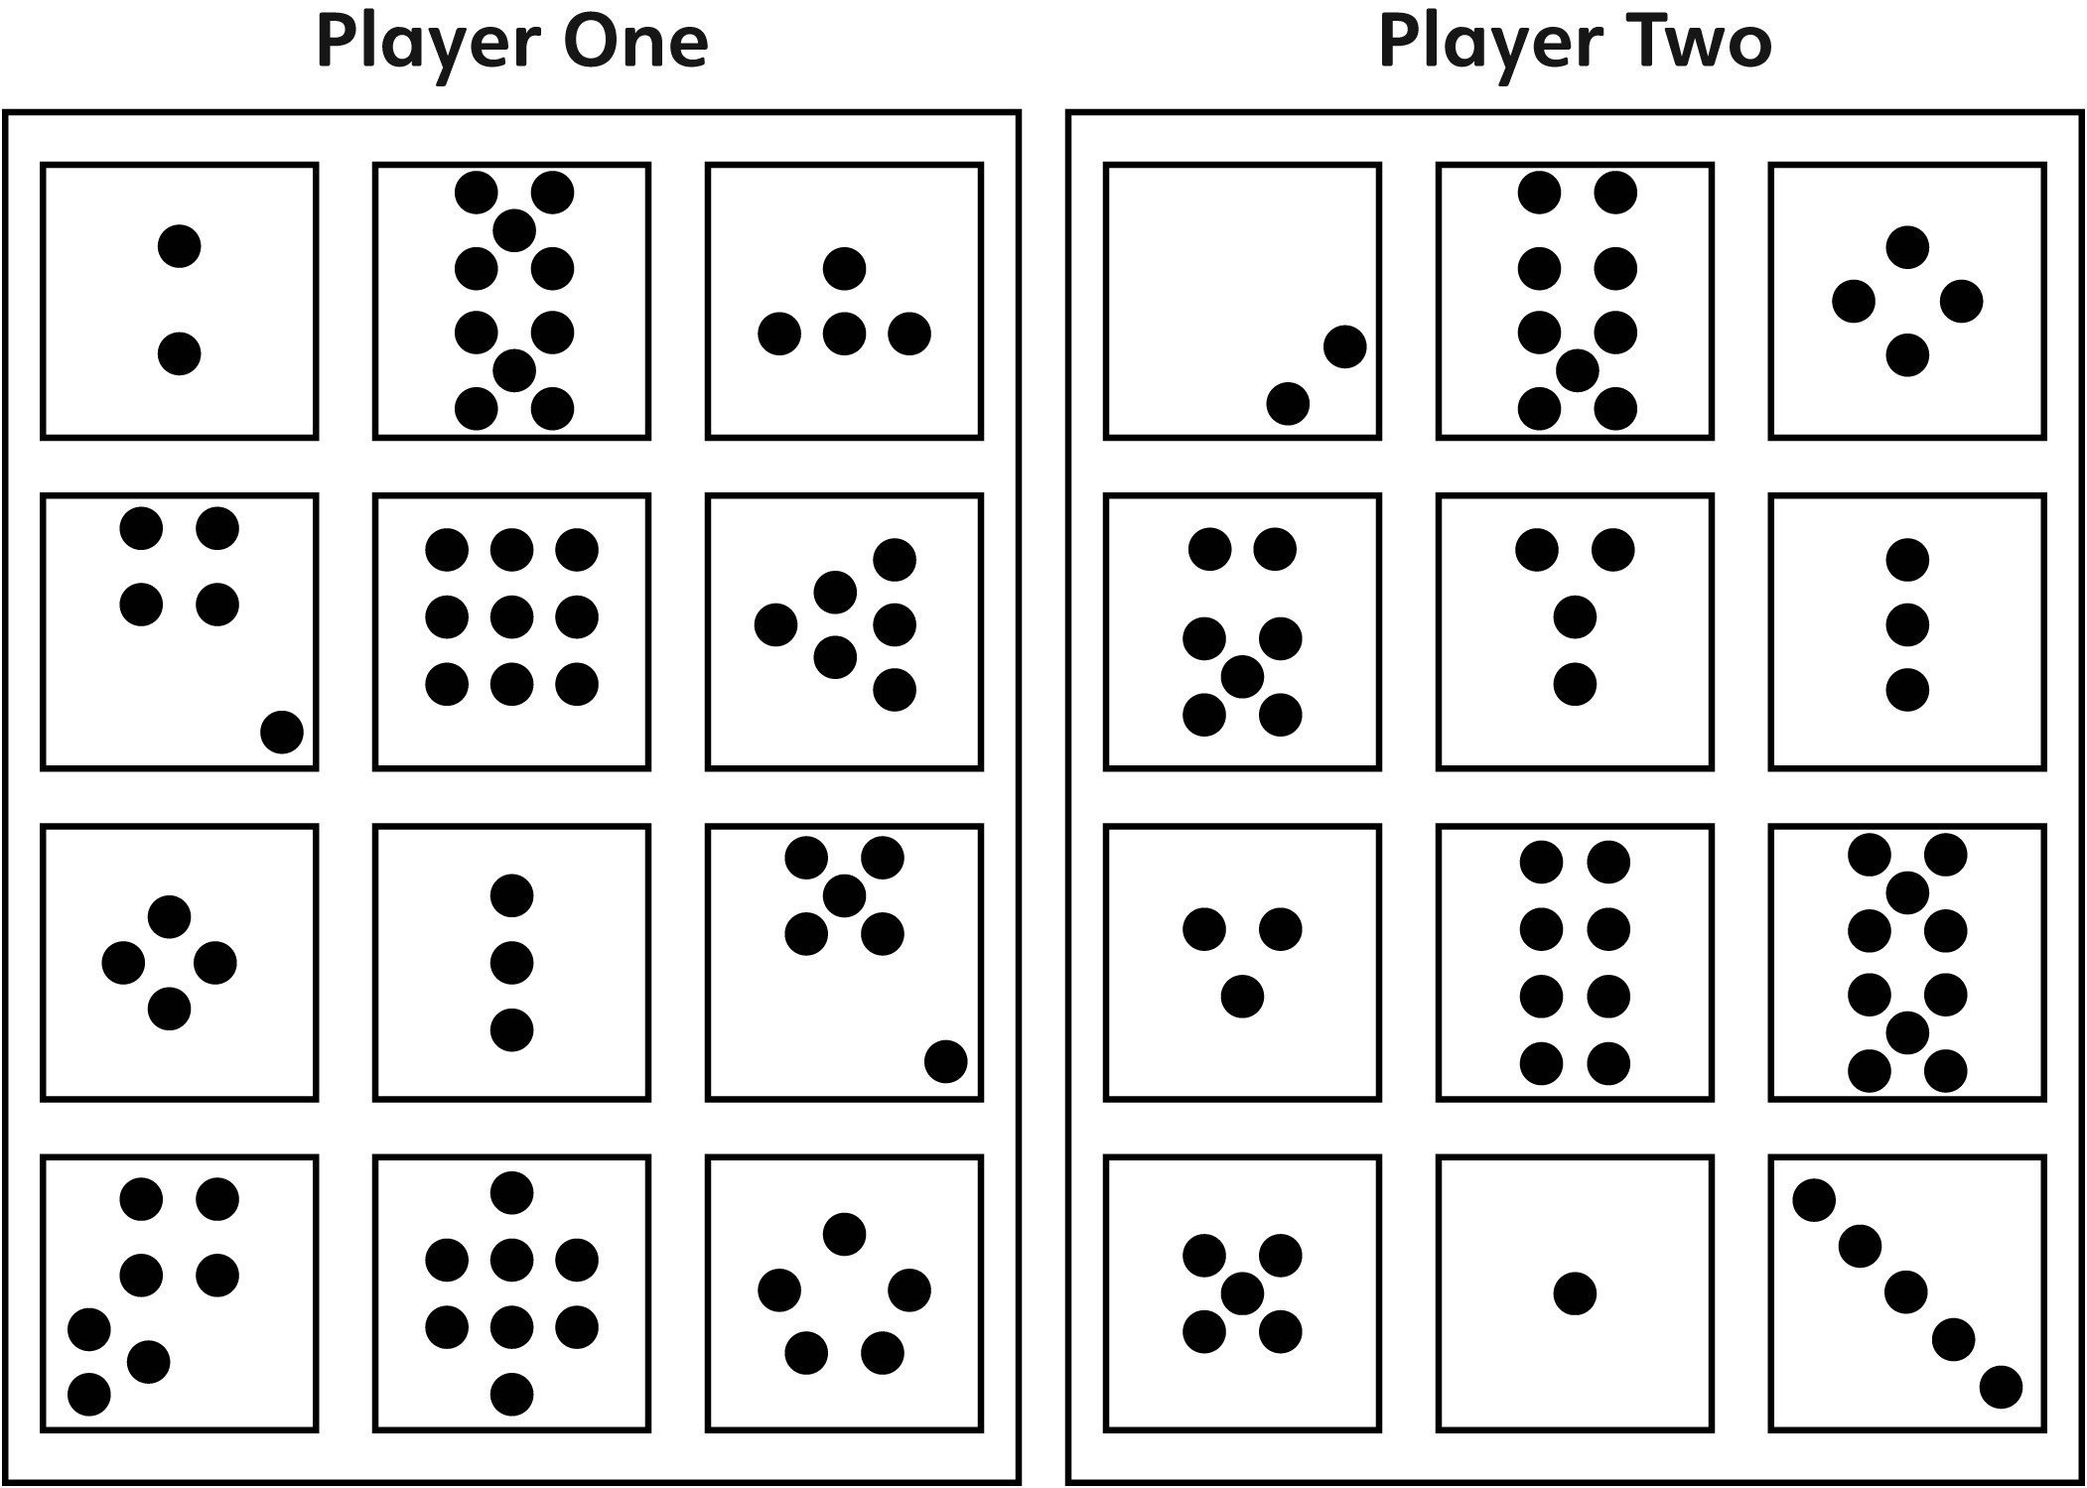

Spot Drop Line Master 10
Name: _________________________________________
How did the counters land?

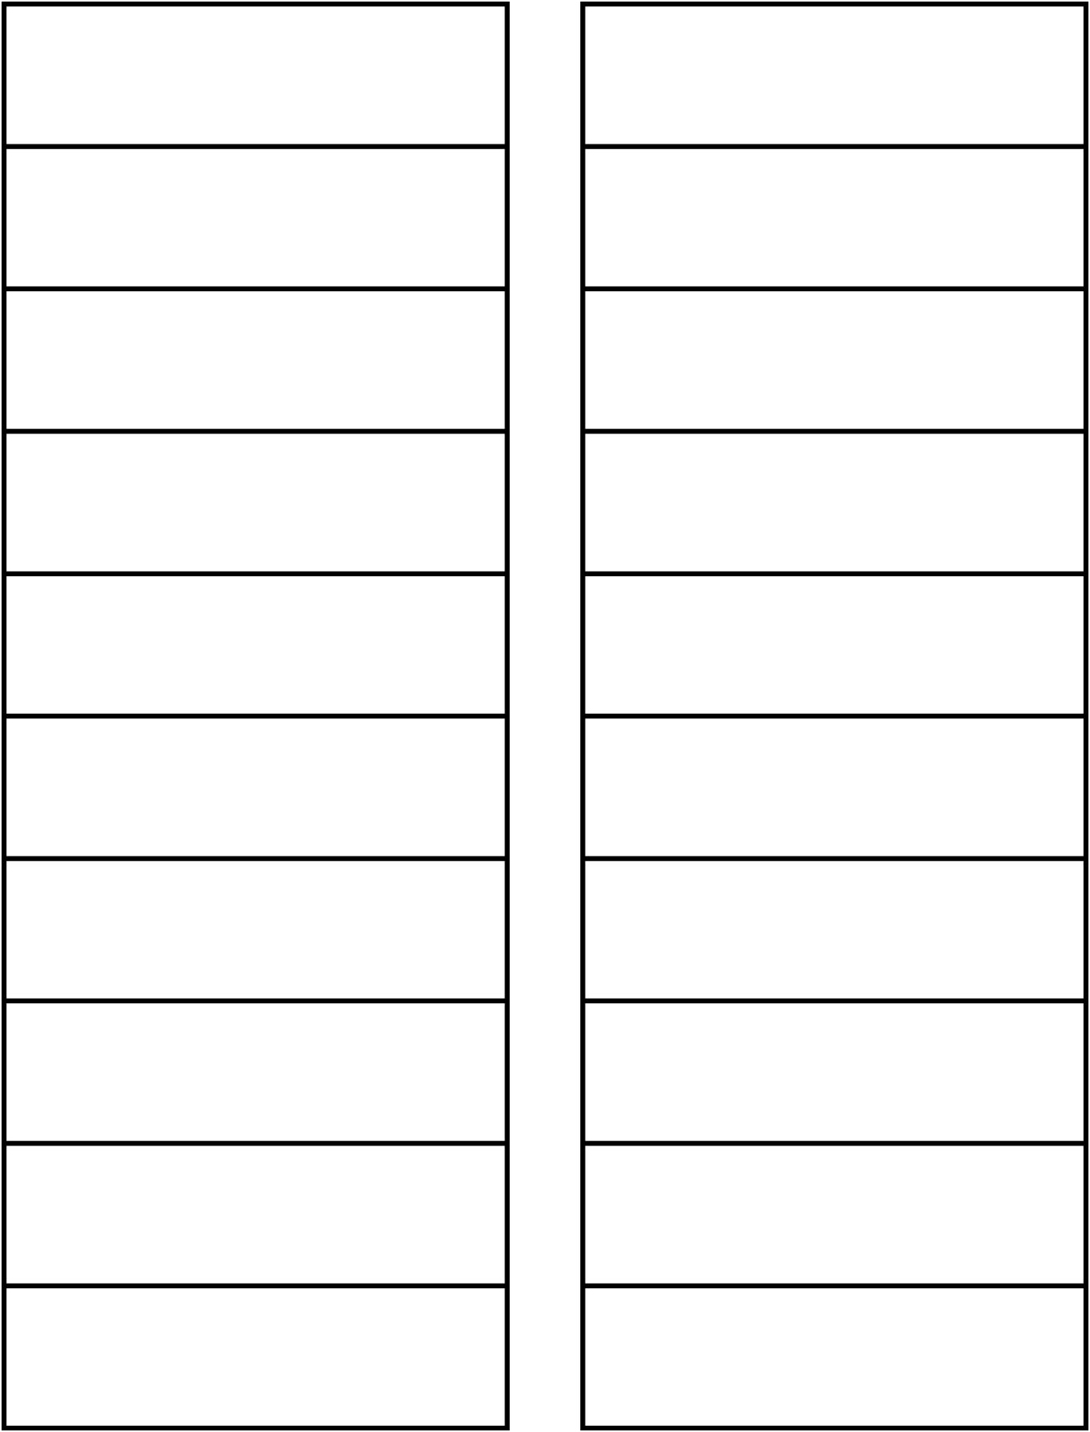

RED
YELLOW

Story Template Line Master 11
Spot Check!  by _________________ | This is _____________.
This is _____________. | This is _____________.

