Acorns for Wilaiya Line Master 1 (Assessment Master)
Name: _____________________________

Count sets to 10 | Not observed | Sometimes | Consistently
Says number name sequence in correct order when counting forward from 1 (stable order)
Says number name sequence in correct order when counting backward from 10 (stable order)
Says one word for each object counted (one-to-one correspondence)
Knows that the last number spoken tells how many objects are in the set (cardinality)
Names and writes numerals
Compare sets to 10
Compares quantities by matching or counting to determine more/less or equal
Strengths:

Next Steps:

Connecting Home and School Line Master 2–1



NOTE TO THE TEACHER

You may wish to send families an Acorns for Wilaiya letter outlining a familiar activity or two they can do at home with their children.

Create a letter using this template and select one or two activities from the suggestions on the next page. Simply delete these instructions and cut and paste the activities you have selected, adapting them to fit your needs.

Connecting Home and School Line Master 2–2

Dear Family:

We have been working on Acorns for Wilaiya, which focuses on Count Sets to 10 and Compare Sets to 10. Try this activity at home with your child.

 – – – – – – – – – – – – – – – – – – – – – – – – – – – – – – – – – – – – – – – – – –
Reading the Story: As you read the story, enjoy counting different objects and living things on the various pages. Look for differences within a group (e.g., acorns with caps and without, different colours of leaves). After you read, use simple objects such as buttons or bread tags, and use the mat on the inside back cover of the book to re-create the story or to play your own acorn game.
 – – – – – – – – – – – – – – – – – – – – – – – – – – – – – – – – – – – – – – – – – –
Drop the Objects: Collect 10 items (buttons, bread tags, coins) and a cup. Hold the items in your hand and drop them over the cup. Have your child count the objects. How many landed in the cup? How many landed beside it? Are there more items in the cup or beside it?
 – – – – – – – – – – – – – – – – – – – – – – – – – – – – – – – – – – – – – – – – – –
Counting Backward: Practise counting backward from 10. Use objects around the house, make groups of 10, and count both forward and backward. You can also count your steps in both directions.
 – – – – – – – – – – – – – – – – – – – – – – – – – – – – – – – – – – – – – – – – – –
Board Games: Play simple board games that require counting such as Snakes and Ladders or Sorry!
 – – – – – – – – – – – – – – – – – – – – – – – – – – – – – – – – – – – – – – – – – –
Sing, Read, and Recite: Look for counting songs, poems, or stories that encourage counting forward or backward such as 5 Little Monkeys and One, Two, Buckle My Shoe.
 – – – – – – – – – – – – – – – – – – – – – – – – – – – – – – – – – – – – – – – – – –
Hop It Out: Use chalk to make a number line showing 0 to 10 on the sidewalk or driveway. Have your child count forward and backward while hopping or stepping between numbers.
 – – – – – – – – – – – – – – – – – – – – – – – – – – – – – – – – – – – – – – – – – –

Sincerely,

___________________________

Counting Mat Line Master 3
Name: _____________________________

1
2
3
4
5
6
7
8
9
10

Acorn Cards Line Master 4

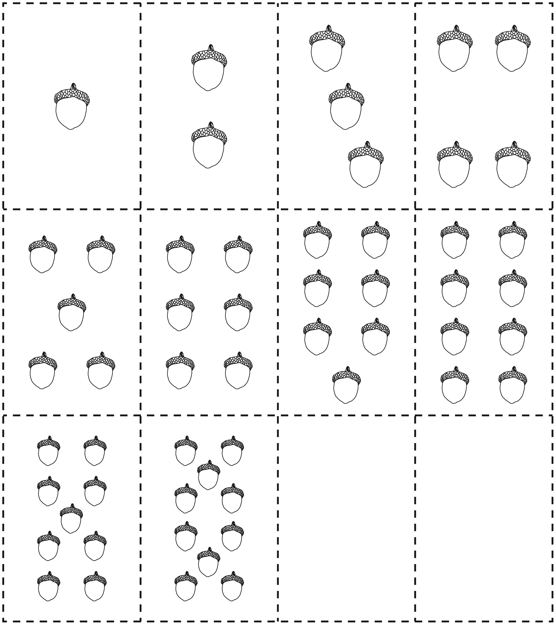

Sorting Mat Line Master 5
Name: _____________________________

Less Than
More Than

Card

Numeral Cards Line Master 6
Name: _____________________________
0 | 1 | 2
3 | 4 | 5
6 | 7 | 8
9 | 10

Handfuls of Acorns Line Master 7
Recording Sheet
Name: _____________________________

First Handful | Second Handful

More or Less Spinner Line Master 8

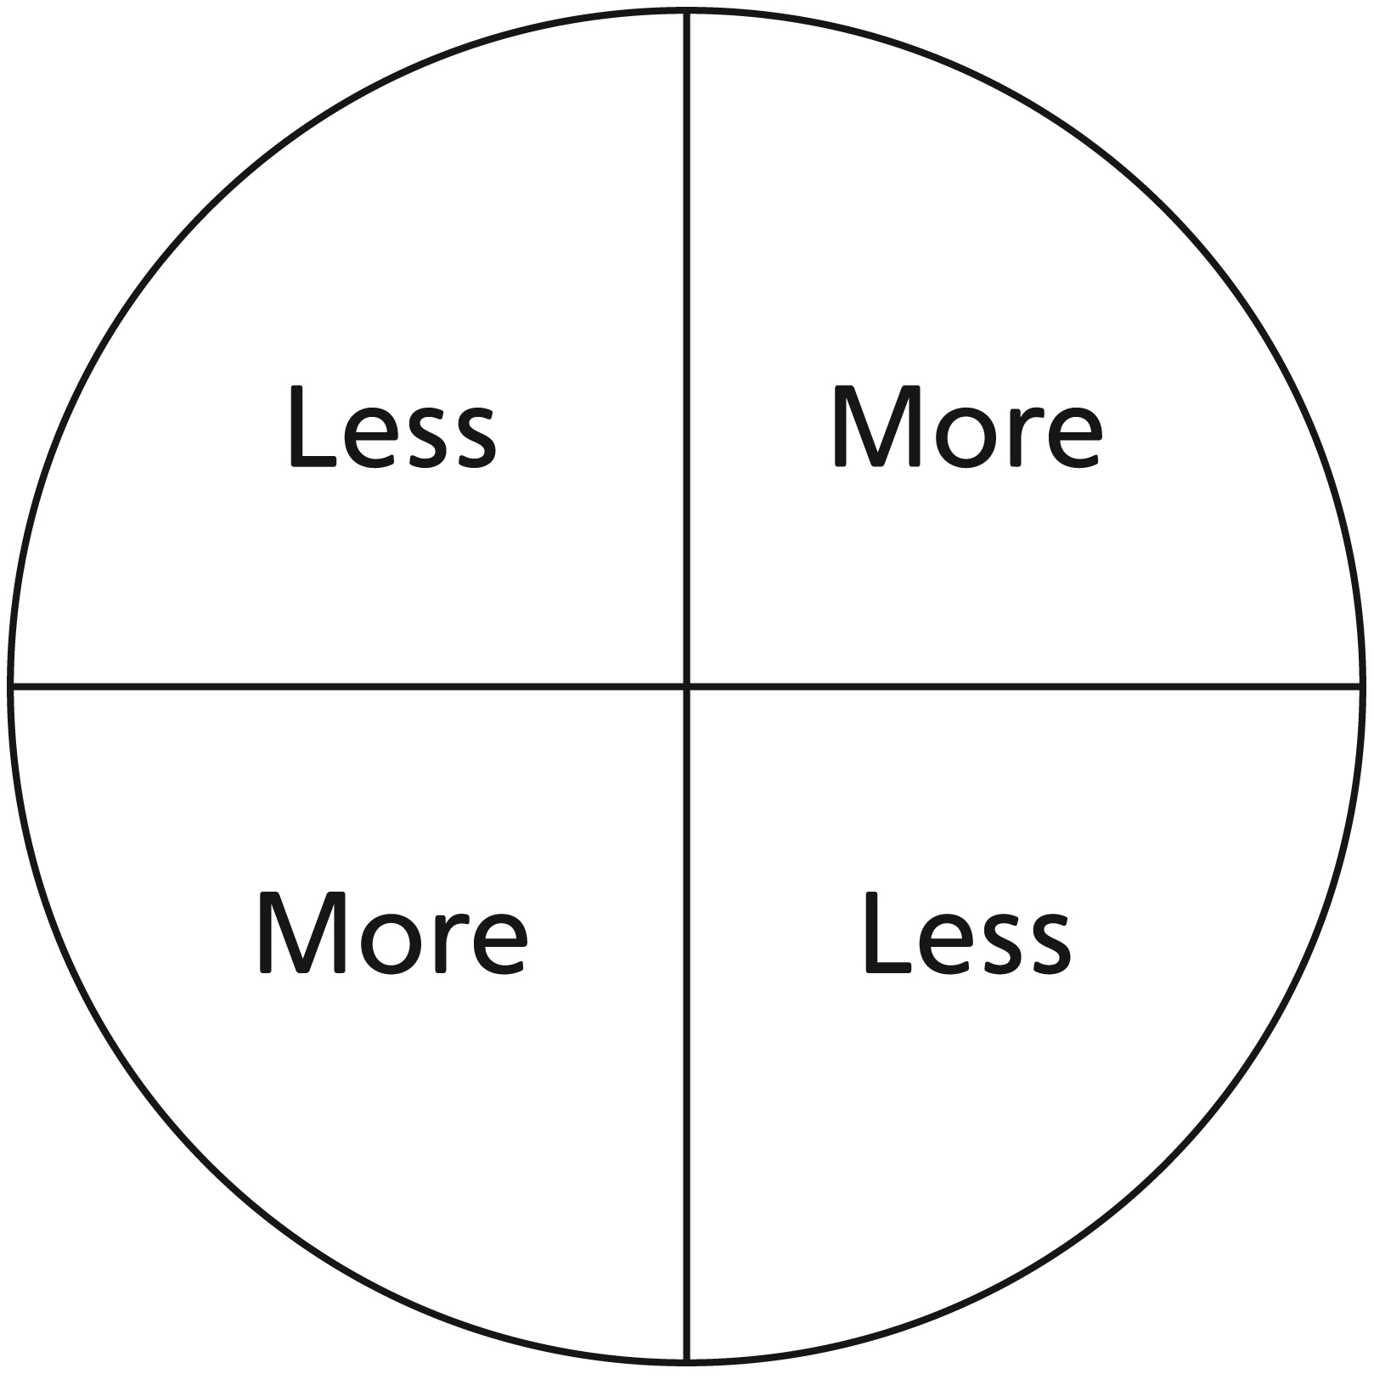

Spin More or Less Line Master 9
Recording Sheet
Keeping Score
- How many counters are in your handful?
- Spin the spinner to see who gets a point.
- Circle your number if you get a point.

Turn | Name ________________________ | Name ________________________
1
2
3
4
5
6
7
8
9
10

My Acorns Line Master 10
Name: _____________________________

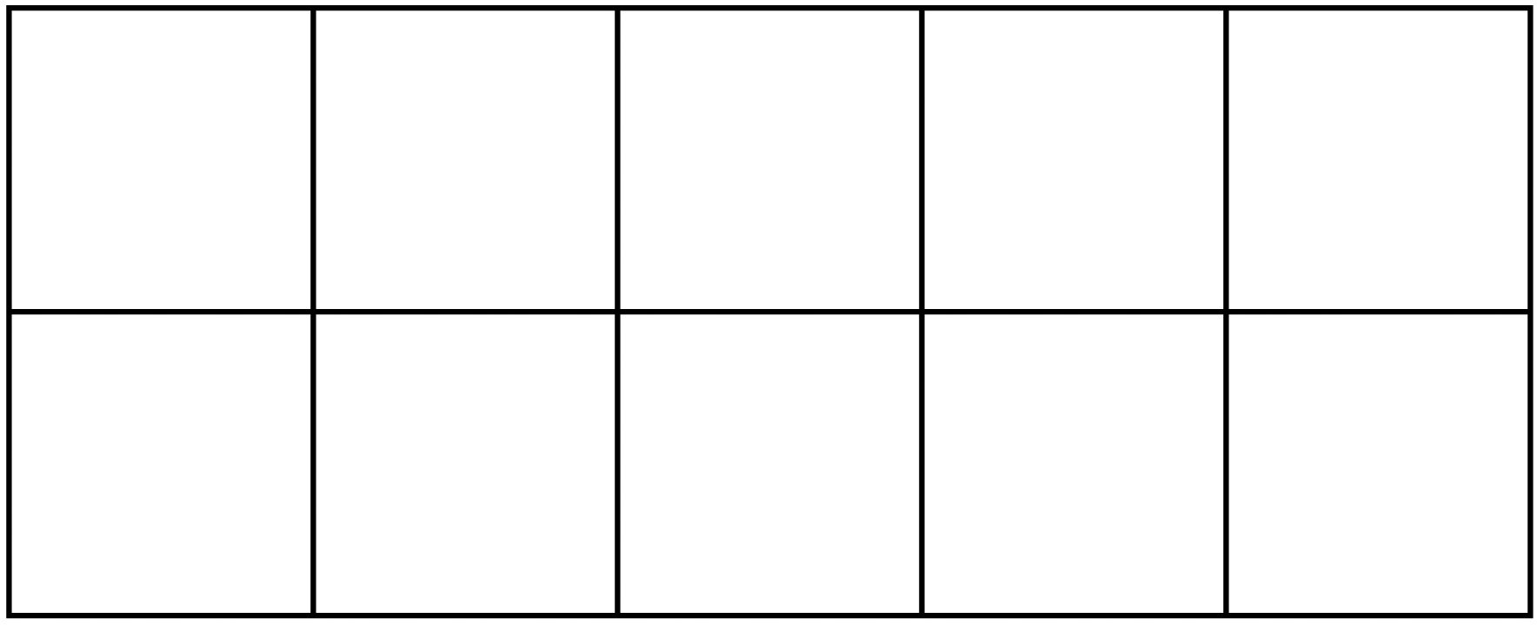

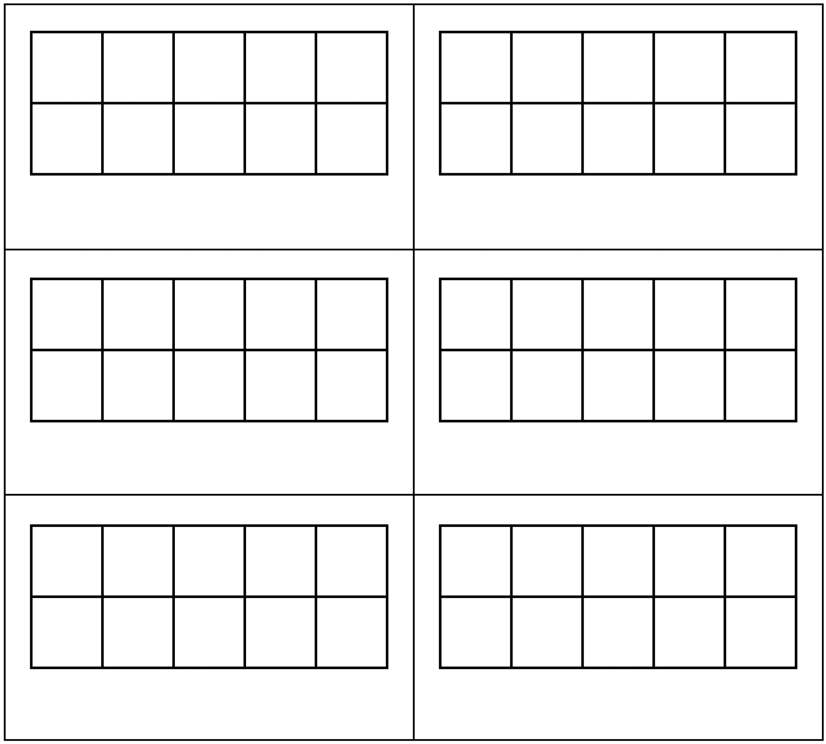

Black Squirrel, Black Squirrel Line Master 11

Name: _______________
Black squirrel, black squirrel,
what do you see?

I see _________ acorns waiting
for me.

How Many? Line Master 12–1
 – – – – – – – – – – – – – – – – – – – – – – – – – – – – – – –– – – – – – – –– – – –
Wilaiya had 5 brown acorns and 8 green acorns.
Which pile has more?

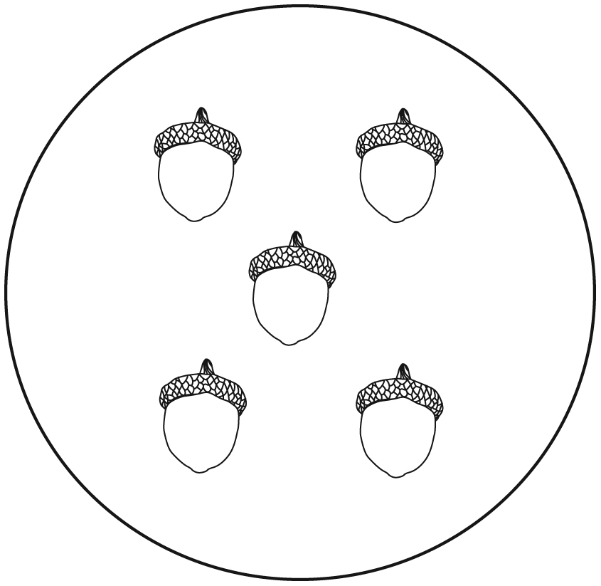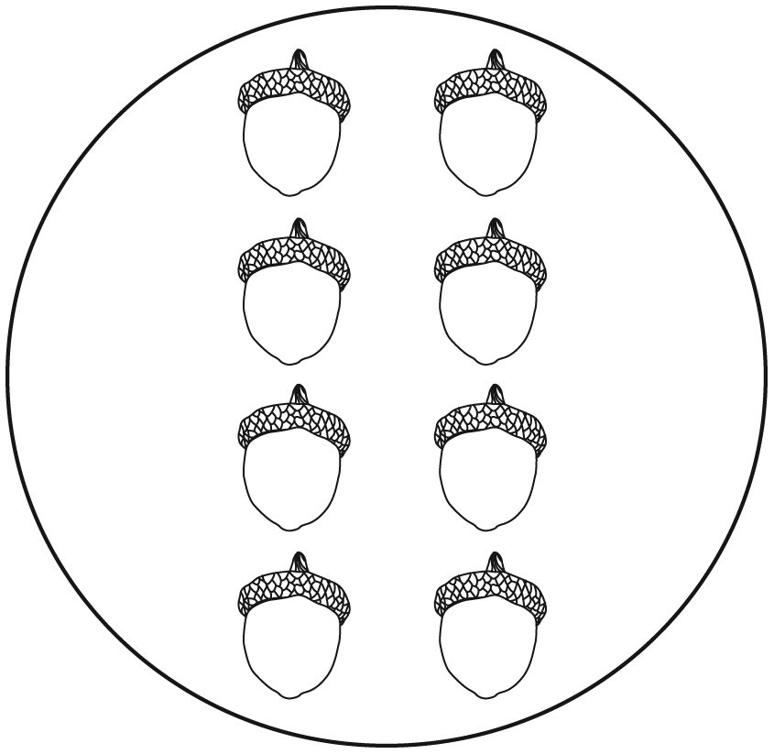
 – – – – – – – – – – – – – – – – – – – – – – – – – – – – – – –– – – – – – – –– – – –
Wilaiya had 7 brown acorns and 4 green acorns.
Which pile has more?

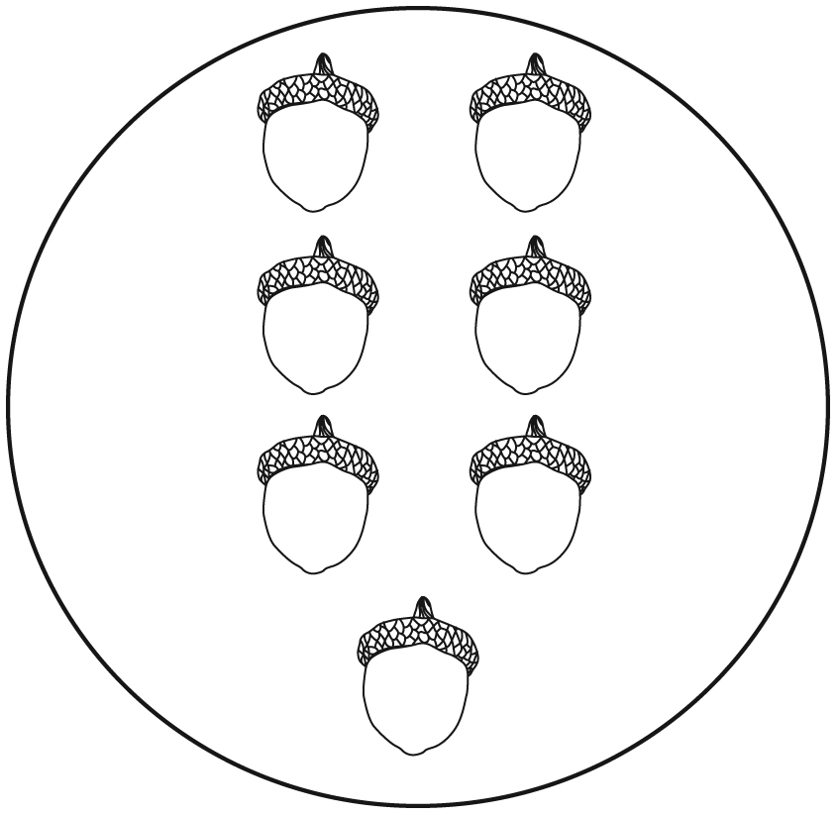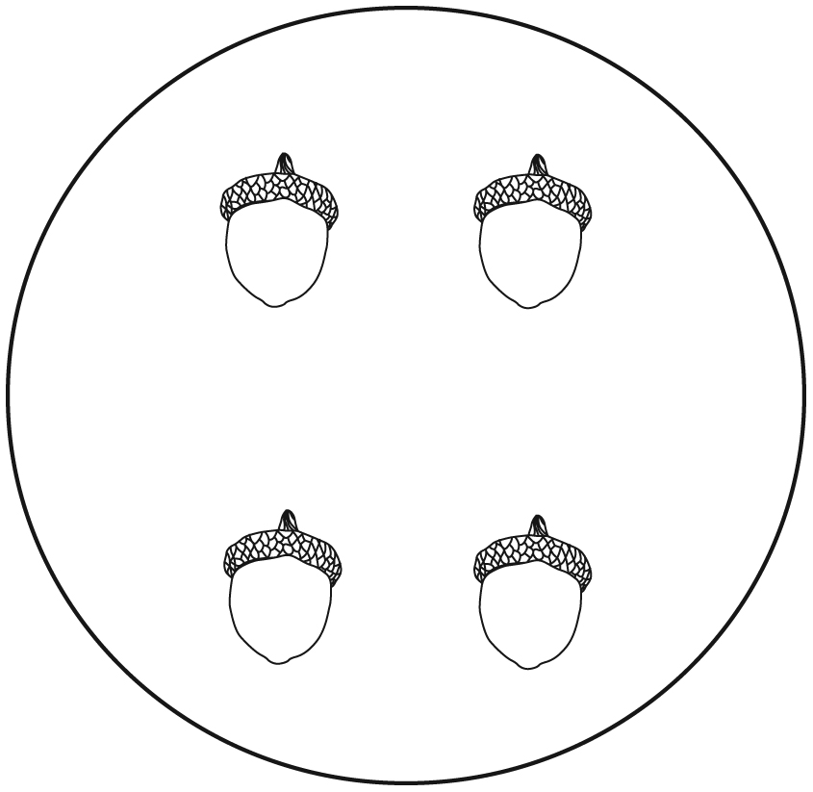

How Many? Line Master 12–2
 – – – – – – – – – – – – – – – – – – – – – – – – – – – – – – –– – – – – – – –– – – –
Wilaiya has 5 acorns. You have more.
Show how many you have.


 – – – – – – – – – – – – – – – – – – – – – – – – – – – – – – –– – – – – – – –– – – –
Wilaiya has 7 acorns. You have fewer.
Show how many you have.

