Hedge and Hog Line Master 1
(Assessment Master)
Name: _____________________________

Collect and Interpret Data | Not observed | Sometimes | Consistently
Poses a question to initiate data collection
Displays collected data on a graph
Interprets concrete graphs
Makes predictions based on displayed data
Sort a Collection
Identifies similarities and differences
Sorts and re-sort a collection
Identifies a sorting rule
Strengths:

Next Steps:

Connecting Home and School Line Master 2–1

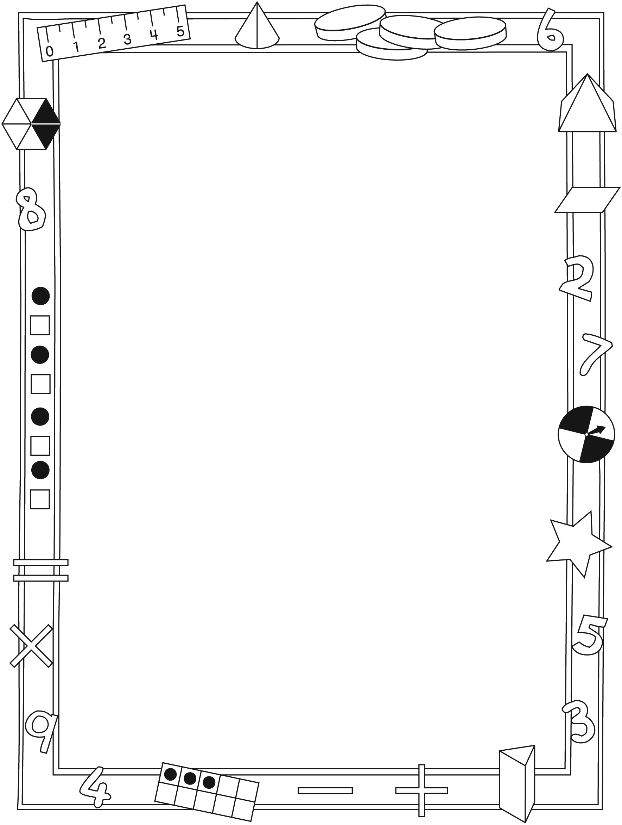

NOTE TO THE TEACHER

You may wish to send families a Hedge and Hog letter outlining a familiar activity or two they can do at home with their children.

Create a letter using this template and select one or two activities from the suggestions on the next page. Simply delete these instructions and cut and paste the activities you have selected, adapting them to fit your needs.

Connecting Home and School Line Master 2–2

Dear Family:

We have been working on Hedge and Hog, which engages children in conversations, investigations, and activities that help to develop their understanding of the big math idea that “Collecting and displaying data can help us predict and interpret situations.” Particular focus is placed on collecting and interpreting data and sorting collections. Try this activity at home with your child.
– – – – – – – – – – – – – – – – – – – – – – – – – – – – – – – – – – – – – – – – – –
Reading the Story: As you read the story, enjoy talking about what Hedge and Hog are finding out about the different materials. After, you might gather some small objects. Invite your child to predict which will sink and which will float and sort them into 2 groups on the Math Mat (see the inside back cover of the book). Provide a container of water so that your child can test his/her predictions and then re-sort the items on the Math Mat. Ask your child to describe the group using the words more and fewer (e.g., there are more sinkers than floaters, fewer things float).
– – – – – – – – – – – – – – – – – – – – – – – – – – – – – – – – – – – – – – – – – –
Heads and Tails: You need about 10 coins and a container. Place 1 coin in the container, and then shake the container and spill the coin onto a surface. Ask: Is heads or tails facing up? Have your child place the coin—as it landed—into one section on the Math Mat (inside back cover of the book). Repeat for all the other coins. Each time your child places a coin on the Math Mat, she/he is creating 2 groups: a “heads” group and a “tails” group. Once all coins have been sorted, ask: Do you think there are more coins that landed heads side up or more that landed tails side up? Count to check your child’s prediction. You might also work with your child to place the 2 groups in 2 straight lines to compare them.
– – – – – – – – – – – – – – – – – – – – – – – – – – – – – – – – – – – – – – – – – –
Let’s Compare: Draw attention to sorted sets around your home, such as cutlery, colours of socks, or lids and pots. For example, open the cutlery drawer and ask your child if he/she thinks there are more spoons or more forks. Remove the spoons and forks and align them to form columns. Ask your child to compare the numbers using language such as: There are more forks than spoons. There are
3 more spoons than forks. There are 3 fewer forks than spoons.
– – – – – – – – – – – – – – – – – – – – – – – – – – – – – – – – – – – – – – – – – –
Sincerely,

___________________________

Hedge and Hog Math Mat Line Master 3

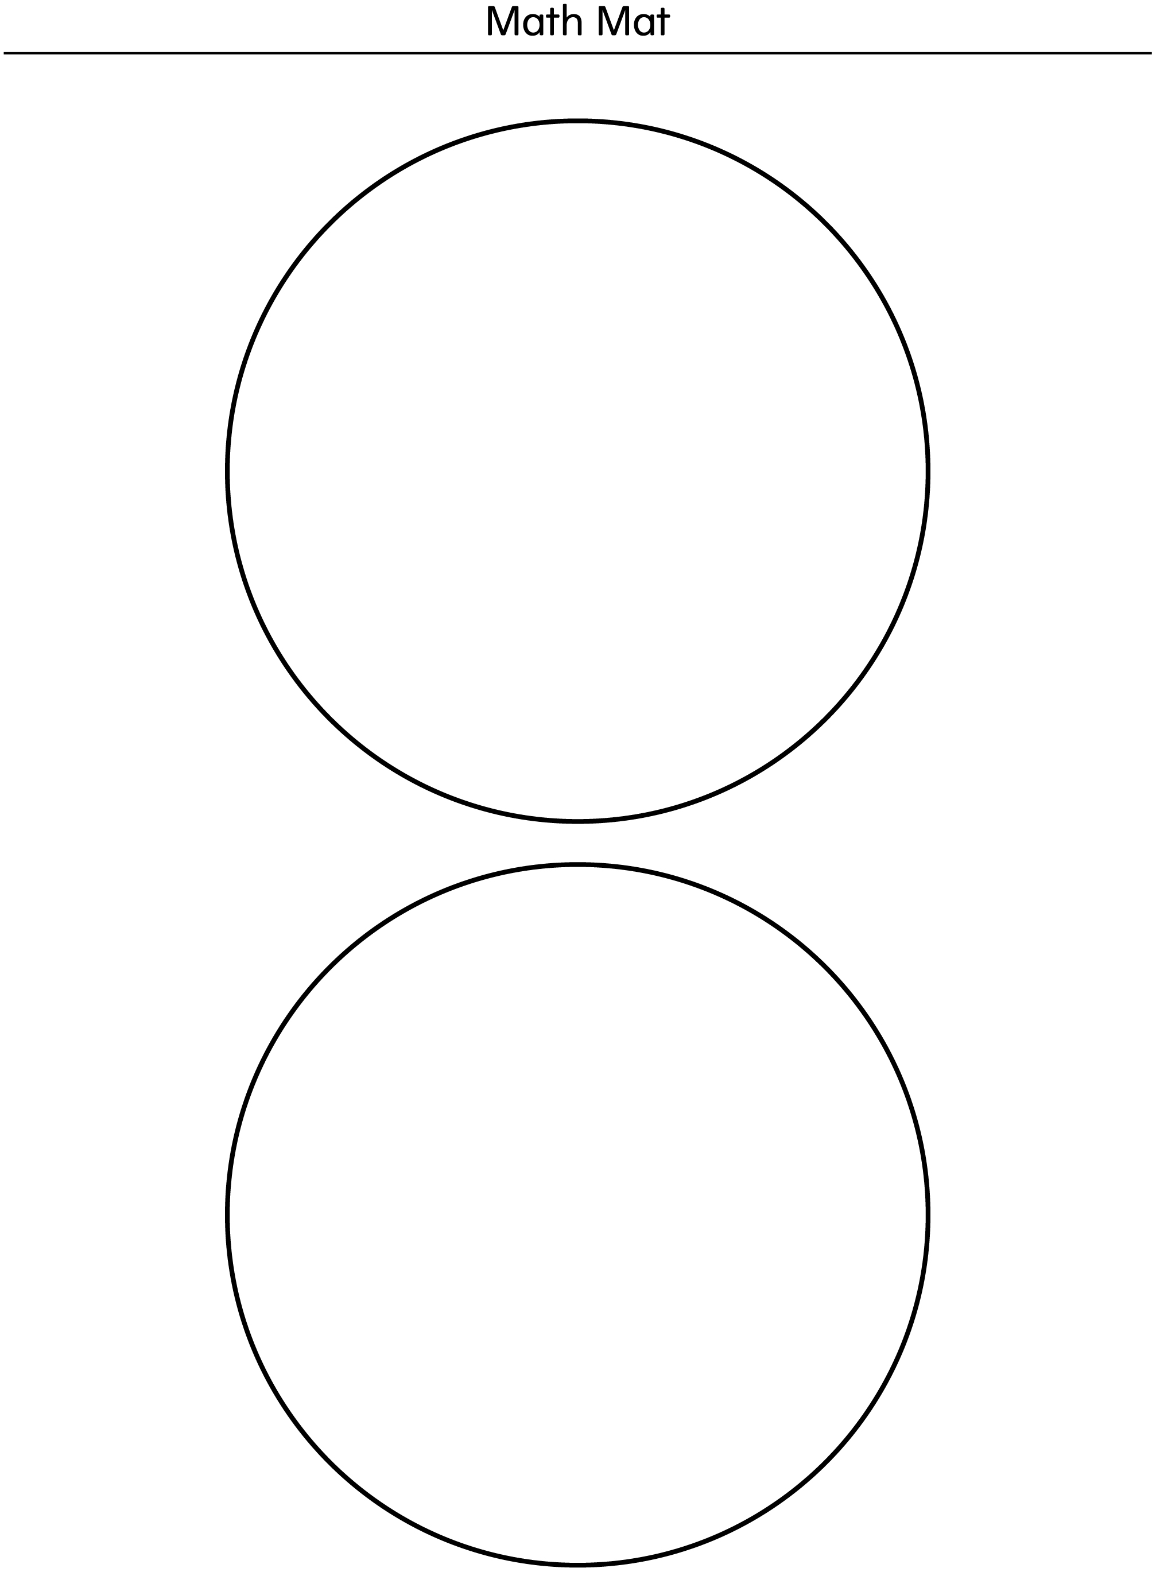

Labels Line Master 4–1

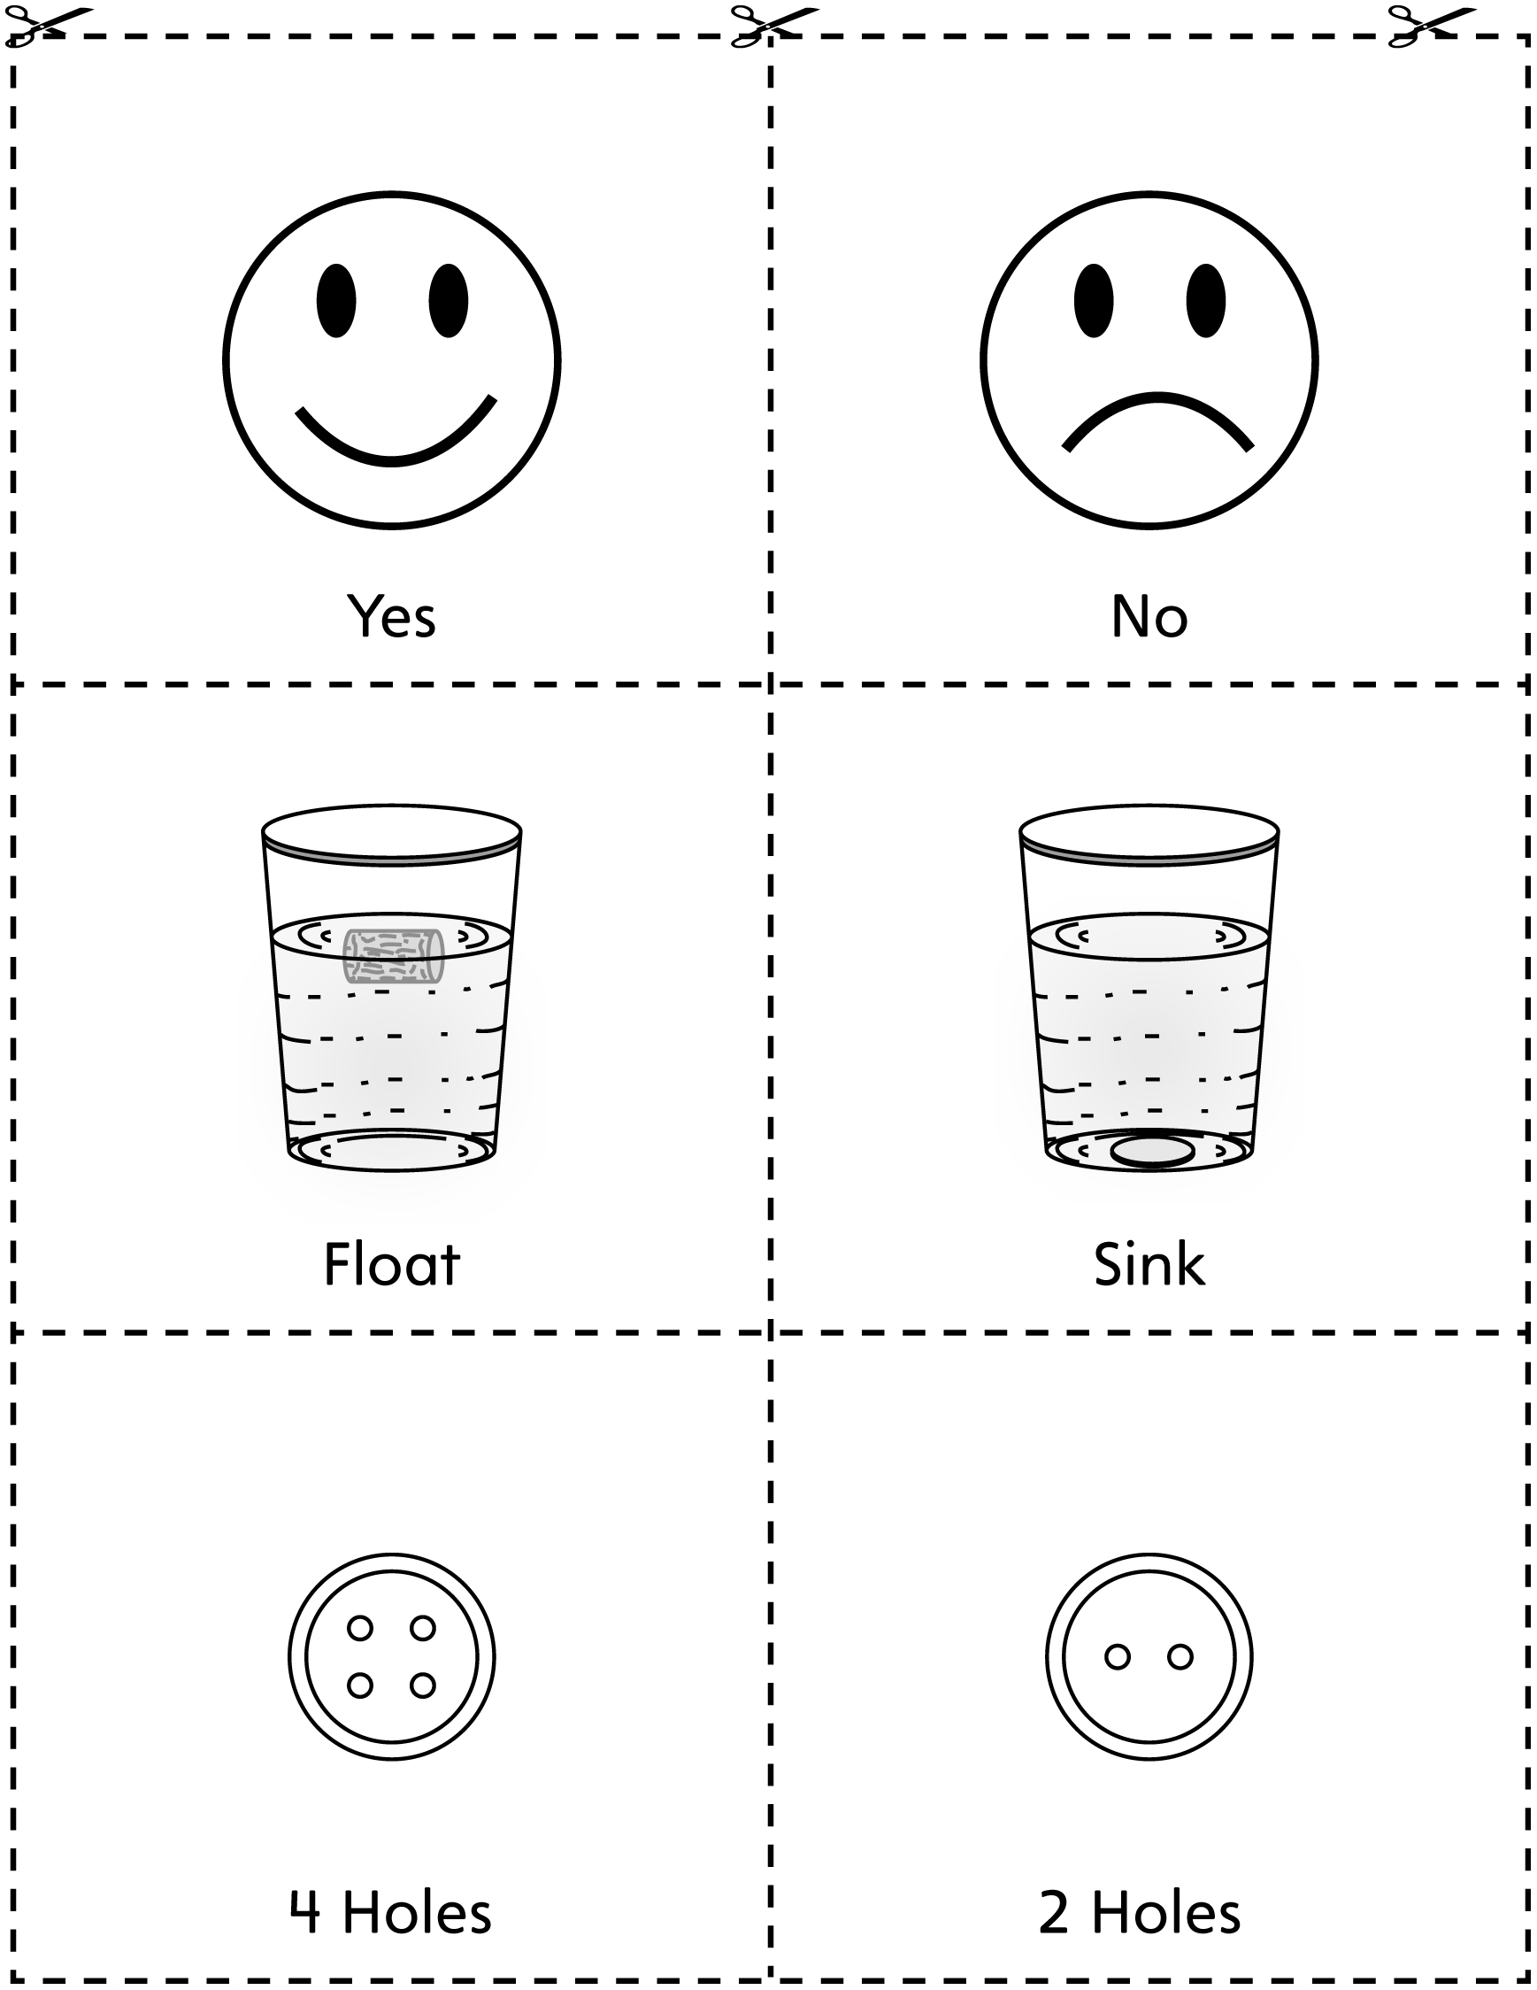

Labels Line Master 4–2

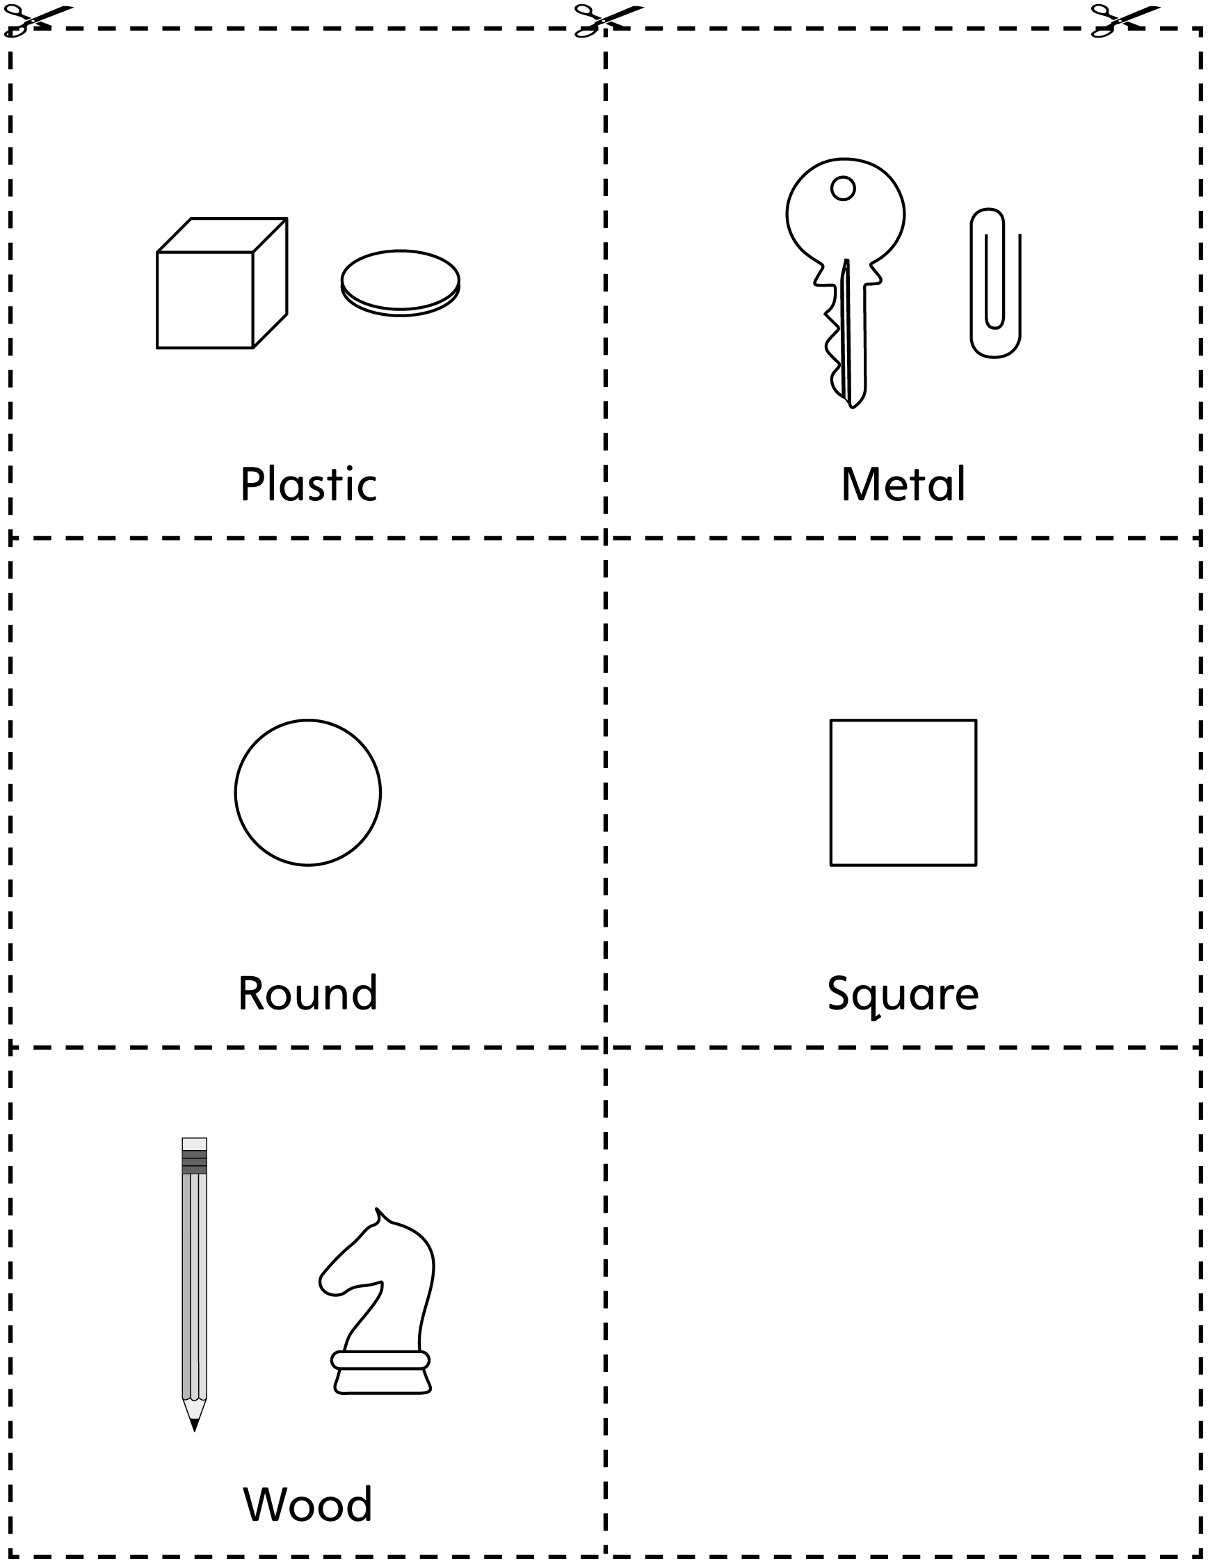

Graphing Mat Line Master 5–1
Name: _____________________________

____________________ _____________________

Graphing Mat Line Master 5–2
Name: _____________________________

_______________ _______________ _______________

Red and Yellow Line Master 6
Name: _____________________________

You will need:
- 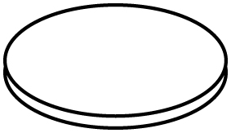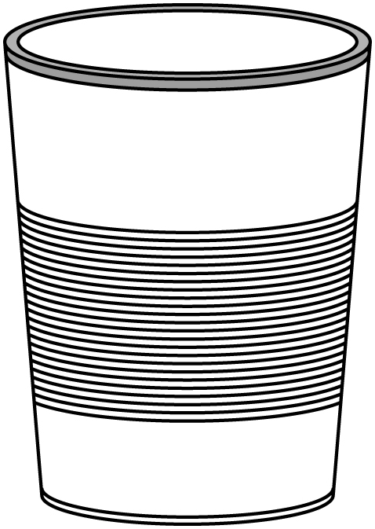a 2-sided counter
- a cup
- 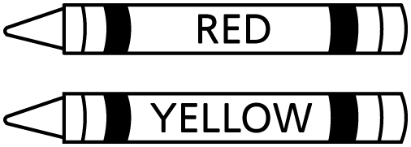crayons in the same colours as the counter

How to play:
1. Take turns.
2. Put the counter in the cup.
3. Spill the counter. What colour lands face up?
4. Colour the graph to match how the counter lands.
5. Which colour wins?

Yellow
Red

Alphabet Cards Line Master 7–1

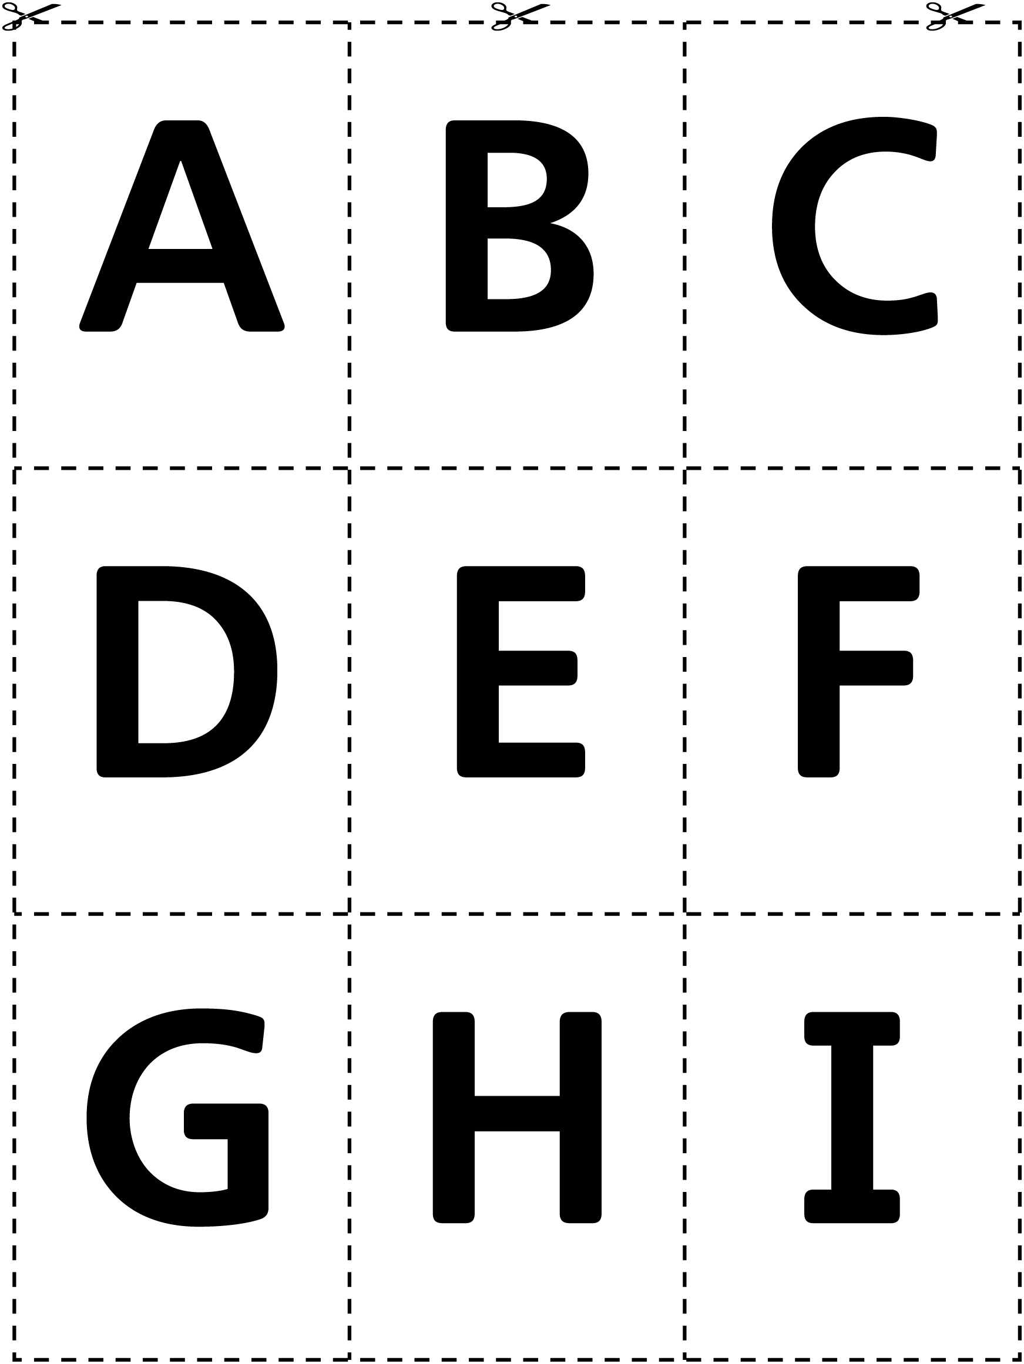

Alphabet Cards Line Master 7–2

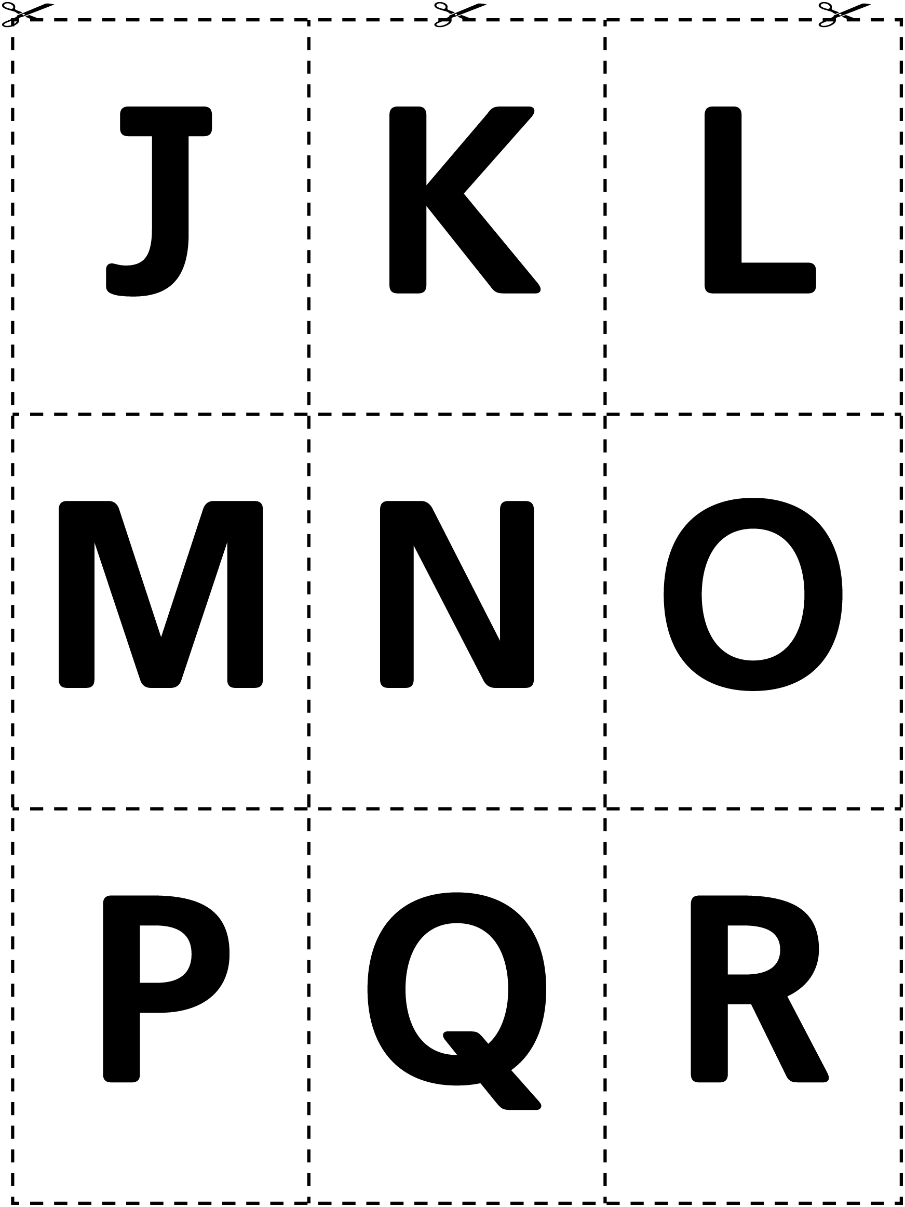

Alphabet Cards Line Master 7–3

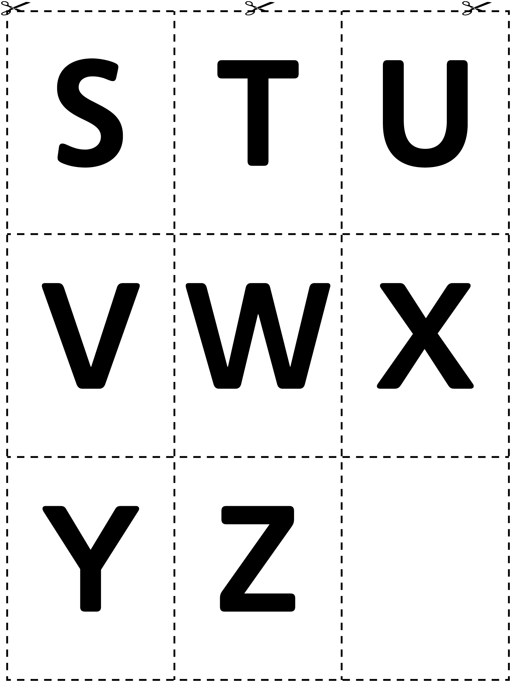

Alphabet Cards Line Master 7–4

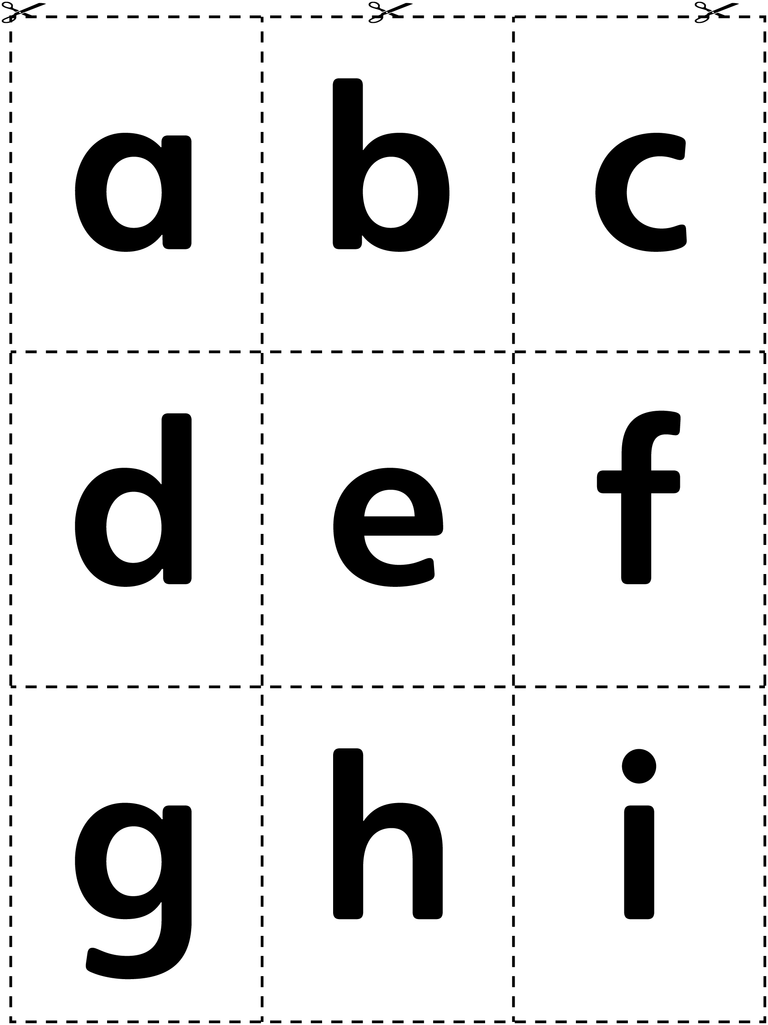

Alphabet Cards Line Master 7–5

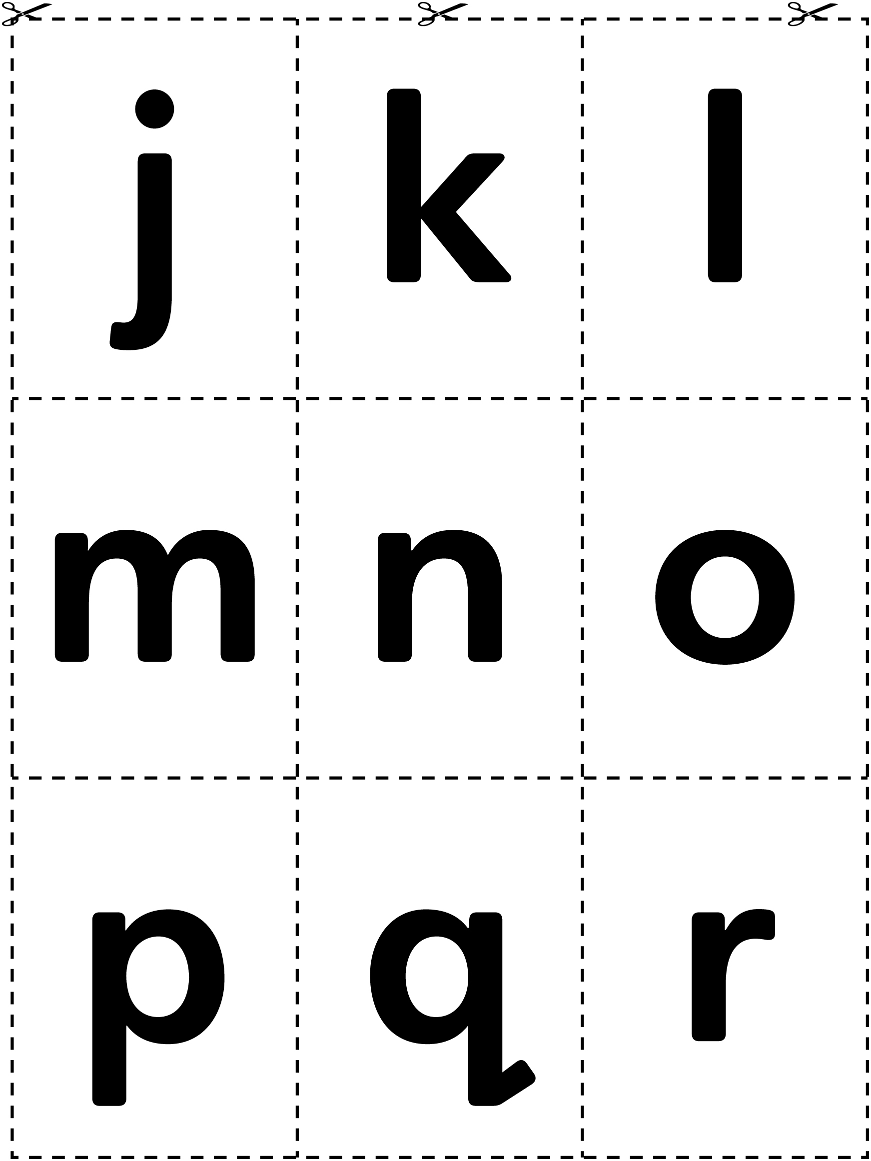

Alphabet Cards Line Master 7–6

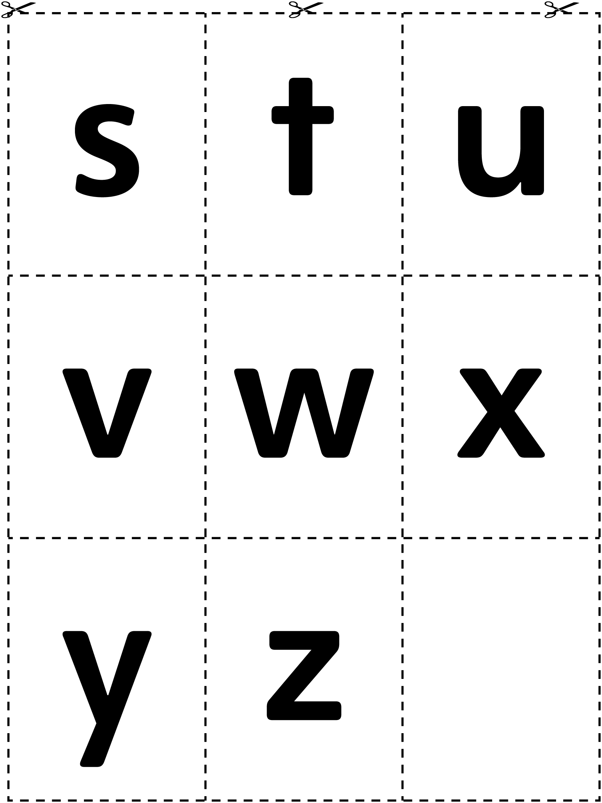

Make a Group Line Master 8–1
Name: _____________________________

Draw 1 more button that belongs in each group.

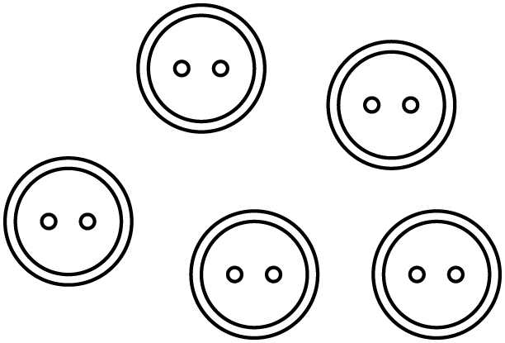 | 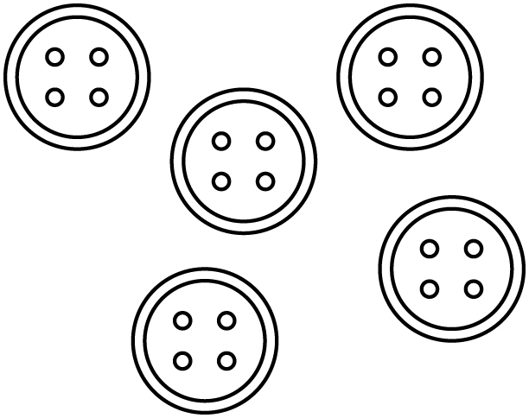
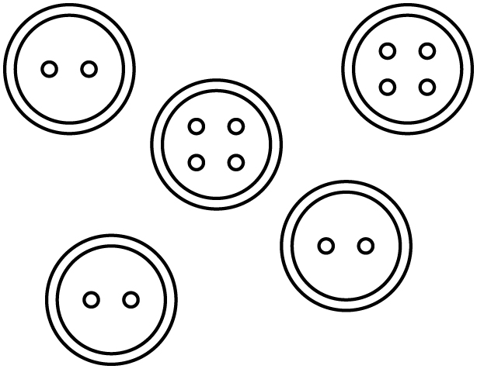 | 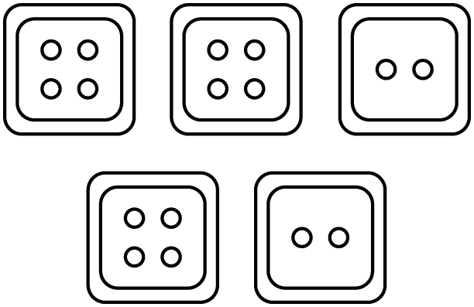

Make a Group Line Master 8–2
Name: _____________________________

Draw an X on the button that does not belong.

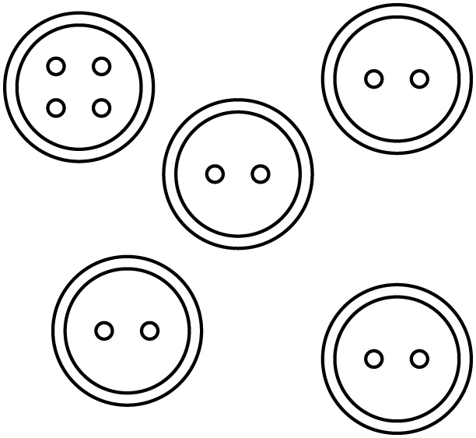 | 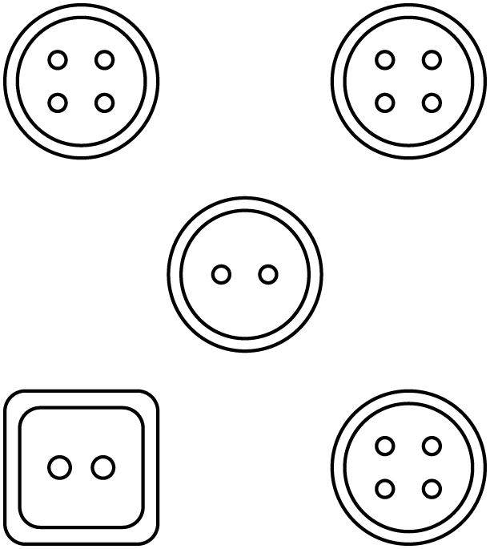
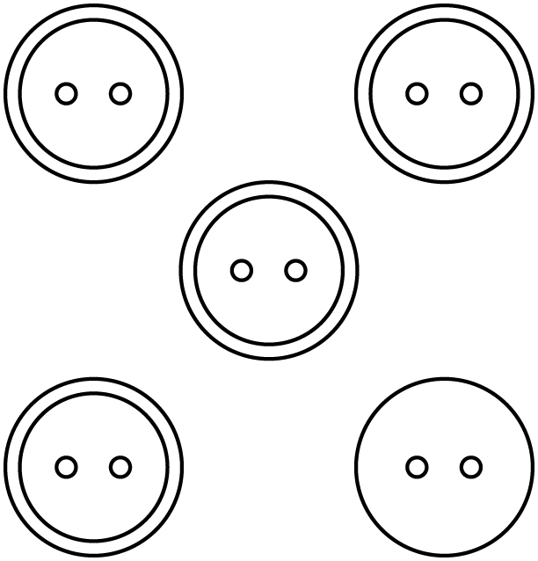 | 