A Lot of Noise Line Master 1
(Assessment Master)
Name: _____________________________

Identify and Extend Repeating Patterns | Not observed | Sometimes | Consistently
Identifies and extends sound/action patterns
Identifies the repeating unit (core) of a pattern
Distinguishes between repeating and non-repeating sequences
Predicts and identifies a missing element of a pattern
Reproduce and Create Repeating Patterns
Reproduces and creates sound (action, colour, shape) patterns
Represents the same pattern different ways
Strengths:

Next Steps:

Connecting Home and School Line Master 2–1

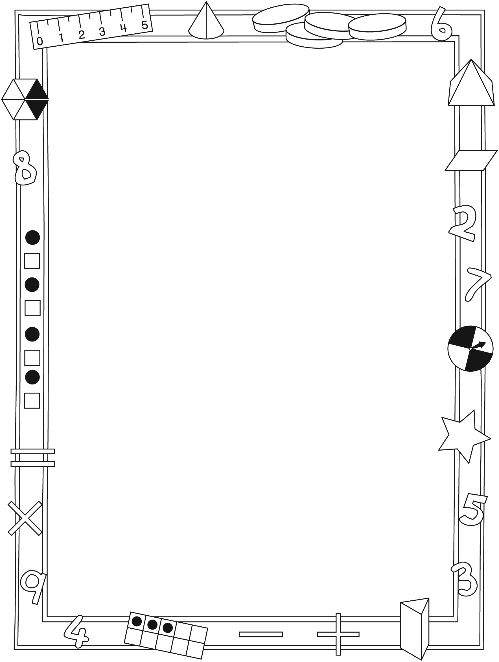

NOTE TO THE TEACHER

You may wish to send families an A Lot of Noise letter outlining a familiar activity or two they can do at home with their children.

Create a letter using this template and select one or two activities from the suggestions on the next page. Simply delete these instructions and cut and paste the activities you have selected, adapting them to fit your needs.

Connecting Home and School Line Master 2–2

Dear Family:

We have been working on A Lot of Noise, which engages children in conversations, investigations, and activities that help to develop their understanding of patterns and repetition. Particular focus is placed on identifying, reproducing, extending, and creating repeating patterns. Try this activity at home with your child.
– – – – – – – – – – – – – – – – – – – – – – – – – – – – – – – – – – – – – – – – – –
Reading the Story: As you read the story, enjoy chanting the sound patterns made by the different objects. You might ask your child to make the pattern longer by saying: What comes next? After that? And after that? After you read, you might find your child chimes in because of the predictable patterned text.
– – – – – – – – – – – – – – – – – – – – – – – – – – – – – – – – – – – – – – – – – –
Pattern Hunt: Search for examples of patterns with your child. You might make
a list to see how many you can find. For each pattern, decide how to describe it, then chant the pattern together.
– – – – – – – – – – – – – – – – – – – – – – – – – – – – – – – – – – – – – – – – – –
Making Patterns: Gather collections of small items to make patterns (e.g., buttons and coins; spoons of two sizes; crayons and markers). Take turns arranging the objects in a pattern for the other to describe and tell what comes next. For example: coin, coin, button, …; big spoon, small spoon, …; crayon, marker, marker, …
– – – – – – – – – – – – – – – – – – – – – – – – – – – – – – – – – – – – – – – – – –
Sincerely,

___________________________

A Lot of Noise Math Mat Line Master 3

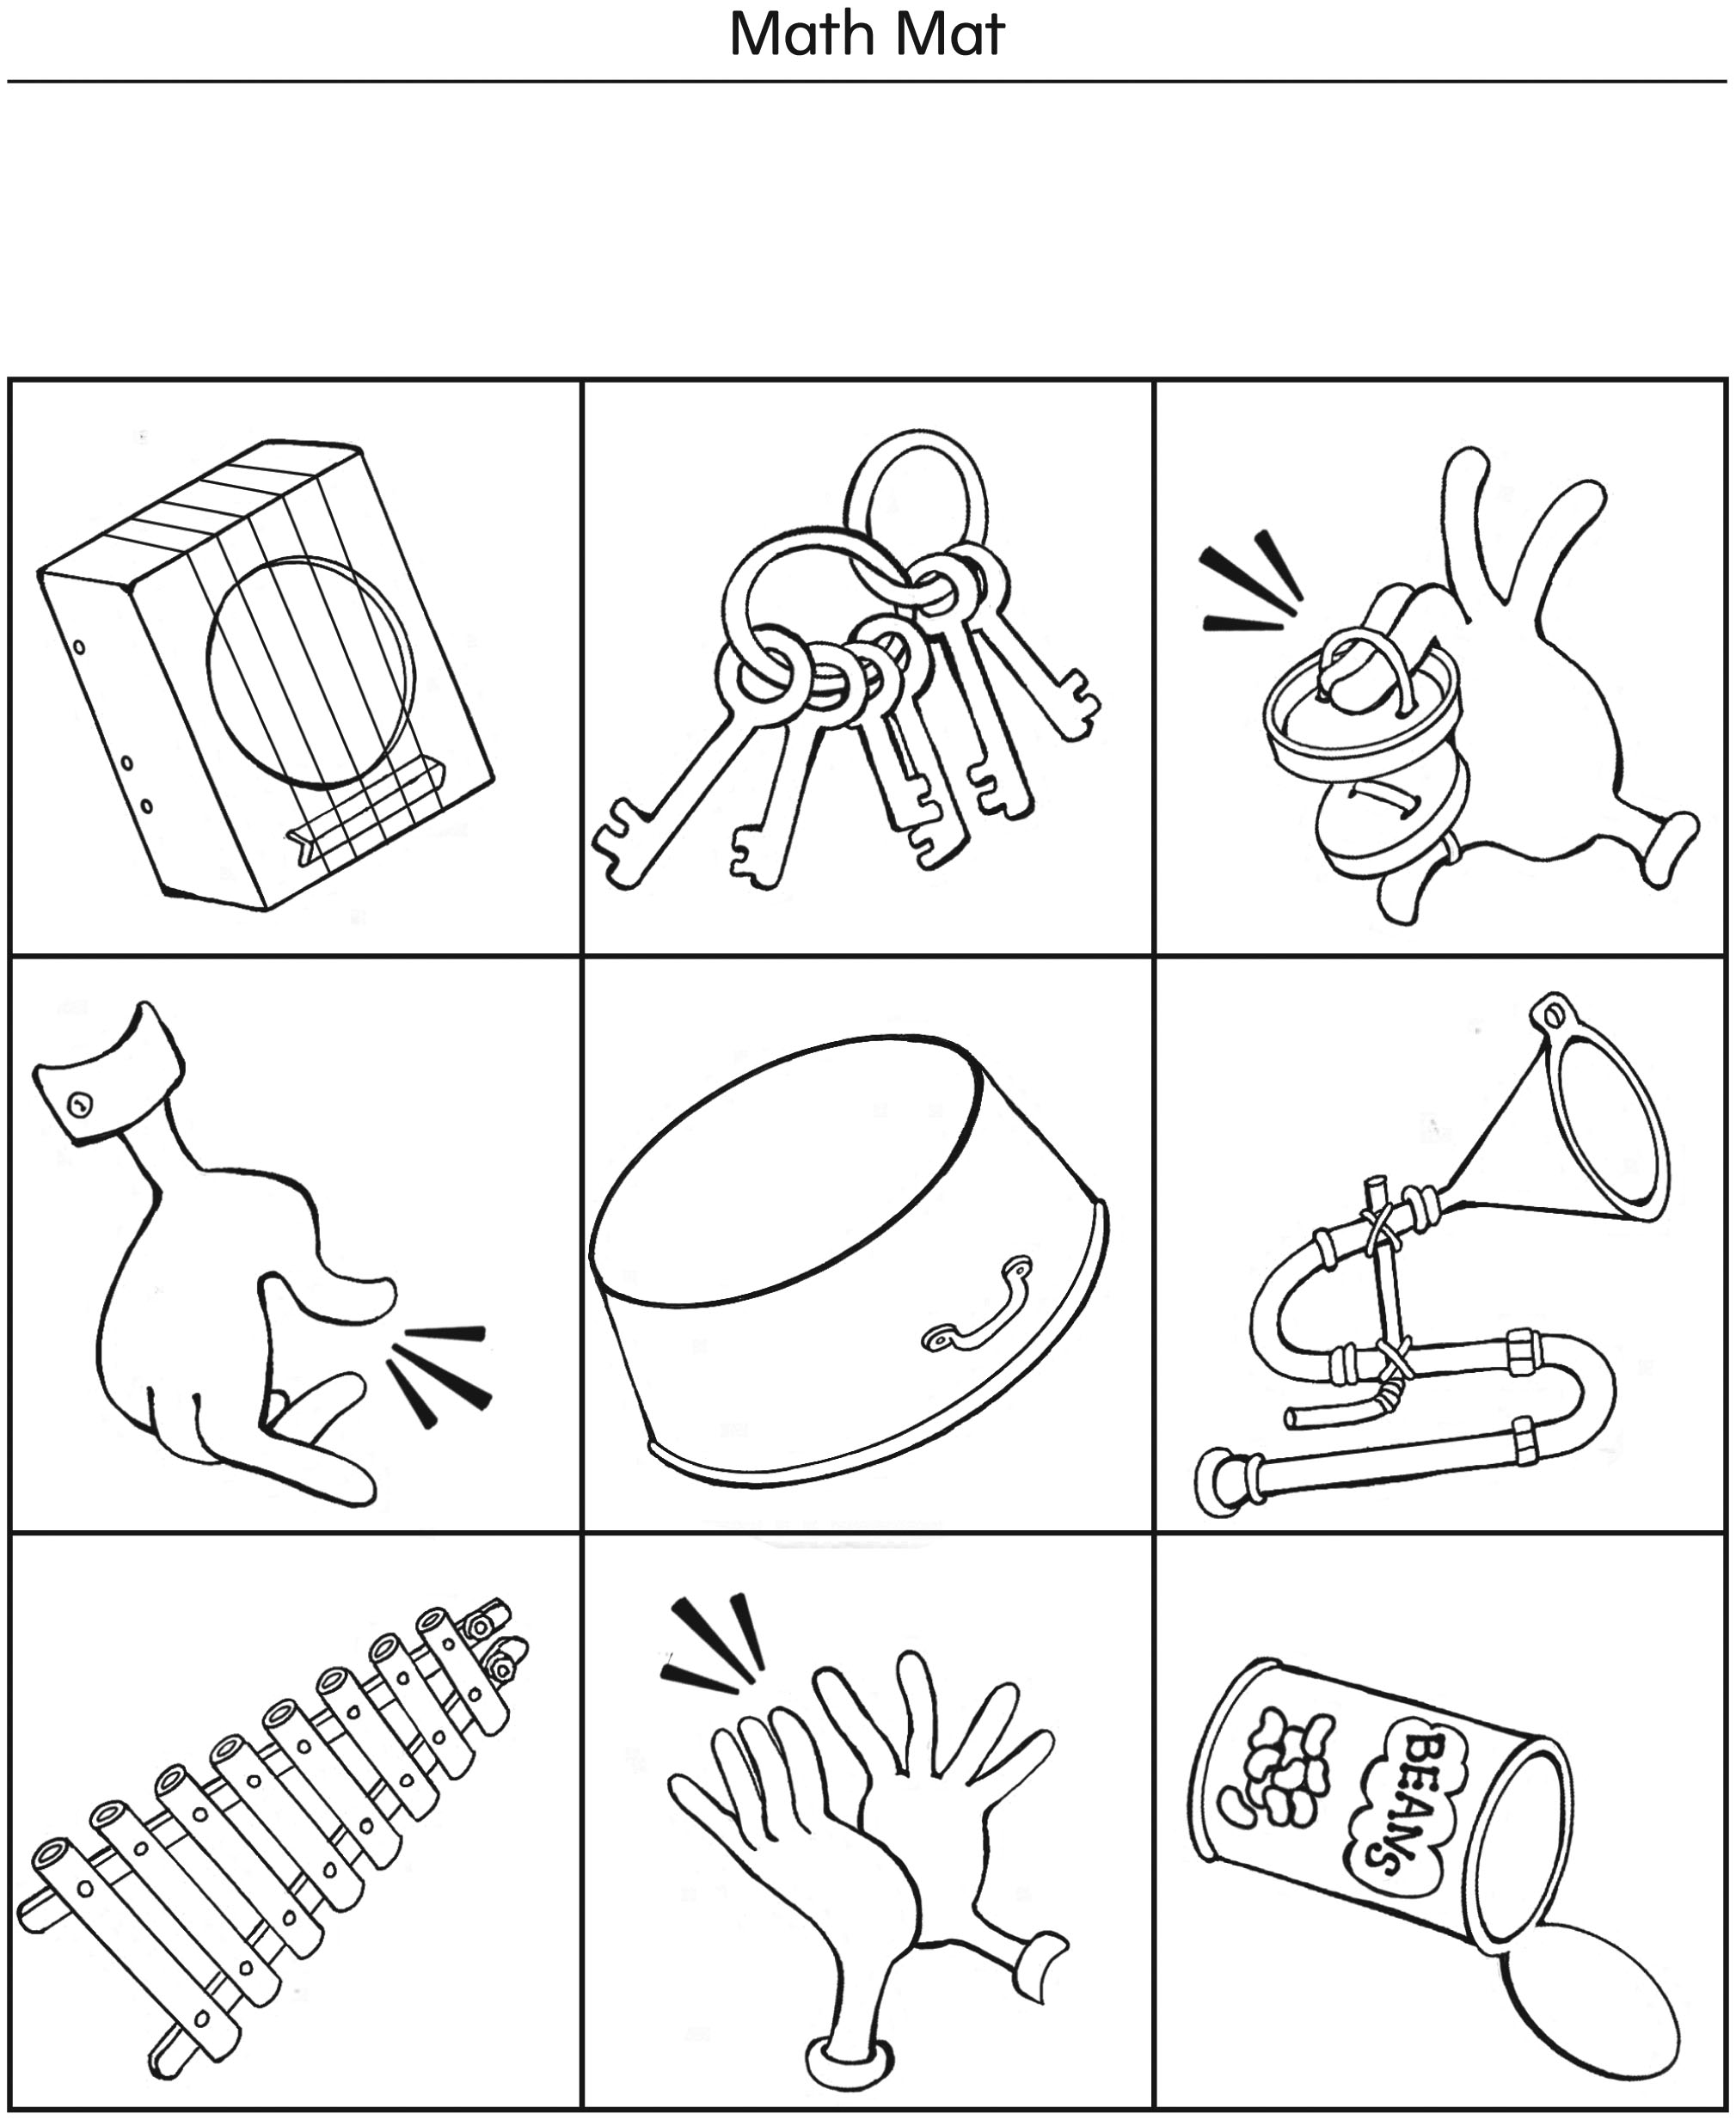

A Lot of Noise Objects Line Master 4

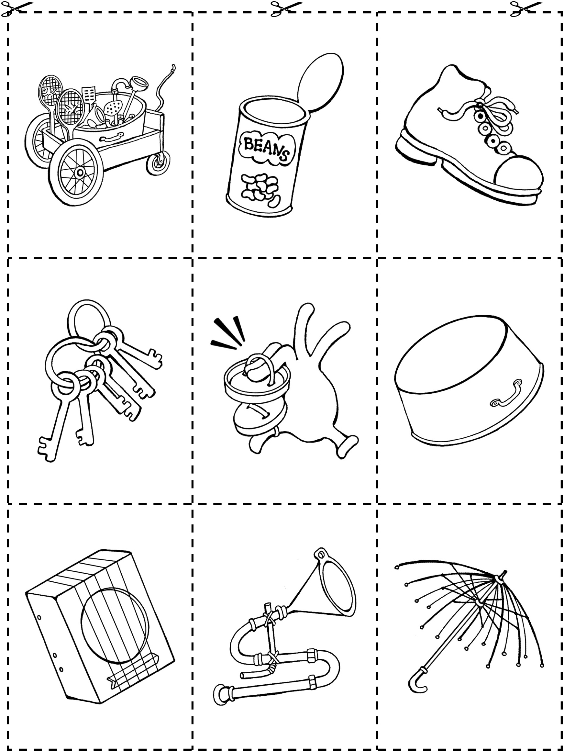

Action Cards Line Master 5

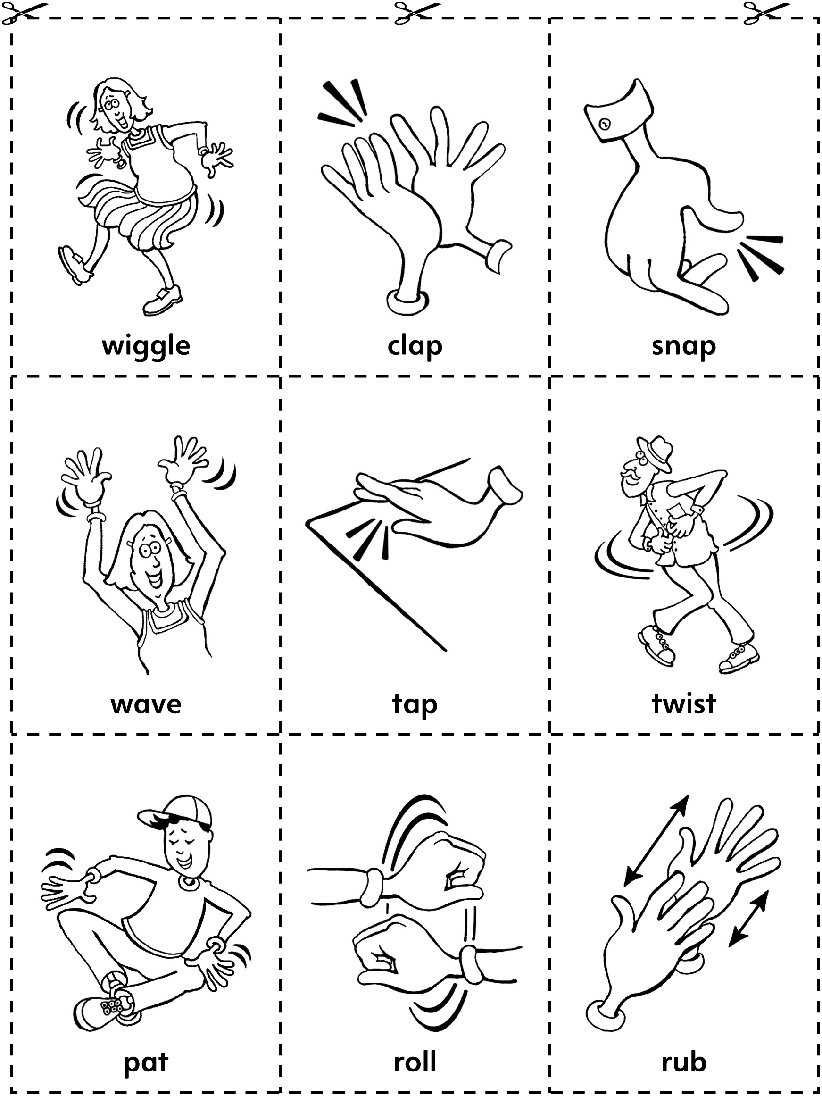

Cube Strips Line Master 6
– – – – – – – – – – – – – – – – – – – – – – – – – – – – – – – – – – – – – – – – – –
– – – – – – – – – – – – – – – – – – – – – – – – – – – – – – – – – – – – – – – – – –
– – – – – – – – – – – – – – – – – – – – – – – – – – – – – – – – – – – – – – – – – –
– – – – – – – – – – – – – – – – – – – – – – – – – – – – – – – – – – – – – – – – – –
– – – – – – – – – – – – – – – – – – – – – – – – – – – – – – – – – – – – – – – – – –
– – – – – – – – – – – – – – – – – – – – – – – – – – – – – – – – – – – – – – – – – –

Pattern Starters Line Master 7–1

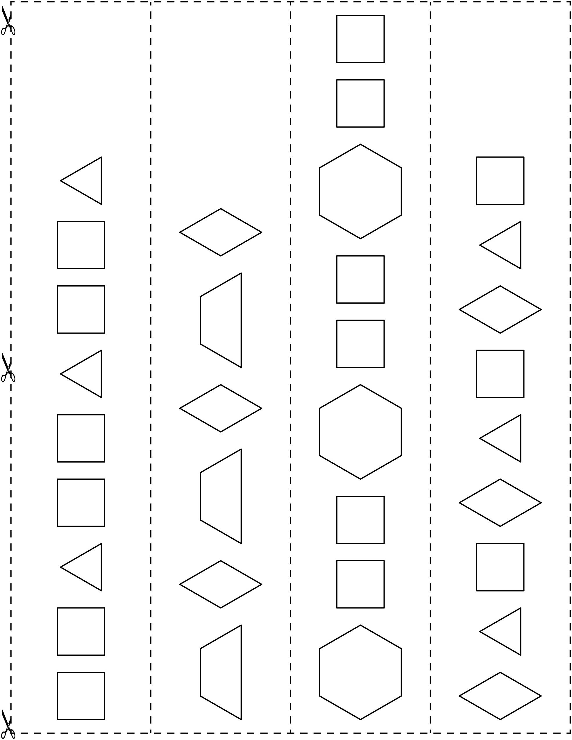

Pattern Starters Line Master 7–2

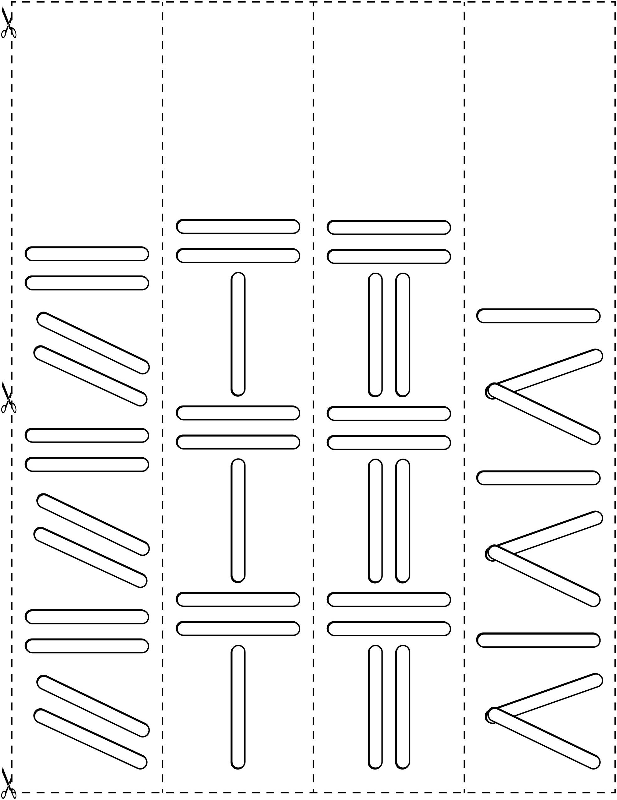

Pattern Starters Line Master 7–3

Musical Patterns Line Master 8

– – – – – – – – – – – – – – – – – – – – – – – – – – – – – – – – – – – – – – – – – –
– – – – – – – – – – – – – – – – – – – – – – – – – – – – – – – – – – – – – – – – – –
– – – – – – – – – – – – – – – – – – – – – – – – – – – – – – – – – – – – – – – – – –
– – – – – – – – – – – – – – – – – – – – – – – – – – – – – – – – – – – – – – – – – –
– – – – – – – – – – – – – – – – – – – – – – – – – – – – – – – – – – – – – – – – – –
– – – – – – – – – – – – – – – – – – – – – – – – – – – – – – – – – – – – – – – – – –
– – – – – – – – – – – – – – – – – – – – – – – – – – – – – – – – – – – – – – – – – –
– – – – – – – – – – – – – – – – – – – – – – – – – – – – – – – – – – – – – – – – – –

Sounds Are Everywhere! Line Master 9
Name: _____________________________

I see | I hear

Solving Problems Line Master 10–1

– – – – – – – – – – – – – – – – – – – – – – – – – – – – – – – – – – – – – – – – – –
Circle what comes next.
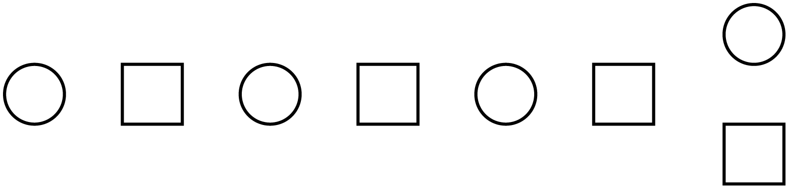
– – – – – – – – – – – – – – – – – – – – – – – – – – – – – – – – – – – – – – – – – –
Circle what comes next.
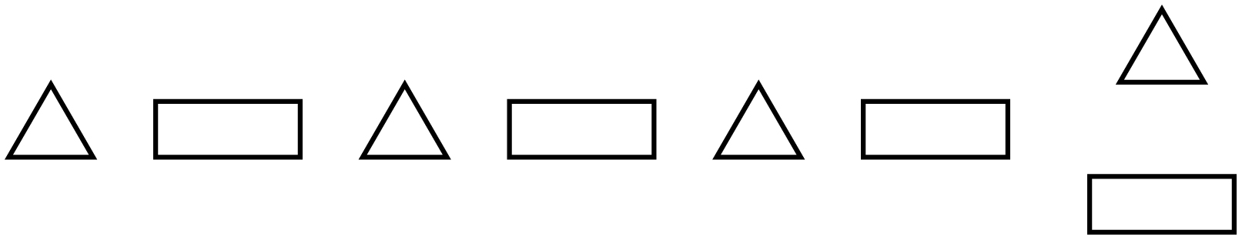
– – – – – – – – – – – – – – – – – – – – – – – – – – – – – – – – – – – – – – – – – –
Circle what comes next.
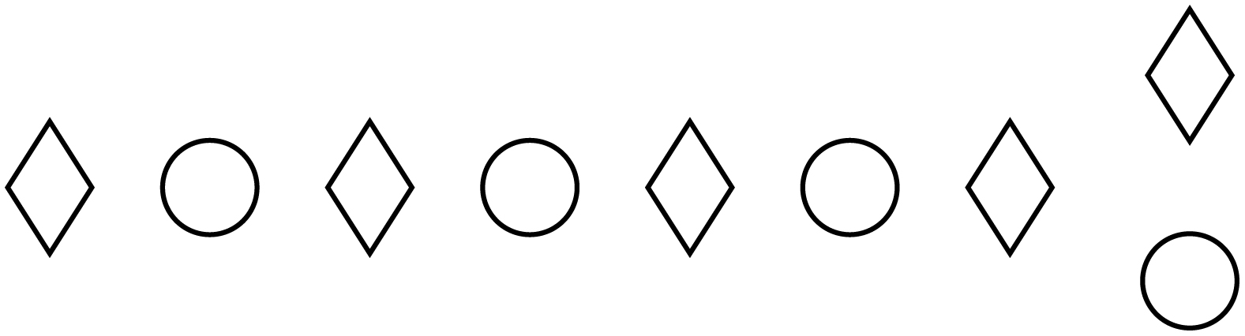
– – – – – – – – – – – – – – – – – – – – – – – – – – – – – – – – – – – – – – – – – –
Circle what comes next.
– – – – – – – – – – – – – – – – – – – – – – – – – – – – – – – – – – – – – – – – – –
Circle what comes next.
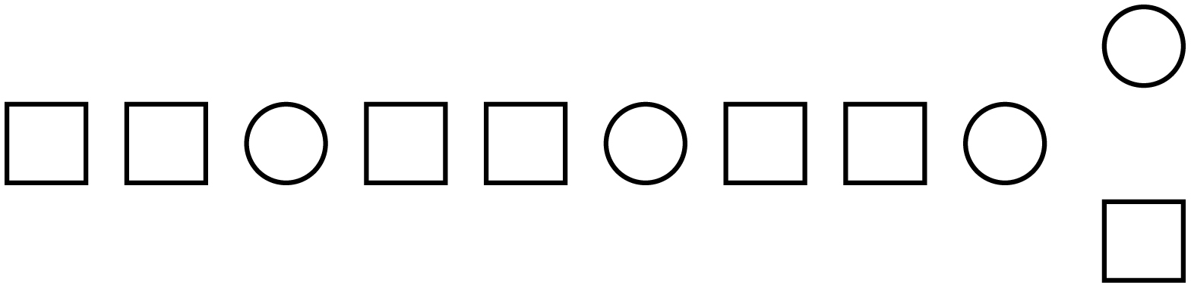
– – – – – – – – – – – – – – – – – – – – – – – – – – – – – – – – – – – – – – – – – –

Solving Problems Line Master 10–2

– – – – – – – – – – – – – – – – – – – – – – – – – – – – – – – – – – – – – – – – – –
What is missing?
– – – – – – – – – – – – – – – – – – – – – – – – – – – – – – – – – – – – – – – – – –
What is missing?
– – – – – – – – – – – – – – – – – – – – – – – – – – – – – – – – – – – – – – – – – –
What is missing?
– – – – – – – – – – – – – – – – – – – – – – – – – – – – – – – – – – – – – – – – – –
What is missing?
– – – – – – – – – – – – – – – – – – – – – – – – – – – – – – – – – – – – – – – – – –
What is missing?
– – – – – – – – – – – – – – – – – – – – – – – – – – – – – – – – – – – – – – – – – –

