**Hundred Charts (101–200)**

**Master 14a**

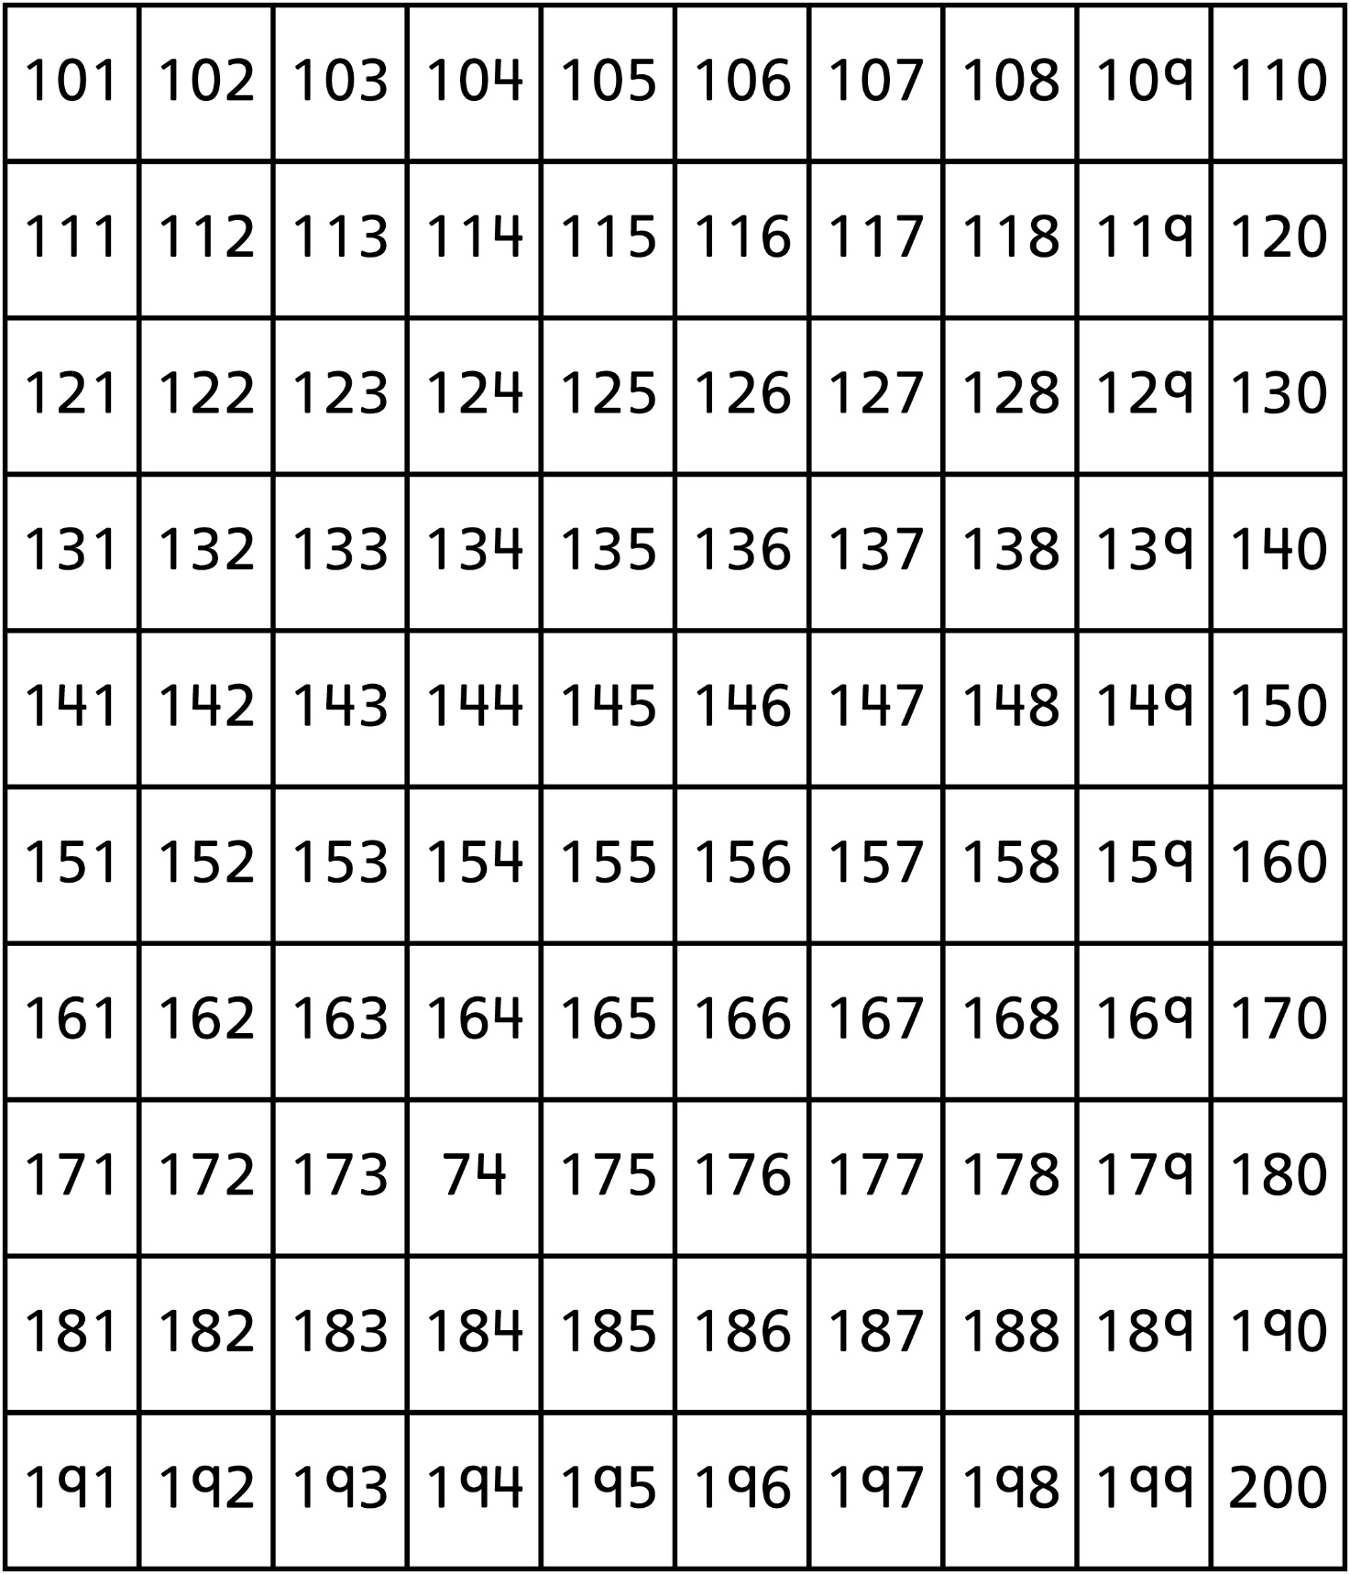



**Hundred Charts (201–300)**

**Master 14b**

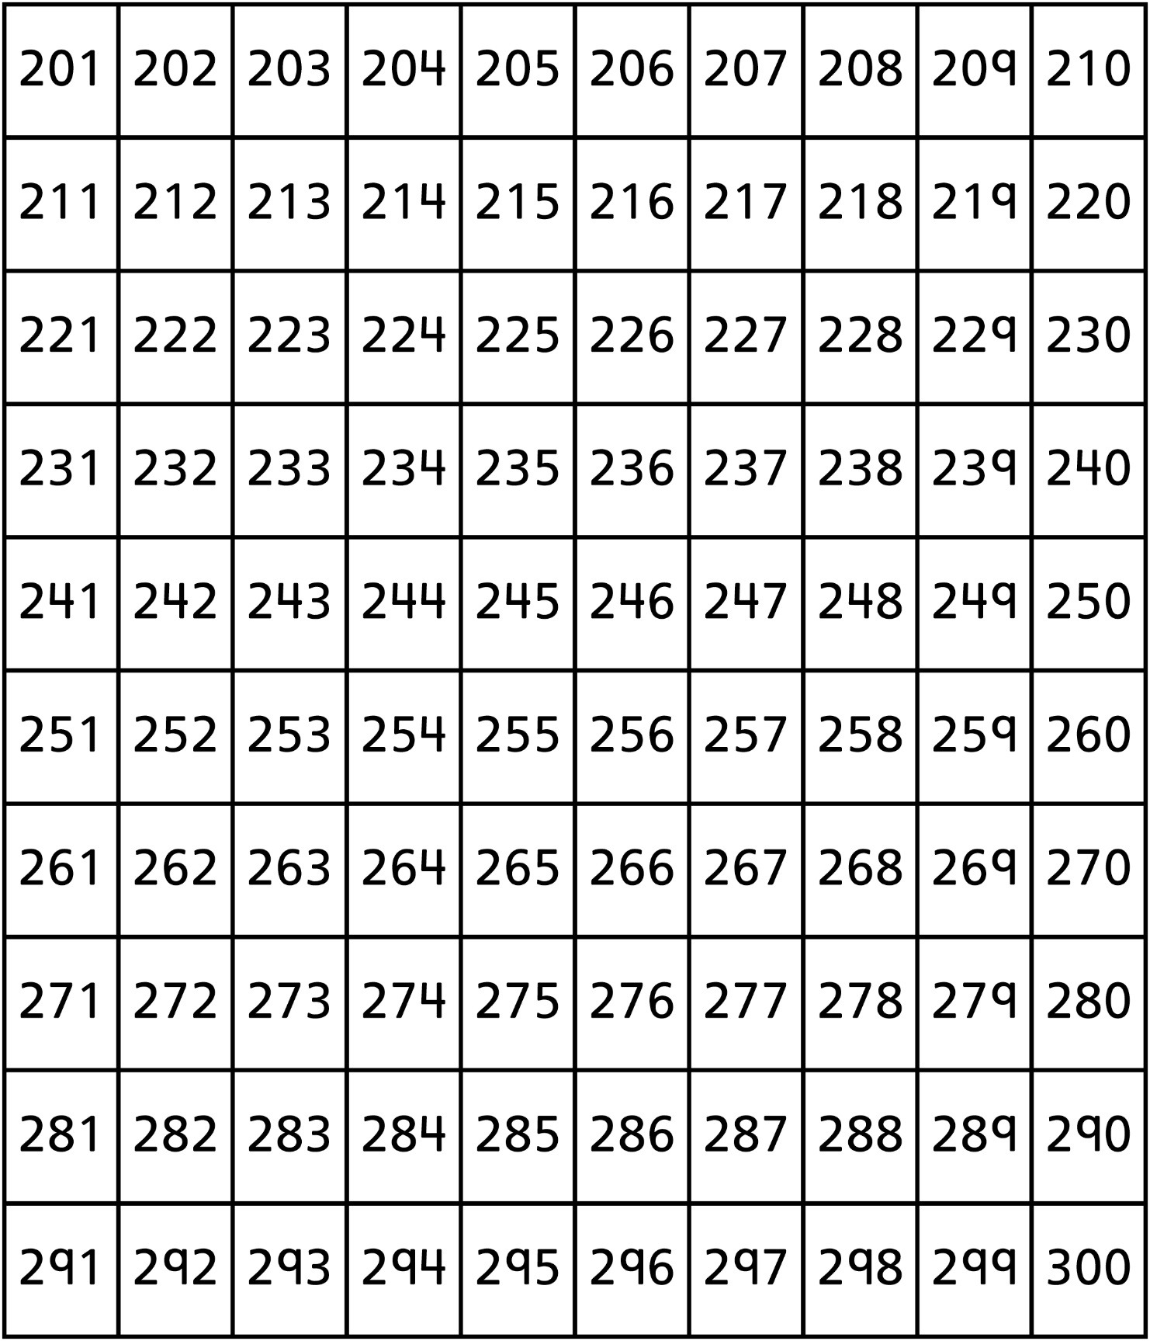

**Hundred Charts (301–400)**

**Master 14c**

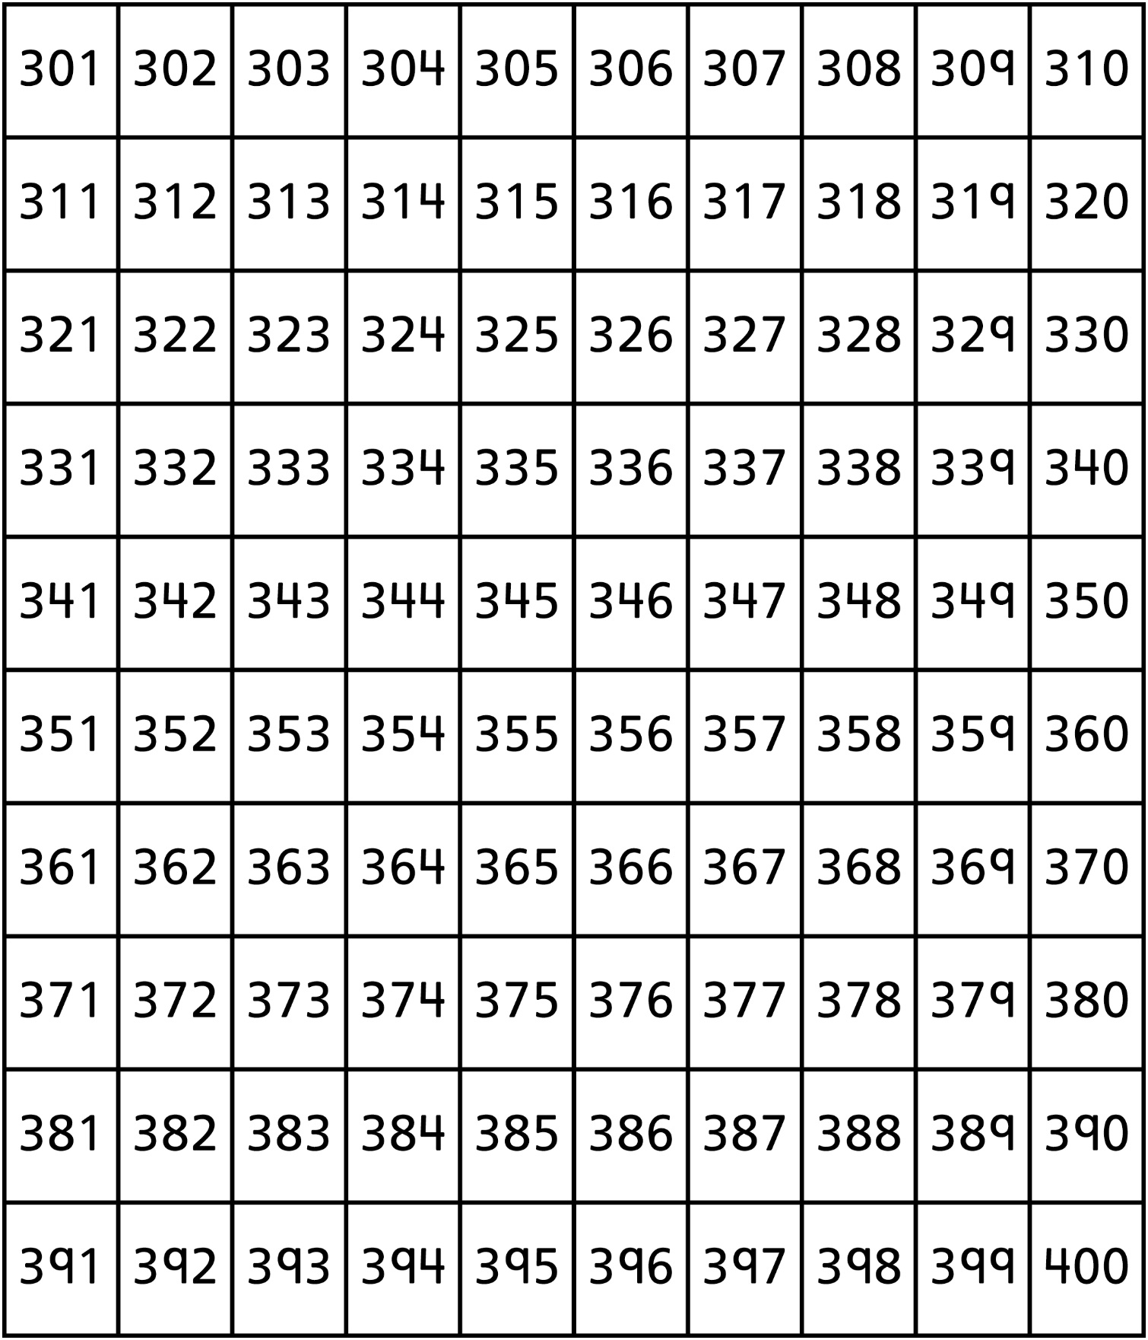

**Hundred Charts (401–500)**

**Master 14d**

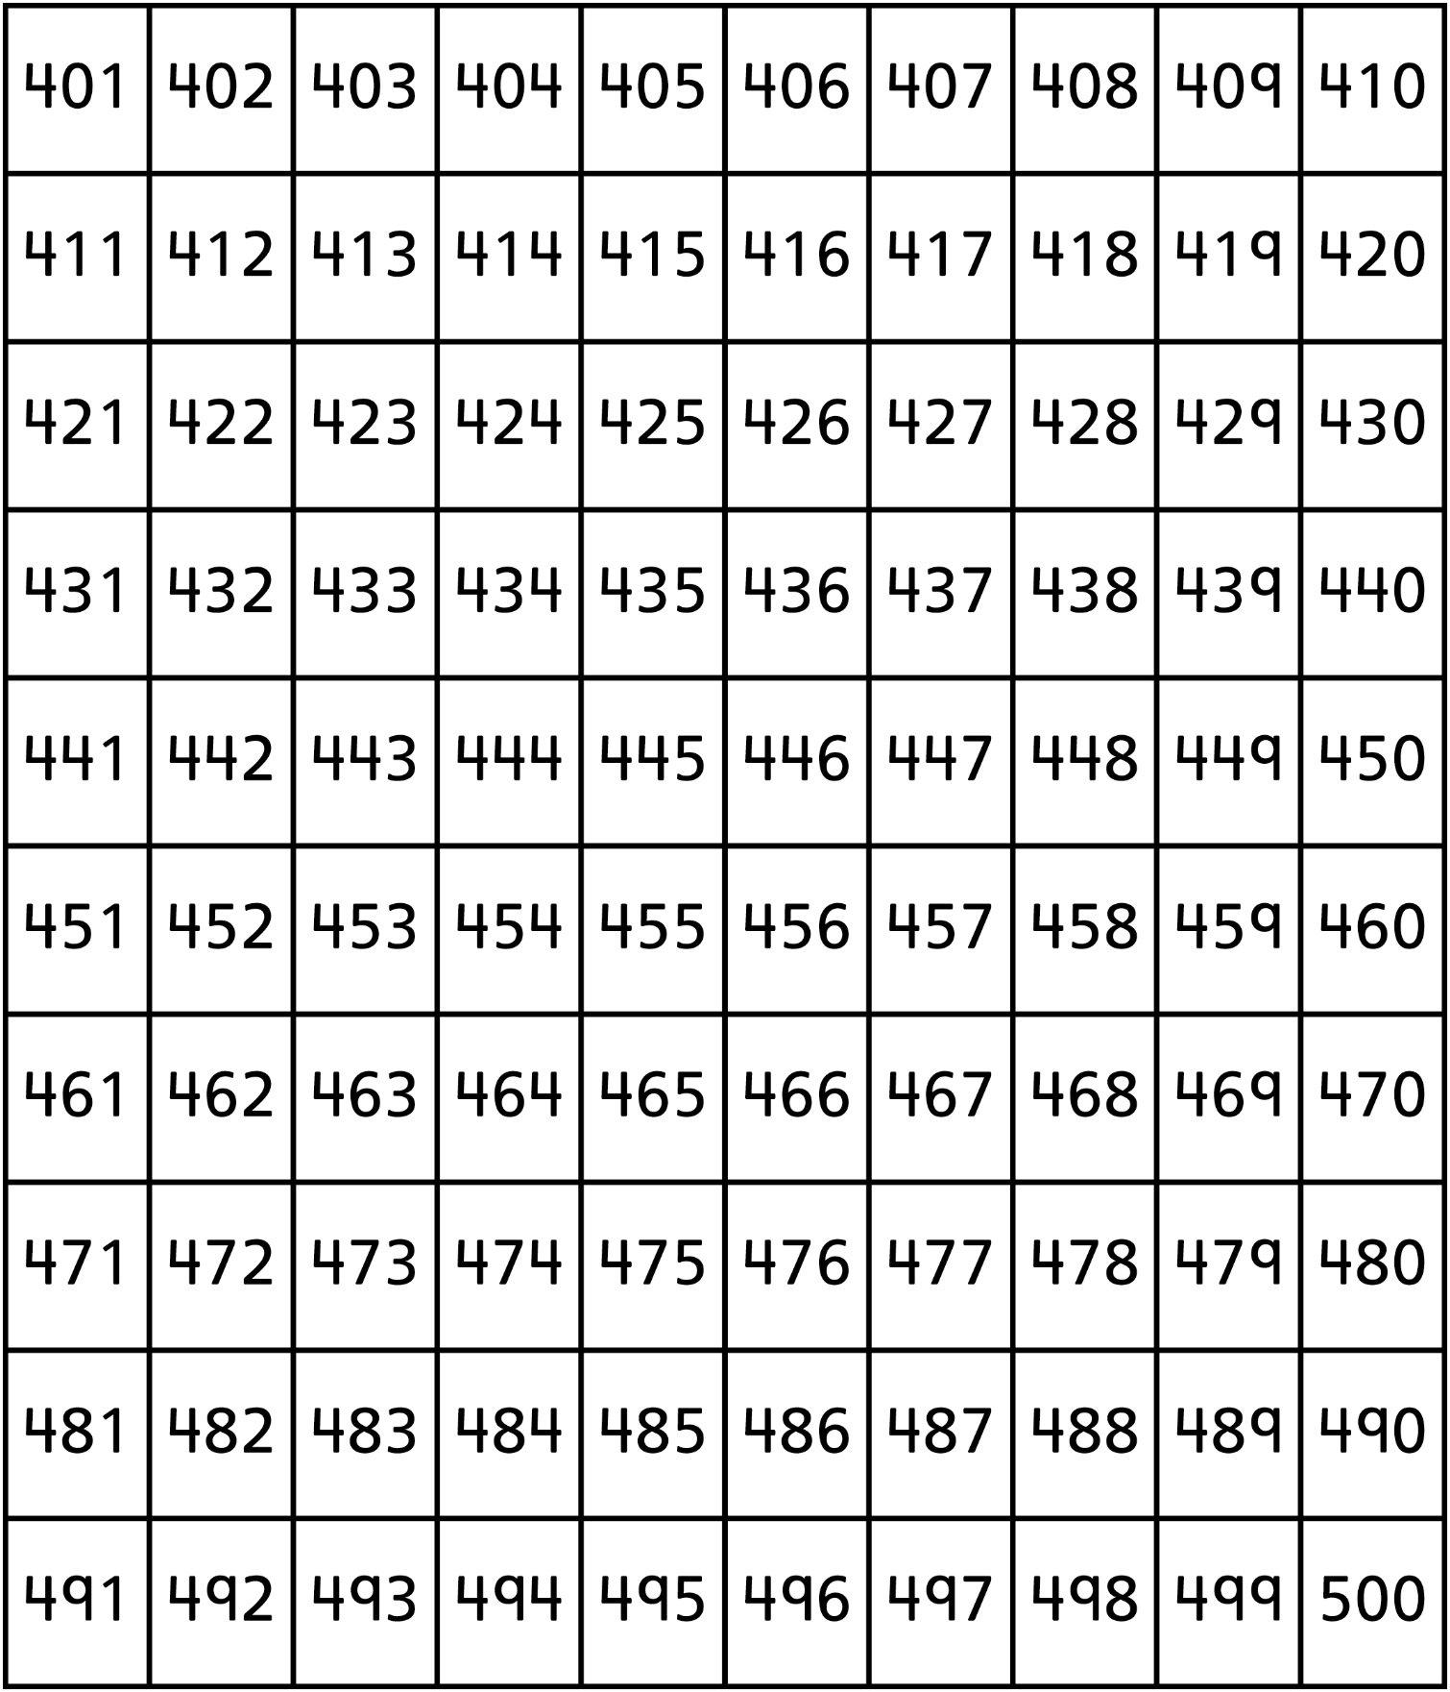

**Hundred Charts (501–600)**

**Master 14e**

**Hundred Charts (601–700)**

**Master 14f**

**Hundred Charts (701–800)**

**Master 14g**

**Hundred Charts (801–900)**

**Master 14h**

**Hundred Charts (901–1000)**

**Master 14i**

