Simulating Multiple Rolls of a Die

Data Management
Unit 1 Line Master 8a

Let’s alter our code from Master 7 to include a loop, or a repeat, which will simulate rolling a die hundreds, thousands, and even millions of times!

A loop is a repetition of instructions used in code. In Scratch, a repeat is used to make code blocks loop through multiple times.

What do you think will happen to the relative frequency
of rolling a 3 with so many rolls?

Relative frequency provides a better estimate of the likelihood
of an event with larger amounts of data.

- We will start by adding a repeat block so that the die rolls
10 times at once.
- Click the link to access the completed code from Master 7:
https://scratch.mit.edu/projects/878489604/editor

- From the Control tab, select the Repeat 10 block and place it around all the code under the green flag block.
- Since we are rolling the die 10 times and are keeping track of the number of times a 3 is rolled in the num3Rolled variable,
we can remove the say 3! block.
- Click on the green flag multiple times to see what happens! Don’t forget that if you’d like to reset the variables to 0,
you can click on the space bar.

Simulating Multiple Rolls of a Die

Data Management
Unit 1 Line Master 8b

Here is a screenshot of the completed code.

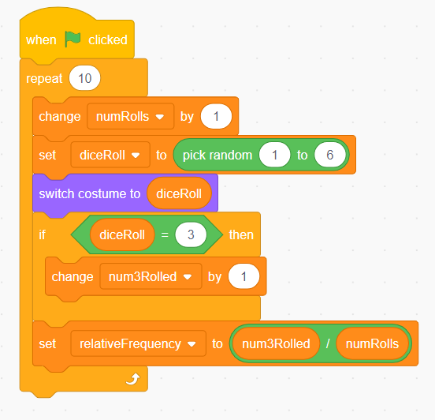

- Let’s loop the code even more times!
- Try changing the repeat number to 100 and then 1000.
- What do you notice about the relative frequency
of rolling a 3?
- Does it get closer to the expected likelihood of $\frac{1}{6}$ or about 0.17?

Simulating Multiple Rolls of a Die

Data Management
Unit 1 Line Master 8c

- When you changed the repeat to 1000, you might have noticed that you had to wait a while for the 1000 rolls to happen.
We can use Turbo Mode in Scratch to make this happen faster!
- To turn on Turbo Mode, select Edit and Turn on Turbo Mode.
- Try clicking the green flag with 1000 in the repeat
to see what happens.
- Change the repeat to 10 000 and even 1 000 000 or more!
- What do you notice about the relative frequency when you roll the die so many times?

