Reflecting a Polygon
Geometry
Unit 1 Line Master 6a

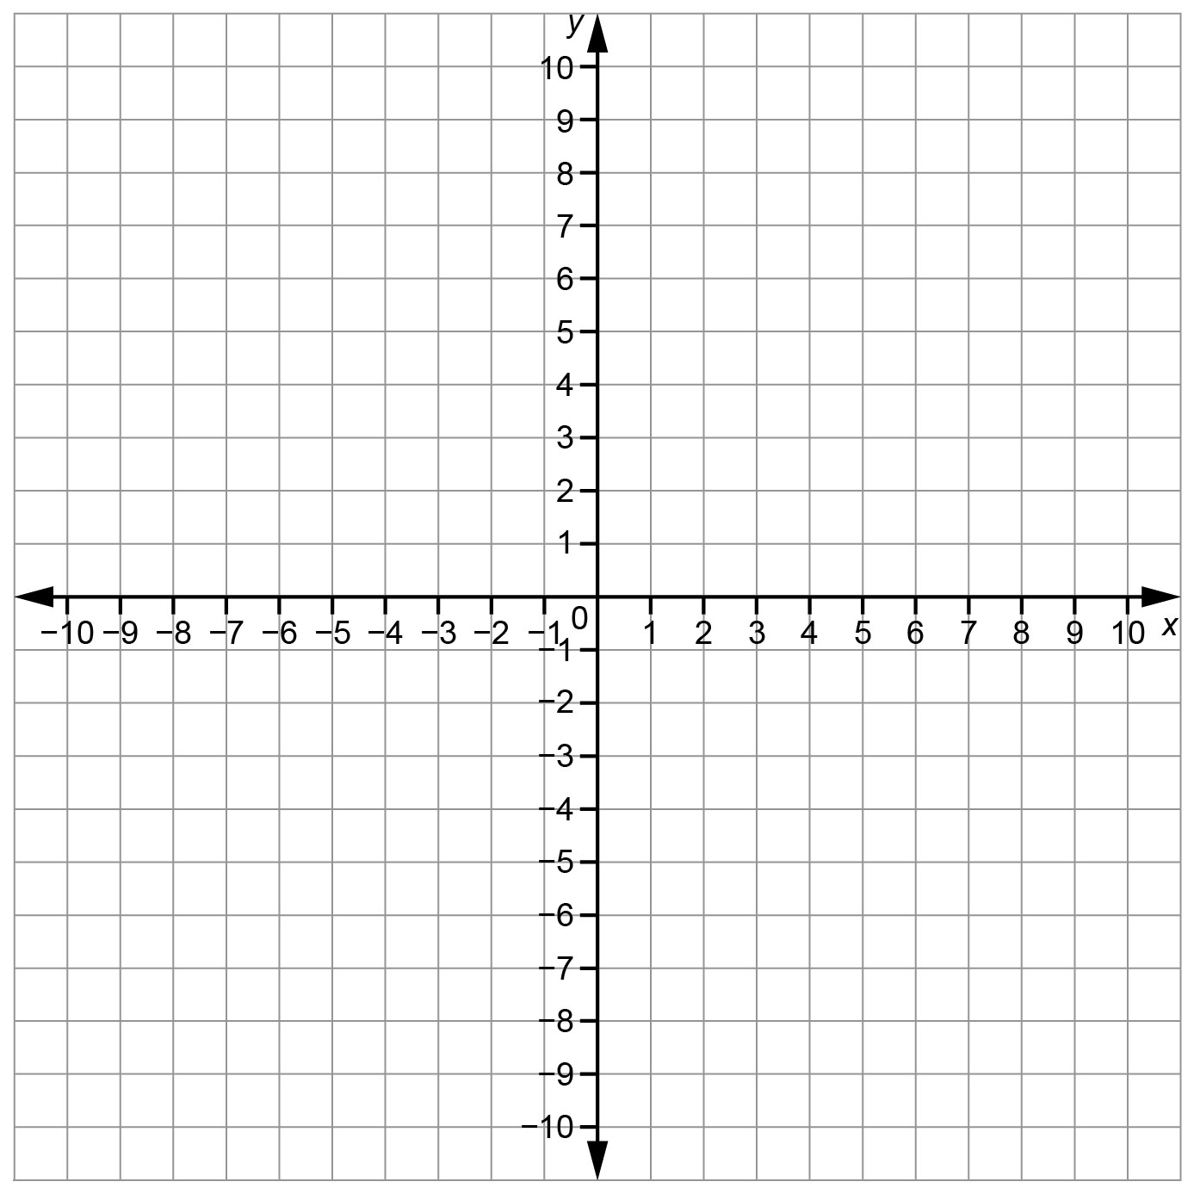

Reflecting a Polygon (cont’d)
Geometry
Unit 1 Line Master 6b

Reflection Image 1
Description | Coordinates of Vertices of Polygon | Coordinates of Vertices of Image 1
Reflection Image 2
Description | Coordinates of Vertices of Polygon | Coordinates of Vertices of Image 2

