Investigating Functions
Identifies variables (dependent and independent) as changing quantities in a given situation.  Kaspar earned $20 to spend on loot bags for their party guests. They want to put a mini flashlight in each loot bag. A flashlight costs $3.  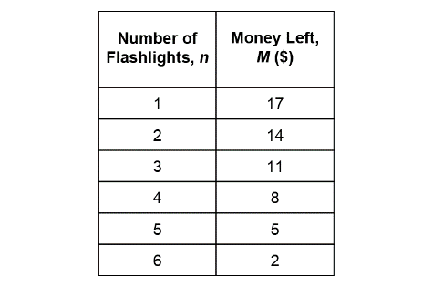  “The money left depends on  the number of flashlights bought.  So, M is the dependent variable and n is the independent variable.” | Describes the rule that relates the values of the dependent variable to the values of the independent variable.  “Multiply the number of flashlights bought by 3, then subtract from 20  to get the money left in dollars.” | Represents corresponding values of the dependent and independent variables of a function (table of values, points on the Cartesian plane).  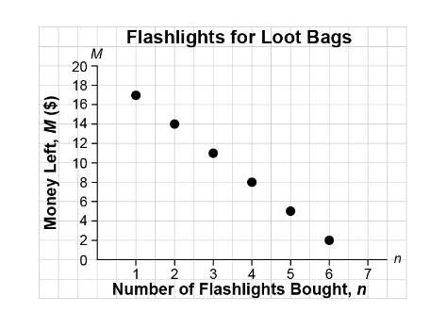  “From the graph, I can see that  as the number of flashlights increases by 1, the money left decreases by 3.” | Represents a function as an algebraic expression.  “I used the rule to write an algebraic expression: Multiply the number  of flashlights purchased, n, by 3, then subtract from 20 to get the money left in dollars, M.  The expression is 20 − 3n.”
Observations/Documentation

Investigating Functions (cont’d)
Relates between various representations of the same function.  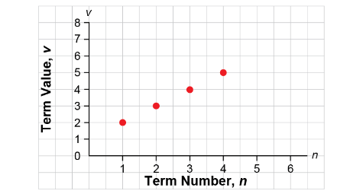  Add 1 to the term number, n, to get the term value, v.  “The graph and the rule  both represent the same function because on the graph,  each term value is one more  than the term number.” | Determines a value of the dependent variable given the independent variable.  Bikes are available for rent for $10, plus $3 per hour. How much would it cost to rent a bike for 9 hours?  “An expression that relates the total cost, C, to the number of hours, n, is 3n + 10.  To find the cost for 9 hours,  I evaluated the expression for n = 9.  3(9) + 10 = 37  It would cost $37.” | Uses strategies flexibly to determine a value of the independent variable given the value of the dependent variable.  A person paid $43. For how many hours did they rent the bike?  “I set the expression equal to 43, then used inverse operations  to solve the equation.”  3n + 10 = 43  3n + 10 – 10 = 43 – 10  3n = 33  $\frac{3n}{3}$ = $\frac{33}{3}$  n = 11 | Flexibly solves problems involving functions.  Yuri has $455 in the bank. To buy tickets, Yuri takes out $15 each week, for 20 weeks. After 20 weeks, will Yuri have enough money left to donate $175 to the Terry Fox Run?  “An expression that relates the amount left in the bank in dollars, A, to the number of weeks, w, is:  455 – 15w  After 20 weeks, the amount left  in the bank will be: 455 – 15(20) =  455 – 300, or 155; $155.  Yuri will not be able to donate $175 to the Terry Fox Run.”
Observations/Documentation

