Multiplication with Proper Fractions
Models multiplication situations concretely and pictorially.  4 × $\frac{3}{5}$ = ?  “I modelled the multiplication with fraction strips, then counted fifths:  4 × $\frac{3}{5}$ = $\frac{12}{5}$, or 2$\frac{2}{5}$” | Uses models and think-addition strategies, to solve multiplication problems.  5 × $\frac{2}{5}$ = ?  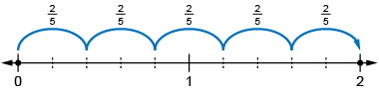  “I know that multiplication is like repeated addition, so I used a number with each whole partitioned into fifths, then took  5 jumps of two-fifths: 5 × $\frac{2}{5}$ = 2” | Relates multiplication of a natural number by a unit fraction to division.  4 × $\frac{1}{5}$ = 4 ÷ 5 | Flexibly solves multiplication problems.  5 × $\frac{3}{4}$ = $\frac{5 × 3}{4}$  = $\frac{15}{4}$  = 3$\frac{3}{4}$
Observations/Documentation

