Multiplying and Dividing Decimals by 2-Digit Numbers
Models multiplication and division situations concretely and pictorially.  1.6 × 3 = ?  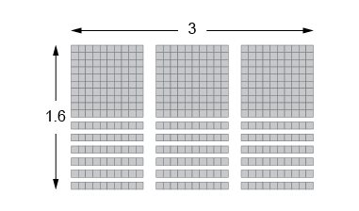  “I used Base Ten Blocks to make an array  with length 3 and width 1.6.  I then counted the blocks to get 4.8.  I could also use repeated addition:.  1.6 + 1.6 + 1.6 = 4.8” | Uses models and other strategies to solve multiplication and division situations.  4.15 × 25 = ?  4.15 × 25 = (4.0 + 0.10 + 0.05) × (20 + 5)  = (4.0 × 20) + (0.10 × 20) + (0.05 × 20)  + (4.0 × 5) + (0.10 × 5) + (0.05 × 5)  = 80.0 + 2.0 + 1.0 + 20 + 0.5 + 0.25  = 103.75 |  |  | Uses the standard algorithm to multiply.  4.15 × 25 = ?  “First, I multiplied as if there was no decimal.  Next, I counted the number of digits  after the decimal point in each factor.  Then I placed the same number of digits  after the decimal point in the product.”  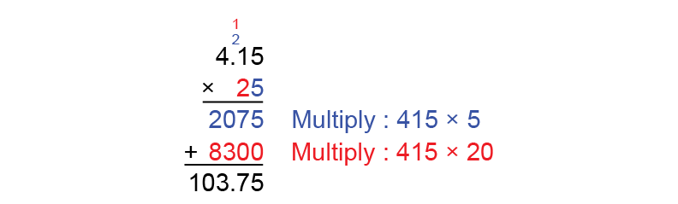
Observations/Documentation

Multiplying and Dividing Decimals by 2-Digit Numbers (cont’d)
Decomposes numbers to use partial quotients  to divide.  4.44 ÷ 12 = ?  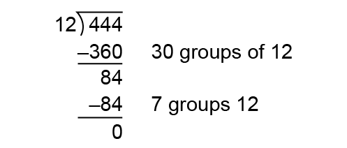  “I used partial quotients to divide  as whole numbers, then estimated  to place the decimal point.  4.44 is about 4 and 12 is about 10.  So, 4 ÷ 10 = 0.40  So, I placed the decimal point so 37  is close to 0.40: 0.37.” | Estimates to determine if answer to multiplication or division problem is reasonable.  “$4.44 is about $4 and 12 is about 10.  So, $4 ÷ 10 = $0.40  So, the answer is reasonable.” |  | Solves multiplication and division problems flexibly using a variety of strategies.  The area of a rectangular garden plot is 95.2 m2. The length of the garden is 14 m.  What is the width?  “I divided as I would whole numbers, then used estimation to place the decimal point.  95.2 is about 100, and 14 is about 10.  100 ÷ 10 = 10.  I placed the decimal point  so that 68 is close to 10: 6.8.  The width of the garden is 6.8 m.”
Observations/Documentation

