Interpreting and Expressing Volume
Explores volume as the amount of space occupied by a 3-D shape.  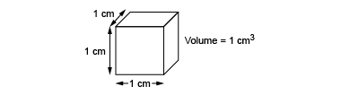  “This cube occupies a space  that can be measured.  Each edge has a length of 1 cm  and it has a volume of 1 cm³.” | Recognizes volume of 3-D shapes in familiar contexts.  “Everyday objects have volume;  for example, a loaf of bread  and a cereal box.” | Models volume using concrete materials (non-standard units).  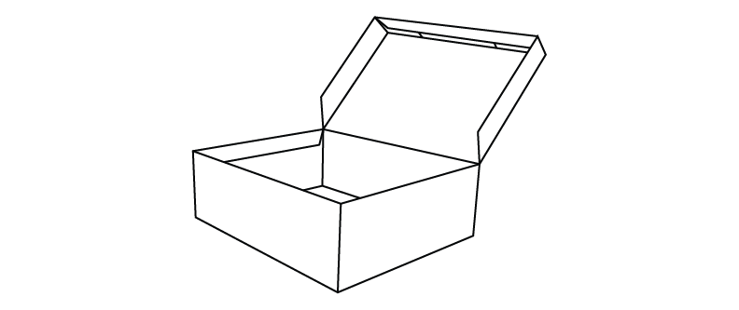  “The volume of the box  is about 12 marbles.  Marbles aren’t the greatest unit because they leave gaps.” | Expresses volume of 3-D shapes using standard units (cubic metres, cubic centimetres).  “I filled the box with centimetre  cubes. The volume of the box  is about 24 cm³.”
Observations/Documentation

Interpreting and Expressing Volume (cont’d)
Models volume of a rectangular prism as a 3-D array of cubic units.  “The prism is a 3-D array of centimetre cubes. There are  12 cubes in each layer and 3 layers: 12 + 12 + 12 = 36.  The prism has volume 36 cm³.” | Recognizes that volume remains the same when decomposed or rearranged.  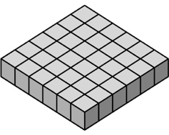  “I rearranged the 36 centimetre cubes to make a different prism.  The number of cubes didn’t change so, the volume is still 36 cm³.” | Determines the volume of a rectangular prism using multiplication.  “The prism has length 4 cm,  width 3 cm and height 3 cm.  The area of the base is  4 cm × 3 cm = 12 cm², and the volume of the prism is:  Area of the base × height  = 12 cm² × 3 cm  = 36 cm³.” | Flexibly solves problems in various contexts that involve the volume of rectangular prisms.  A square prism has height 11 cm and volume 539 cm³. Determine the side length of the square base.  “Volume = area of base × height 539 cm³ = Area of the base × 11 cm  539 ÷ 11 = 49  So, the area of the base is 49 cm².  The base is a square, so all sides are equal: 49 cm² = s × s  Since 7 × 7 = 49, the side length  of the square base is 7 cm.”
Observations/Documentation

