Data Management
Unit 1 Line Master 1a
Data Sets

Data Sets

Set A
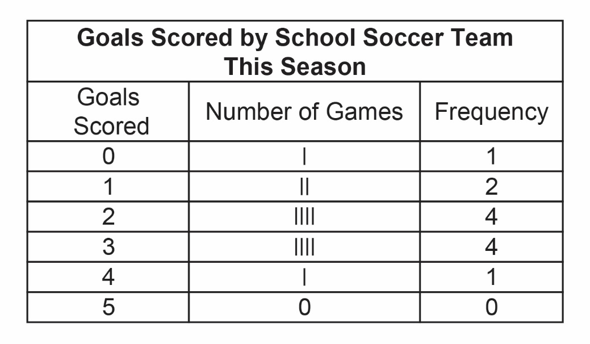
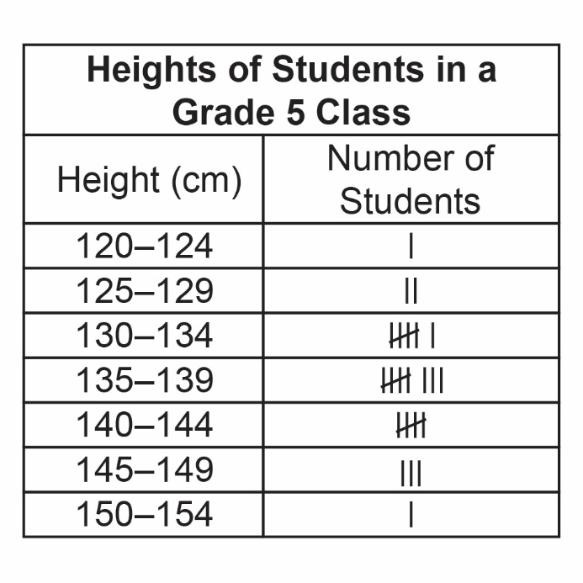
Set B

Data Management
Unit 1 Line Master 1b
Data Sets (cont’d)

Set C
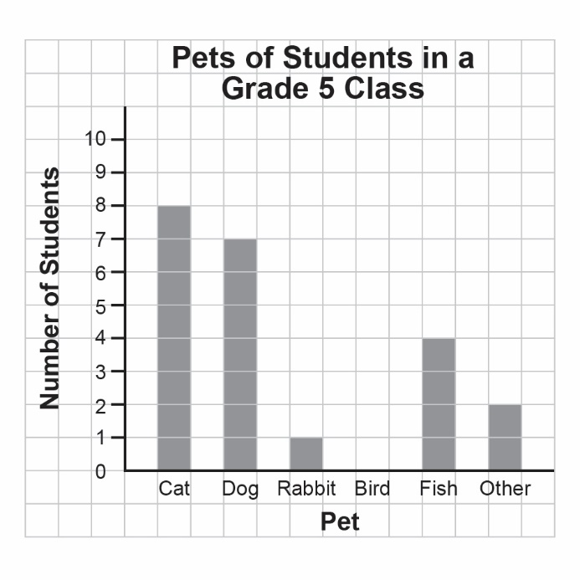

Set D

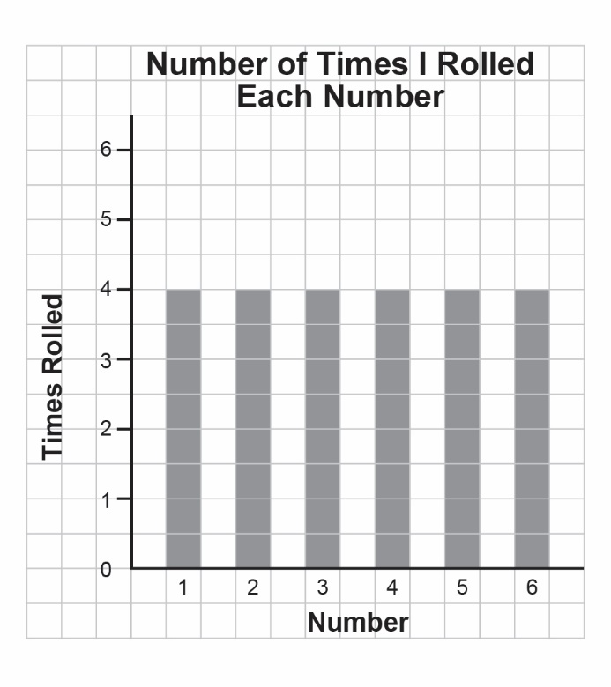

Data Management
Unit 1 Line Master 1c
Data Sets (cont’d)

Set E
A student’s practice times, in seconds, for the 200-m dash:
30, 27, 28, 31, 29, 31, 28, 27, 29, 32, 29, 28, 28, 33, 29

Set F
Pulse rates of Grade 5 Students (beats per minute):
69, 83, 66, 78, 82, 67, 76, 84, 64, 72, 80, 72, 70, 69, 80, 66, 72, 88, 88, 72, 65, 78, 68, 71

