Using Variables

Patterning and Algebra
Unit 2 Line Master 1

Problem or Picture | Equation
Janie rolled 10 with two number cubes.
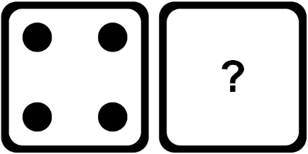
What number was on the other cube?
There are 12 cars in the parking lot.
The cars are parked in rows of 4.
How many rows are there?
 | 3a = 15
