Complete the Chase!
Gameboard

Number
Unit 5 Line Master 5

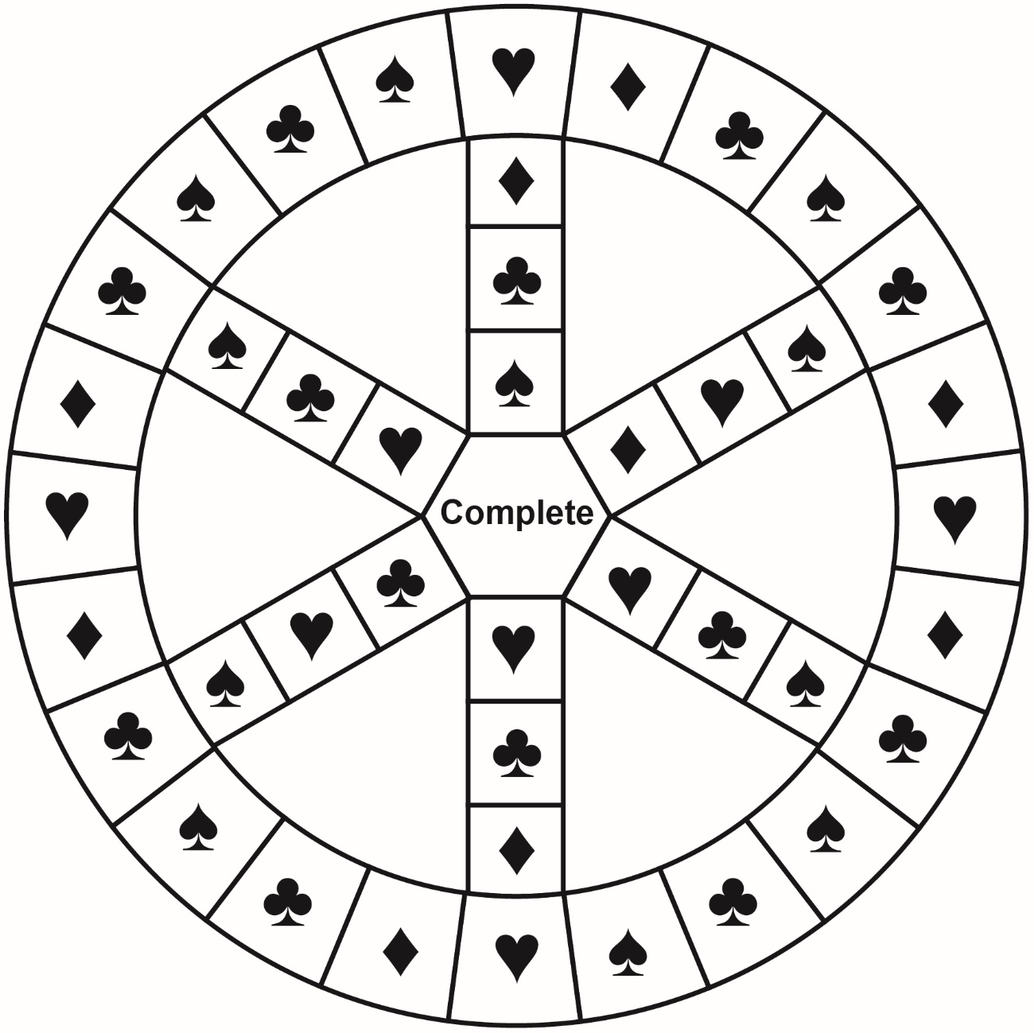
Legend
♥ Estimating | ♦ Adding decimals
♣ Subtracting decimals | ♠ Adding/subtracting fractions

