Coding Designs with Rotation Symmetry

Geometry
Unit 1 Line Master 8a

Designs found in nature as well as those created by artists sometimes have rotation symmetry. We will use coding to create neat designs
that have rotation symmetry.

- Let’s start with some code that creates a design of a circle of squares.

- Click the link to access Scratch: Designs and Rotation Symmetry.
https://scratch.mit.edu/projects/879197398/editor/

Click on the green flag.

- What is the rotation symmetry of this circle of squares design?
The code gives us a hint!
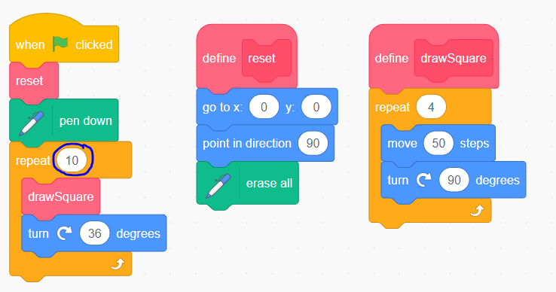

Coding Designs with Rotation Symmetry
(cont’d)

Geometry
Unit 1 Line Master 8b

- Let’s alter the code to create a design that has a rotation symmetry of 36, rather than 10.
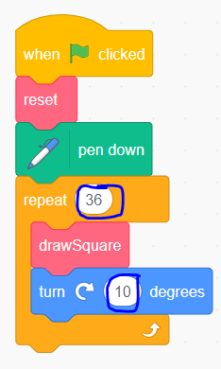
We need to change two values to do this:

- Change the value of the repeat block to 36.
- Change the rotation angle after each square is drawn. The product of the repeat block and turn block must be 360°. So, since the repeat is now 36, we divide 360° by 36:
360° ÷ 36 = 10°
So, the new turn value is 10 degrees.

Try it out! Does it draw 36 squares in a full circle?

- Alter the code to create other designs with a circle of squares by changing the order of rotation. Remember that the product of the value of the repeat block and the turn block must be 360°.

- Share your designs with your classmates.

