Rotation Symmetry and
2-D Shapes

Geometry
Unit 1 Line Master 6a

If you can rotate a 2-D shape less than one full turn and it still looks the same,
the shape has rotation symmetry.

Let’s explore what we mean by this.
All regular polygons have rotation symmetry. The number of times a shape can be rotated within 360°(one full turn) and still look the same is called the order of rotation symmetry. When determining if a shape has rotation symmetry, we rotate it about its centre.

Cut out or trace the shapes below and rotate them about their centre
to see for yourself.

The order of rotation symmetry of a regular polygon is equal to the number of sides or angles!

A shape has rotation symmetry if it coincides with itself in less than one full turn about the centre of the shape.

The number of times a shape coincides with itself within a rotation of 360°, including either the beginning or ending position, is its order of rotation symmetry.

Geometry
Unit 1 Line Master 6b
Rotation Symmetry and
2-D Shapes(cont’d)

Fill in the missing numbers.

An equilateral triangle has 3 equal sides  and 3 equal angles.  In one full turn about its centre, an equilateral triangle coincides with itself (looks the same) 3 times. So, an equilateral triangle has order of rotation symmetry 3. | 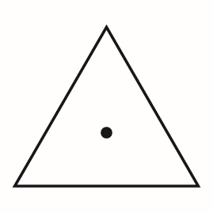
A square has ___ equal sides and ___ equal angles.

In one full turn about its centre, a square coincides with itself (looks the same) ____ times. So, a square has order of rotation symmetry ____.
A regular pentagon has ___ equal sides and ___ equal angles.  In one full turn about its centre, a regular pentagon coincides with itself (looks the same) ____ times. So, a regular pentagon has order of rotation symmetry ____. | 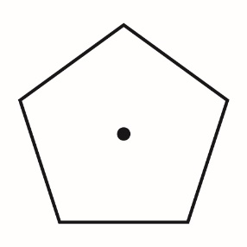
A regular hexagon has ___ equal sides and ___ equal angles.  In one full turn about its centre, a regular hexagon coincides with itself (looks the same) ____ times. So, a regular hexagon has order of rotation symmetry ____. | 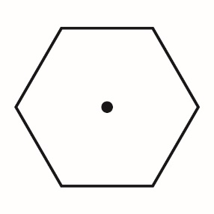

Repeat for a regular polygon of your choice.  A ______________________ has ___ equal sides and ___ equal angles.  In one full turn about its centre, a ____________________ coincides with itself (looks the same) ____ times. So, a ______________________ has order of rotation symmetry ____. | Draw the polygon here with the centre marked.
Geometry
Unit 1 Line Master 6b
Rotation Symmetry and
2-D Shapes(cont’d)

On Line Master 7, we will use this information to write code
to model rotation symmetry.

