Symmetry in First Nations Regalia

Data Sets

Geometry
Unit 1 Line Master 1a

First Nations Regalia: The Story

Since time immemorial, First Nations have and continue to have a deep-rooted connection to the natural world, which is evident in regalia designs. Material and symbols from the natural world are included in the designs. They might include inspirations and elements from water, land, and sky. For example, reflections of plants and medicines, flowers, sky (sun, moon, stars), water, and animals and their tracks might be found in some designs.

Symmetry in a design reflects living in balance and harmony with oneself, others, and the natural world. Each person’s regalia tells a unique story and there is significance and meaning embedded in the colours, symbols, shapes, and designs.

Traditionally, shells, paints, bones, talons, animal teeth, bark, plants, flowers, and quillwork were used to create designs on clothing made from plant and tree fibers and animal hides. Today, regalia and their designs may be created from traditional natural materials, but they may also include silk or synthetic ribbon, fabrics, canvas, plastic or glass beads, and metal.

Designs are unique to each person and family and vary from nation to nation, community to community, and family to family. Designs and colour choices may come from the passing down of symbols within family and community, dreams, reflections of the natural world, and favourite things. Regalia designs tell a unique and personal story. The design and style of regalia are significant to the style of powwow dance.

Geometry
Unit 1 Line Master 1b
Symmetry in First Nations Regalia (cont’d)

Data Sets

Music and dance have always been a part of ceremony within First Nations cultural ways. Various styles of powwow dance and regalia designs have emerged over time to become what they are today. Each style of powwow dance has a purpose and the regalia worn is distinct to each style of dance.

Traditionally, music and dance were done for healing, ceremony, and celebration. Contemporary powwow dance is often competitive, although roots of healing, ceremony, and celebration continue within both contemporary and traditional powwows.

Some dance styles include traditional, fancy, and jingle. Capes can be found in most women’s powwow dance regalia. Copying regalia designs and powwow dances does not honour First Nations deep-rooted cultural connection to the regalia and dance. However, some powwows feature an ‘Intertribal’ dance where all are welcome to respectfully participate in that round of the powwow. It would be best to inquire of powwow organizers as to whether they have that category of dance at their powwow and what the requirements are to respectfully participate.

Geometry
Unit 1 Line Master 1c
Symmetry in First Nations Regalia
(cont’d)

Data Sets

Stories Through Symmetry

- What symmetrical designs can be found within
First Nations regalia?

- Complete this symmetrical design, then add colour.
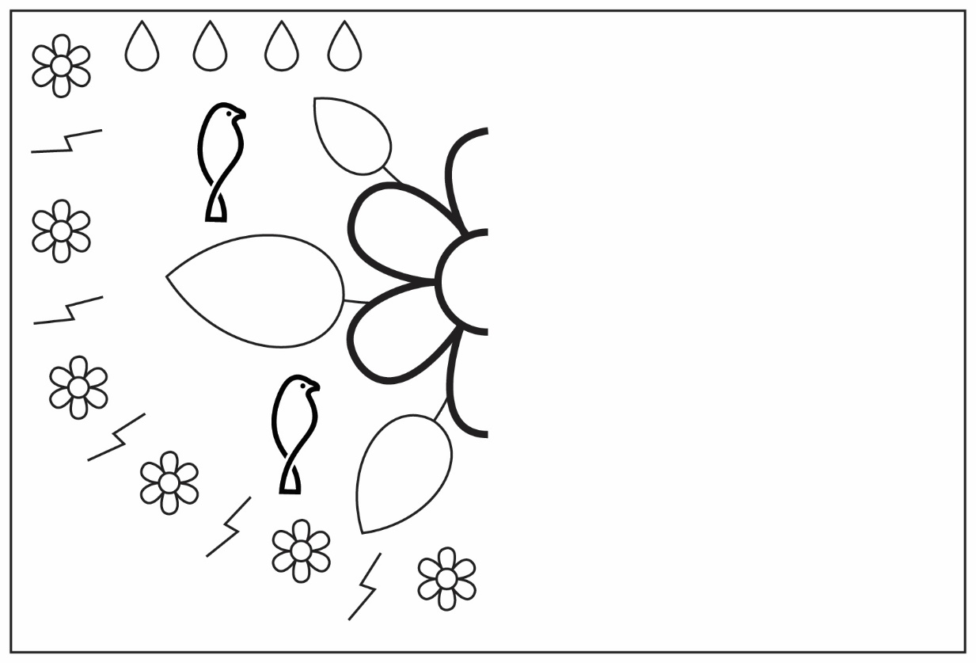

Symmetry in First Nations Regalia
(cont’d)

Data Sets

Geometry
Unit 1 Line Master 1d

Extension

- Share a story of your choice through a symmetrical design.

- What is the meaning and significance of your symmetrical design? What story does your design tell?

