Using Variables to Represent a Problem as an Equation
Interprets word problems/pictures and identifies the unknown part  Our class needs to set up rows  of 6 chairs for a presentation.  There are 30 chairs altogether.  How many rows do we need?  “The unknown is the number of rows of 6 chairs needed to make an array of 30 chairs.” | Translates word problems into equations using variables, operations, and numbers  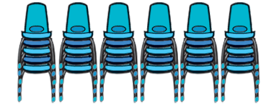  “The unknown, n, is the number of rows. I know there are 6 chairs in each row and a total of 30 chairs.  So, 6n = 30.” | Describes equivalent relationships using more than one equation (including formulas)  “I know the area of a rectangle is base multiplied by height, which is 30. If the base is 6, then the height must be n. I could write the equation 30 = 6n or 30 ÷ 6 = n.” | Flexibly writes algebraic equations using a variety of strategies  6n = 30  30 ÷ n = 6  “I can use the inverse operation  to rewrite the equation.”
Observations/Documentation

