Adding and Subtracting Fractions with Like Denominators
Expresses the composition or decomposition of a quantity as a sum or difference  <catch: pick up  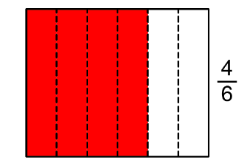  “I can think of $\frac{4}{6}$ as $\frac{1}{6}$ + $\frac{1}{6}$ + $\frac{1}{6}$ + $\frac{1}{6}$, or as $\frac{1}{6}$ + $\frac{3}{6}$ .  I can also think of $\frac{4}{6}$ as $\frac{6}{6}$ − $\frac{1}{6}$ − $\frac{1}{6}$, or as $\frac{6}{6}$ − $\frac{2}{6}$.” | Adds and subtracts concretely or pictorially  $\frac{3}{4}$ + $\frac{2}{4}$ = ?  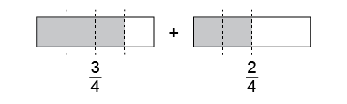  “Because each whole is divided into fourths, I can add the parts. 3 fourths + 2 fourths = 5 fourths. 5 fourths make 1 whole and $\frac{1}{4}$.”  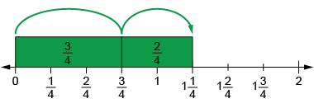  $\frac{3}{4}$ + $\frac{2}{4}$ = $\frac{5}{4}$ = 1$\frac{1}{4}$  “I modelled on the number line,  then counted on from $\frac{3}{4}$:  4 fourths, 5 fourths.” | Adds and subtracts symbolically  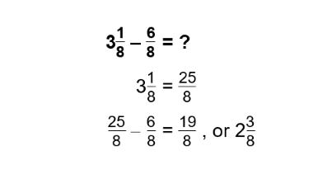  “I converted 3$\frac{1}{8}$ to $\frac{25}{8}$,  then subtracted. I checked my answer using addition.” | Flexibly solves problems involving the addition and subtraction of fractions  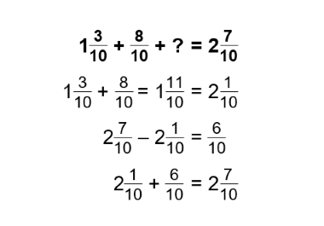  “$\frac{6}{10}$ needs to be added to the other fractions to equal 2$\frac{7}{10}$.”
Observations/Documentation

