Exploring Ratios
Understands difference between part-part and part-whole relationships  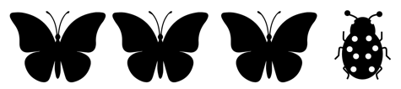  “Butterflies to ladybugs is a part-part relationship and butterflies to all insects is a part-whole relationship.” | Expresses part-part and part-whole relationships with ratios  “Butterflies to ladybugs: 3:1,  a part-part ratio.  Butterflies to all insects: 3:4,  a part-whole ratio.” | Expresses part-whole relationships in different ways (i.e., ratios, fractions, decimals, percents)  “Butterflies to all insects:  3:4, $\frac{3}{4}$, 0.75, 75%” | Flexibly interprets and expresses ratios to represent different situations  4:5  “A 4:5 ratio could represent a  part-part situation, such as:  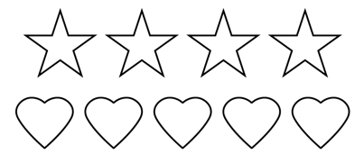  Or it could represent a part-whole situation, such as:”  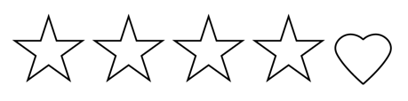
Observations/Documentation
.

