Exploring Fractions and Decimals
Uses counting to determine improper fractions and mixed numbers  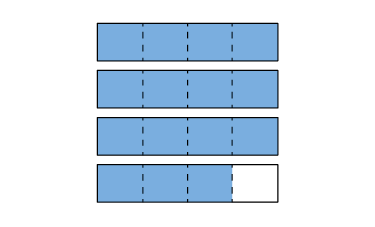  “I counted 15 one-fourths.  Each four-fourths is one whole,  so $\frac{15}{4}$ = 3$\frac{3}{4}$.” | Models fractions using quantities, lengths, and areas  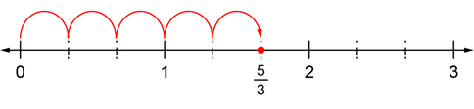  “I took jumps on a number line to show $\frac{5}{3}$” | Expresses improper fractions as mixed numbers and vice versa  $\frac{5}{3}$= 1$\frac{2}{3}$  “5 = 3 + 2  So, $\frac{5}{3}$= $\frac{3}{3}$ + $\frac{2}{3}$, which is the same as  1 + $\frac{2}{3}$= 1$\frac{2}{3}$.” | Compares and orders fractions, including improper fractions and mixed numbers (e.g., using benchmarks)  $\frac{11}{7}$, $\frac{16}{9}$, $\frac{13}{12}$  $\frac{11}{7}$ = 1$\frac{4}{7}$, $\frac{16}{9}$ = 1$\frac{7}{9}$, $\frac{13}{12}$ = 1$\frac{1}{12}$  “All the fractions are between  1 and 2. I compared to benchmarks:  1$\frac{4}{7}$ is a little more than 1 and  one-half. 1$\frac{7}{9}$ is pretty close to 2.  1$\frac{1}{12}$ is very close to 1.  So, from least to greatest:  $\frac{13}{12}$, 1$\frac{4}{7}$, 1$\frac{7}{9}$.”
Observations/Documentation
.

Exploring Fractions and Decimals (cont’d)
Represents decimal numbers to thousandths  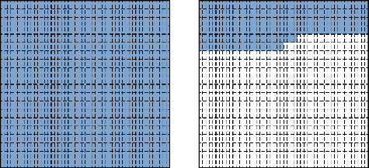  “I shaded the grids to show 1.254.” | Identifies a decimal between two given decimals  2.834, ?, 2.84  “Both decimals have 2 wholes.  I know 2.834 has  834 thousandths and 2.84 has  840 thousandths.  836 is between 834 and 840.  So, 2.836 is between 2.834 and 2.84.” | Rounds decimals to a specified place value (e.g., nearest hundredth)  “2.517 is closer to 2.52 than to 2.51, so I round up to 2.52.” | Flexibly compares and orders decimals  2.7, 2.649, 2.76  “I ordered the decimals from least to greatest: 2.649, 2.7, 2.76.”
Observations/Documentation

