Conceptual Meaning of Whole Number Addition and Subtraction
Recognizes addition and subtraction situations to 1 000 000  How many views did the video get on its first two days online?  “To find the total number of views, I need to add the number of views on Day 1 and the number of views on Day 2.” | Models and symbolizes ways to solve problems to 1 000 000  156 231 + 275 489 = ?  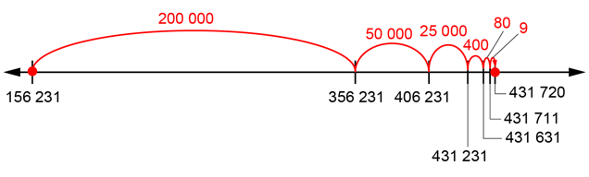 | Uses an understanding of place value to decompose numbers to solve problems to  1 000 000  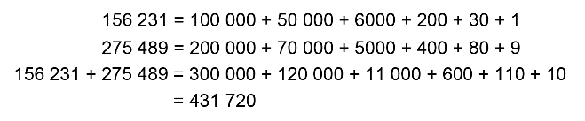  “I added hundred thousands with hundred thousands, ten thousands with ten thousands, thousands with thousands, and so on.  I added like units.”
Observations/Documentation

Conceptual Meaning of Whole Number Addition and Subtraction (cont’d)
Uses an understanding of place value to add and subtract to 1 000 000 using the standard algorithm  968 867 – 790 283 = ?  “I used the standard algorithm.” | Estimates to determine if answer to problem is reasonable  968 867 – 790 283 = ?  “968 867 is close to 970 000 and 790 283 is close to 800 000.  970 000 – 800 000 = 170 000.  178 584 is close to 170 000.  So, my answer is reasonable.” | Creates and solves multi-step addition and subtraction problems flexibly using a variety of strategies  A dancing monkey video got 54 977 likes one day and 127 522 likes the next. How many more likes does it need to reach 250 000?  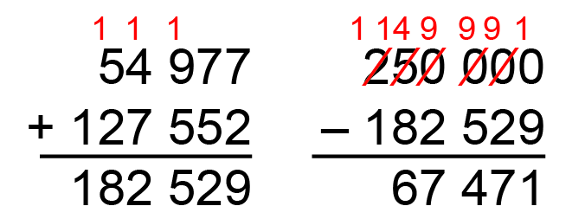
Observations/Documentation

