Extending Whole Number Understanding
Represents 6-digit number on place-value chart (decomposes in one way)  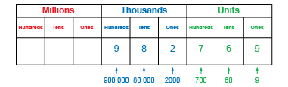  “982 769 has 9 hundred-thousands,  8 ten-thousands, 2 thousands, 7 hundreds,  6 tens, and 9 ones.” | Represents 7-digit number on place-value chart (decomposes in one way)  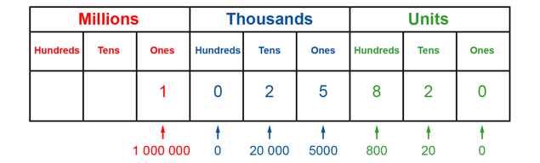  “1 025 820: I used the digits of the number to tell me the number to write in each column.” | Uses relationships among place-value positions to read and write a number in more than one way  “1 million, 2 ten-thousands, 5 thousands,  8 hundreds, and 2 tens, can also be 1 million,  25 thousands, 820 ones.”  1 025 820 = 1 000 000 + 20 000 + 5000 + 800 + 20
Observations/Documentation

Extending Whole Number Understanding (cont’d)
Uses place-value to compare and order numbers to 10 000 000  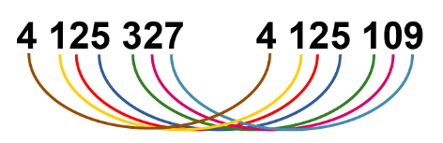  “Both start with 4 million 125 thousands.  3 hundreds is greater than 1 hundred,  2 tens is greater than 0 tens,  and 7 ones is less than 9 ones.  So, 4 125 327 is greater than 4 125 109.” | Rounds 6- and 7-digit numbers to various places  “1 025 820 rounded to the nearest ten  is 1 025 820, to the nearest hundred  is 1 025 800, to the nearest thousand  is 1 026 000, to the nearest ten thousand  is 1 030 000, to the nearest hundred thousand is 1 000 000, and to the nearest million  is 1 000 000.” | Represents and compares numbers flexibly using place-value relationships  “1 025 820 =  1 000 000 + 20 000 + 5000 + 800 + 20  1 025 820 =  1 000 000 + 20 000 + 5000 + 700 + 120  1 025 820 =  1 000 000 + 20 000 + 5000 + 700 + 110 + 10”
Observations/Documentation

