Measuring Area and Perimeter of Rectangles
Recognizes that the perimeter of a rectangle is the distance around and area is the number of tiles that cover it  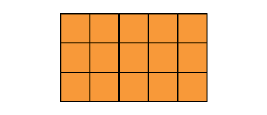  “Perimeter of rectangle: 3 + 5 + 3 + 5 = 16,  16 units; Area: 3 × 5 = 15, 15 square units.” | Uses algebraic formulas to determine the perimeter and area of a rectangle  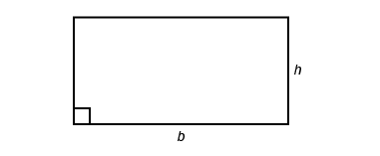  “To determine the perimeter of a rectangle, I use the formula P = 2b + 2h and to determine the area, I use the formula A = b × h.  For a rectangle with b = 6 m and h = 3 m:  Perimeter: 2 × 6 m + 2 × 3 m = 18 m  Area: 6 m × 3 m = 18 m².” | Compares the perimeters and areas of rectangles  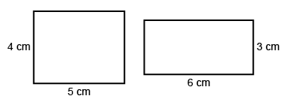  “Both rectangles have a perimeter of 18 cm:  2 × 4 + 2 × 5 = 18; 2 × 6 + 2 × 3 = 18.  The rectangles have different areas:  4 cm × 5 cm = 20 cm² and 6 cm × 3 cm = 18 cm².”
Observations/Documentation

Measuring Area and Perimeter of Rectangles (cont’d)
Constructs a rectangle with given perimeter/area and explains strategy used  Perimeter = 24 m  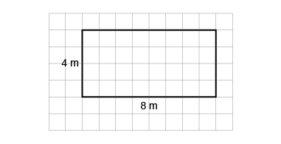  “To construct a rectangle with perimeter 24 m, the sum of the base and height needs to be  24 m ÷ 2 = 12 m. I chose 8 m and 4 m.  To determine the area, I multiplied the base by the height: 8 m × 4 m = 32 m².” | Constructs different rectangles for a given area and describes the rectangle with the least perimeter  Area = 16 cm²  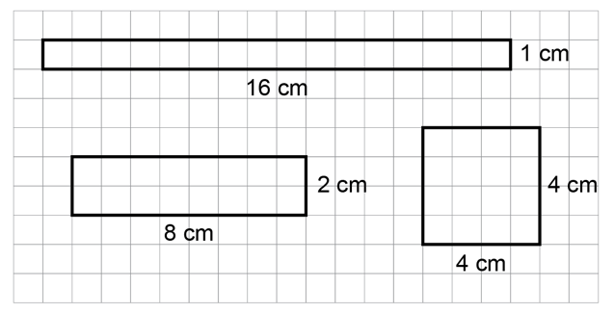  “The rectangle with the least perimeter  is a square.” | Flexibly solves problems involving a given area and/or perimeter in a variety of contexts.  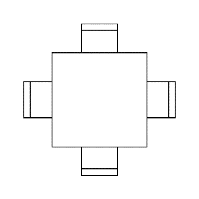  A square table can seat 1 student on each side.  24 tables are pushed together to make 1 large rectangular table. What is the greatest number of students who could be seated?  “For an area of 24 square units, the length and width can be: 1 and 24; 2 and 12; 3 and 8; 4 and 6. For the greatest number of students, the perimeter has to be the greatest, which means its width is the least, 1 unit, and the length is 24 units.  The perimeter is 50 units,  so 50 students can be seated.”
Observations/Documentation

