Relationships Among Standard Units of Area
Recognizes that area is measured using square units  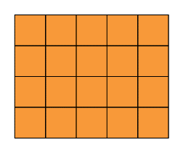  ”I covered the rectangle with square tiles and determined the area to be 20 square units.” | Relates a centimetre/metre to a square centimetre/metre  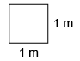  “A square with side length 1 m  has an area of 1 m².” | Expresses the relationship between square centimetres, square metres, and square kilometres  “1 m = 100 cm, so 1 m² = 100 cm × 100 cm  = 10 000 cm²  1 km = 1000 m, so 1 km² = 1000 m × 1000 m  = 1 000 000 m²”
Observations/Documentation

Relationships Among Standard Units of Area (cont’d)
Identifies which metric unit should be used to measure an area  The Classroom Floor  “I could use a metre stick to determine the length and width of the classroom.  So, I would use a square metre to measure the area of the floor.” | Uses benchmarks to estimate area using metric units, then measures to check (square centimetre, square metre)  The Classroom Floor  ”I visualize covering the classroom floor with about 50 tabletops, so I estimate its area  to be about 50 m².  When I measured to check, the classroom was  8 m long and 6 m wide. So, the actual area is  8 m × 6 m = 48 m².  My estimate was close.” | Flexibly chooses an appropriate metric unit to estimate and measure area and explains reasoning  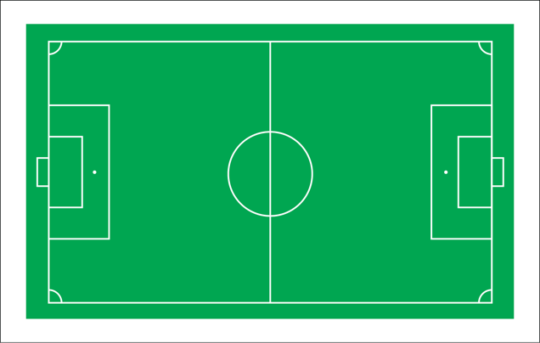  “I’d estimate and measure the area of the soccer field in square metres. I could use square centimetres, but the number would be so large that it would be difficult to relate to.”
Observations/Documentation

