Locating and Plotting Points on a Coordinate Grid
Uses coordinates to describe the location of points on a grid  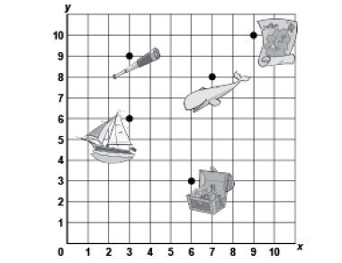  “The treasure chest is located at  (6, 3).” | Plots, locates, and labels points on a grid  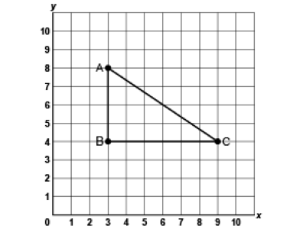  “I plotted A(3, 8), B(3, 4) and C(9, 4).  I joined the points to create a right triangle.” | Uses positional language to describe the location of a point on a grid in relation to another point  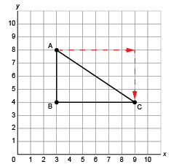  “Move right 6 squares and  down 4 squares from  Point A to get to Point C.” | Flexibly models and describes the location of the vertices of a polygon on a grid  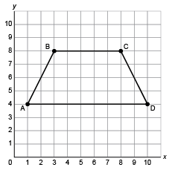  “The vertices of the trapezoid are at: A(1, 4), B(3, 8), C(8, 8), D (10, 4).”
Observations/Documentation

