Understanding Symmetry
Recognizes symmetry on 2-D and 3-D shapes  ”I used a Mira to find the line of symmetry.  When I folded the ladybug in half along the line, the two halves matched exactly.” | Shows line(s) of symmetry on 2-D shapes  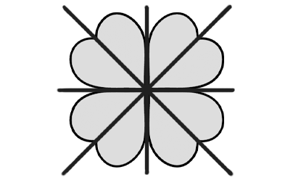  “I drew 4 lines to show the lines  of symmetry on the clover.  I used a Mira to check.” | Describes order of rotation symmetry of 2-D shapes  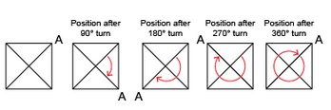  “A square has rotation symmetry  of order 4.”
Observations/Documentation

Understanding Symmetry (cont’d)
Relates number of reflection and rotation symmetries of regular polygons to number of equal sides and angles  “A square has 4 equal sides and 4 equal angles. So, it has 4 lines of symmetry and order of rotation symmetry 4.” | Classifies 2-D shapes by the number of reflection or rotation symmetries  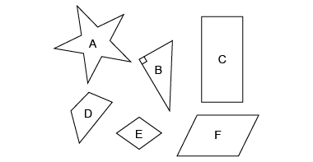  “I classified the shapes by order of rotation symmetry. Shapes B and D have order of rotation symmetry 1, Shapes C, E, and F have order of rotation symmetry 2, and Shape A has order of rotation symmetry 5.” | Recognizes line and rotation symmetry in the environment  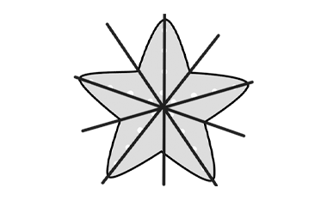  “A starfish has 5 lines of symmetry and  order of rotation symmetry 5."
Observations/Documentation

