Data Collection
Differentiates between open-ended and closed-list questions  What is your favourite fruit?  “This is an open-ended question because respondents can answer in their own words.” | Collects data using closed-list questions and categories  “What is your favourite fruit: orange, apple, banana, grapes, or other?”  Orange, apple, apple, grapes, other, banana, orange, …, orange, apple | Categorizes collected data  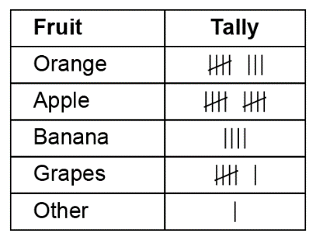  “I marked a tally each time a student chose a particular fruit.”
Observations/Documentation

Data Collection (cont’d)
Organizes categorized data in frequency tables  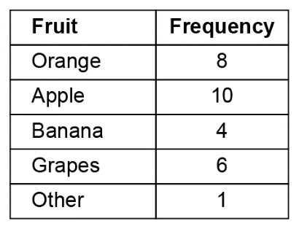  “I organized the data in a frequency table so I can see and compare the numbers of students who chose each fruit.” | Represents data using bar graphs and dot plots  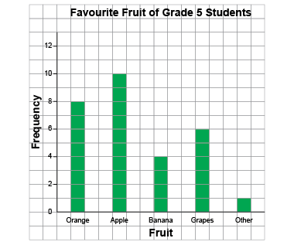  “I showed the data on a bar graph.” | Flexibly represents data based on frequency (including stem-and-leaf plots)  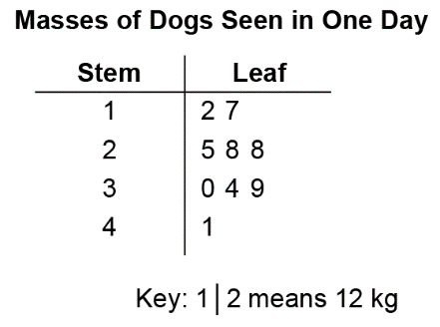  “I see the same number of dogs had a mass between 20 kg and 29 kg as between 30 and  39 kg.”
Observations/Documentation

Frequency and Mode
Notices changes in frequency across categories in tables and graphs  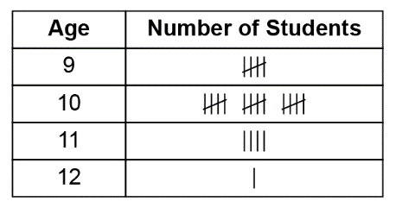  “I see more students are 10 years old than 9 years old.” | Counts individual data points to determine frequency  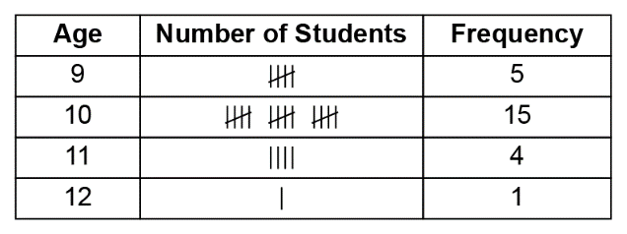  “Five students are 9 years old and 15 students are 10 years old.” | Identifies mode as a measure of frequency  “The mode is 10 years old because it has the highest frequency, 15.”
Observations/Documentation

Frequency and Mode (cont’d)
Identifies the mode in various representations of data  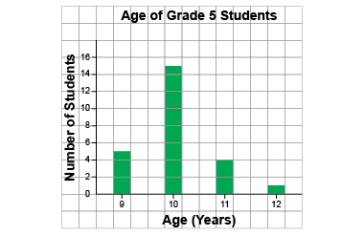  “The mode is 10 years old because it is the category with the tallest bar.” | Recognizes data sets with no mode, one mode, or multiple modes  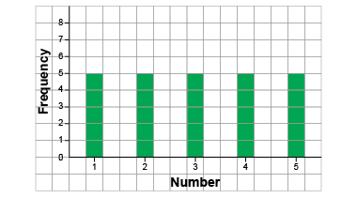  “The data set has no mode because all the bars are the same height.” | Uses the mode to justify possible answers  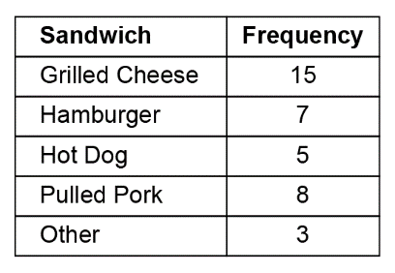  “The mode is grilled cheese sandwich, so I am going to focus on selling different types of grilled cheese sandwiches on my food truck.”
Observations/Documentation

