***Money Adventure* Gameboard**

**Number**

**Unit 8 Line Master 3**

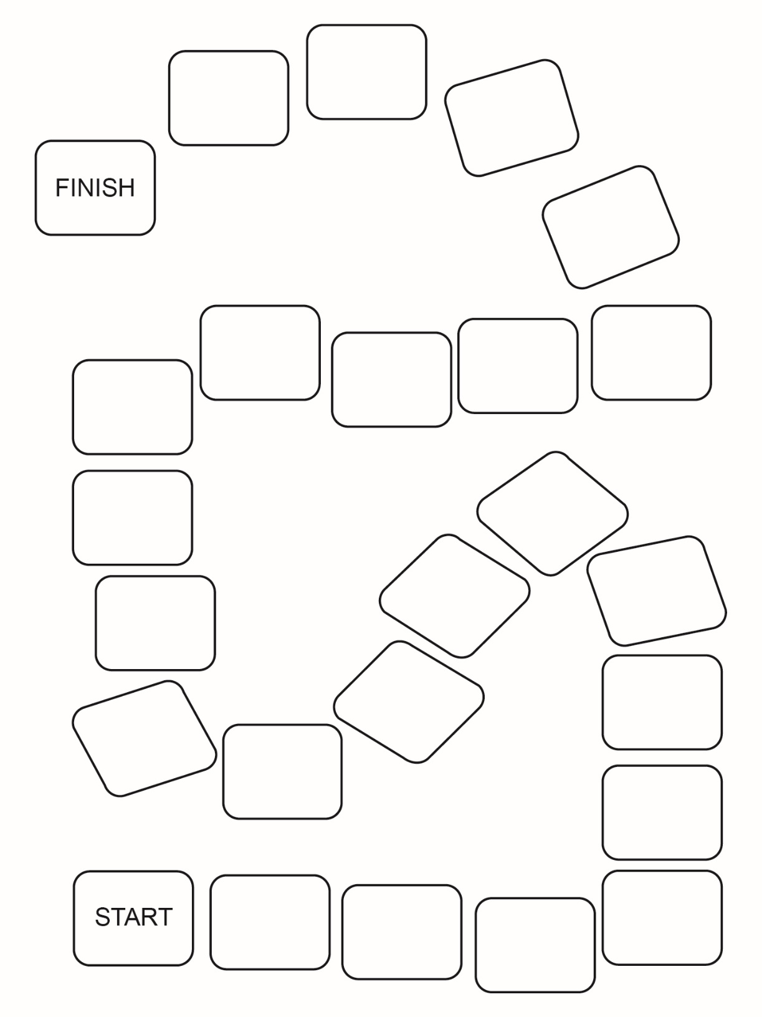

Cards