*Marsh Dash!*

Gameboard A

**Number**

**Unit 6 Line Master 3a**

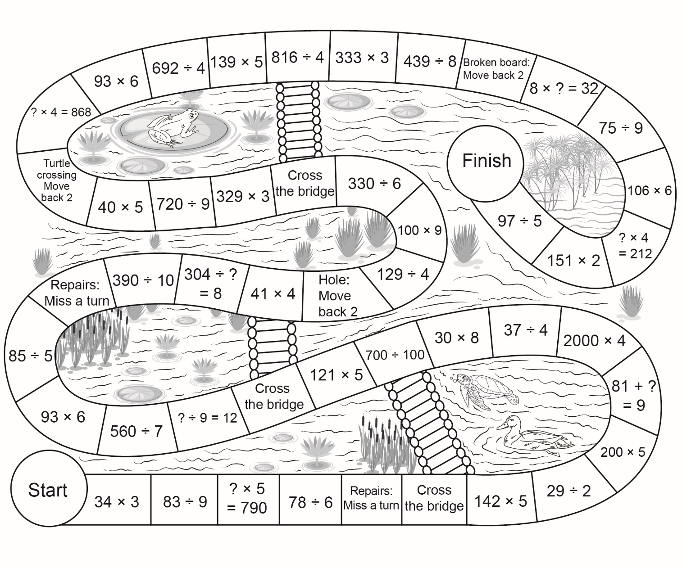

*Marsh Dash!*

Gameboard B

**Number**

**Unit 6 Line Master 3b**

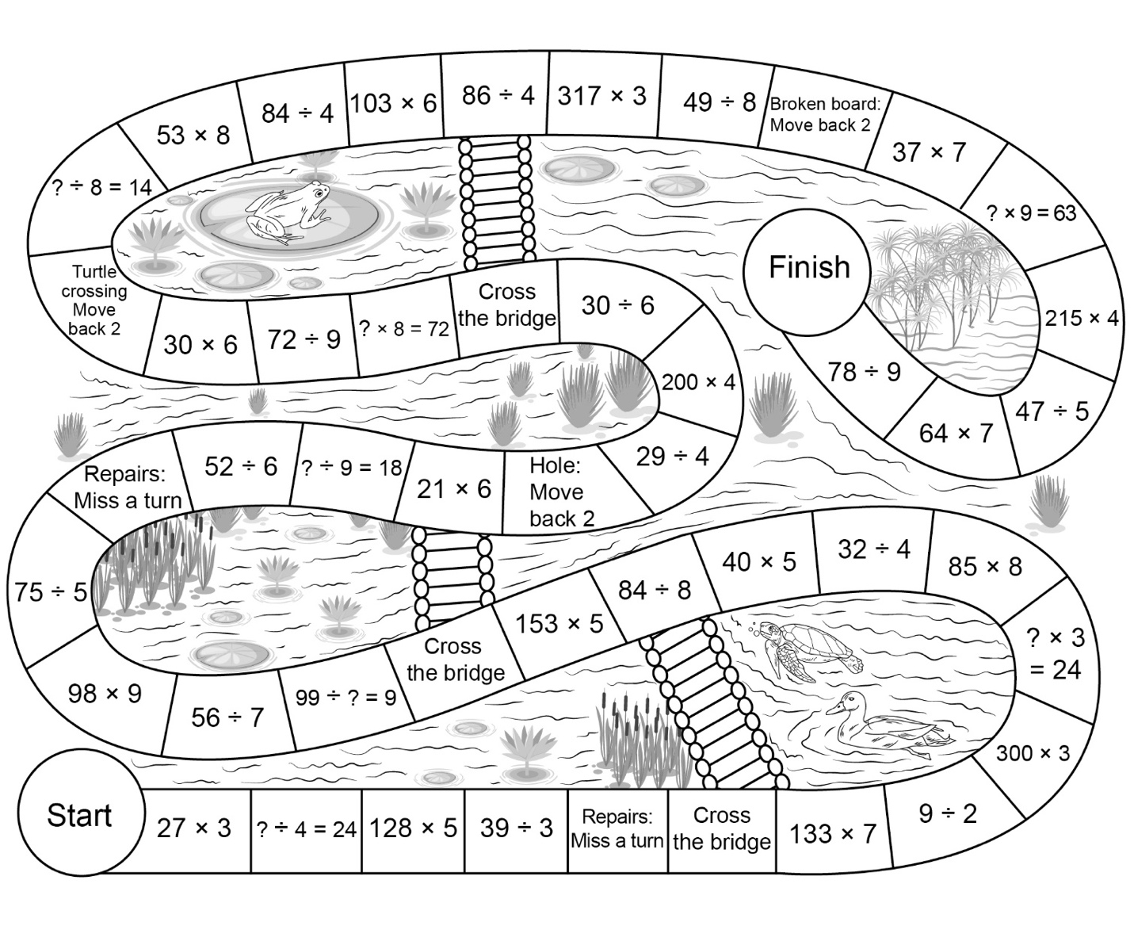

*Marsh Dash!*

Blank Gameboard

**Number**

**Unit 6 Line Master 3c**

