*Ring the Bell!*

Gameboard

**Number**

**Unit 6 Line Master 1a**

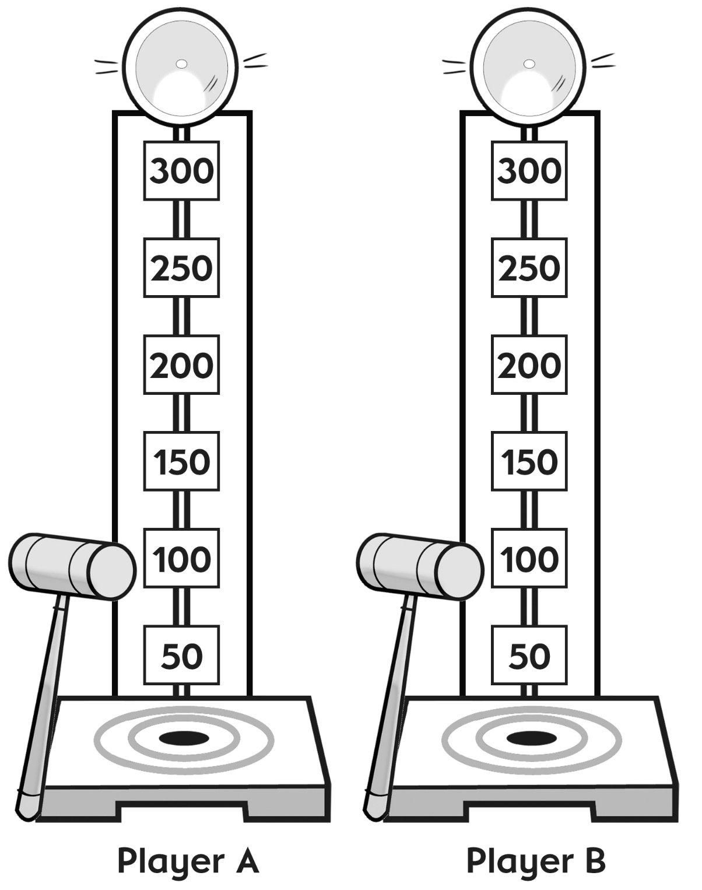

*Ring the Bell!* (cont’d)

Gameboard

**Number**

**Unit 6 Line Master 1b**

|  |  |
| --- | --- |
|  |  |
| **Player A** | **Player B** |