Start Time | End Time
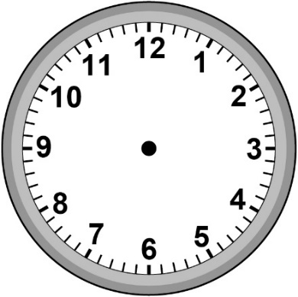  Time:  _______ | 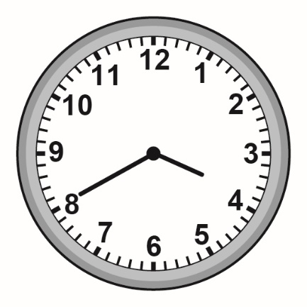  Time:  _______
Duration: $\frac{1}{2}$ h or _____ min
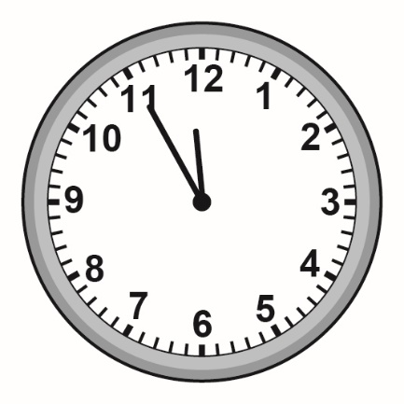  Time:  _______ | Time:  _______
Duration: $\frac{2}{3}$ h or _____ min
Time:  _______ | 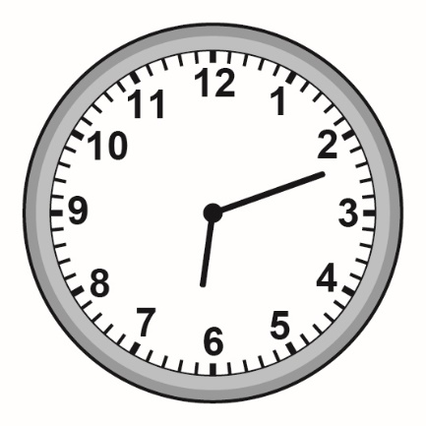  Time:  _______
Duration: $\frac{3}{4}$ h or _____ min
Start and End Times

Measurement
Unit 2 Line Master 2

