Measurement
Unit 2 Line Master 1
Finding Duration

Start Time | End Time
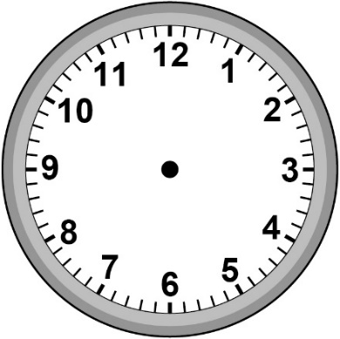  2:20 p.m. | 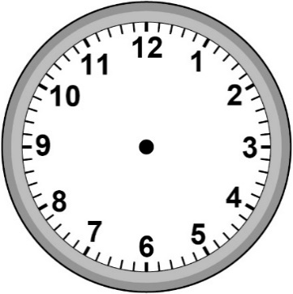  3:05 p.m.
Duration:
7:10 a.m. | 7:30 a.m.
Duration:
8:45 p.m. | 9:25 p.m.
Duration:

