**Cover Me!**

**Measurement**

**Unit 1 Line Master 7a**



**Cover Me!**

**Measurement**

**Unit 1 Line Master 7b**

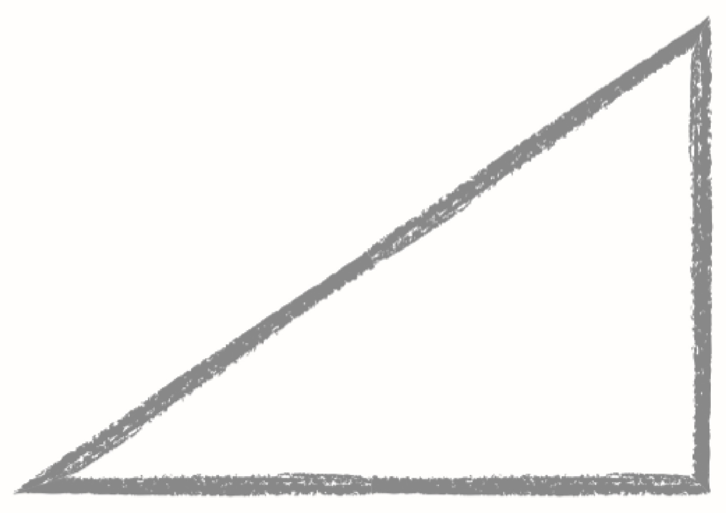

**Cover Me!**

**Measurement**

**Unit 1 Line Master 7c**

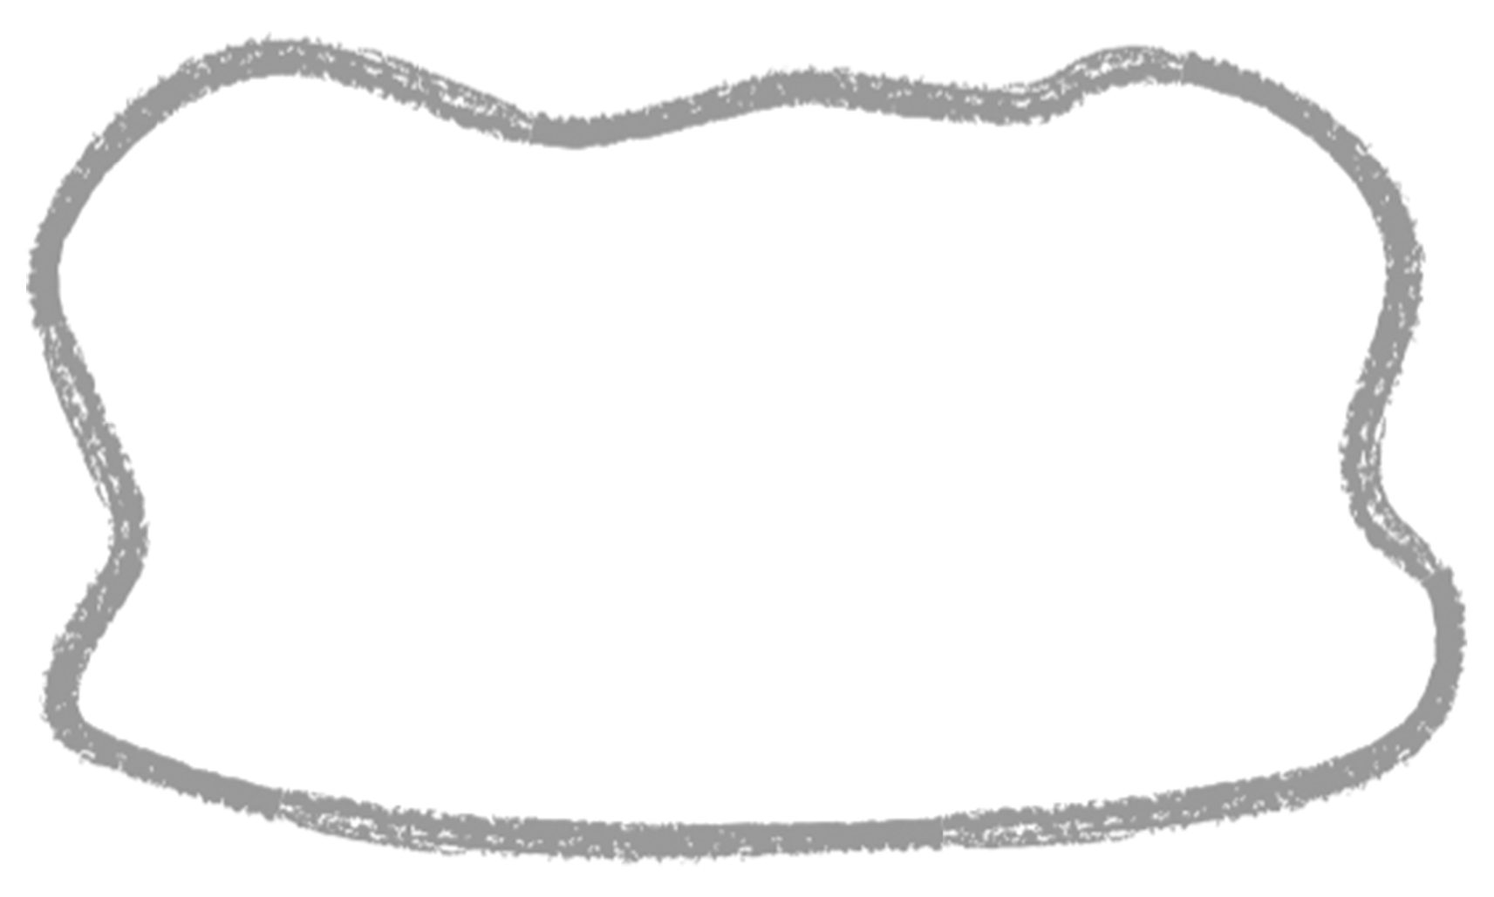

**Cover Me!**

**Measurement**

**Unit 1 Line Master 7d**

