Algorithms and Classifying Triangles

Geometry
Unit 1 Line Master 7a

You have written algorithms for completing different daily routines. Let’s take a look at writing algorithms to help us classify triangles according to their side lengths or angle measures.

- Here is an algorithm for classifying triangles according to their angle measures.

Algorithm for classifying a triangle according to angle measures
Measure all three angles.
If one angle is equal to 90 degrees, it’s a right triangle.
If one angle is greater than 90 degrees, it’s an obtuse triangle.
If all three angles are less than 90 degrees, it’s an acute triangle.

Use the algorithm to classify five of these triangles.
Check if you get the correct answer each time.
If not, adjust the algorithm as necessary.
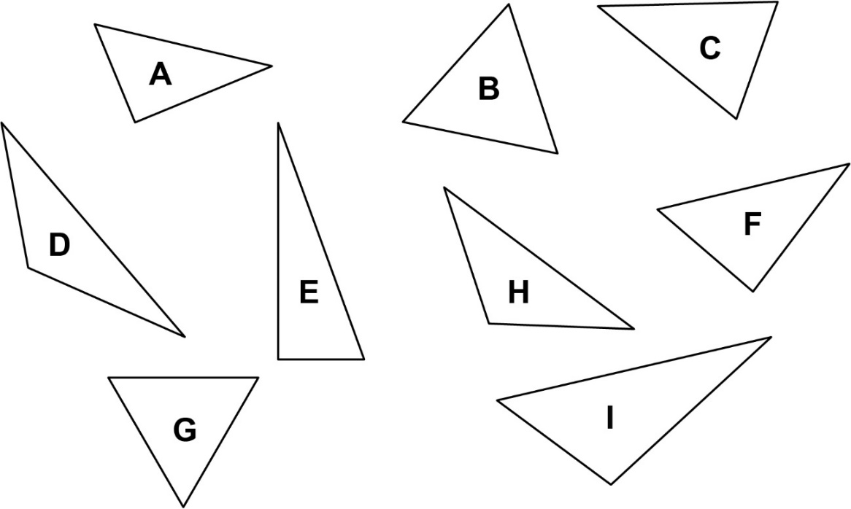

Algorithms and Classifying Triangles
(cont’d)

Geometry
Unit 1 Line Master 7b

Answers:
A: Right triangle B: Acute triangle
C: Acute triangle D: Obtuse triangle
E: Right triangle F: Right triangle
G: Acute triangle H: Obtuse triangle
I: Obtuse triangle

- Write an algorithm for classifying a triangle according to
side lengths.

Algorithm for classifying a triangle according to side lengths

Use your algorithm to classify five of these triangles.
Check if you get the correct answer each time.
If not, adjust the algorithm as necessary.

Algorithms and Classifying Triangles
(cont’d)

Geometry
Unit 1 Line Master 7c

Answers:
A: Scalene triangle B: Equilateral triangle
C: Isosceles triangle D: Scalene triangle
E: Scalene triangle F: Scalene triangle
G: Equilateral triangle H: Isosceles triangle
I: Scalene triangle

