Algorithms and Routines

Geometry
Unit 1 Line Master 6a

An algorithm is a sequence of instructions. We follow sequences of instructions, whether we notice or not, during our daily lives.

A recipe to bake a cake is an algorithm. When we engage in certain routines, such as getting ready for school, we are working our way through an algorithm.

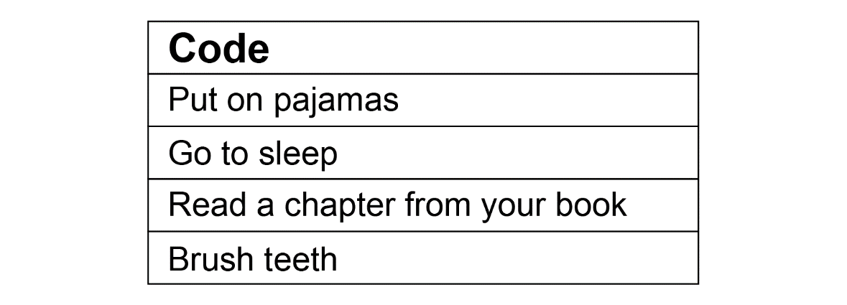
What is this algorithm for?

If this algorithm was for your bedtime routine, would it be
in the correct order?

How might you reorganize the steps in the algorithm so that
it is accurate?
Is more than one sequence possible? Explain.

Within this algorithm for a bedtime routine, there could be additional algorithms with further sequences of instructions.
For example, when you brush your teeth, you follow another sequence of instructions!

Algorithms and Routines (cont’d)

Geometry
Unit 1 Line Master 6b

Another routine that you likely engage in several times per day is washing your hands. Write an algorithm for washing your hands.

You might include instructions to repeat steps a certain number of times. You might include instructions to repeat steps only under certain conditions, such as if your hands are still dirty. Specific instructions help to make algorithms more straightforward to follow.

Code: Washing your hands

Compare your algorithm for washing your hands with that of a classmate’s. How are they alike? How are they different?

Algorithms and Routines (cont’d)

Geometry
Unit 1 Line Master 6c

- On your own or with a partner, choose another typical daily routine. Write an algorithm for completing that routine.

Code:

Is there more than one way to write the sequence of instructions
in your algorithm? Explain.
Have your classmates try to figure out what routine your algorithm was written for.

