Geometry
Unit 1 Line Master 5a
Is It, or Isn’t It?

Use transformations to determine if these are geometric shapes
or close approximations.

- What geometric properties must
a rectangle have?

Rectangle or close approximation

What transformations did you use to make your decision? Explain.

- What geometric properties must
a parallelogram have?

Parallelogram or close approximation

What transformations did you use to make your decision? Explain.

Geometry
Unit 1 Line Master 5b
Is It, or Isn’t It? (cont’d)

- What geometric properties must
an equilateral triangle have?

Equilateral triangle or close approximation

What transformations did you use to make your decision? Explain.

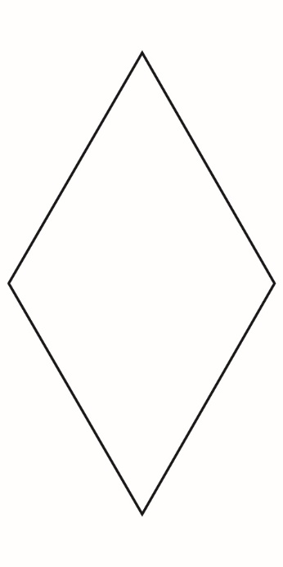
4. What geometric properties must a rhombus have?

Rhombus or close approximation

What transformations did you use to make
your decision? Explain.

Geometry
Unit 1 Line Master 5c

Is It, or Isn’t It? (cont’d)

5. What geometric properties must
a square have?

Square or close approximation

What transformations did you use to make
your decision? Explain.

6. What geometric properties must an isosceles triangle have?

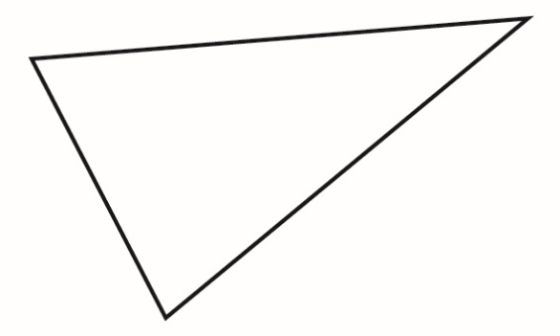

Isosceles triangle or close approximation

What transformations did you use to make
your decision? Explain.

