Variables and Equations
Evaluates a given expression (using the order of operations)  9 × 8 − 3 + 16 ÷ 4 = 72 − 3 + 4  = 73  “I have to do multiplication and division first. If the order isn’t followed and I perform the operations in the order in which they appear, I get 21 R1.” | Writes equivalent expressions (for the same number)  5 × 5, 30 ÷ 2 + 10, 3 × 5 + 2 × 6 − 2  “All of these expressions have value 25.” | Represents balance using concrete materials  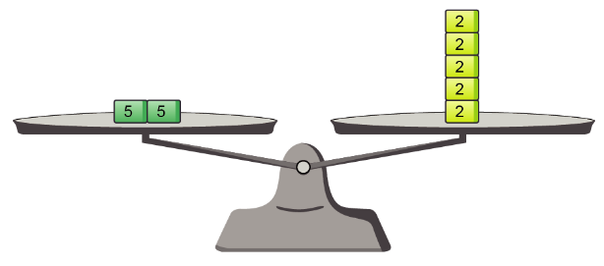  “The expressions 5 + 5 and 2 × 5 are equivalent because the pans are balanced.  Both have value 10.”
Observations/Documentation

Variables and Equations (cont’d)
Represents preservation of equality symbolically (with or without an unknown)  4 + 2 = 5 + 1  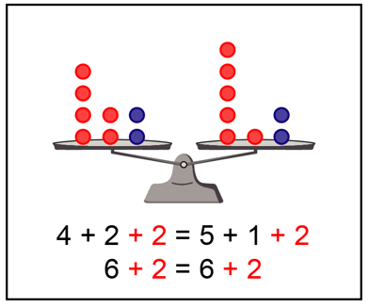  “I added 2 to each side to keep the balance.” | Finds the unknown value in an equation representing a situation  ♦ − 8 = 6  ♦ + 8 − 8 = 6 + 8  ♦ = 14  “I added 8 to each side to preserve equality and to isolate ♦.“ | Solves problems using equations  “I have 2 sets of cards, with the same number of cards in each set.  I have 24 cards. How many cards are in each set?”  “Let ∎ represent the number of cards in each set.”  2 ∎ = 24  2 ∎ ÷ 2 = 24 ÷ 2  ∎ = 12  “There are 12 cards in each set.”
Observations/Documentation

