Investigating Increasing and Decreasing Sequences
Recognizes increasing and decreasing sequences in multiple representations.  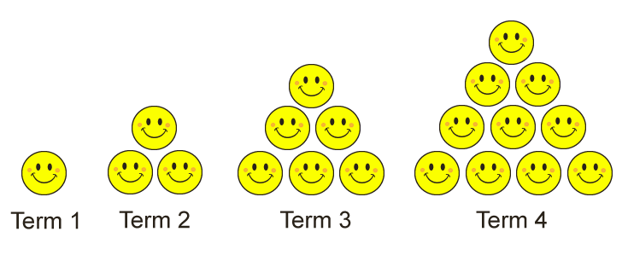  “That is an increasing sequence because the number of happy faces increases with each term.” | Creates and explains increasing and decreasing sequences, including numerical sequences.  “The happy faces form equilateral triangles. We start with 1 happy face, add 2 happy faces, then increase the number added by 1 each time.” | Expresses a concrete or pictorial sequence as a number sequence.  “The number sequence is:  1, 3, 6, 10, …” | Recognizes and describes increasing and decreasing arithmetic sequences.  1, 3, 5, 7, …  “This is an increasing arithmetic sequence as 2 is added each time.  Initial term: 1.  Constant change: Add 2.”
Observations/Documentation

Investigating Increasing and Decreasing Sequences (cont’d)
Writes the first 5 terms of an arithmetic sequence given the initial term and constant change.  “Initial term: 30.  Constant change: Subtract 3.  30, 27, 24, 21, 18, …” | Recognizes and describes increasing and decreasing geometric sequences.  2, 4, 8, 16, 32, …  “This is an increasing geometric sequence as a term is multiplied by 2 to get the next term.  Initial term: 2.  Constant change: Multiply by 2.” | Writes the first 5 terms of a geometric sequence given the initial term and constant change.  “Initial term: 2.  Constant change: Multiply by 3.  2, 6, 18, 54, 162, …” | Fluently recognizes and describes different increasing and decreasing sequences and uses them to solve problems.  It takes Sami 40 min to make  1 bracelet.  How many bracelets can Sami make in 4 h?  “This is an increasing arithmetic sequence. Initial term: 40.  Constant change: + 40.  40, 80, 120, 160, 200, 240  4 h = 240 min  Sami can make 6 bracelets. “
Observations/Documentation

