Conceptual Meaning of Multiplication and Division with Larger Numbers
Models multiplication and division situations concretely and pictorially  6 × 287 = ?  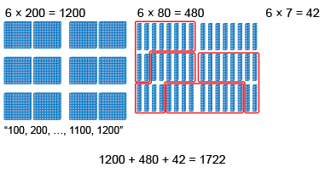  “I traded groups of 10 rods for a flat.” | Models multiplication and division situations using an open array  6 × 287 = ?  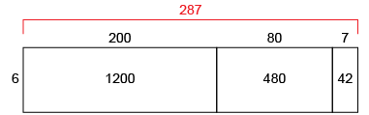  “I can use an open array to help me multiply.” | Uses place value to multiply and divide natural numbers by 10, 100, and 1000  34 × 200 = 34 × 2 × 100  = 68 × 100  = 6800  “I used the associative property  to make friendly numbers.”
Observations/Documentation

Conceptual Meaning of Multiplication and Division with Larger Numbers (cont’d)
Decomposes numbers and uses standard algorithm to multiply and divide  6 × 287 = ?  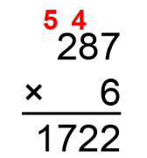  “I used the standard algorithm to multiply the numbers.” | Estimates to determine if answer to multiplication or division problem is reasonable  6 × 287 = 1722  287 is close to 300.  6 × 300 = 1800  “1800 is close to the answer I calculate, 1722.  So, my answer is reasonable.” | Creates and solves multiplication and division problems flexibly using a variety of strategies  123 ÷ 6 =?  “I counted 123 photographs to put in an album. Each page can hold 6 photographs. How many pages will I need?”  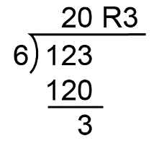  “I round up to 21 pages to be sure  all photos will fit.”
Observations/Documentation

