Determining Multiples and Factors
Uses skip-counting or repeated addition to find multiples  4, 8, 12, 16, 20, …  “To find multiples of 4, I skip counted by 4.” | Uses familiar basic facts to identify some multiples and factors  2 × 4 = 8  3 × 4 = 12  10 × 4 = 40  “I thought of the multiplication facts for 4  that I know.” | Uses efficient strategies to determine multiples and identify all factors  “To find factors of 8, I start  8 ÷ 1 = 8  Factors are 1 and 8.  8 ÷ 2 = 4  Factors are 2 and 4.  8 ÷ 3 = X  8 ÷ 4 = 2  So, 1, 2, 4, and 8 are all factors.”
Observations/Documentation

Determining Multiples and Factors (cont’d)
Uses concrete materials to identify prime and composite numbers  “7 is prime because it has only 2 factors, 1 and 7. 12 is composite because it has more than  2 factors: 1 and 12, 2 and 6, and 3 and 4.” | Identifies common multiples/factors and greatest common factor for a pair of numbers  Factors of 24: 1, 2, 3, 4, 6, 8, 12, 24  Factors of 56: 1, 2, 4, 7, 8, 14, 28, 56  “The greatest common factor is 8.” | Solves problems involving common factors and multiples  “Choir practice is every 5th day.  Gymnastics is every 3rd day.  That means choir and gymnastics both happen every 15th day.”
Observations/Documentation

Fluency of Multiplication and Division Facts
Recalls and demonstrates multiplication and divisions facts  to 5 × 5  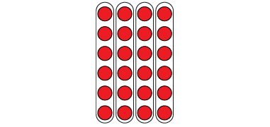  “I know that 4 × 6 = 24  and that 24 ÷ 6 = 4.  The array shows both facts.” | Uses inverse operations to solve multiplication and division problems  “I can rewrite 24 ÷ 6 = ?  as 6 × ? = 24.” | Uses known facts to determine unknown facts  “I can use the distributive property to split the multiplication into facts that I know, then add.”  5 × 9 = 5 × 5 + 5 × 4  25 + 20 = 45  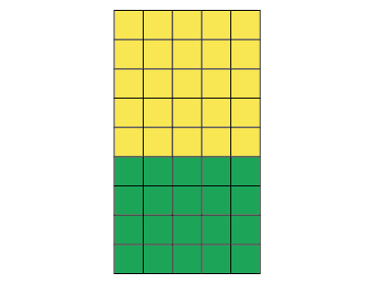 | Fluently creates and solves whole number multiplication problems with factors to 12 and related division problems  There are 96 basketballs with  the same number on each of  12 shelves.  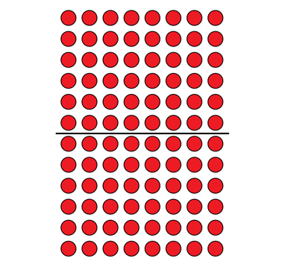  12 × □ = 96, so 96 ÷ 12 = □  12 × 8 = 96  Or  12 × 8 = 6 × 8 + 6 × 8  = 48 + 48  = 96
Observations/Documentation

